**curl --location --globoff 'https://restcountries.com/v3.1/name/{name}?fullText=true'  
  
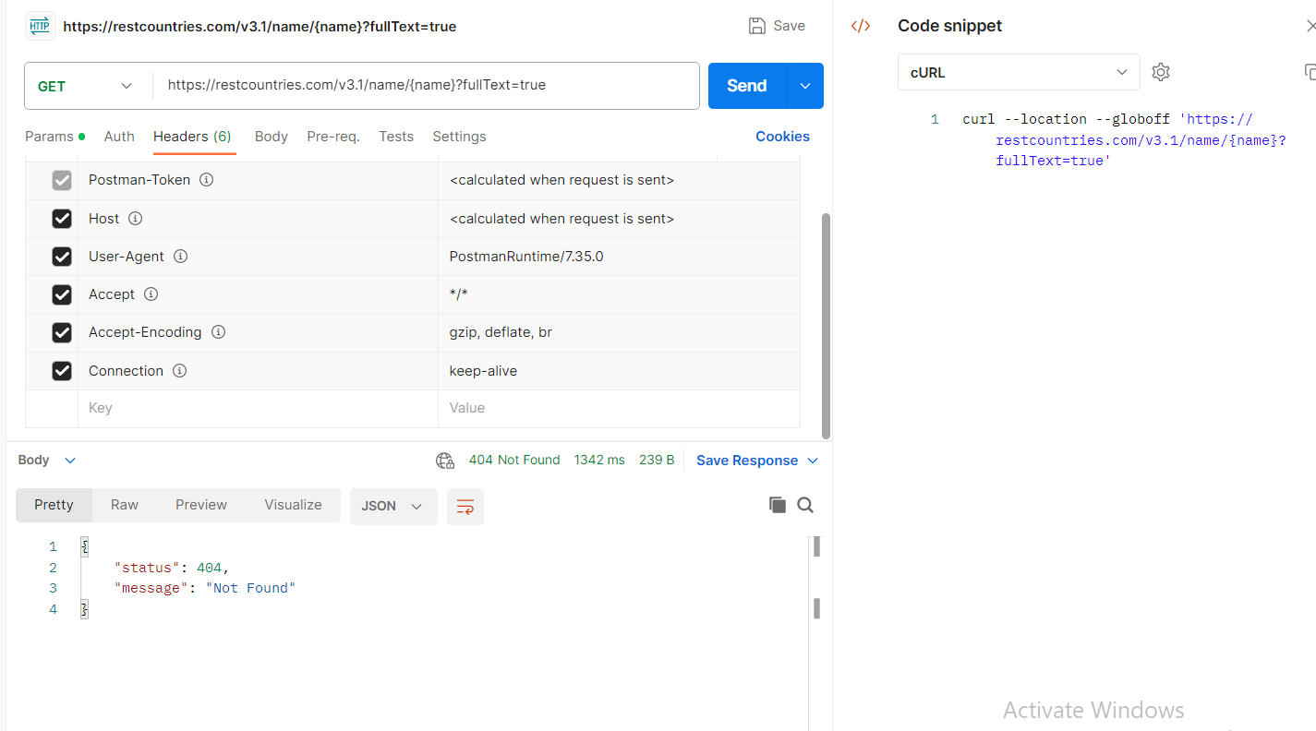**404 is a not found error. Which means the server is responding to a point, but it can't find the resource