

University of Engineering & Management, Kolkata

*Department of Computer Application*

***Stream:*** ***MCA***

**Session: 2023-2025**

**Subject: PROGRAMMING LAB**

1. Write a C program to find power of a number using for loop.
2. Write a C program to find all factors of a number.
3. Write a C program to calculate factorial of a number.
4. Write a C program to find HCF (GCD) of two numbers.
5. Write a C program to find LCM of two numbers.
6. Write a C program to check whether a number is Prime number or not.
7. Write a C program to print all Prime numbers between 1 to n.
8. Write a C program to find sum of all prime numbers between 1 to n.
9. Write a C program to find all prime factors of a number.
10. Write a C program to check whether a number is Armstrong number or not.
11. Write a C program to print all Armstrong numbers between 1 to n.

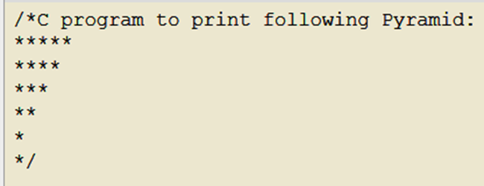

1. 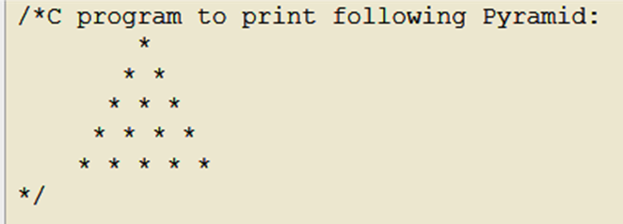
2. 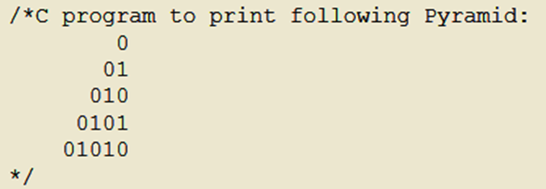
3. 