Hello All,

The following pictures are screen captures from what I have so far.

Each are sequential to each other from start to end.

I have not included any pictures of the query results because they are just plain text at the moment.

Enjoy!!

The user is brought to this page where they select the phase of the project.

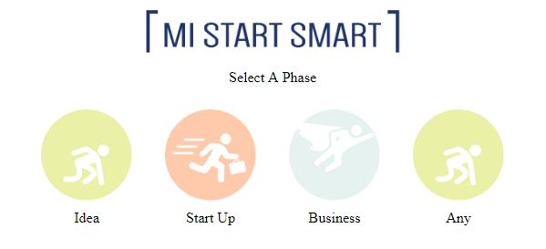

The can select one phase at a time.

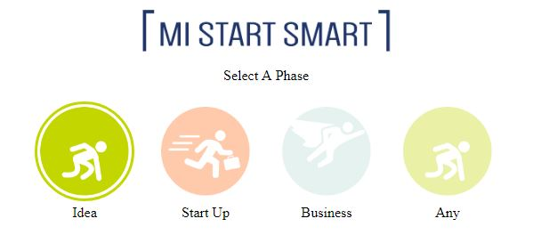

And only one phase...

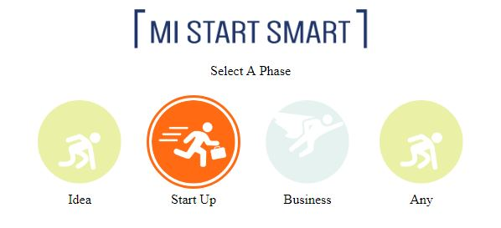

This was frozen for photographic purposes, however when a user selects one they will automatically be moved to the next page where they can select the services they wish.

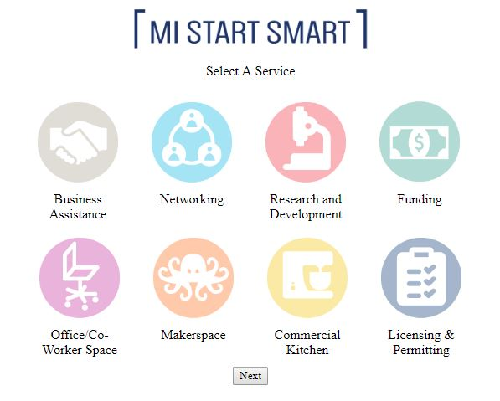

The can select no services, one service…

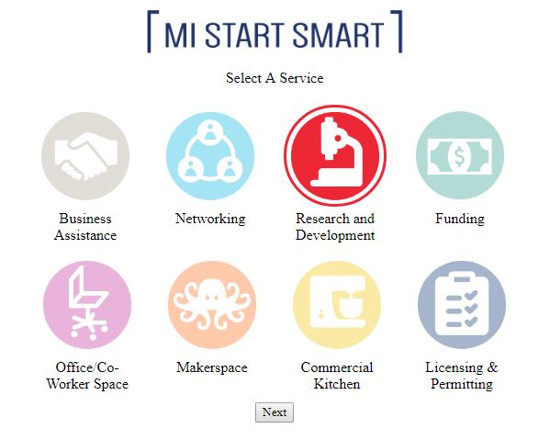

Or multiple services…

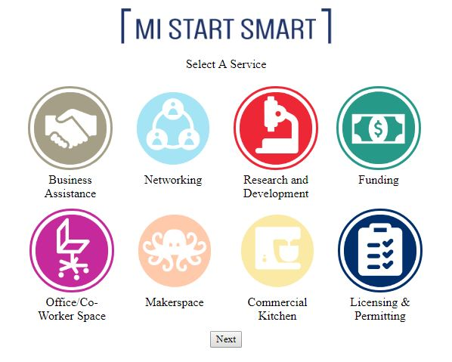

When the services they wish to have are selected they will press the next button which will bring them to the county page, they will do the same thing as the service page, select the ones they want and press next. I apologize for the Bland “Next” button, but I have no fancy thing to make it yet ☹

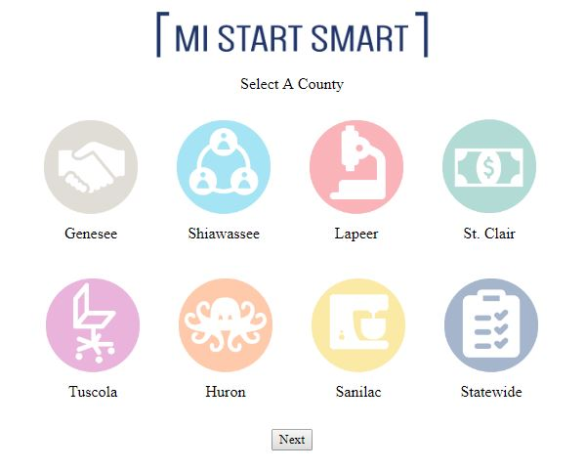

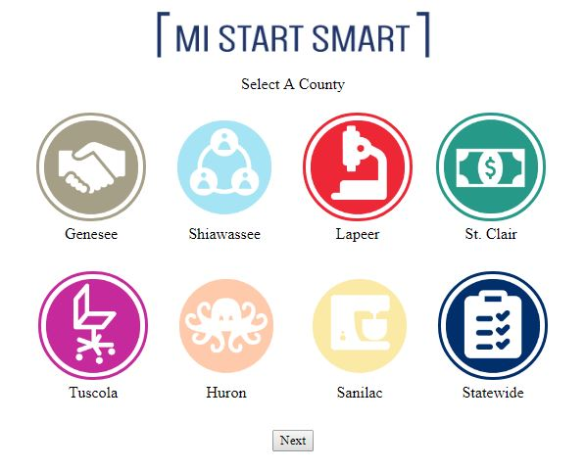

From here they would click “Next” and be brought to the query results. Which, as I have stated previously, have yet to be styled.

I have also not figured out how to get the fonts to work yet… This is currently in progress…. -_-