Product Review Sentiment Classification using Deep Learning: A Comparative Study of MLP, TextCNN, and BiLSTM Models

Final report on
Deep Learning Project
[ICT-4442]
Submitted By
Pankhuri Kumari (230911084)
Jambhorkar Arya Sachin (230911088)
Sai Prasad Prusty (230911298)
Team No.: 5
SCHOOL OF COMPUTER ENGINEERING
MANIPAL INSTITUTE OF TECHNOLOGY,
MANIPAL ACADEMY OF HIGHER EDUCATION
October 2026
Product Review Sentiment Classification using Deep Learning: A Comparative Study of MLP, TextCNN, and BiLSTM Models
Pankhuri Kumari (230911084), Jambhorkar Arya Sachin (230911088), and Sai Prasad Prusty (230911298)
School of Computer Engineering, Manipal Institute of Technology, Manipal Academy of Higher Education, Manipal, India
Abstract—Online product reviews are a rich but unstructured source of customer opinion. This paper presents a controlled comparison of three deep learning architecture families for binary sentiment classification of Amazon product reviews: a multi-layer perceptron (MLP) on TF-IDF features, a TextCNN over learned word embeddings, and a bidirectional LSTM (BiLSTM). All models are trained on the same balanced 20,000-review subset of the Amazon Polarity dataset, with one cleaning pipeline, one fixed stratified 80/10/10 split (16,000/2,000/2,000) and the same metrics (accuracy, precision, recall, F1), so that performance differences can be attributed to architecture. In the initial five-epoch configuration the MLP achieved the best test accuracy (86.55%, F1 0.8646), ahead of TextCNN (84.85%, F1 0.8510) and BiLSTM (82.55%, F1 0.8275). All three models over-fitted quickly: training accuracy reached 98–100% while validation loss was lowest after the first epoch. After tuning with early stopping and regularisation, the best model was the MLP with 88.18% accuracy (F1 0.8833; mean of three seeds), ahead of TextCNN (86.82%) and BiLSTM (86.55%); tuning helped the BiLSTM most (+4.0 points over its baseline). We explain the differences through each architecture's inductive bias, relate them to the sampling uncertainty of a 2,000-review test set, and examine failure cases such as negation, mixed sentiment and sarcasm. A manual review of 50 misclassified reviews found mixed sentiment to be the most common cause (26 of 50), and 102 test reviews (5.1%) were misclassified by all three models.
Keywords—sentiment analysis, product reviews, deep learning, multi-layer perceptron, TextCNN, BiLSTM, text classification, Amazon Polarity

I. Introduction
Customers increasingly read other buyers' reviews before purchasing, and sellers monitor the same text to judge satisfaction and decide what to improve. The volume of reviews makes manual reading impractical, so automatic sentiment classification, which labels a review as expressing a positive or negative opinion, has become a standard natural language processing task [1], [2]. The task is attractive for a comparative study because its labels are unambiguous, public datasets are large, and the metrics are well understood.
Methods for the task have changed considerably. Early systems paired bag-of-words features with classical learners [1], often using TF-IDF term weighting [3]. Neural approaches then introduced learned word embeddings [4], convolutional sentence classifiers [5] and recurrent networks built on the LSTM cell [6]. Today, fine-tuned pre-trained Transformers such as BERT [7] define the state of the art. Published results for these families are usually obtained with different datasets, preprocessing and tuning effort, which makes it hard to see how much of a reported gain comes from the architecture itself.
This mini project isolates that effect. We implement three architecture families from the course, which are a feed-forward MLP on TF-IDF features, a TextCNN and a BiLSTM, and train them on the same balanced 20,000-review subset of the Amazon Polarity dataset [8] with the same cleaning, split and metrics. Each family is implemented end to end by one team member. The contributions of this report are: (i) a controlled three-way comparison under one protocol; (ii) an analysis of training dynamics showing where and why each model starts to over-fit; (iii) a statistical treatment of the test results (confidence intervals and paired tests) so that small gaps are not over-interpreted; and (iv) an error analysis of review types that the models find hard. The code is available in the project repository.
The rest of the paper is organised as follows. Section II reviews related work, Section III states the objectives, Section IV describes the three models, Section V the experimental setup, Section VI the results and discussion, and Sections VII and VIII conclude and outline future work.

II. Literature Review

A. Representations and early sentiment classifiers
Pang et al. showed that supervised classifiers trained on movie reviews outperform simple hand-built keyword baselines, which established sentiment polarity as a text classification problem [1]. Such classifiers typically use weighted term counts, of which TF-IDF is the best known [3]. Maas et al. released the IMDB movie-review corpus together with word vectors that capture sentiment-related information, and reported about 88.9% accuracy with a vector-based logistic regression model [2]. Dense word embeddings learned with the skip-gram model and negative sampling [4] later became the usual input for neural classifiers, because they place words with similar meaning close together and are cheap to train on large corpora.

B. Convolutional models
Kim applied a single-layer CNN with max-over-time pooling to pre-trained word2vec embeddings and improved the state of the art on four of seven sentence classification benchmarks [5]. This design is the basis of our TextCNN. Zhang et al. proposed character-level CNNs and, importantly for this project, introduced the Amazon review polarity dataset together with several other large-scale text classification datasets; their models were competitive with, and at large data sizes better than, traditional bag-of-words baselines [8].

C. Recurrent models
The LSTM cell uses gated memory to overcome the vanishing-gradient problem and can bridge lags of more than a thousand steps in the synthetic tasks used by Hochreiter and Schmidhuber [6]. Schuster and Paliwal showed that a bidirectional recurrent network, which uses both past and future context, outperforms a unidirectional one on phoneme recognition [9]; this is the reason our BiLSTM reads each review in both directions. Zhou et al. added an attention layer on top of a BiLSTM and obtained a state-of-the-art F1 of 84.0 on SemEval-2010 Task 8 without external lexical features [10], which makes attention a natural extension of our recurrent model. Socher et al. built a recursive neural tensor network on the Stanford Sentiment Treebank, raising sentence-level accuracy from 80% to 85.4% and showing that explicit composition helps with negation [11]; this motivates our focus on negation in the error analysis.

D. Efficient linear baselines and Transformers
Joulin et al. showed that fastText, a linear classifier over averaged n-gram embeddings, is on par with much deeper models on tasks such as AG News, Yelp and Amazon reviews while training orders of magnitude faster [12]. This result sets the expectation that an n-gram-based MLP can be a strong baseline on product reviews. At the other end, the Transformer architecture [13] replaced recurrence with self-attention, and BERT, a pre-trained bidirectional Transformer fine-tuned on labelled data, reports state-of-the-art results across many classification benchmarks, with accuracy above 90% on many sentiment tasks [7].

E. Positioning of this work
The studies above report results on different datasets with different preprocessing, so their numbers cannot be compared directly. Our work does not aim to beat the Transformer state of the art. Instead it holds data, split and metrics fixed and varies only the architecture across the feed-forward, convolutional and recurrent families, in a low-resource setting of 16,000 training reviews where over-fitting is a central issue and where regularisation techniques such as dropout [14] matter.

III. Objectives
O1. To compare MLP, TextCNN and BiLSTM classifiers on binary sentiment classification of Amazon Polarity reviews under identical data, split and metrics, reporting accuracy, precision, recall and F1 for each model.
O2. To explain the performance differences through each architecture's ability to model local versus sequential patterns and through its train–validation gap, and to test whether the observed gaps exceed test-set sampling uncertainty.
O3. To characterise common failure modes (negation, mixed sentiment, sarcasm) by measuring how the error rate changes across review types.

IV. Methodology
All three models use a sigmoid output unit, binary cross-entropy loss, the Adam optimiser [15] with learning rate 10⁻³, batch size 32 and a decision threshold of 0.5, and are implemented in Keras/TensorFlow. Dropout [14] is used for regularisation. The Interim baselines were trained for a fixed five epochs. For the final study each model is tuned on the validation set with early stopping on validation loss (patience 2, up to 15 epochs, best weights restored), as described in Section V-D. Table I summarises the baseline configurations.
Table I
Baseline model configurations (Interim phase)
Model | Input | Architecture | Trainable parameters | Regularisation
MLP | TF-IDF, 1–2-grams, 20,000 features | Dense 256 (ReLU) – Dense 64 (ReLU) – Dense 1 (sigmoid) | 5,136,769 | Dropout 0.3 after each hidden layer
TextCNN | 100 token ids; Embedding 20,000 × 100 | Conv1D (128 filters, k = 5, ReLU) – global max-pool – Dense 64 – Dense 1 | 2,072,449 | Dropout 0.3 before output
BiLSTM | 100 token ids; Embedding 20,000 × 100 | Bidirectional LSTM (64 units per direction) – Dense 64 – Dense 1 | 2,092,801 | Dropout 0.3 before output

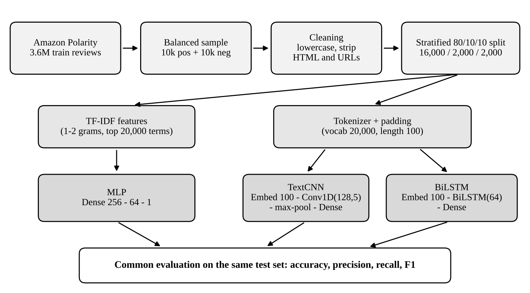
Fig. 1. Experimental pipeline. Both embedding-based models share one tokenised input; all models share one split and one metric set.

A. MLP on TF-IDF features (implemented by Pankhuri Kumari)
Architecture and configuration. Each review is converted to a 20,000-dimensional TF-IDF vector over unigrams and bigrams [3]; the vectoriser is fitted on the training reviews only. The vector feeds a dense layer of 256 ReLU units, a dropout layer (0.3), a dense layer of 64 ReLU units, a second dropout layer (0.3) and a single sigmoid unit. The network has 5,136,769 trainable parameters, of which 5,120,256 are in the first layer, so almost all capacity is spent on mapping sparse n-gram evidence to a hidden representation. The baseline was trained for five epochs.
Why this model. The MLP is the classical feed-forward baseline. It has no notion of word order beyond the bigrams in its input, so any advantage of the convolutional or recurrent models over it measures what local filters or sequence modelling add beyond a bag of n-grams. Results on fastText [12] suggest that this baseline can be hard to beat on review text. Tuning: hidden units {128, 256, 512}, dropout {0.3, 0.5} and learning rate {10⁻³, 3×10⁻⁴}. Selected configuration: 256 hidden units (second layer 64 units), dropout 0.5 and learning rate 10⁻³, with a validation accuracy of 0.896; the parameter count is unchanged at 5,136,769. All twelve configurations reached a validation accuracy between 0.888 and 0.896, a spread smaller than the sampling error of a 2,000-review validation set, so the choice among them is only weakly determined by the data.

B. TextCNN on word embeddings (implemented by Sai Prasad Prusty)
Architecture and configuration. Reviews are tokenised with a Keras tokenizer (vocabulary 20,000 with an out-of-vocabulary token), truncated or padded to 100 tokens, and passed through a trainable 100-dimensional embedding layer (2,000,000 parameters). A Conv1D layer with 128 filters of width 5 and ReLU activation slides over the sequence, global max-pooling keeps the strongest response of each filter, and a dense layer of 64 units, dropout (0.3) and a sigmoid unit follow. The model has 2,072,449 trainable parameters. Following Kim [5], the design uses convolution plus max-over-time pooling, but with one filter width and embeddings initialised randomly rather than from pre-trained word2vec [4].
Why this model. Each filter acts as a learned detector of a short phrase such as “not good” or “highly recommend”, and max-pooling makes the detection independent of where in the review the phrase occurs. Convolutions are also cheap to compute: in the Interim runs on Colab an epoch took about 2–7 s for the TextCNN against 6–13 s for the BiLSTM. Tuning: filter widths {5} or {3, 4, 5}, embedding dropout {0, 0.3} and learning rate {10⁻³, 5×10⁻⁴}, with dropout 0.5 before the output. Selected configuration: filter widths {3, 4, 5} with 128 filters each, no embedding dropout, dropout 0.5 and learning rate 5×10⁻⁴, with a validation accuracy of 0.871. The three parallel convolutions raise the parameter count to 2,178,689. The eight configurations lay between 0.855 and 0.871. Embedding dropout of 0.3 lowered validation accuracy in all four matched pairs, the lower learning rate raised it in all four, and the multi-width filters gave a small gain in three of four, but every one of these differences is at most 1.3 points.

C. BiLSTM on word embeddings (implemented by Jambhorkar Arya Sachin)
Architecture and configuration. The BiLSTM uses the same tokenised input and 100-dimensional embedding as the TextCNN, so the two differ only in the layer that processes the embeddings. A bidirectional LSTM with 64 units per direction reads the sequence forwards and backwards [6], [9] and its two final states are concatenated into a 128-dimensional vector, followed by a dense layer of 64 ReLU units, dropout (0.3) and a sigmoid unit. The model has 2,092,801 trainable parameters, 2,000,000 of them in the embedding and 84,480 in the two recurrent directions. In the Interim baseline sequences are padded at the end with zeros and no mask is applied, so the recurrent layers also process padding positions.
Why this model. It is the only one of the three that models word order and longer-range context explicitly, and the LSTM gates mitigate vanishing gradients on long inputs [6]. It therefore tests whether sequence modelling pays off for reviews that are only about 100 tokens long. Tuning: units {64, 128}, embedding dropout {0, 0.3} and masking of padded positions {off, on}, with dropout 0.5 before the output. Masking is included because unmasked end-padding forces the backward LSTM to start on padding and lets the forward LSTM's final state follow many padding steps. Selected configuration: 64 units per direction, embedding dropout 0.3, dropout 0.5, masking of padded positions switched on and learning rate 10⁻³, with a validation accuracy of 0.886; the parameter count is unchanged at 2,092,801.

V. Experimental Setup

A. Dataset
We use the Amazon Polarity dataset [8], loaded from the Hugging Face hub (fancyzhx/amazon_polarity). It contains 3,600,000 training and 400,000 test reviews labelled positive or negative. Review title and body are concatenated into one text field. To keep training feasible on the free tier of Google Colab, a balanced subset of 20,000 reviews (10,000 positive and 10,000 negative) is sampled from the training split with a fixed random seed (42).

B. Preprocessing
Text is lowercased, HTML tags and URLs are removed, characters other than letters, digits, whitespace and the punctuation marks ! ? ' , . are replaced by spaces, and whitespace is normalised. Punctuation that can carry emphasis or negation (for example “don't”) is deliberately kept. Two feature pipelines are built from the same cleaned text: TF-IDF vectors for the MLP, and padded integer sequences (maximum length 100, truncation and padding at the end, vocabulary capped at 20,000) for the TextCNN and BiLSTM. Both the TF-IDF vectoriser and the tokenizer are fitted on the training split only, so no vocabulary information leaks from validation or test data.

C. Data split
The subset is split 80/10/10 into training, validation and test sets, stratified by label, with a fixed seed so that all three models see identical splits (Table II). The test set is used only to report the final numbers of each configuration; all model selection uses the validation set.
Table II
Data split (identical for all models)
Split | Reviews | Positive | Negative
Training | 16,000 | 8,000 | 8,000
Validation | 2,000 | 1,000 | 1,000
Test | 2,000 | 1,000 | 1,000

D. Training and tuning protocol
Interim baseline: each model was trained for five epochs with the configuration in Table I and evaluated once on the test set. Final study: each model is tuned on the validation set over the small grids given in Section IV, with early stopping on validation loss (patience 2, maximum 15 epochs, best weights restored). The configuration with the highest validation accuracy is then re-trained with three random seeds and evaluated on the test set; we report the mean and standard deviation over seeds. The data split stays fixed across seeds. Experiments run on Google Colab.

E. Evaluation metrics
With positive sentiment as the positive class, we report accuracy, precision, recall and F1 on the test set for every model, using the same code. Because a 2,000-review test set has non-trivial sampling error, we also give the normal-approximation 95% confidence interval for accuracy, which has a half-width of 1.5–1.7 percentage points for accuracies between 82% and 87%. Differences between two models on the same test reviews are assessed with the exact McNemar test [16] on the reviews that exactly one of the two models misclassifies.

VI. Results and Discussion

A. Baseline results
Table III reports the test-set results of the three Interim baselines, trained for five epochs on the same 16,000 training reviews. The MLP is best on every metric except recall, where the TextCNN is slightly higher (0.865 against 0.859). The BiLSTM is lowest on all four metrics. All three models reach very high training accuracy, 0.985 to 0.9996 by the fifth epoch, which is far above their validation accuracy of 0.835 to 0.874.
Table III
Test-set results of the baselines (5 epochs, n = 2,000)
Model | Accuracy | Precision | Recall | F1 | Parameters | Train acc. (ep. 5) | Val. acc. (ep. 5)
MLP | 0.8655 | 0.8703 | 0.8590 | 0.8646 | 5,136,769 | 0.9995 | 0.8725
TextCNN | 0.8485 | 0.8374 | 0.8650 | 0.8510 | 2,072,449 | 0.9996 | 0.8735
BiLSTM | 0.8255 | 0.8182 | 0.8370 | 0.8275 | 2,092,801 | 0.9849 | 0.8350

B. Results after tuning
Table IV reports the same metrics after validation-based tuning with early stopping, as mean ± standard deviation over three seeds. The MLP is the best tuned model (accuracy 0.8818 ± 0.0029), followed by the TextCNN (0.8682 ± 0.0055) and the BiLSTM (0.8655 ± 0.0023). The Epochs column counts the epochs run before early stopping, including the two patience epochs, so the restored weights come from epoch 1 for the MLP and BiLSTM and epoch 2 for the TextCNN. The standard deviation is the sample standard deviation over the three seeds.
Table IV
Test-set results after tuning (mean ± std over 3 seeds)
Model | Selected configuration | Epochs | Accuracy | Precision | Recall | F1
MLP | 256 units, dropout 0.5, lr 10⁻³ | 3 | 0.8818 ± 0.0029 | 0.8723 ± 0.0033 | 0.8947 ± 0.0023 | 0.8833 ± 0.0028
TextCNN | k = {3, 4, 5}, 128 filters, dropout 0.5, lr 5×10⁻⁴ | 4 | 0.8682 ± 0.0055 | 0.8781 ± 0.0342 | 0.8580 ± 0.0557 | 0.8664 ± 0.0125
BiLSTM | 64 units, emb. dropout 0.3, mask on, dropout 0.5, lr 10⁻³ | 3 | 0.8655 ± 0.0023 | 0.8714 ± 0.0279 | 0.8593 ± 0.0337 | 0.8646 ± 0.0031

The ranking of the baselines is unchanged, but the gaps are smaller. The MLP now leads the TextCNN by 1.4 points (baseline: 1.7) and the BiLSTM by 1.6 points (baseline: 4.0), and the TextCNN leads the BiLSTM by only 0.3 points (baseline: 2.3). Tuning improved the BiLSTM most (+4.0 points over its baseline accuracy), then the TextCNN (+2.0) and the MLP (+1.6), which fits the observation that the baseline BiLSTM suffered most from over-fitting. Every one of the three MLP seeds (0.8785 to 0.884) scores higher than every run of the TextCNN (0.862 to 0.8725) and the BiLSTM (0.863 to 0.8675).
Accuracy is stable across seeds for all three models (standard deviation at most 0.6 points), but precision and recall are not stable for the two embedding models. The TextCNN's precision ranges from 0.848 to 0.915 and its recall from 0.798 to 0.908 over the three seeds, and the BiLSTM's from 0.840 to 0.893 and from 0.832 to 0.897, whereas the MLP's vary by less than 0.01. The embedding models therefore trade false positives for false negatives from seed to seed at almost unchanged accuracy, because the 0.5 threshold falls at a different place on a differently trained model. Accuracy and F1 are the more reliable summaries for them.
The validation accuracy of the selected configurations (0.896, 0.871 and 0.886) is higher than the corresponding mean test accuracy (0.882, 0.868 and 0.866). Part of this difference is the optimism of choosing the best of 12, 8 and 8 configurations on the same validation set, which is why the test set was kept apart for the final numbers.

C. Training dynamics
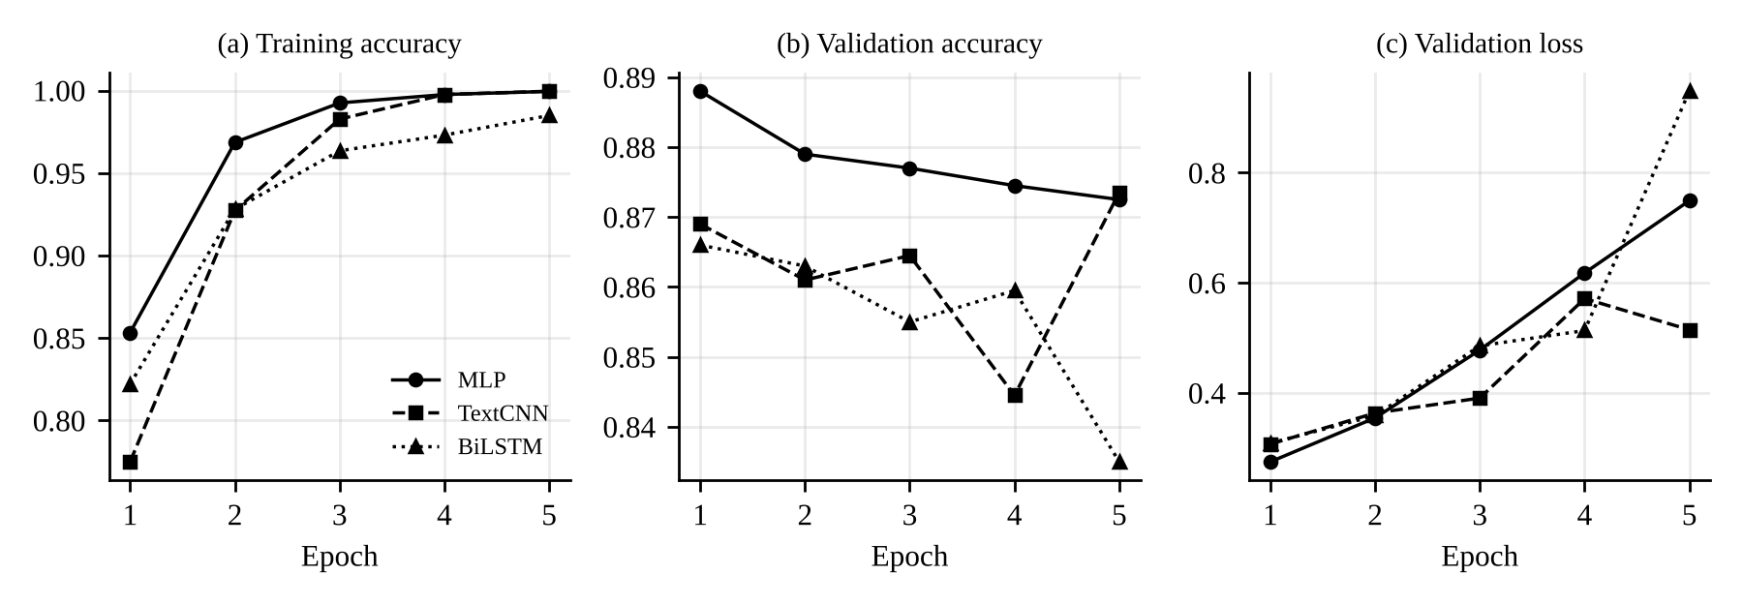
Fig. 2. Training accuracy, validation accuracy and validation loss per epoch for the three baselines (values from the executed Interim notebook).
Fig. 2 shows the same pattern for all three models. Training accuracy rises towards 1.0 within three to five epochs, while validation loss is lowest after the first epoch (0.275 for the MLP, 0.307 for the TextCNN and 0.309 for the BiLSTM) and then increases. By the fifth epoch the validation loss has grown to 0.749 for the MLP and to 0.948 for the BiLSTM, so the networks continue to fit the training reviews while their predictions on unseen reviews become more confident and less reliable. The MLP's validation accuracy peaks at 0.888 after one epoch, whereas the TextCNN's validation accuracy fluctuates (0.845 to 0.874) and the BiLSTM's declines to 0.835. The fixed five-epoch protocol therefore penalises each model for training too long, and the ranking of the baselines may partly reflect how fast each model over-fits. This motivated early stopping and stronger regularisation in the final study.
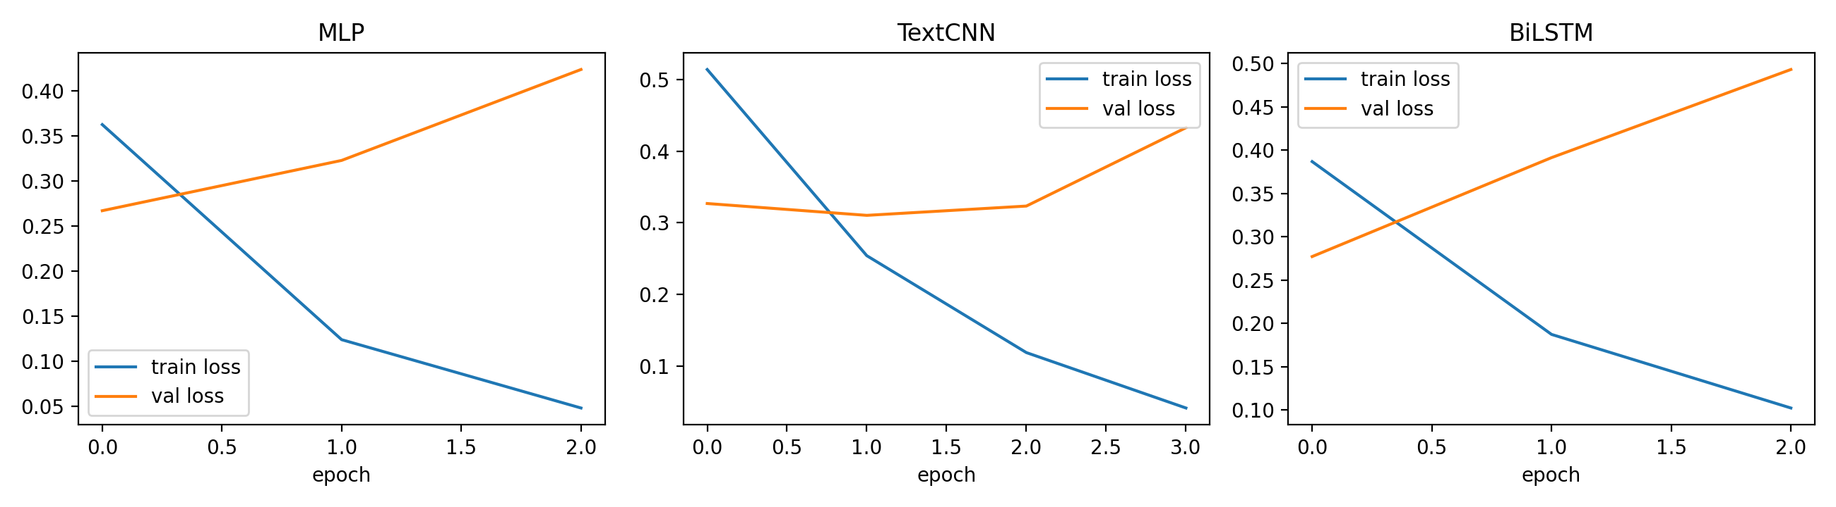
Fig. 3. Training and validation loss per epoch of the tuned models (seed 42; the epoch axis starts at 0). Training stops two epochs after the validation-loss minimum and the best weights are restored.
Fig. 3 shows the tuned runs. Early stopping ends training after three epochs for the MLP and BiLSTM and four for the TextCNN, and the restored weights come from the first epoch for the MLP and BiLSTM and the second for the TextCNN. The validation loss is therefore at its minimum (read from the figure: about 0.27, 0.31 and 0.28) after only one or two passes over the 16,000 reviews, even with dropout raised to 0.5, while the training loss keeps falling (to about 0.05, 0.04 and 0.10 in the last epoch). The tuned models still over-fit within a few epochs. Early stopping limits the damage but does not remove its cause, which is the small training set.

D. Why the architectures differ
MLP. In product reviews, polarity is carried largely by a small set of strong words and short phrases (for example “waste of money”, “highly recommend”), and unigram plus bigram TF-IDF features expose exactly this evidence directly. This is consistent with the observation that shallow n-gram models can match deeper networks on review data [12]. The MLP also has the largest number of parameters (5.1 million), but they are concentrated in the first layer over sparse inputs, and its validation accuracy peaks earliest, so it reaches its best generalisation quickly and then memorises.
TextCNN. The TextCNN detects local patterns with filters of width 5 and keeps the strongest response with max-pooling, which suits phrase-level sentiment cues. However, its 2,000,000-parameter embedding table is learned from scratch from only 16,000 reviews, so many words have few examples and the model memorises (training accuracy 0.9996). Its recall (0.865) exceeds its precision (0.837): it produces more false positives (168) than false negatives (135), meaning that it is somewhat biased towards predicting positive.
BiLSTM. The BiLSTM scored lowest in the baseline, and its validation loss rose most sharply (0.948 at epoch 5). Two explanations are plausible. First, the recurrent layer has to learn useful long-range structure from the same small training set, and with limited data its extra flexibility is more likely to be used for memorisation than for generalisation. Second, end-padding without masking makes the backward LSTM start on a run of padding tokens and the forward LSTM end on one, which dilutes the signal. We treat the second point as a hypothesis, which the masking option in the tuning grid tests directly. After tuning, masking was selected. Switching mask_zero on gave a higher validation accuracy than the unmasked counterpart in all four matched pairs (64 or 128 units, embedding dropout 0 or 0.3): 0.881 against 0.875, 0.886 against 0.876, 0.879 against 0.8735 and 0.8725 against 0.8685, a gain of 0.4 to 1.0 points (mean 0.6). Each gap is smaller than the sampling error of a 2,000-review validation set and all come from a single seed, so the result supports the hypothesis without proving it. Most of the BiLSTM's improvement over its baseline comes from early stopping and the stronger dropout instead: the unmasked tuned configurations already reach 0.869 to 0.876, against 0.835 at the fifth epoch of the baseline.
Take-away. For reviews of about 100 tokens, where sentiment is mostly lexical, extra architectural machinery for word order did not help in the baseline setting. This does not show that sequence models are inferior: it shows that with 16,000 training reviews, randomly initialised embeddings and no regularisation beyond dropout, simpler models generalise at least as well. Pre-trained embeddings or attention are the natural ways to give the sequence models more to work with. After tuning the conclusion is unchanged but weaker: the BiLSTM closes most of the gap (0.3 points behind the TextCNN and 1.6 behind the MLP) but does not overtake the n-gram MLP.

E. Statistical reliability
With 2,000 test reviews, the 95% confidence half-width for accuracy is about 1.5 percentage points for the MLP, 1.6 for the TextCNN and 1.7 for the BiLSTM. The baseline gap between the MLP and the BiLSTM (4.0 points) is clearly larger than this uncertainty, whereas the gaps between the MLP and TextCNN (1.7 points) and between the TextCNN and BiLSTM (2.3 points) are comparable to it. The baseline ordering of the top two models is therefore suggestive but not conclusive. For the tuned models the half-widths are about 1.4 points for the MLP and 1.5 for the TextCNN and BiLSTM, computed from the three-seed mean accuracies. The exact McNemar tests on the seed-42 predictions give p = 0.0091 for the MLP against the TextCNN (the MLP alone is wrong on 103 reviews, the TextCNN alone on 145), p = 0.046 for the MLP against the BiLSTM (98 against 129) and p = 0.52 for the TextCNN against the BiLSTM (125 against 114). The first two differences are significant at the 5% level and the third is not. Three caveats apply. First, with three comparisons a Bonferroni-corrected threshold would be 0.017: the MLP's lead over the TextCNN would still be significant, but its lead over the BiLSTM (p = 0.046) would not, so that comparison is only borderline evidence. Second, the seed-42 TextCNN is its weakest seed (0.862 against a mean of 0.868), so the test for this pair probably overstates the typical gap (2.1 points at seed 42 against 1.4 on average). Third, McNemar captures the sampling variation of the test reviews but not the variation between training runs; the fact that all three MLP seeds beat all six TextCNN and BiLSTM runs (Section VI-B) is therefore a useful second piece of evidence. The 0.3-point difference between the TextCNN and the BiLSTM is indistinguishable from noise, so these two models cannot be ranked.

F. Error analysis
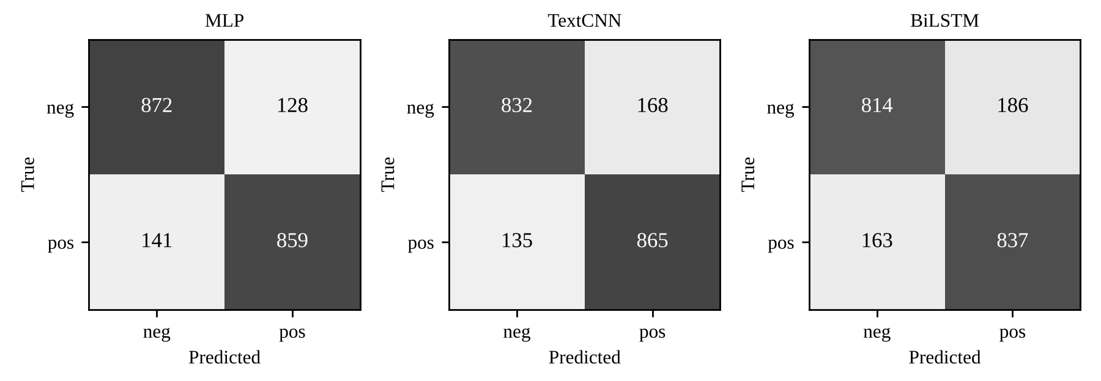
Fig. 4. Confusion matrices of the baselines on the test set (1,000 negative and 1,000 positive reviews). Counts are reconstructed from the reported precision and recall; they reproduce the reported accuracies exactly.
Fig. 4 shows how the baselines err. The MLP's errors are balanced (128 false positives, 141 false negatives). The TextCNN (168 false positives, 135 false negatives) and the BiLSTM (186 false positives, 163 false negatives) both lean towards the positive class, and the BiLSTM makes the most errors of both kinds. Typical reasons for such errors in review sentiment are negation (“not bad”), mixed reviews that praise one aspect and criticise another, sarcasm, and reviews whose title and body disagree. Because the dataset's labels come from star ratings, some reviews are also simply ambiguous or mislabelled. Fig. 5 and Table V show the same analysis for the tuned models.
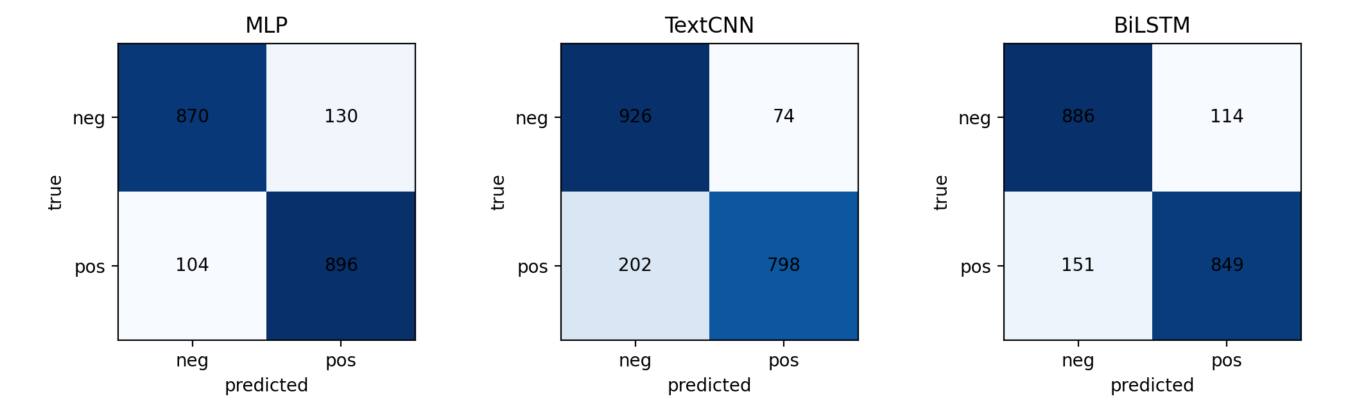
Fig. 5. Confusion matrices of the tuned models on the test set (seed 42; 1,000 negative and 1,000 positive reviews).
After tuning, the MLP's seed-42 errors are still balanced (130 false positives, 104 false negatives). The TextCNN now errs in the opposite direction from its baseline (74 false positives, 202 false negatives) and the BiLSTM (114 false positives, 151 false negatives) has also moved towards the negative side. The positive-class bias noted for the baselines is therefore not a fixed property of the architecture: it changes with the configuration and the seed, as the spread of precision and recall in Table IV also shows.
Table V
Test error rate by review type (tuned models, seed 42)
Review type | Reviews | MLP | TextCNN | BiLSTM
Contains negation words | 1,359 | 12.4% | 13.9% | 14.3%
Contains contrast words (but, however, although) | 995 | 14.3% | 15.6% | 16.2%
Contains exclamation mark | 640 | 10.8% | 13.9% | 13.4%
Short (≤ 30 tokens) | 253 | 7.1% | 9.9% | 10.3%
Long (> 100 tokens, truncated) | 592 | 14.4% | 17.6% | 17.1%
All test reviews | 2,000 | 11.7% | 13.8% | 13.2%

Table V gives the error rate by review type. The MLP has the lowest error rate in every category. Reviews containing contrast words (but, however, although, though, yet) are harder than average for all three models (14.3%, 15.6% and 16.2% against 11.7%, 13.8% and 13.3% overall), which is consistent with mixed sentiment being a main failure mode. Negation words occur in 68% of the reviews (1,359), and the error rate in this group is close to the overall rate (0.7, 0.1 and 1.1 points higher), so a keyword flag for negation does not isolate difficult cases. Short reviews (at most 30 tokens) are the easiest (7.1% to 10.3% error) and long reviews (more than 100 tokens) the hardest (14.4% to 17.6%). For the TextCNN and BiLSTM this may be partly caused by truncation at 100 tokens, but the MLP, which reads the whole review, is also worst on long reviews, so longer reviews probably also contain more mixed opinions. The two embedding models are 2.6 to 3.2 points worse than the MLP on short, long and exclamation reviews, but only 1.3 to 1.9 points worse on negation and contrast reviews. This is the pattern one would expect if local or sequential context helped on such reviews, but it should not be over-interpreted: the categories overlap, they are simple keyword and length heuristics, and an error rate of 14% on 995 reviews already has a 95% half-width of about 2.2 points.
Table V counts errors per model, but the models also share many of them. Of the 2,000 test reviews, 1,541 (77.1%) are classified correctly by all three models, 245 are misclassified by exactly one (69 only by the MLP, 96 only by the TextCNN and 80 only by the BiLSTM), 112 by exactly two and 102 (5.1%) by all three. The 102 shared errors are 44% of the MLP's 234 errors, 37% of the TextCNN's 276 and 38% of the BiLSTM's 265. Because the three architectures have very different inductive biases, text that all of them misclassify is more likely to be ambiguous or mislabelled than to expose a weakness of one architecture.
To characterise the errors we read 50 misclassified test reviews from errors_to_label.csv (25 drawn at random from the 102 misclassified by all three models and 25 from the 357 misclassified by one or two) and assigned each a single primary category. Mixed sentiment was the most common (26 of 50, 52%): the reviewer praises and criticises in the same text, for example “starts weak, ends awesome”, where all three models predicted negative (probability of positive 0.15, 0.13 and 0.08) for a positive review. It accounts for 10 of the 25 reviews missed by all three models and 16 of the 25 others. The remaining reviews were 13 other, 6 sarcasm, irony or humour, 4 label noise or ambiguous and 1 negation. The 13 “other” errors were 5 positive reviews that use negative-sounding words to describe a problem the product solves (for example “put an extremely stinky diaper in here, and you won't smell it again”, probability of positive 0.34, 0.25 and 0.47), 3 reviews with unusual language or spelling (one in Spanish, one in dialect and one with the misspelt word “econonical”), 3 reviews that express an opinion without sentiment words (for example a complaint that a seat is “very very short”), 1 abusive text that is not a product review, and 1 long list of complaints on which only the BiLSTM was wrong, at probability 0.54.
Sarcasm is a clear failure case: for “saccharine sickly sweet. if you have a taste for hyper earnest sentiment and treacle, this is the cd for you” (labelled negative) all three models predicted positive (0.94, 0.93 and 0.95). Four reviews looked mislabelled or ambiguous. The clearest is “great bag!! i love this bag!!!”, labelled negative, to which all three models gave a probability of positive of at least 0.99; the models are right and the label is wrong. Three of the 25 reviews missed by all three models (12%) fell in this category, which is consistent with a part of the shared errors being label noise, although such a small sample gives only a rough estimate. Negation was the deciding factor in only one of the 50 reviews, so this sample does not confirm negation as a leading failure mode; this agrees with the small effect of negation words in Table V.
Two limitations apply to this analysis. The sample is stratified (half of it comes from the reviews missed by all three models), so its percentages describe the sample and should not be extrapolated to all 459 reviews misclassified by at least one model. The categories were also assigned by a single reader after the predictions were known, so they are indicative only. A second annotator and a larger sample would be needed to report agreement and reliable proportions.

VII. Conclusion
We compared an MLP on TF-IDF features, a TextCNN and a BiLSTM for binary sentiment classification of Amazon product reviews under a single data split and metric set. In the five-epoch baseline, the MLP performed best (accuracy 86.55%, F1 0.8646), followed by the TextCNN (84.85%) and the BiLSTM (82.55%). All three over-fitted, with validation loss minimal after one epoch, and the gap between the top two models is of the same size as the uncertainty of a 2,000-review test set, so only the gap to the BiLSTM is clearly outside sampling noise. After tuning, the MLP was again the best model (accuracy 88.18 ± 0.29%, F1 0.8833), 1.4 points ahead of the TextCNN (86.82%) and 1.6 points ahead of the BiLSTM (86.55%). The ranking is unchanged, but the gap to the BiLSTM shrank from 4.0 to 1.6 points because early stopping, stronger dropout and masking of padded positions helped the recurrent model most. The exact McNemar test supports the MLP's lead over the TextCNN (p = 0.009) and, more weakly, over the BiLSTM (p = 0.046, which does not survive a correction for three comparisons), while the TextCNN and BiLSTM cannot be separated (p = 0.52). The error analysis shows a limit that all three models share: 5.1% of the test reviews were misclassified by every model, and in a manual review of 50 errors mixed sentiment was the most common cause (26 of 50), followed by sarcasm, unusual vocabulary and a few apparently mislabelled reviews. Overall, in this low-data setting with sentiment carried mostly by lexical cues, the additional structure of the convolutional and recurrent models did not by itself give an advantage over a regularised n-gram MLP; how the models are trained and regularised mattered as much as which family was chosen.

VIII. Future Work
Several limitations affect the conclusions: only 20,000 of the 4,000,000 available reviews are used, a single data split is used so split-to-split variance is not captured, the test set has only 2,000 reviews, reviews are truncated to 100 tokens, and the task is binary with no neutral class. Natural extensions are (i) training on a larger share of the dataset; (ii) initialising the embeddings of the TextCNN and BiLSTM with pre-trained vectors [4]; (iii) adding attention to the BiLSTM [10] and comparing against a fine-tuned Transformer [7], [13]; (iv) cross-validation and cross-domain tests, for example on IMDB movie reviews [2]; (v) a three-class variant with a neutral label; and (vi) a larger manual error study with annotated review types.

Acknowledgement
The authors thank the faculty of the Deep Learning course (ICT-4442) at the School of Computer Engineering, Manipal Institute of Technology, for guidance, and acknowledge Google Colab for the compute used in the experiments.
Use of external tools. A large language model (Claude, Anthropic) was used to help draft the text of this report and the experiment and error-analysis script (final_experiments.py) from the team's Interim report and repository, to transcribe the final results into the tables, and to suggest categories for the manual error review in Section VI-F. The team reviewed the text and verified every number against the executed notebook and its own runs. No other external tutorials or code were used beyond the Keras, scikit-learn and Hugging Face datasets documentation.

References
[1] B. Pang, L. Lee, and S. Vaithyanathan, “Thumbs up? Sentiment classification using machine learning techniques,” in Proc. Conf. Empirical Methods Natural Lang. Process. (EMNLP), 2002, pp. 79–86.
[2] A. L. Maas, R. E. Daly, P. T. Pham, D. Huang, A. Y. Ng, and C. Potts, “Learning word vectors for sentiment analysis,” in Proc. 49th Annu. Meeting Assoc. Comput. Linguistics (ACL), Portland, OR, USA, 2011, pp. 142–150.
[3] G. Salton and C. Buckley, “Term-weighting approaches in automatic text retrieval,” Inf. Process. Manage., vol. 24, no. 5, pp. 513–523, 1988.
[4] T. Mikolov, I. Sutskever, K. Chen, G. Corrado, and J. Dean, “Distributed representations of words and phrases and their compositionality,” in Proc. NeurIPS, 2013, pp. 3111–3119.
[5] Y. Kim, “Convolutional neural networks for sentence classification,” in Proc. EMNLP, Doha, Qatar, 2014, pp. 1746–1751.
[6] S. Hochreiter and J. Schmidhuber, “Long short-term memory,” Neural Comput., vol. 9, no. 8, pp. 1735–1780, 1997.
[7] J. Devlin, M.-W. Chang, K. Lee, and K. Toutanova, “BERT: Pre-training of deep bidirectional transformers for language understanding,” in Proc. NAACL-HLT, Minneapolis, MN, USA, 2019, pp. 4171–4186.
[8] X. Zhang, J. Zhao, and Y. LeCun, “Character-level convolutional networks for text classification,” in Proc. Adv. Neural Inf. Process. Syst. (NeurIPS), 2015, pp. 649–657.
[9] M. Schuster and K. K. Paliwal, “Bidirectional recurrent neural networks,” IEEE Trans. Signal Process., vol. 45, no. 11, pp. 2673–2681, Nov. 1997.
[10] P. Zhou, W. Shi, J. Tian, Z. Qi, B. Li, H. Hao, and B. Xu, “Attention-based bidirectional long short-term memory networks for relation classification,” in Proc. 54th Annu. Meeting ACL (Short Papers), Berlin, Germany, 2016, pp. 207–212.
[11] R. Socher et al., “Recursive deep models for semantic compositionality over a sentiment treebank,” in Proc. EMNLP, Seattle, WA, USA, 2013, pp. 1631–1642.
[12] A. Joulin, E. Grave, P. Bojanowski, and T. Mikolov, “Bag of tricks for efficient text classification,” arXiv:1607.01759, 2016.
[13] A. Vaswani et al., “Attention is all you need,” in Proc. NeurIPS, 2017, pp. 5998–6008.
[14] N. Srivastava, G. Hinton, A. Krizhevsky, I. Sutskever, and R. Salakhutdinov, “Dropout: A simple way to prevent neural networks from overfitting,” J. Mach. Learn. Res., vol. 15, no. 56, pp. 1929–1958, 2014.
[15] D. P. Kingma and J. Ba, “Adam: A method for stochastic optimization,” in Proc. Int. Conf. Learn. Represent. (ICLR), 2015.
[16] Q. McNemar, “Note on the sampling error of the difference between correlated proportions or percentages,” Psychometrika, vol. 12, no. 2, pp. 153–157, 1947.

Individual Contribution Statement

Member name | Reg. No. | Model / task owned | Key contributions | Signature
Pankhuri Kumari | 230911084 | MLP (TF-IDF) | Dataset acquisition script; TF-IDF pipeline; MLP implementation and integration. Final phase: tuned the MLP over the 12-configuration grid with early stopping; ran the exact McNemar tests and the confidence-interval analysis; wrote the statistical reliability section.
Jambhorkar Arya Sachin | 230911088 | BiLSTM | Text-cleaning function; shared tokenizer pipeline; BiLSTM implementation. Final phase: tuned the BiLSTM, including the padding-mask comparison; produced the error-by-review-type table and the manual review of misclassified reviews; wrote the error analysis section.
Sai Prasad Prusty | 230911298 | TextCNN | Train/validation/test split logic; TextCNN implementation; evaluation and comparison-table code. Final phase: tuned the TextCNN (filter widths, embedding dropout, learning rate); ran the three-seed final evaluation and produced the result tables and figures; assembled the report and slides.

