Software Requirement Specifications(SRS)
23MCCE34
23MCCE14
1.Introduction
1.1.Purpose:
This SRS document describes the functional and non-functional requirements of the Prashikshan-Internship Management System. The purpose of this system is to manage internship activities between students, faculty, companies, and administration in an organized and automated manner.
1.2.Scope:
- It allows Students to register, apply for Internships , Submit Logbooks , Attempt Skill Tests .
- Allows Companies to register, Post Internships, View Applicants, and Select Students.
- Allows faculty to Review Logbooks , and Evaluate Students.
- Allows Admin to Approve Companies, Manage Users, Generate Reports, and Issue Certificates.
1.3.Definitions, Acronyms, Abbreviations:
- SRS – Software Requirement Specifications
- UI – User Interface
- DFD – Data Flow Diagram
- DB – Database
- Admin – System Administrator
- Logbook - Internship activity report submitted by students
1.4.References:
Project Feasibility Report, Use Case Diagram of Prashikshan System, Data Flow Diagrams (DFD Level 0, Level 1, Level 2), MySQL Official Documentation, PHP/HTML/CSS/JavaScript Official Documentation.
1.5.Overall Description:
- The system is an online internship management platform that integrates students, faculty, companies, and administration under a single system.
- It manages internship posting, application, logbook validation, evaluation, skill tests, and certificate generation.
2.Overall Description
2.1.Product Perspective:
Prashikshan is a standalone web-based system that uses a centralised database, provides a role-based access control for different type of users , operates on client-server architecture.
2.2.Product Functions:
- Student : Register, Login , View Internships , Apply For Internships, Submit logbook, Attempt skill test, View learning resources.
- Company: Register, Post internship, View applicants, Select student.
- Faculty: Review logbook, Evaluate student, Generate reports, Upload learning resources.
- Admin: Approve company, Manage users, Issue certificates, Generate reports
2.3.User Characteristics:
- Student: Basic computer knowledge, internet access.
- Company: Able to manage internship postings and applicant review.
- Faculty: Moderate system knowledge, able to review and evaluate student performance.
- Admin: Technical knowledge, system management skills.

2.4.User Constraints:
- Internet connection required.
- Users must have valid login credentials.
- Students must meet eligibility criteria.
- Only approved companies can post internships.
2.5.Assumptions and Dependencies:
- Users have valid login credentials.
- System depends on server availability.
- Database connectivity must be active.
- Companies provide correct internship data.
2.6.Apportioning Requirements:
Future enhancements may include:
- Mobile application version.
- Integration with LinkedIn or placement portals.
- AI-based student recommendation system.
3.Specific Requirements
3.1 Interface Requirements:
3.1.1 External Interface:
- Web browser interface (Chrome, Firefox, Edge)
- Responsive UI
3.1.2 Hardware Interface:
- Server system
- Client device (PC/Laptop/Tablet)
- Internet connectivity
    - Software Interface:
- Web server
- Backend (Java/PHP/Node.js)
- Database (MySQL)
3.1.4 Communication Interface:
- HTTP/HTTPS protocol
- Secure login authentication
- Email notifications for internship approval
3.2.Functional Requirements
3.2.1 Use Case Model / Information Flows:

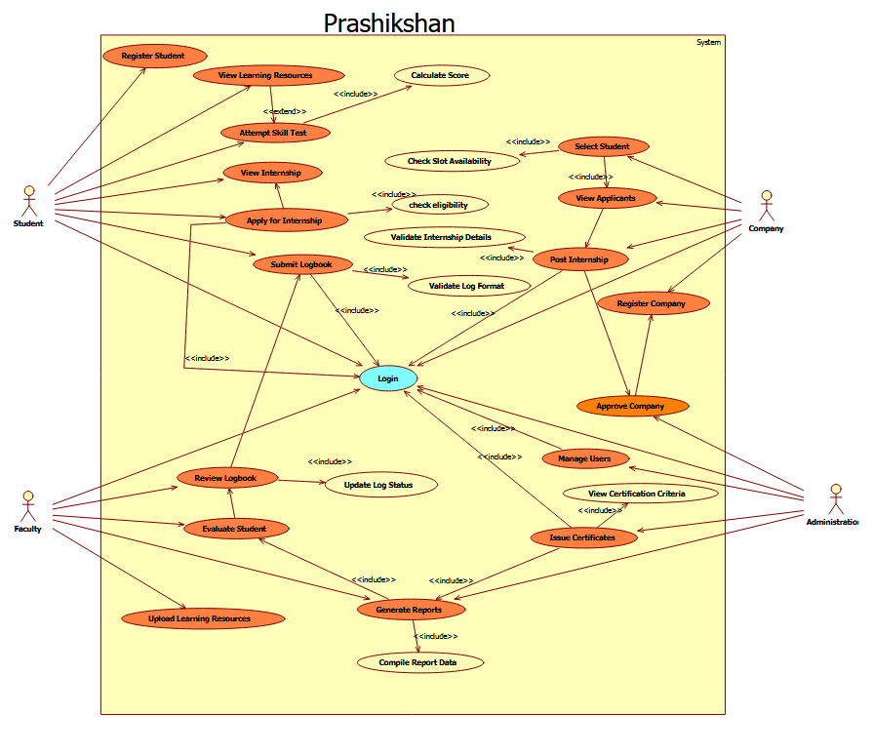

3.2.2 Use Case Specifications:
1.
Field | Details
Use Case ID | UC-01
Use Case Name | Student Registration
Actors | Student
Description | Allows a new student to create an account by providing personal and academic details and uploading resume.
Preconditions | Student not already registered; System available
Postconditions | Account created; Student can log in
Normal Flow | 1. Open registration page 2. Enter details 3. Upload resume 4. Submit form 5. System validates 6. Account created
Alternate Flow | A1: Invalid data → Error shown → Student corrects
Priority | High
Frequency | Once per student
Business Rules | Resume must be PDF; Email must be unique
Assumptions | Student has valid credentials

2.
Field | Details
Use Case ID | UC-02
Use Case Name | View Internships
Actors | Student
Description | Allows student to view available internship opportunities

Field | Details
Preconditions | Use Case Name
Postconditions | Actors
Normal Flow | 1. Login 2. Select “View Internships” 3. System displays internship list
Alternate Flow | A1: No internships available | View Internships
Priority | High | Student
Frequency | Multiple times
Business Rules | Only approved internships shown
Assumptions | Companies have posted internships

3.
Use Case ID | UC-03
Use Case Name | Apply for Internship
Created By | Project Team
Last Updated By | Project Team
Date Created | 23-02-2026
Date Last Updated | 23-02-2026
Actors | Student
Description | Allows a student to apply for an internship.
Preconditions | Student logged in. Internship active.
Post Conditions | Application recorded. Status set to Pending.
Normal Flow | 1. Student selects internship.2. Clicks Apply.3. System checks eligibility.4. Application stored.

Alternate Flows | A1: Not eligible. A2: Deadline expired.
Priority | High
Frequency | Multiple times
Business Rules | One application per internship.
Assumptions | Student profile complete.

4.
Field | Details
Use Case ID | UC-04
Use Case Name | Submit Logbook
Created By | Project Team
Last Updated By | Project Team
Date Created | 23-02-2026
Date Last Updated | 23-02-2026
Actors | Student
Description | Allows student to submit internship logbook entries.
Preconditions | Internship active.
Post Conditions | Log stored. Pending review.
Normal Flow | 1. Student enters task details.2. Submits entry.3. System stores log.
Alternate Flows | A1: Invalid format.
Priority | High
Frequency | Daily
Business Rules | Format restrictions apply.
Assumptions | Internship ongoing.

5.
Field | Details
Use Case ID | UC-05
Use Case Name | Attempt Skill Test
Created By | Project Team
Last Updated By | Project Team
Date Created | 23-02-2026
Date Last Updated | 23-02-2026
Actors | Student
Description | Allows student to attempt skill assessment.
Preconditions | Student logged in.
Post Conditions | Skill score generated.
Normal Flow | 1. Student starts test.2. Answers questions.3. Submits test.4. Score displayed.
Alternate Flows | A1: Time expired.
Priority | Medium
Frequency | As required
Business Rules | Time-bound test.
Assumptions | Questions preloaded.

6.
Field | Details
Use Case ID | UC-06
Use Case Name | View Learning Resources

Created By | Project Team
Last Updated By | Project Team
Date Created | 23-02-2026
Date Last Updated | 23-02-2026
Actors | Student
Description | Allows access to learning materials.
Preconditions | Student logged in.
Post Conditions | Resources displayed.
Normal Flow | 1. Student selects module.2. System displays content.
Alternate Flows | A1: No resources available.
Priority | Medium
Frequency | Multiple times
Business Rules | Category-based access.
Assumptions | Resources uploaded.

7.
Field | Details
Use Case ID | UC-07
Use Case Name | Register Company
Created By | Project Team
Date Created | 23-02-2026

8.
Field | Details
Use Case ID | UC-08
Use Case Name | Post Internship
Created By | Project Team
Last Updated By | Project Team
Date Created | 23-02-2026
Date Last Updated | 23-02-2026
Actors | Company
Description | Allows posting internship opportunities.
Preconditions | Company approved and logged in.
Post Conditions | Internship listed.
Normal Flow | 1. Enter internship details.2. Submit.3. Internship published.
Alternate Flows | A1: Invalid deadline.

Description | Allows company to create account.
Preconditions | Company not registered.
Post Conditions | Account created (Pending approval).
Normal Flow | 1. Enter company details. 2. Submit form. 3. System saves data.
Alternate Flows | A1: Invalid data.
Priority | High
Frequency | Once per company
Business Rules | Admin approval required.
Assumptions | Valid company credentials.

9.
Field | Details
Use Case ID | UC-09
Use Case Name | View Applicants
Created By | Project Team
Last Updated By | Project Team
Date Created | 23-02-2026
Date Last Updated | 23-02-2026
Actors | Company
Description | View list of student applicants.
Preconditions | Internship exists.
Post Conditions | Applicant list displayed.
Normal Flow | 1. Select internship.2. View applicants.
Alternate Flows | A1: No applicants available.
Priority | Medium
Frequency | Multiple times
Business Rules | Only for posted internships.
Assumptions | Students have applied.

Priority | High
Frequency | Multiple times
Business Rules | Limited slots allowed.
Assumptions | Company logged in.

10.
Field | Details
Use Case ID | UC-10
Use Case Name | Select Student
Created By | Project Team
Last Updated By | Project Team
Date Created | 23-02-2026
Date Last Updated | 23-02-2026
Actors | Company
Description | Select student for internship.
Preconditions | Applicants available.
Post Conditions | Student selected.
Normal Flow | 1. Review applicants.2. Select student.3. Confirm selection.
Alternate Flows | A1: Slot already filled.
Priority | High
Frequency | Per internship
Business Rules | Cannot exceed slot limit.
Assumptions | Applicant list available.

11.
Field | Details
Use Case ID | UC-11
Use Case Name | Review Logbook
Created By | Project Team

12.
Field | Details
Use Case ID | UC-12
Use Case Name | Evaluate Student
Created By | Project Team
Last Updated By | Project Team
Date Created | 23-02-2026
Date Last Updated | 23-02-2026
Actors | Faculty
Description | Allows faculty to evaluate student internship performance.
Preconditions | Internship completed. Logbook reviewed.
Post Conditions | Evaluation score recorded.
Normal Flow | 1. Select student.2. Enter remarks and score.3. Submit evaluation.4. System stores evaluation.

Date Created | 23-02-2026
Date Last Updated | 23-02-2026
Actors | Faculty
Description | Allows faculty to review internship logbook entries.
Preconditions | Student submitted log entries. Faculty logged in.
Post Conditions | Logbook marked Approved/Rejected. Student notified.
Normal Flow | 1. Faculty logs in.2. Selects student logbook.3. Reviews entries.4. Approves or rejects.5. System updates status.
Alternate Flows | A1: Logbook incomplete → Reject.
Priority | High
Frequency | Multiple times during internship
Business Rules | Only assigned faculty can review. Approval required for report generation.
Assumptions | Log entries stored properly.

13.
Field | Details
Use Case ID | UC-13
Use Case Name | Generate Reports
Created By | Project Team
Last Updated By | Project Team
Date Created | 23-02-2026
Date Last Updated | 23-02-2026
Actors | Faculty, Admin
Description | Generates internship progress and performance reports.
Preconditions | Internship data available. User logged in.
Post Conditions | Report generated and displayed/downloaded.
Normal Flow | 1. Select report type.2. System collects data.3. System compiles report.4. Report displayed.
Alternate Flows | A1: No data available.
Exceptions | Report generation failure.
Priority | Medium

Normal Flow | 1. Select student.2. Enter remarks and score.3. Submit evaluation.4. System stores evaluation.
Alternate Flows | A1: Missing evaluation fields.
Exceptions | System failure during submission.
Priority | High
Frequency | Once per internship
Business Rules | Evaluation must follow grading criteria.
Assumptions | Internship completed successfully.

14.
Field | Details
Use Case ID | UC-14
Use Case Name | Upload Learning Resource
Created By | Project Team
Last Updated By | Project Team
Date Created | 23-02-2026
Date Last Updated | 23-02-2026
Actors | Faculty
Description | Allows faculty to upload learning materials.
Preconditions | Faculty logged in.
Post Conditions | Resource stored and available to students.
Normal Flow | 1. Select upload option.2. Enter title and category.3. Upload file/link.4. System validates and stores resource.
Alternate Flows | A1: Invalid file format.
Exceptions | Upload failure.
Priority | Medium
Frequency | As required
Business Rules | Only authorized roles can upload.
Assumptions | Storage available.

Frequency | As required
Business Rules | Only authorized roles can generate reports.
Assumptions | Data stored correctly.

15.
Use Case ID | UC-15
Use Case Name | Approve Company
Created By | Project Team
Last Updated By | Project Team
Date Created | 23-02-2026
Date Last Updated | 23-02-2026
Actors | Admin
Description | Allows admin to approve or reject company registrations.
Preconditions | Company registered. Admin logged in.
Post Conditions | Company status updated. Company notified.
Normal Flow | 1. View pending companies.2. Review details.3. Approve or reject.4. System updates status.
Alternate Flows | A1: Invalid company details.
Exceptions | Database update failure.
Priority | High
Frequency | As needed
Business Rules | Only admin can approve.
Assumptions | Company registration exists.

16.
Field | Details
Use Case ID | UC-16
Use Case Name | Issue Certificate

17
Field | Details
Use Case ID | UC-17
Use Case Name | Manage System
Created By | Project Team
Date Created | 23-02-2026
Actors | Admin
Description | Allows admin to manage users, modules, and system configurations.

Created By | Project Team
Last Updated By | Project Team
Date Created | 23-02-2026
Date Last Updated | 23-02-2026
Actors | Admin
Description | Allows admin to generate internship completion certificate.
Preconditions | Internship completed. Logbook approved. Evaluation completed.
Post Conditions | Certificate generated. Student can download certificate.
Normal Flow | 1. Select completed internship.2. Click issue certificate.3. System generates certificate.4. Certificate stored and available.
Alternate Flows | A1: Internship not completed.
Exceptions | Certificate generation failure.
Priority | High
Frequency | Once per completed internship
Business Rules | All approvals required before issuing certificate.
Assumptions | Student fulfilled all requirements.

Preconditions | Admin logged in.
Post Conditions | System settings updated.
Normal Flow | 1. Select management option.2. Update user/module settings.3. Save changes.4. System updates database.
Alternate Flows | A1: Invalid configuration.
Exceptions | System update failure.
Priority | Medium
Frequency | As required
Business Rules | Only admin has management rights.
Assumptions | Proper access control implemented.

3.2.3. Analysis Classes / Data Dictionary
Class | Attributes

Student | studentID, name, email, department, CGPA

Company | companyID, name, location, internshipDetails

Internship | internshipID, domain, duration, slots

Logbook | logID, studentID, submissionDate, status

Evaluation | evalID, score, remarks

Certificate | certID, issueDate

3.3.Performance Requirements
- System should support 500+ concurrent users
- Response time < 3 seconds
- Report generation < 5 seconds
3.4.Logical Database Requirements
- Relational Database (MySQL)
- Tables: Student, Company, Internship, Applications, Logbook, Evaluation, Certificates, Admin
3.5. Design Constraints
Web-based architecture, Role-based authentication, Must follow institutional internship policy, Data privacy regulations must be followed
3.6. Software System Attributes
3.6.1.Reliability
System uptime ≥ 95%, Backup and recovery mechanism.
3.6.2.Availability
Available 24/7 except maintenance, Cloud hosting recommended.
3.6.3.Security
Password encryption, Role-based access control, Secure HTTPS communication, SQL injection prevention.
3.6.4.Maintainability
Modular architecture, Easy to update internship rules, Scalable database design.
3.6.5.Portability
Compatible with Windows Linux, Browser-independent, Deployable on cloud platforms.

4. Supporting Information
The supporting information for the Prashikshan Internship Management System includes the Feasibility Report, Use Case Diagram, Data Flow Diagrams (Level 0, Level 1, Level 2), IEEE SRS standard template, sample application and logbook formats, and details of possible future enhancements such as a mobile application and analytics dashboard.

