MINI PROJECT 2: FAST FOURIER TRANSFORM ALGORITHM

# FFT usage

FFT decomposes a finite time series into a set of waves and can be used for detecting cyclical patterns in stock prices.

# FFT steps

The steps for FFT in finance are the following:

1. Download stock prices
2. Detrend stock prices
3. Smooth detrended stock prices
4. Apply FFT Algorithm

# Lab Data

I decided to choose **Agrium Inc**. as an example. **Agrium Inc.** is a major retail supplier of agricultural products and services in North America, South America and Australia and a wholesale producer and marketer of all three major agricultural nutrients and a supplier of specialty fertilizers in North America.

Agrium was founded as Cominco Fertilizers, Limited (short for Consolidated Mining and Smelting Company Limited) in 1931 and changed its name to Agrium, Incorporated in 1995. Agrium is headquartered in Calgary, Alberta, Canada. **Crop Production Services, Inc.**, a subsidiary company, is based in Loveland, Colorado and is the location of Agrium's Retail Business Unit head office. The company is a part-owner of Canpotex, which manages all potash exporting from Saskatchewan.

As a result I expect to find a cycle in the company stocks prices

# Execution

Initially historical prices have been obtained from Google Finance. The relevant graph is represented below.

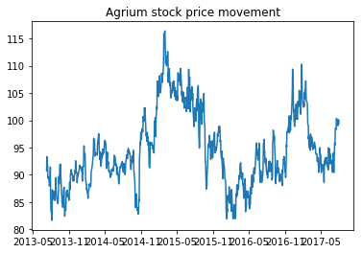

Figure 1 - Agrium historical stock quotes

The next step was to eliminate the trend:

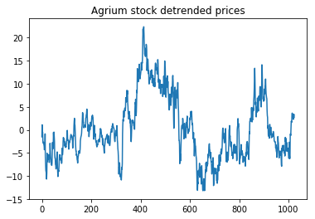

Figure 2 - Detrended Agrium stock prices

After that detrended Agrium stock prices were smoothed using Blackman window function with parameter = ‘20’:

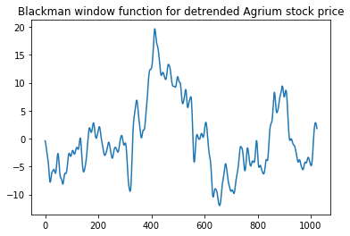

Figure 3 - Smoothed Agrium stock prices

Finally, Fast Fourier Transform Algorithm was applied:

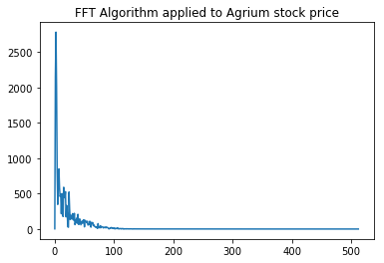

Figure 4 - FFT Algorithm results

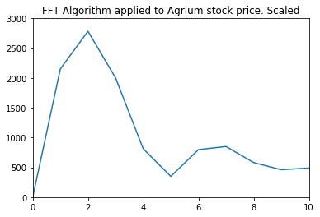

Figure 5 - FFT algorithm results. Scaled

According to the graph, there is one important spike at the beginning. The frequency of this cycle = 2. Since the whole period is 1024 trading days, the cycle is about 2 years. The second cycle is about half of a year. The last cycle could be seen as a seasonal factor.