Table of Contents

1 The Black-Scholes Model 1

1.1 Assumptions of the Black-Scholes Option-Pricing Model 1

1.2 Results: 2

2 Binomial Option Pricing Model 2

2.1 An advantage of the binomial option-pricing model 3

2.2 Assumptions of the Binomial Pricing Model 3

2.3 Results 3

3 Oil pricing 3

3.1 *Factors that influenced the oil price:* 4

*3.1.1* *Decrease in oil demand in Europe and China due to slowdown of economy [3]* 4

*3.1.2* *Increase in oil production in USA (including tight oil) => decrease in import [4]* 5

3.1.3 *OPEC pricing policy and global competition [5]* 7

*3.1.4* *War in Syria, Libya and Nigeria - one of the key oil players* 7

3.1.5 Crisis in Russia 7

3.1.6 Market Manipulation [6] 7

3.1.7 *Finance market expectations* 7

3.1.8 Strong dollar [7] 8

3.2 Oil price forecasting 8

3.2.1 Technical analysis (Global) 8

3.2.2 Technical analysis (Local) 9

3.2.3 Fundamental analysis 9

3.2.4 Demand 11

3.2.5 Dollar 12

3.2.6 Trend-Line Model 12

*3.3* *General conclusion* 12

4 Sources 13

# The Black-Scholes Model

***The Black-Scholes Model*** *is a mathematical model used to estimate the price of European-style options (call and put).*

*The model requires the following inputs to estimate the price of an option:*

*S = current stock price*

*K = strike price or exercise price*

*r = risk free rate of interest*

σ *= implied volatility*

*t = time to maturity (in years)*

*The pricing model is:*

c=*- Call option price*

p=*- Put option price*

d1=

d2=

*where*

*N(x) is the cumulative probability distribution function for the standardized normal distribution (mean = 0 and standard deviation = 1). In other words, it the probability that a variable with standard normal distribution N(0, 1) will be less than x.*

## Assumptions of the Black-Scholes Option-Pricing Model

The following are some of the key assumptions underlying the Black-Scholes option pricing model:

1. The risk-free rate is known and constant over the life of the option.

2. The probability distribution of stock prices is lognormal.

3. The variability of a stock’s return is constant.

4. The option is to be exercised only at maturity, if at all.

5. There are no transaction costs involved in trading options.

6. Tax rates are similar for all participants who trade options.

7. The stock of concern does not pay cash dividends.

Source *[1]**.*

## Results:

My result of call and put options price for Microsoft stock is:

|  |  |
| --- | --- |
| ***Call option price*** | ***Put option price*** |
| 4,817116755 | 4,751419606 |
|  |  |

# Binomial Option Pricing Model

Binimial Option Pricing Model - is an options valuation discrete model.

This makes BOPM a very useful tool in valuing American-style and exotic options that can be exercised before the expiry date.

Model Parameters:

S0 - Stock Price

X - Exercise Price

r - Interest Rate

σ - Volatility

t - Time to Maturity

N - Number of Steps

D - Dividend Yield

The up move and down move factor are calculated as:

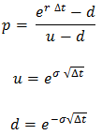

Where

***p*** - Probability of up movement

***u* -** Up movement

***d* -** Down movement

## An advantage of the binomial option-pricing model

An advantage of the binomial option-pricing model is that it can be used to price both European-style and American-style options with or without dividends. European options are put or call options that can be exercised only at maturity; American options can be exercised at any time prior to maturity.

## Assumptions of the Binomial Pricing Model

The following are the main assumptions of the binomial pricing model:

1. The continuous random walk underlying the Black-Scholes model can be modeled by a discrete random walk with the following properties:

* The asset price changes only at discrete time steps.
* At each time step, the asset price may move either up or down; thus there are
* Only two returns, and these two returns are the same for all time steps.
* The probabilities of moving up and down are known.

2. The world is risk-neutral. This allows the assumption that investors’ risk preferences are irrelevant and that investors are risk-neutral. Furthermore, the return from the underlying asset is the risk-free interest rate.

Source [1]

## Results

There is a difference with the Black-Scholes model result, but it is ok. The accuracy of the binomial model depends on the number of the steps.

|  |  |
| --- | --- |
| Binomial Option Pricing Model result: | |
| Call | Put |
| 5,059395857 | 4,993699 |

# Oil pricing

The period graph is

During this time there was significant drop.

Minimal, Maximal and Average price is listed in table below:

|  |  |
| --- | --- |
| Min | 26,19 |
| Max | 107,95 |
| Average | 60,99845 |

## *Factors that influenced the oil price:*

### *Decrease in oil demand in Europe and China due to slowdown of economy* *[3]*

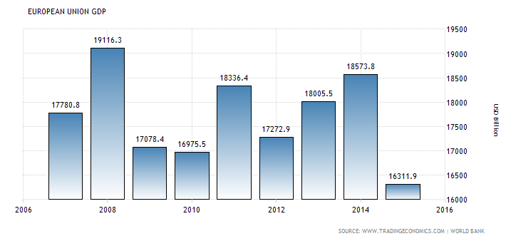

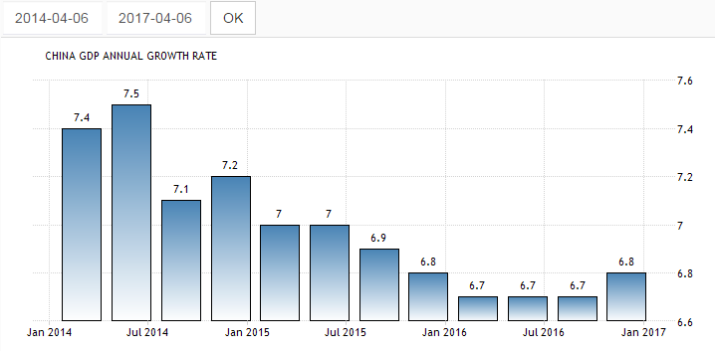

### *Increase in oil production in USA (including tight oil) => decrease in import* *[4]*

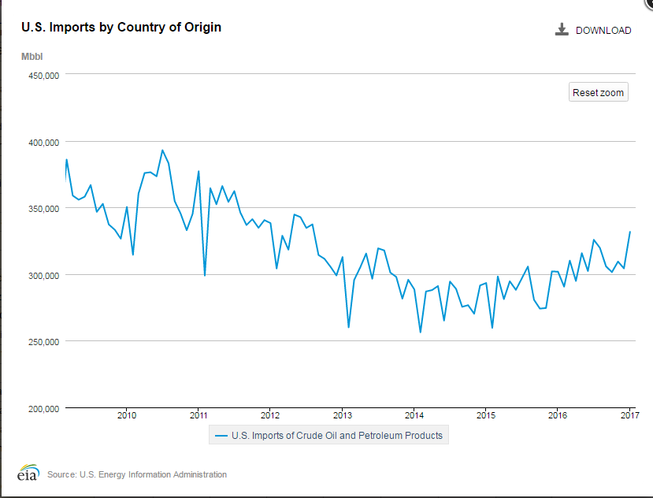

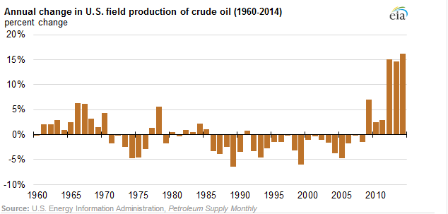

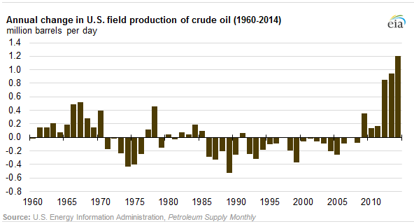

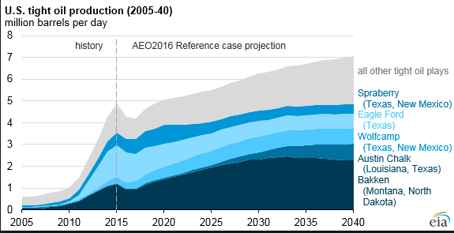

### *OPEC pricing policy and global competition* *[5]*

OPEC was not able to deside to limit oil production.

According to Dr. Gary Ross, chief executive of PIRA Energy Group, OPEC cannot manage the market anymore.

That is why some members (precisely Saudi Arabia) rejected to limit oil production not to lose their share in the market.

### *War in Syria, Libya and Nigeria - one of the key oil players*

This wars makes governments to find money and sell their oil cheaper.

Moreover, ISIS during the war needs money too, so they sell oil cheaper moving the prices down.

Note: Syria and Libya in 2014 product almost nothing, Nigeria's changes are not sufficient.

### Crisis in Russia

After oil price dropped, Russia faced big problems with budget deficit. In order to solve this problem, taking into consideration the fact that OPEC did not have an agreement, Russia had to product and cell more oil.

2014 - 6.2 MMBD

2015 - 6.5 MMBD

2016 - 7.2 MMBD

### Market Manipulation [6]

Some people believe, that oil price is manipulated to harm Russia and Iran (actually, this was made at least twice 1986, 1998)

At the same time, this manipulation has not only political reasons but also business ones (to cut off competitors)

### *Finance market expectations*

Since forwards and futures prices nowadays have huge influence on oil real price, new information about tight USA oil, wars with ISIS, OPEC problems, etc. makes investors sell oil, making downward pressure on the price. One more notice: the price falls quickly and returns back gradually.

### Strong dollar [7]

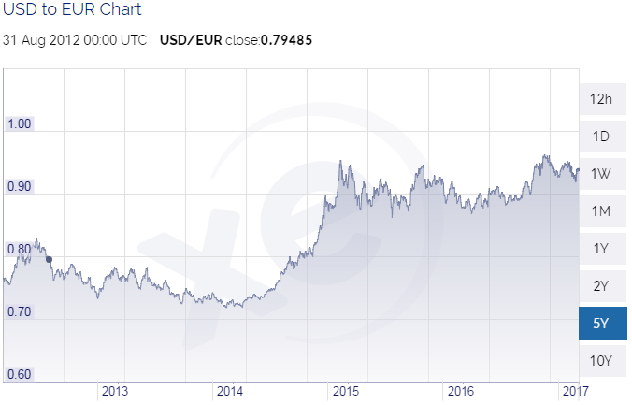

It is well-known fact that dollar rate influence oil price(and vise versa). So, we should take this fact in account.  
As we can see during 2014-2015 dollar grew significantly. Based on inverse relationship between the two, it was possible to make a decision that oil price dropped.

## Oil price forecasting

### Technical analysis (Global)

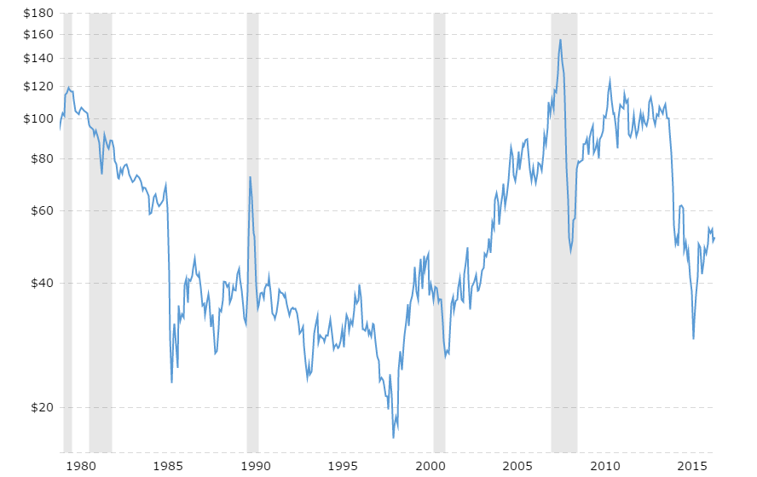

**$22 ~ 50%**

**$22 ~ 28%**

**$68**

**$30**

$108

Based on global technical analysis, It seems that current situation is similar to period 1985 - 1990. So , after huge drop oil price rised up to $22 that is equal approximatelly 50% of the drop. Oil price drop during 2014 was about $70 => quick roll-back is not expected to be more than $40 (up to $70). After that the price is likely to drop down again.

The same scenario was in 2008-2009 when price plummeted from $150 to $50 and then rised again (about 50%) up to $100

Based on historical data, average year volatility during relatively "ordinary" time is no more than $10, so during the next year I don't expect oil price to be under $50 - 2* $10 = $30 anyway.

**Conclusion:** based on technical analysis we can expect oil price to be (roughly) between $30 and $70 during the next year.

Personally, I expect the price to reach at least $60 first. (based on 50% roll-back strategy)

### Technical analysis (Local)

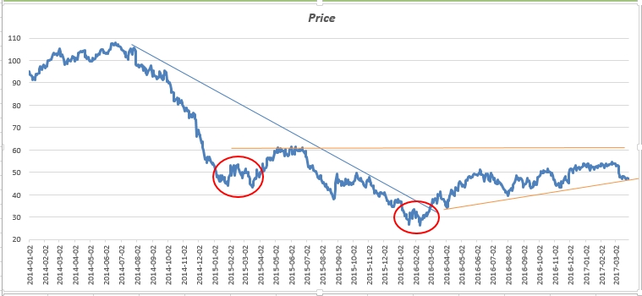

We can see clear uptrend. By the way 2015-04-02 and 2016-02-02 was wonderful moment for long.

From this graph I can assume that the price will go up but will not breakthrough $60 line.

### Fundamental analysis

U.S. Crude Oil Production - Historical Chart [8]

Gradually declined



**Conclusion: US oil production gradually declined**

OPEC production graph [9]

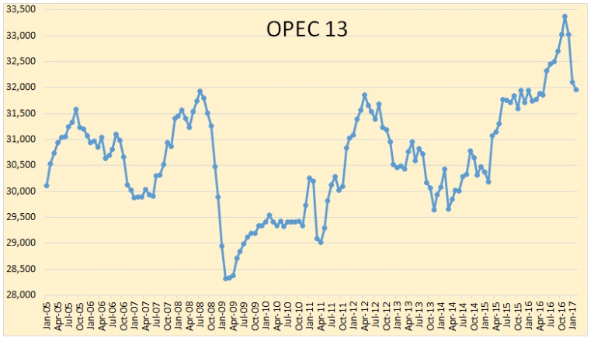

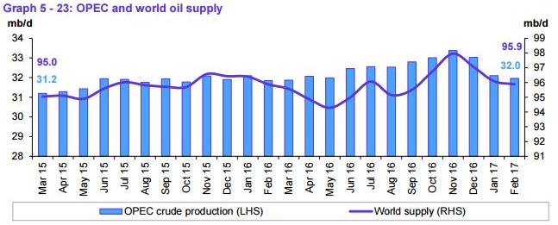

**Conclusion: OPEC oil production decreased considerably and in general world supply decreased.**

### Demand

World oil demand grew by 1.38 mb/d in 2016, higher by around 50 tb/d than in the previous month’s report, to average 95.05 mb/d. This was mainly as a result of positive adjustments in 4Q16 data, which accounted for the most up-to-date figures from regions around the world. In 2017, world oil demand is expected to stand at 96.31 mb/d, showing a growth of 1.26 mb/d, higher by approximately 70 tb/d from the previous month’s projections. Most of the oil demand growth is anticipated to originate from Other Asia, led by India, followed by China, then OECD America. The OECD Asia Pacific is the only region anticipated to reduce its oil requirements in 2017.

The rebalancing of the oil market, driven by the recent successful OPEC – Non-OPEC Declaration of Cooperation, is likely to further enhance the global oil industry, leading to even more global economic growth and hence higher oil demand growth in 2017. [10]

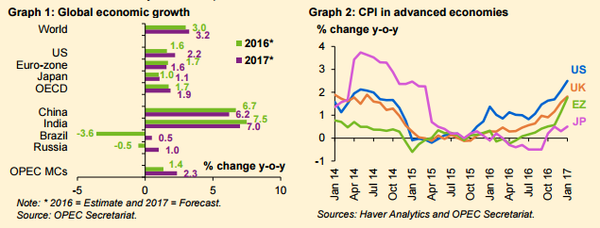

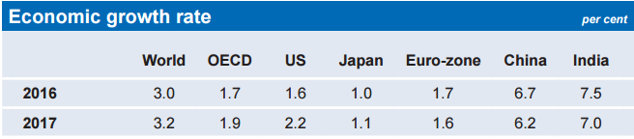

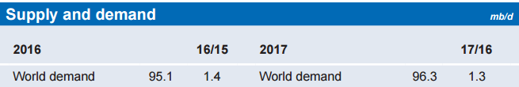

**Conclusion: world growth rate in increased, so oil demand increased too.**

### Dollar

It is expected that normalisation of US Federal Reserve (Fed) monetary policy will continue in 2017, given the inflationary support coming from the ongoing rebalancing of the oil market. This may also apply to other major central banks, though a relatively more accommodative stance is expected from some banks, particularly the European Central Bank (ECB) and the Bank of Japan (BoJ). Moreover, global debt levels remain high in some key economies, an issue that will probably require further attention as interest rates may rise gradually and the US dollar may continue to strengthen. [10]

### Trend-Line Model

For modelling I suggest to use only 2016-2017 data to make short-term forecasting more accurate.

I use **trend-line model** to forecast oil price.

**Conclusion:** Based on trend-line, we can conclude that oil price is going up. I close future we can expect oil price changing according to equation:

**Y = 0.0645*X + 34.853**

**Based on the equation:**

|  |  |  |  |  |
| --- | --- | --- | --- | --- |
| Forecasted | Actual | # | Date | Ratio |
| 55,1705 | 50,25 | day #315 | 2017-04-03 | 0,089187 |
| 55,106 | 50,54 | day #314 | 2017-03-31 | 0,082858 |
| 55,0415 | 50,3 | day #313 | 2017-03-30 | 0,086144 |
| 54,977 | 49,47 | day #312 | 2017-03-29 | 0,100169 |
| 54,9125 | 48,36 | day #311 | 2017-03-28 | 0,119326 |

## *General conclusion*

As we can see from historical data, oil price is highly volatile. It is appears to be extremely difficult to forecast this price since there are many factors that influence the price, they are:

a) Global politics and market manipulations (first of all).

b) Supply and demand.

c) Wars.

d) Market expectations based on reports and news.

e) Dollar rate

However, there are periods that are rather stable. During these periods, technical analysis could be applied.  
So, to forecast oil price first fundamental analysis should be executed and only then technical (if you want). All news and reports should be monitored (especially main oil market players' reports).

In my opinion, oil price will rise up to at least $60 (likely $70) during 2017. But I expect high volatility.

In short-term period trend line model provides good result as we can see in table above.

# Sources

|  |  |  |  |  |  |  |  |  |  |  |  |  |  |  |  |  |  |  |  |  |
| --- | --- | --- | --- | --- | --- | --- | --- | --- | --- | --- | --- | --- | --- | --- | --- | --- | --- | --- | --- | --- |
| |  |  | | --- | --- | | 1 | Financial Markets and Institutions, 11th Edition, Jeff Madura | | 2 | [Yahoo Finance https://finance.yahoo.com/](https://finance.yahoo.com/) | | 3 | <http://www.tradingeconomics.com/> | | 4 | <https://www.eia.gov/> | | 5 | <http://www.reuters.com/article/us-opec-meeting-idUSKCN0JA0O320141128> | | 6 | <http://oilprice.com/Energy/Oil-Prices/Did-The-Saudis-And-The-US-Collude-In-Dropping-Oil-Prices.html> | | 7 | <https://www.thealertinvestor.com/oil-and-the-dollar/> | | 8 | <http://www.macrotrends.net/1369/crude-oil-price-history-chart> | | 9 | <http://peakoilbarrel.com/opec-crude-oil-production-charts/> | | 10 | [http://www.opec.org Monthly oil Market Report 14 March 2017](http://www.opec.org/) | |