1. **Create table Query:**

CREATE TABLE places 5

location_id INTEGER PRIMARY KEY,

location_name VARCHAR,

coordinates GEOMETRY

);

1. **Insertion:**

INSERT INTO places VALUES(1, 'Lyon_Center', ST_MakePoint(-118.288,34.025)),

( 2, 'HermanOstrow', ST_MakePoint(-118.287,34.024)),

( 4, 'GloryaKaufman', ST_MakePoint(-118.286,34.023)),

(5, 'USC_Church',ST_MakePoint(-118.284,34.023)),

( 7, 'OIS', ST_MakePoint(-118.282,34.022)),

( 8, 'Ralphs', ST_MakePoint(-118.291,34.032)),

( 10, 'Home', ST_MakePoint(-118.289,34.032)),

( 3, 'Tommy_Trojan', ST_MakePoint(-118.290,34.020)),

( 9, 'EGG', ST_MakePoint(-118.288,34.032));

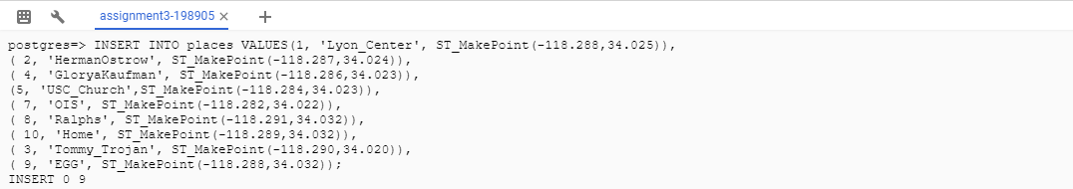

1. **Convex Hull**

select ST_AsText(ST_ConvexHull(ST_Collect((d.coordinates)))from places As d;

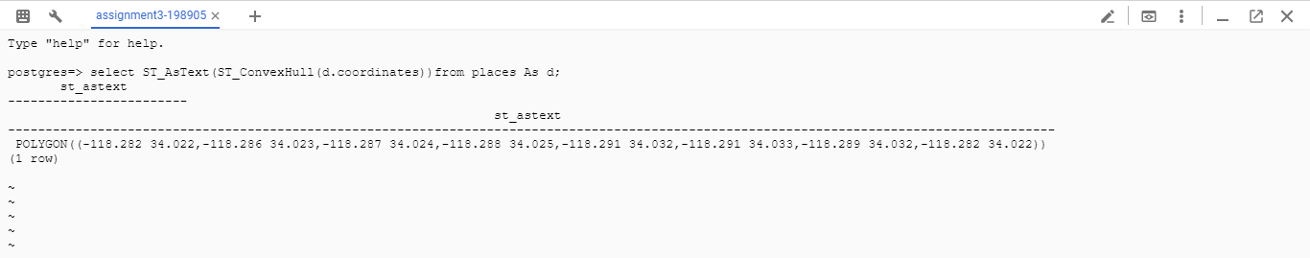

1. **K-nearest Neighbour**

select p2.location_name from places p1,places p2

where p1.location_name='Home' and p1.location_name<>p2.location_name

order by ST_Distance(p1.coordinates,p2.coordinates)

limit 3;

