Selected Projects Showcasing Custom Themes, Performance, and Scalability
https://bandgstaging.wpengine.com/our-story/leadership - Brasfield and Gorrie Construction site
This site was originally built by my previous company, and the client wanted to separate their team into two groups: Senior Leadership and Executive Leadership. They didn’t want a new Custom Post Type, they wanted to continue using the existing “People” custom post type. I was given only the Figma design, so the first challenge was figuring out how they could assign people to these two new teams in the backend while still supporting filtering on the frontend.
To solve this, I used the existing “department” taxonomy for the People custom post type and simply added two new taxonomy terms: senior-leadership and executive-leadership.

Backend Work
I created a new page template and applied it to a new WordPress page called “Leadership.” The client also wanted the ability to feature selected Senior and Executive members at the top of the page. To support this, I added two ACF relationship fields to the Leadership page settings so they could choose featured members.
Another challenge was displaying the remaining team members below the featured ones, without duplicates. This required some careful logic. To optimize performance, I created a reusable PHP function where I passed the post count and taxonomy as arguments. This function handled both taxonomy filters on the frontend. Using this list, I could easily exclude the featured people from the main array and output the rest cleanly. I enjoyed writing this function and experimenting with array filtering in PHP.

Frontend Work
The frontend was built using Twig templates. Each page is composed of blocks, reusable components, and modules. One challenge was avoiding repeated code for the Senior and Executive sections. To keep everything clean, I created a reusable Twig partial with variable support so it could handle both sections using conditional logic and variables.
Another requirement was a hover effect where an image “curtain” slides over each person’s card. I handled this with simple CSS hover states combined with TailwindCSS transitions and delay classes. The entire page is fully responsive, and all styling was done using TailwindCSS.
2. https://proedgedental.com/toolkits - Proedge Dental Marketing Site
This is another WordPress site built by my previous company. The site used a section- and block-based structure, and while I built many different blocks across the site, this page was one of the most challenging.
This page is the Toolkits archive template. “Toolkits” is a Custom Post Type, and all the filters on the page come from its taxonomy terms. There was also an additional filter for keyword search. Because there were many toolkits, I used the REST API to fetch results based on a combination of taxonomy filters and search input. Since this is a custom post type, I created custom REST API endpoints. I wrote a PHP function to query toolkits using both taxonomy queries and the default WordPress search query.
Depending on the user’s selection, the results could be filtered by search, by taxonomy, or by both together. On initial page load, I displayed nine toolkits. If more existed, a “Load More” button appeared to fetch additional posts. I used an Alpine.js loop to render the toolkits in groups of nine, and relied on standard WordPress pagination in the backend to manage the remaining posts.
3. I don’t have the live project URL because I worked on it right before I was laid off and it hasn’t launched yet, but I can share an interesting challenge I worked on.

The team wanted a way to add Bible verses—sometimes with links, sometimes without—to the WordPress WYSIWYG editor, but with special background and text styling. If they added this directly in the editor, they would need to manually write multiple lines of HTML and custom CSS every time. To make it easier, I created a custom shortcode so they could insert the styled verse with just a single line.
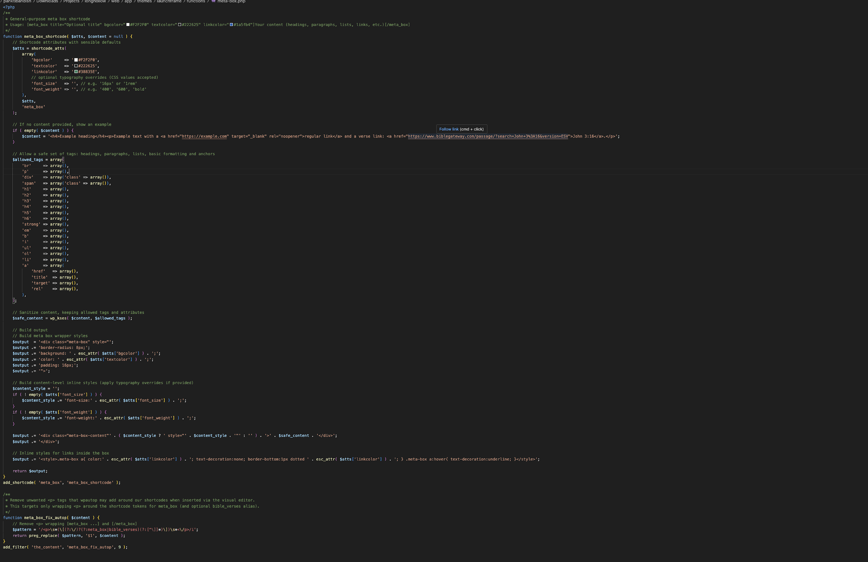
To do this, I built a custom PHP shortcode function that supports optional HTML tags and color settings, all with sensible default values. This allowed the team to add styled verses quickly and consistently without touching any code.

4. https://passioncitychurch.com - Passion City Church Site
This project involved a full reskin and rebuild of an existing WordPress site, which I completed independently from architecture through implementation. The goal was to modernize the front end, improve performance and maintainability, and provide a flexible content system for long-term scalability.
The site was built using a fully custom, component- and block-based WordPress theme, leveraging Timber (Twig) for clean, logic-separated templating and Tailwind CSS for a scalable, utility-first styling approach. This architecture enabled reusable components and consistent design patterns across pages while keeping the codebase modular and easy to maintain.
I focused heavily on responsive design, ensuring a seamless experience across desktop, tablet, and mobile devices. Performance optimization was a key priority, including optimized asset loading, efficient CSS structure, and front-end best practices to support improved page speed and Core Web Vitals. The rebuild preserved existing content while enhancing layout flexibility for content editors.
From a technical standpoint, this project demonstrates my ability to:
- Design and implement custom WordPress themes from the ground up
- Build component-driven architectures for scalable front-end development
- Translate design and content requirements into reusable blocks
- Optimize performance while maintaining visual consistency
- Deliver production-ready solutions independently for large, content-driven sites
Overall, this project highlights my experience working solo on complex WordPress builds, balancing clean code, performance, and usability while creating a maintainable system that supports ongoing growth and iteration.

5. https://tnaqua.org/ - WordPress Maintenance & Ongoing Support
In addition to full site builds, I provided ongoing WordPress maintenance and support for production websites, ensuring long-term stability, performance, and security. This work involved proactively monitoring site health, managing updates, and resolving issues to keep sites running smoothly as content and traffic scaled.
My responsibilities included core, theme, and plugin updates, managing backups, and addressing compatibility issues to prevent downtime. I regularly troubleshot and resolved plugin conflicts, caching issues, and performance bottlenecks, ensuring consistent functionality across environments.
Performance optimization was a key focus of this maintenance work. I implemented best practices such as image optimization, asset cleanup, and frontend performance improvements to support faster load times and improved Core Web Vitals. I also assisted with SEO and analytics upkeep, ensuring tracking remained accurate after updates or feature changes.
This maintenance work required close collaboration with content editors, designers, and stakeholders, as well as clear documentation of changes and workflows. Through ongoing support and proactive optimization, I helped ensure WordPress sites remained secure, performant, and easy to manage over time.

