Aero2Astro
Panneerselvam N
(21/09/2021)
Model Summary:

Model - 1: PP-Yolo v1
ins = 1000
bs = 8
lr = 0.0002
epochs = 1983
model : ppyolo_r50vd_dcn_1x_coco
Training Data:
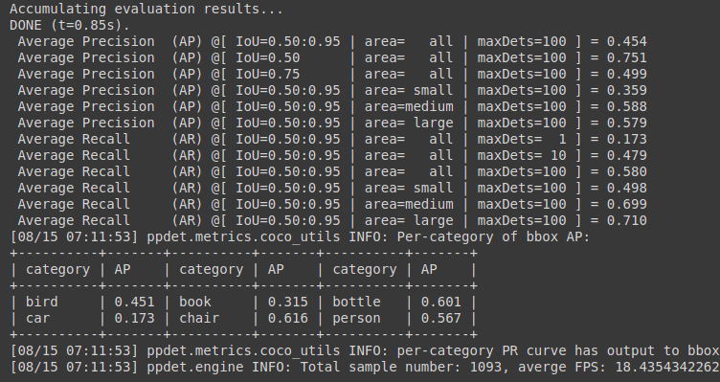
Test Data:

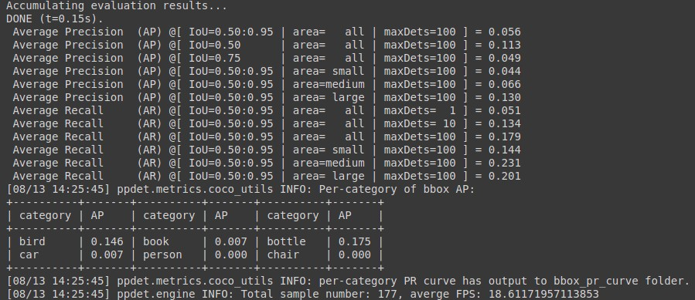

Model – 2 :(PP-Yolo v2)
ins = 500
bs = 8
lr = 0.0002
e[ochs = 1711
model : ppyolov2_r101vd_dcn_365e_coco
Training Data :
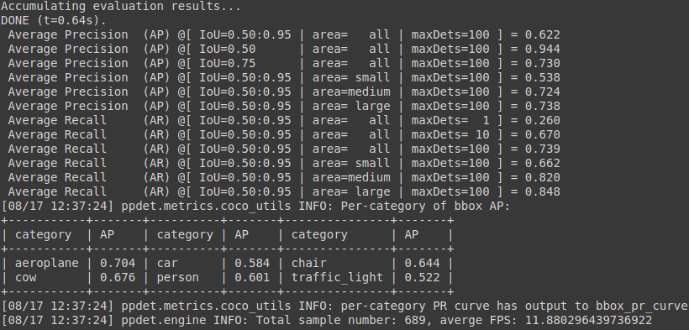
Test data :

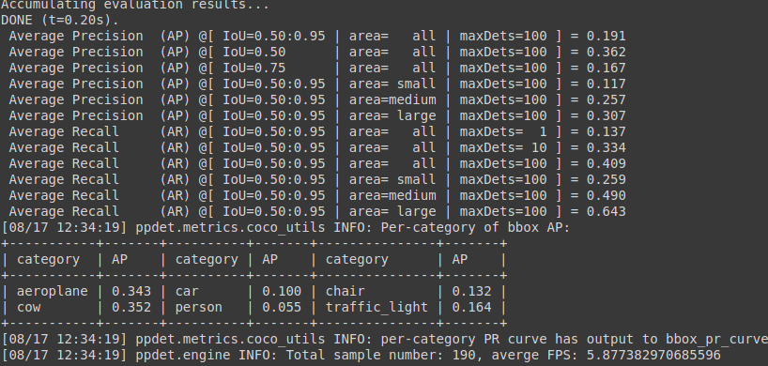

Model - 3:(Faster Rcnn)
Backbone = Faster_rcnn_X_101_32x8d_FPN_3x
bs = 4
lr = 0.001
ins = 500
itrations : 83500
Test :
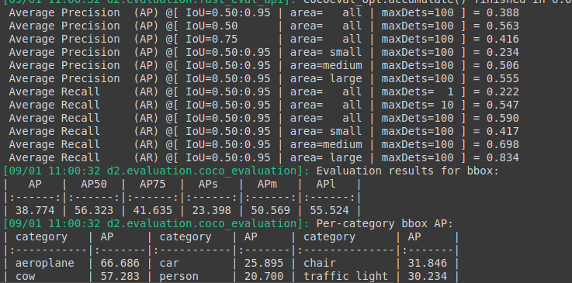
Train :
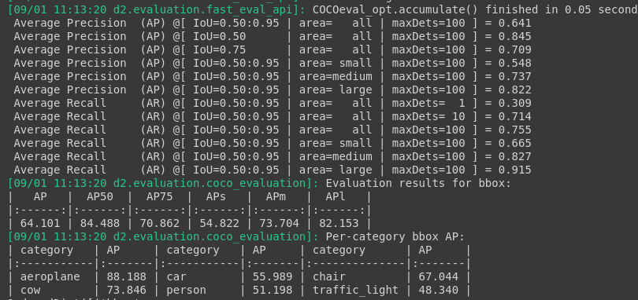

Model – 4 (Faster Rcnn – with augmentation)
Augmentation : Resize (1024), Horizontal Flip
iterations - 149500
Test:

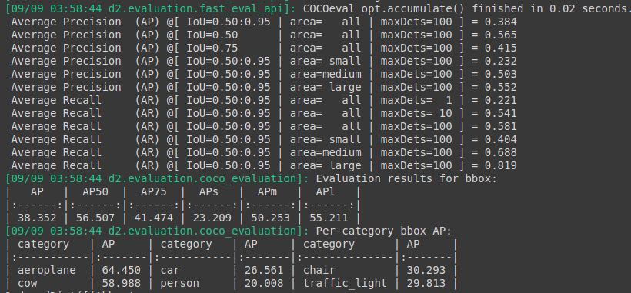
Train :

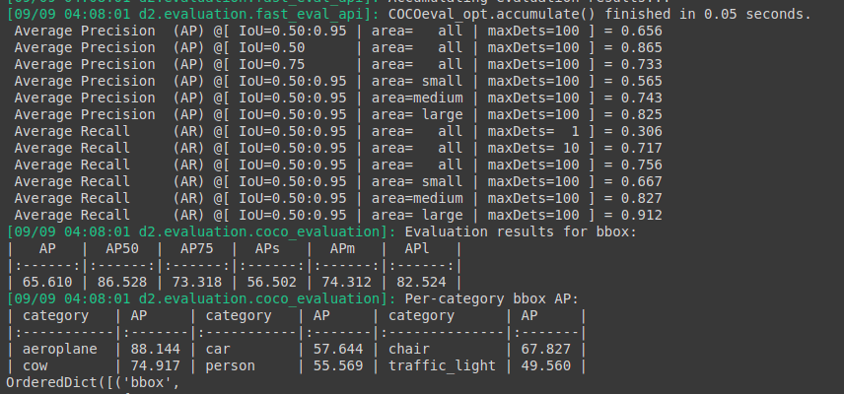

Model – 5:(Faster Rcnn with Augmentation)

Augmetation : Resize(1024),Hflip ,Random brightness , Random Rotation , Random crop
Iterations : 159500
Test:

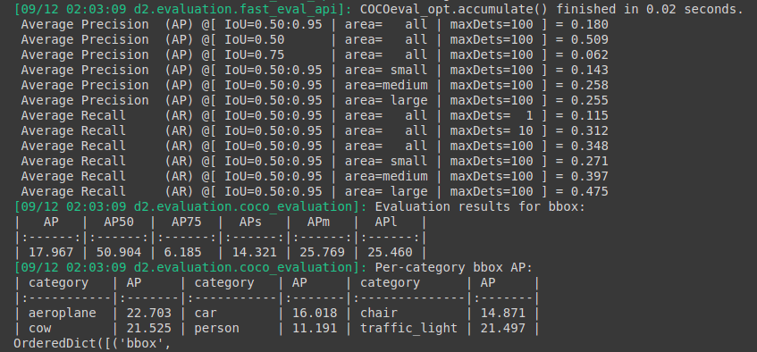
Train :

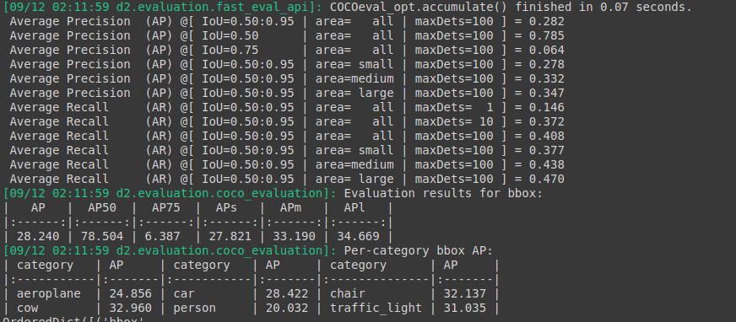
Model – 6 (Faster Rcnn with augmentation )
Augmentation : Resize(1024) ,Random brightness , Random Rotation , Random crop

Iterations : 201499

Test :

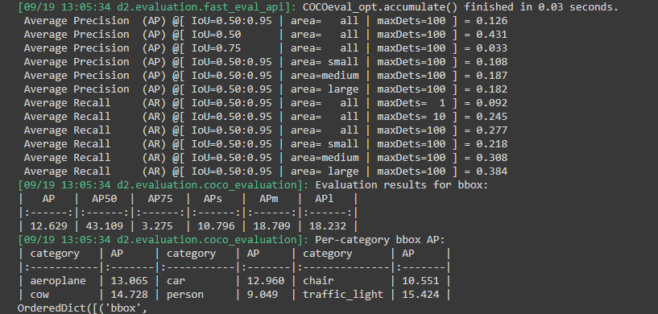
Train :

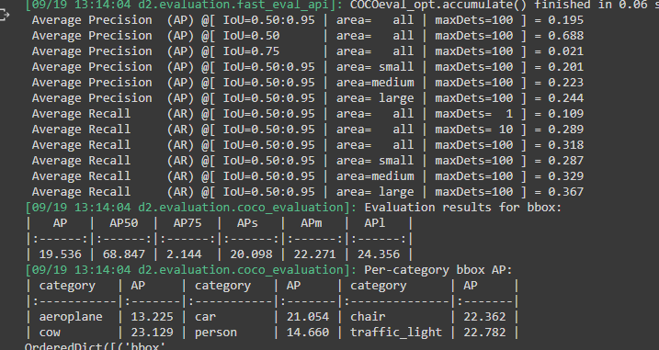

Best model :

PP – Yolo v2 : ppyolov2_r101vd_dcn_365e_coco
Average Precision : 0.307
Average Recall : 0.643
FPS : 11. 88

Faster RcNN :( Backbone = Faster_rcnn_X_101_32x8d_FPN_3x without any augmentation)
Average Precision : 0.555
Average Recall : 0.834
Inference Time : 0.731 s / per image

Faster Rcnn gives good accuracy with compared to other models but one disadvantage is , it gives less FPS.

PP-Yolo v2 gives Moderate accuracy and FPS . So, PP-Yolo v2 is the winner of above models.

