Panneerselvam N
(011/09/2021)
Today i had trained faster rcnn model upto 159499 iterations with more augmemtation.And also evaluated with both training and test data set.

Previous Checkpoint: 138000
Test :
Augmentation : Resize(1024), HFlip
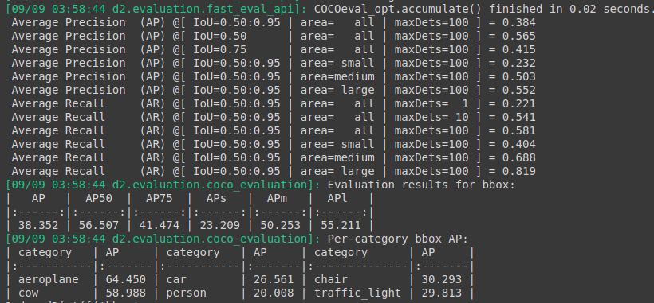
Train :

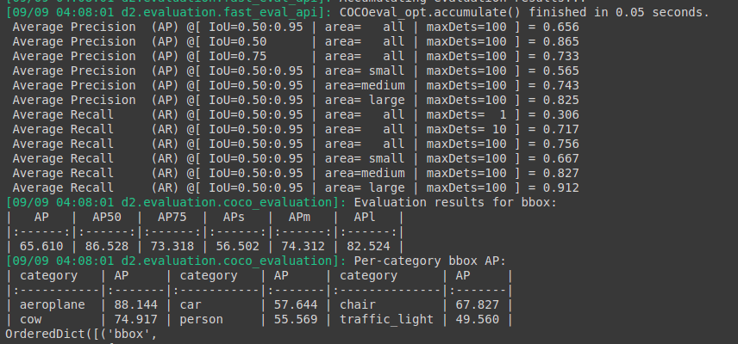
Previous Chechpoints : 149500 itr
Augmetation : Resize(1024),Hflip ,Random brightness , Random Rotation , Random crop

Test :

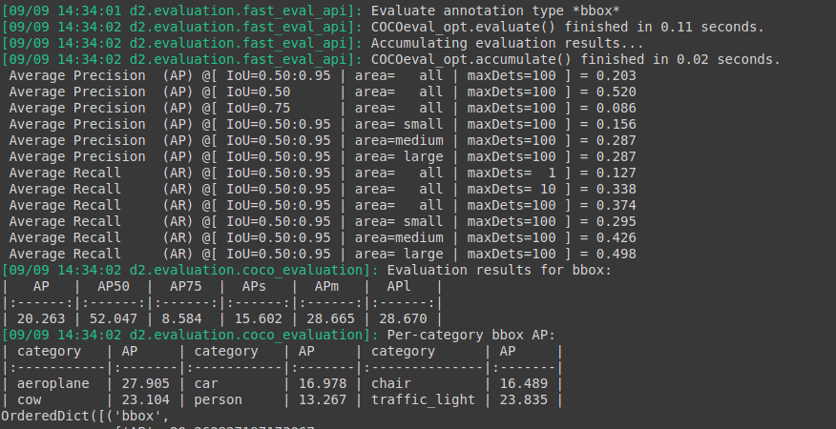
Train :

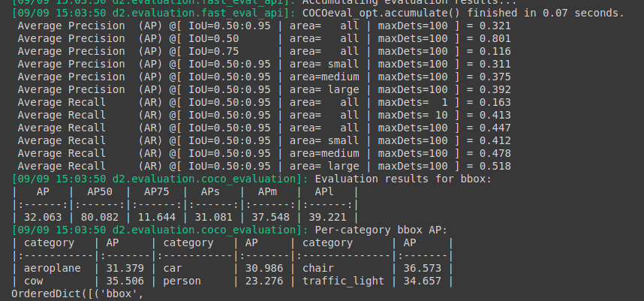
Current Checkpoints : 159500 itr

Test:

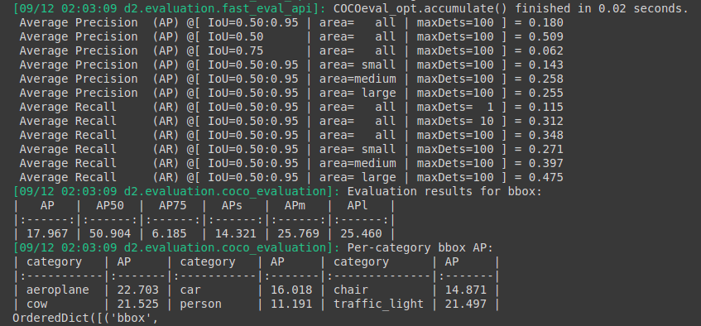
Train :

