Panneerselvam N
(18/09/2021)
Today i had trained faster rcnn model upto 201499 iterations with more augmemtation. And also evaluated with both training and test data set.

Previous Checkpoint: 138000
Test :
Augmentation : Resize(1024), HFlip
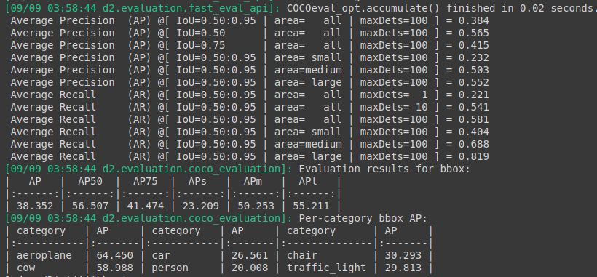
Train :

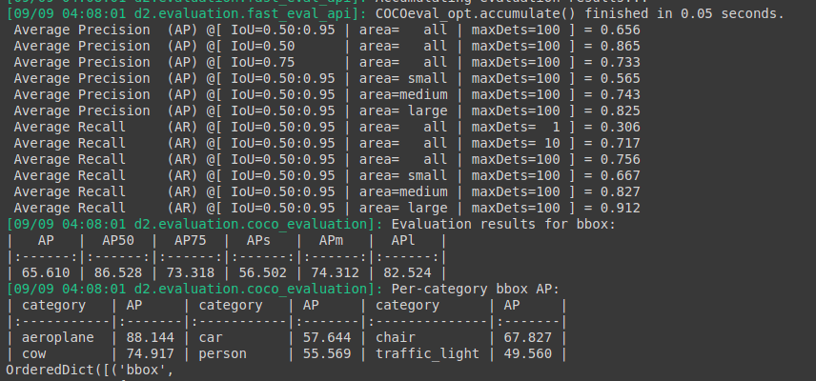
Previous Checkpoints : 159500 itr
Augmentation : Resize(1024),Hflip ,Random brightness , Random Rotation , Random crop

Test:

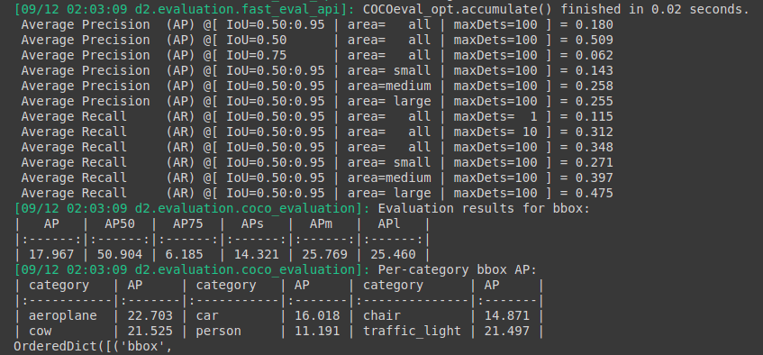
Train :

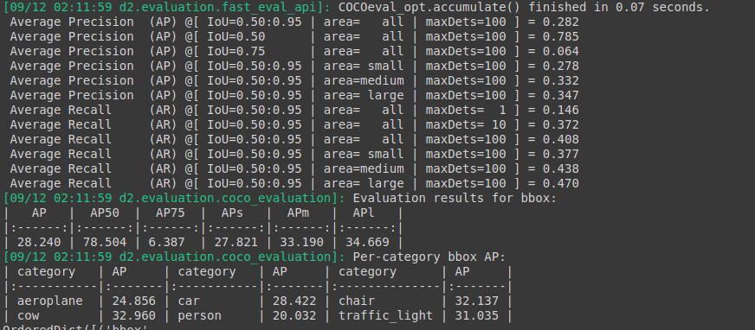

Previous Checkpoints : 169500 itr

Test :
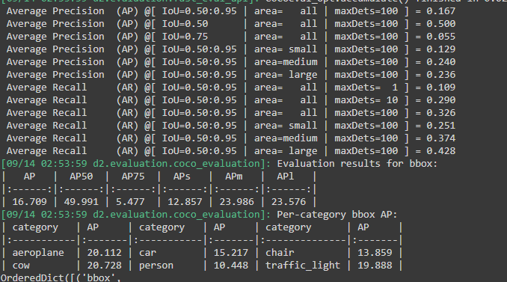
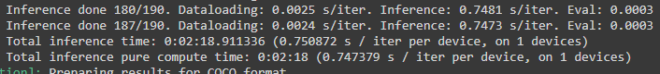
Train :
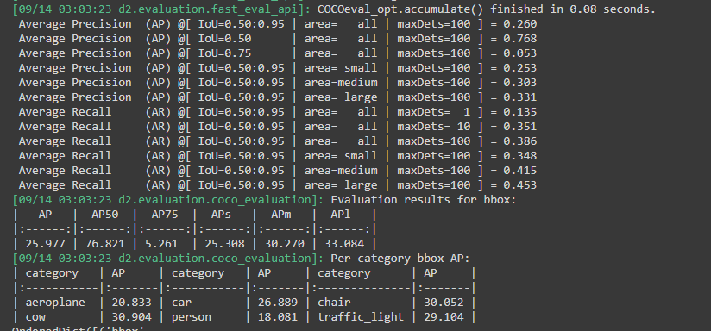

Previous Checkpoint : 189000 itr

Test :

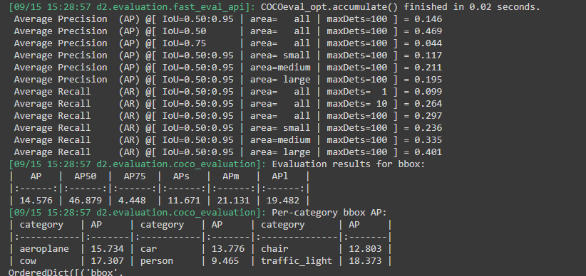
Train :
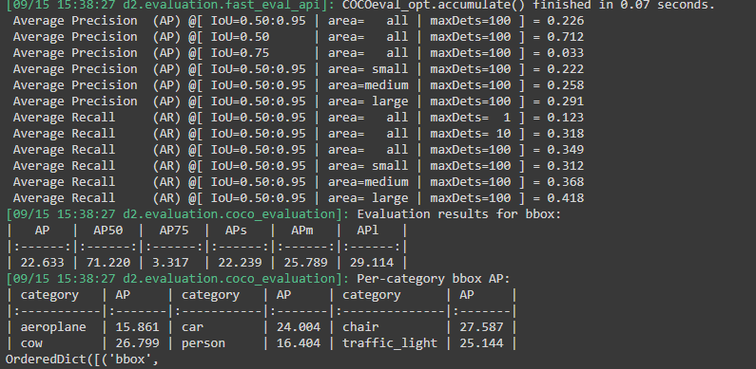

Performance after removing horizontal Flip:
Previous checkpoints: 196500 itrs

Test :
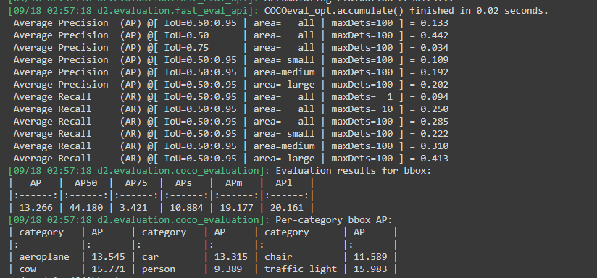
Train:

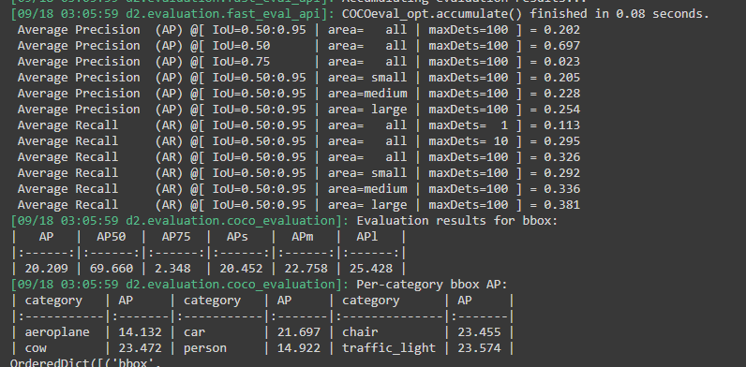

Current checkpoint : 201499 itr

Test :

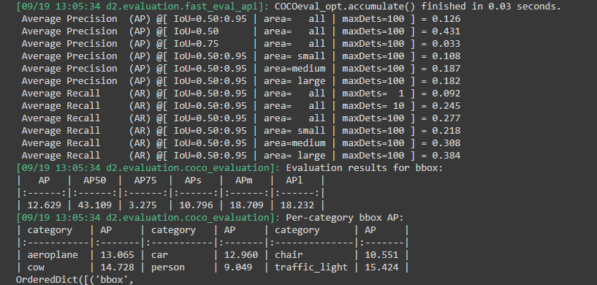
Train :

