Name : Panneerselvam N
Role : Research Intern – Inspect
Date : 14/06/2021
TensorFlow Practice

Today I have learned TensorFlow’s Fuctional API. TensorFlow has two types of High Level API
- Sequential API
- Functional API

Sequential API means , it like a stack structure we can add as much of layer in sequential way.But it is not flexible.

Functional API , It is very flexible API ,we can add any layers in between them.

I have created one simple CNN structure ,for CIFAR-10 datasets which has 10 different classes. I got around 94% accuracy.

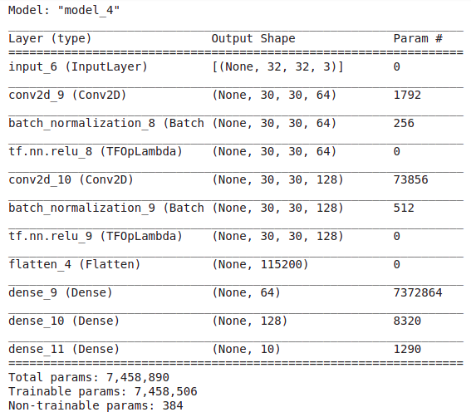

Yolov4 Custom Model Validating

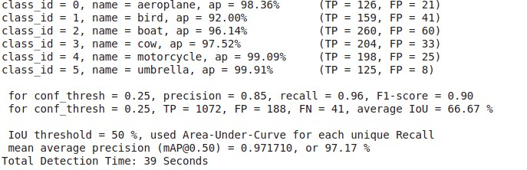
Above image shows performance of my model during training, I had trained around 7-8 hrs with 3400 epochs.

Image with Single class:

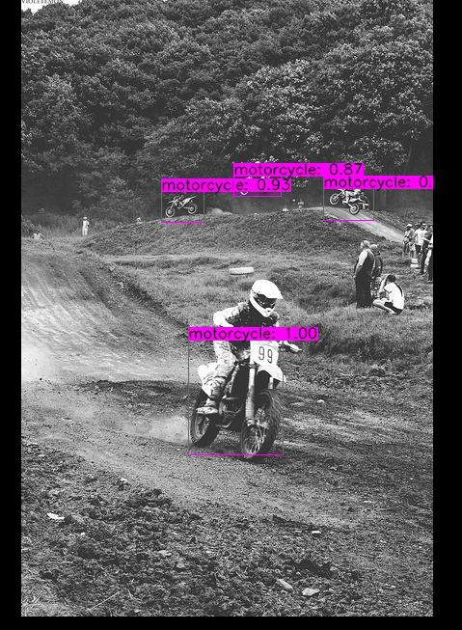
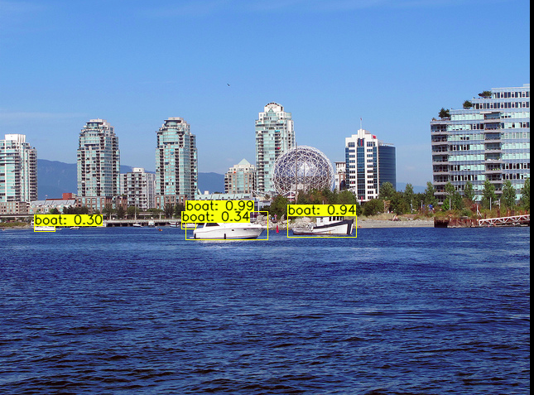

Image with Multiple Classes :

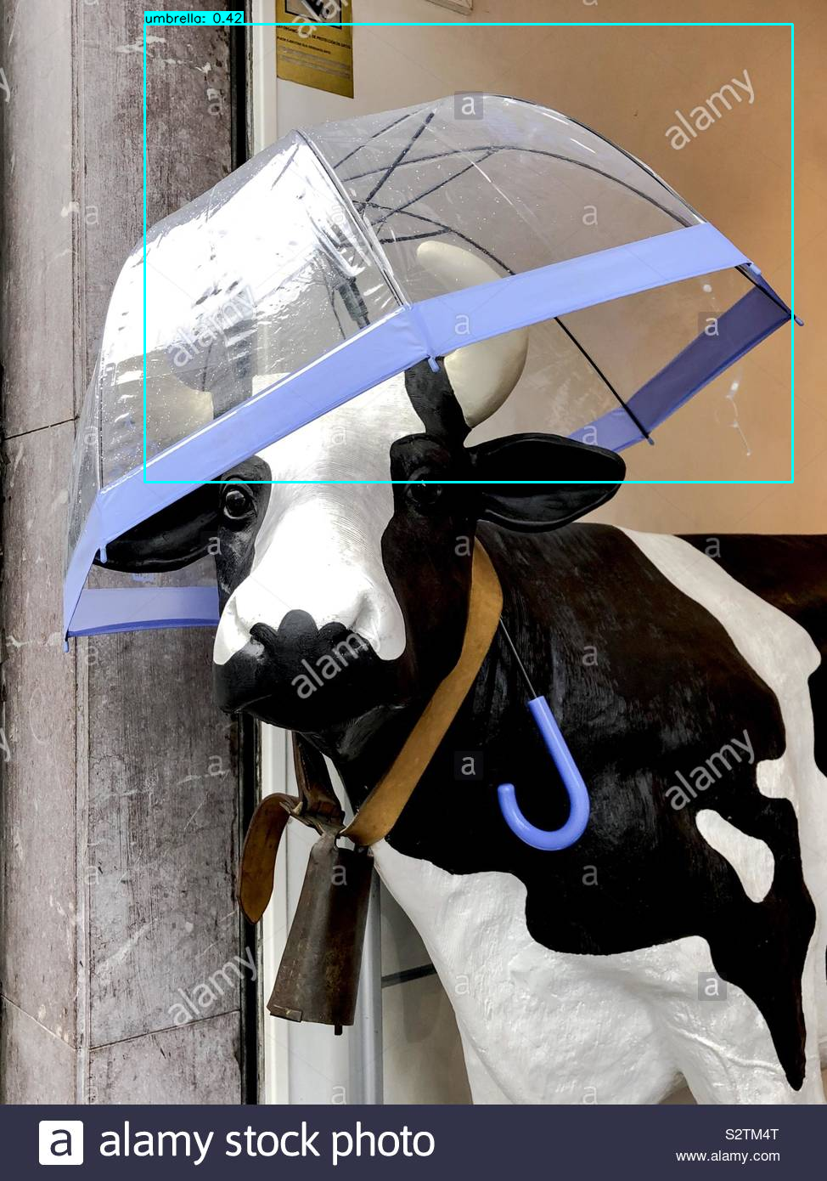

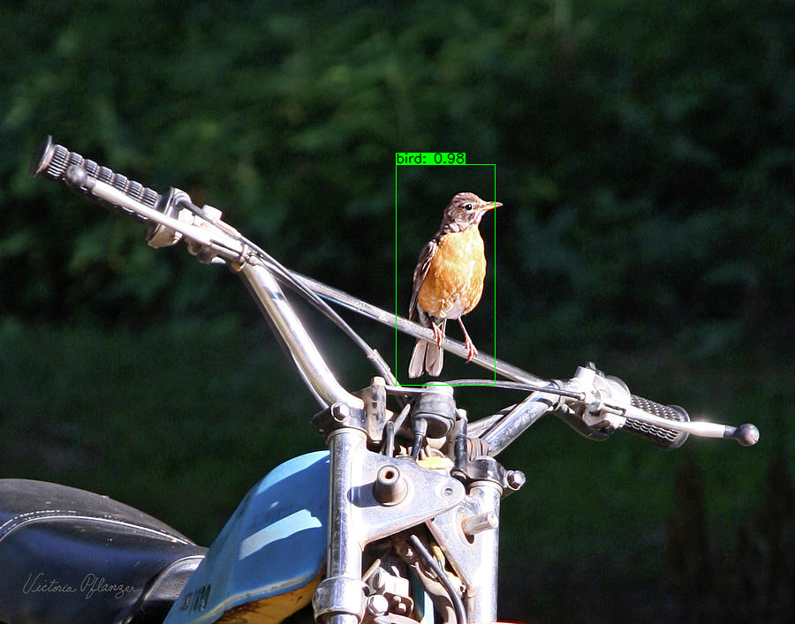
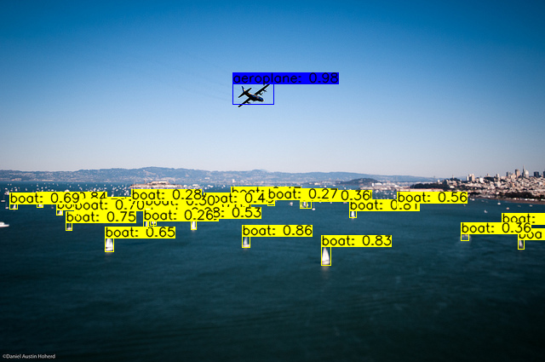





Conclusion :
Model fails when multiple objects in one image.This is because of model over-fitting . I have used only 1200 images for 6 classes, that’s why model doesn’t well on multiple objects.

