Aero2Astro
Panneerselvam N
(01/11/2021)

Today i had trained Yolo v4 model upto 21800 epochs with jitter = 0.45. And also evaluated with both training and test dataset.

Threshold_IOU = 0.2
Train:
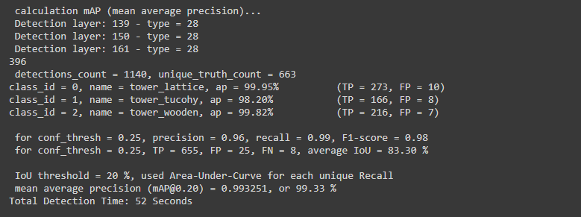
Test:
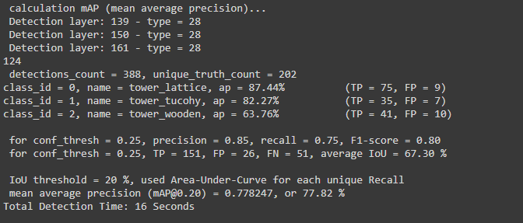
Val:
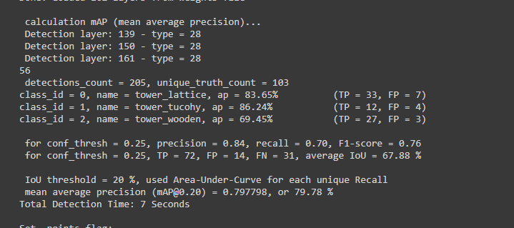
Threshold_IOU = 0.6
Train:
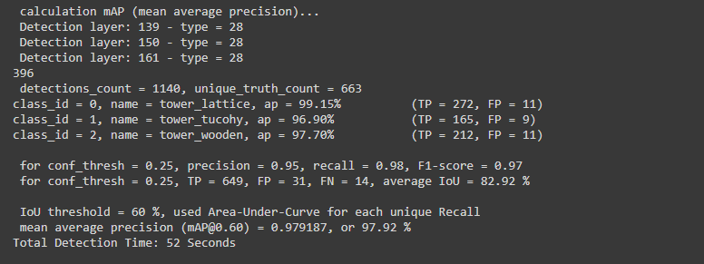
Test:
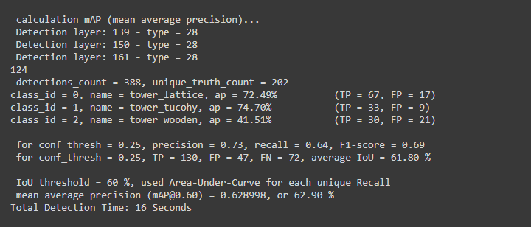
Val:
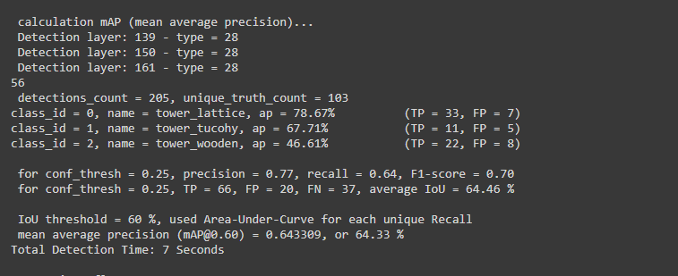

Image: 08_1830.jpg
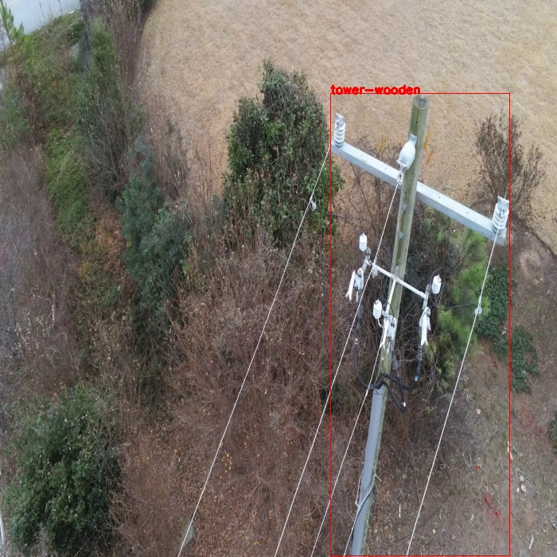
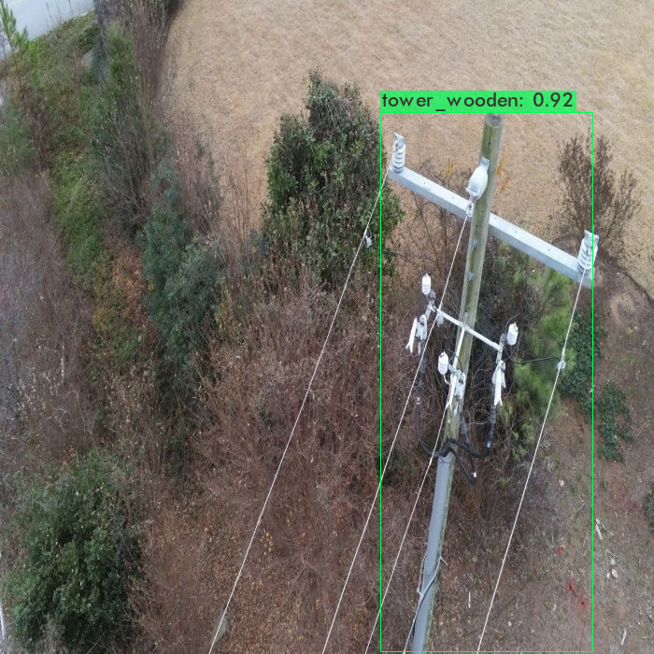
Correctly detected.

Image:14_01171.jpg
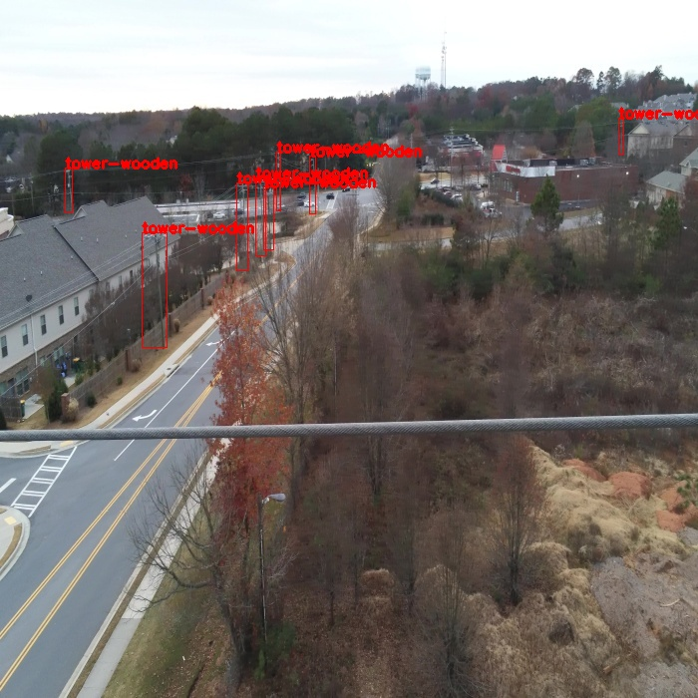
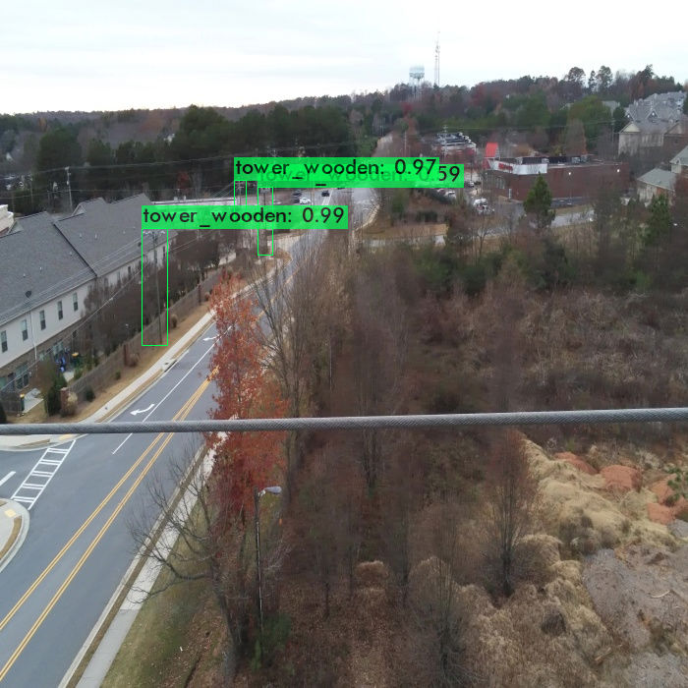
Some wooden towers are not detected.

Image:19_00137.jpg
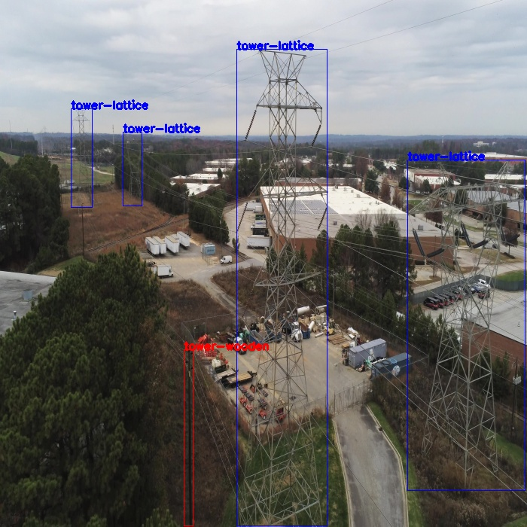
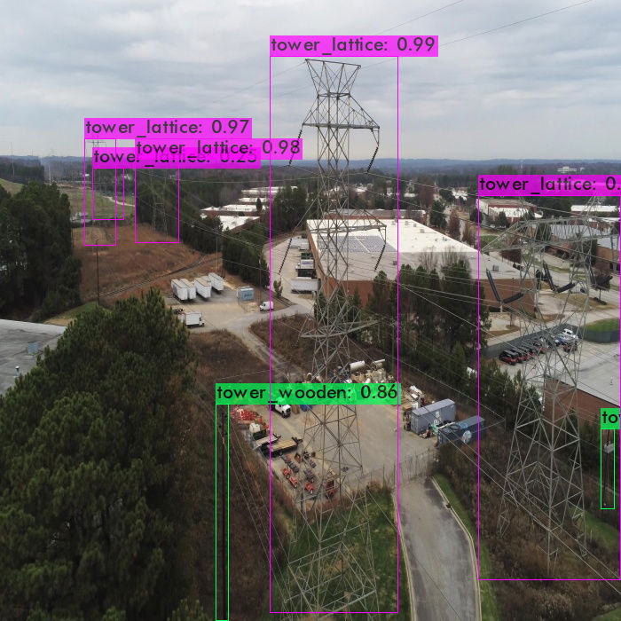
Right side wooden tower is wrong detection.

Image : 20_7215.jpg

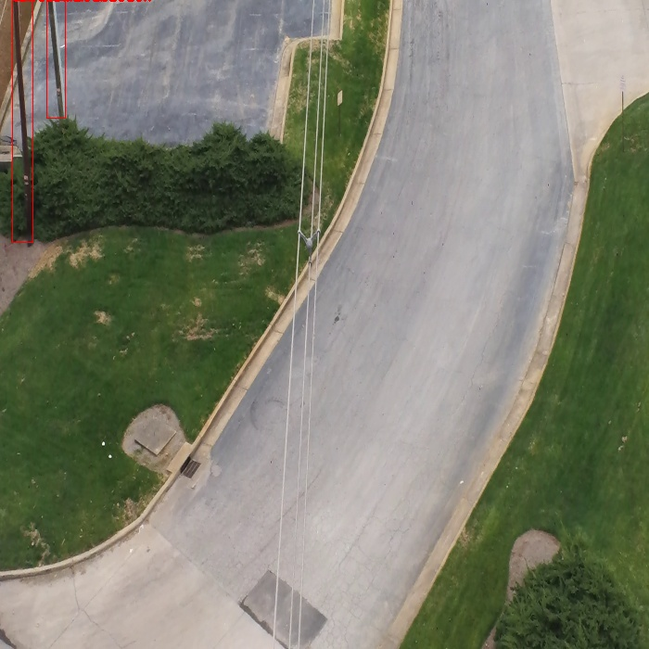
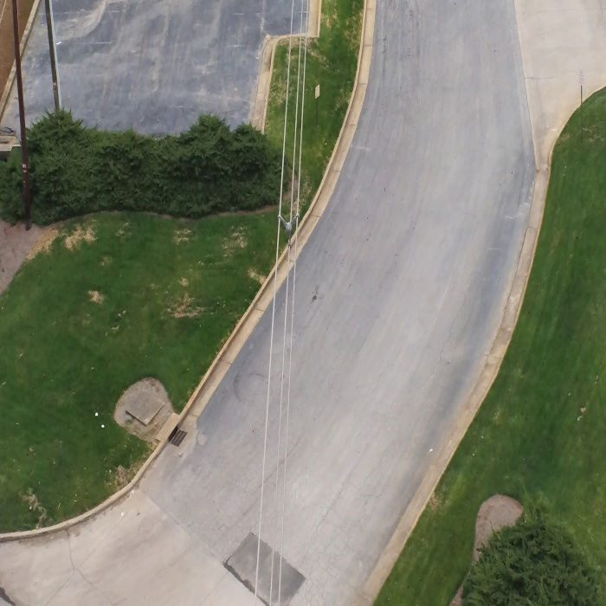
Wooden tower is not detected.

Image:25_00029.jpg
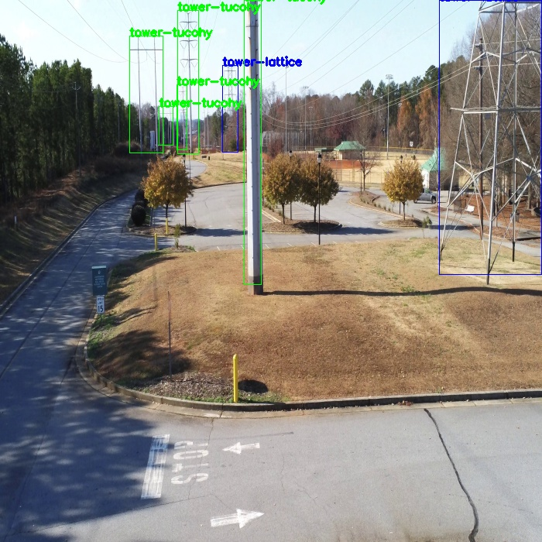
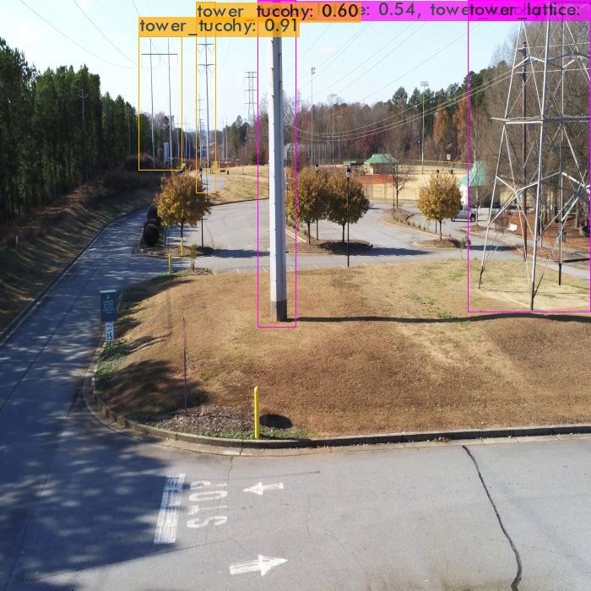
Tucohy tower is mis-classified as Lattice. And also one lattice tower is not detected .
Image :43_00591.jpg
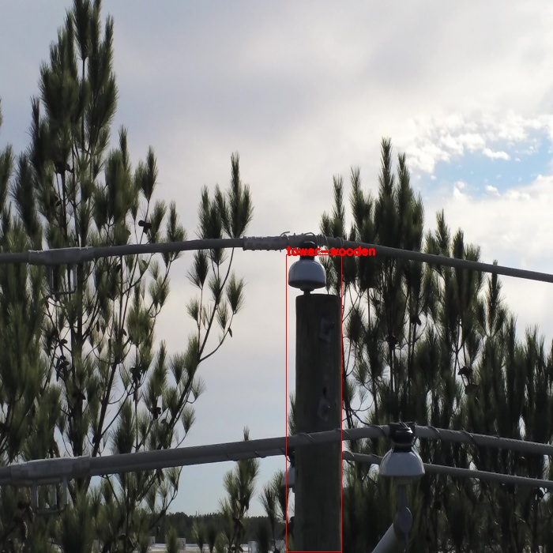
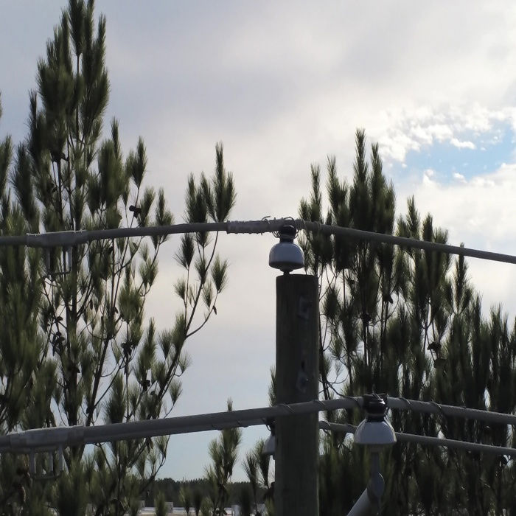
Wooden tower is not detected.

Image:58_00956.jpg

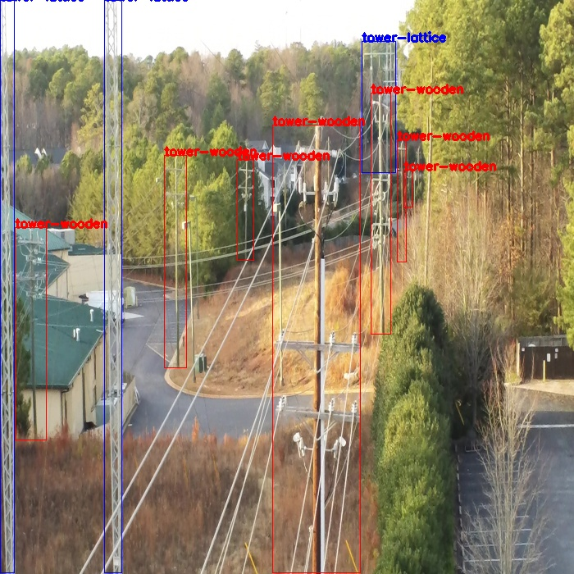
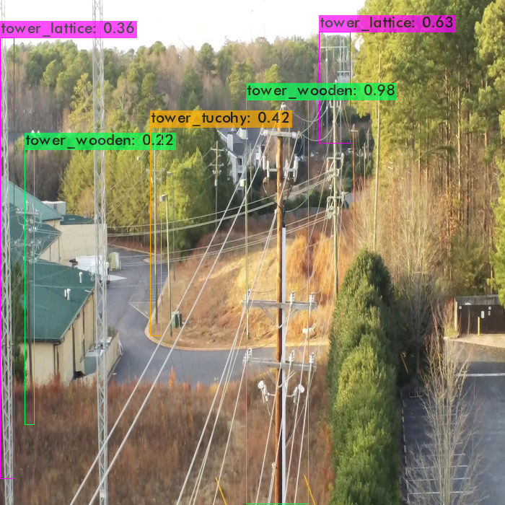
Some lattice towers are not detected, and wooden is mis-classified as tucohy.
Image: 66_00191.jpg
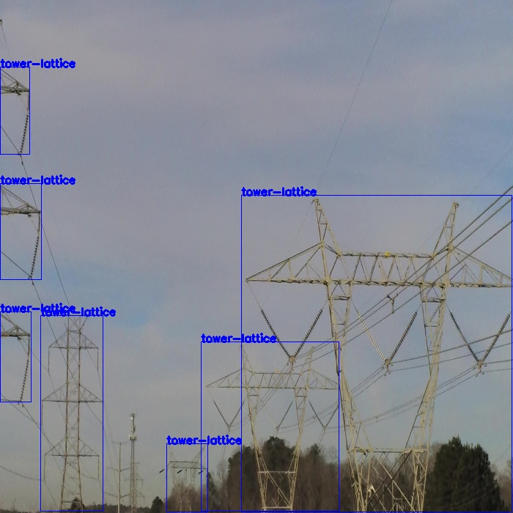
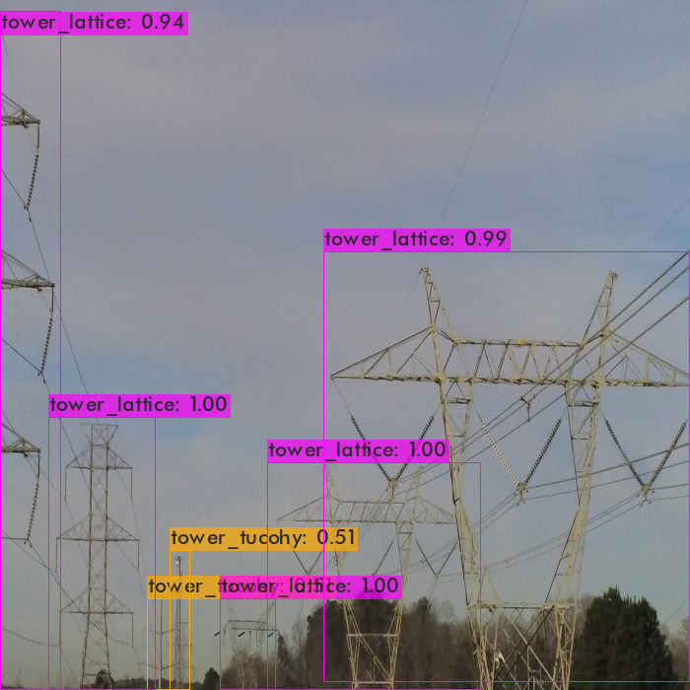
Some lattice towers are mis-classified as tucohy.

