Aero2Astro
Panneerselvam N
(06/11/2021)
Today i had trained Yolov4(modified anchor box) model upto 1900 epochs.And also evaluated with train , test and val dataset.
Threshold_IOU = 0.2
Train:
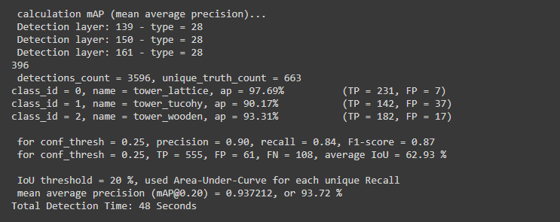
Test :
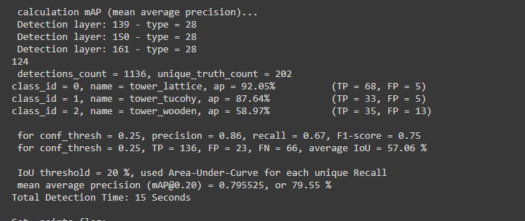
Val:
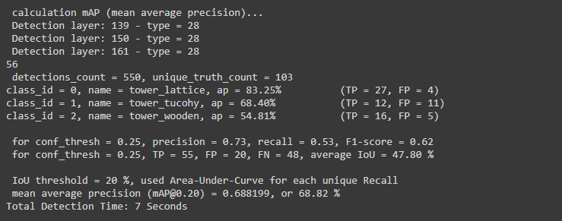
Threshold_IOU = 0.6
Train:
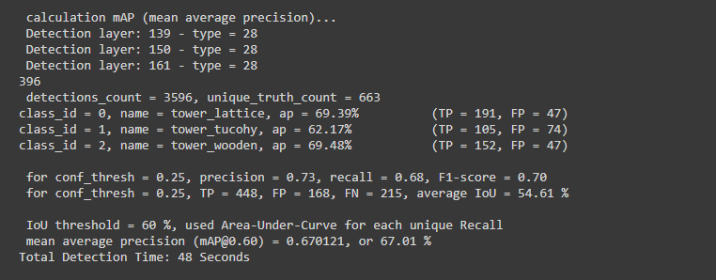
Test ;
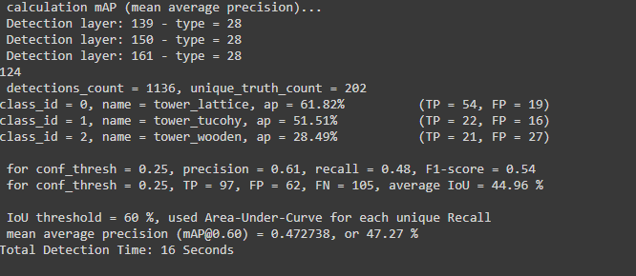
Val:

