Aero2Astro
Panneerselvam N
(11/10/2021)

Today i had trained Yolo v4 model upto 7200 epochs. And also evaluated with both training and test dataset.

Threshold = 0.2
Train :

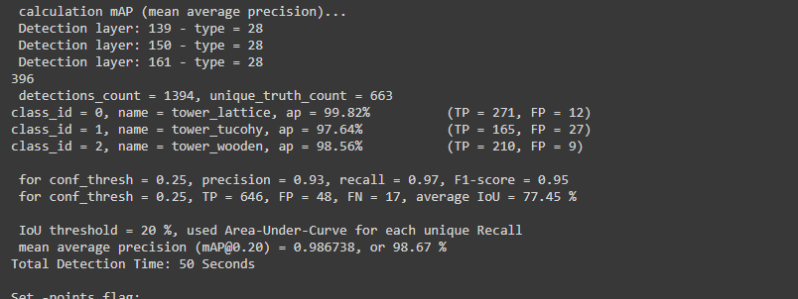

Test:

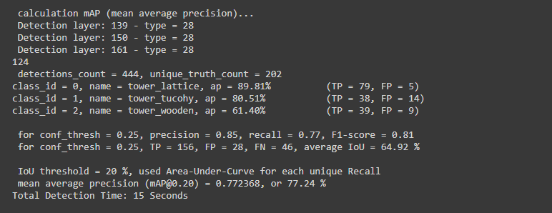

Threshold = 0.6

Train :

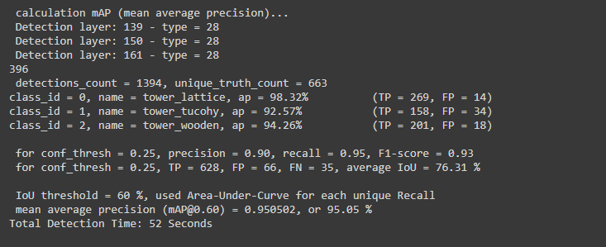

Test :

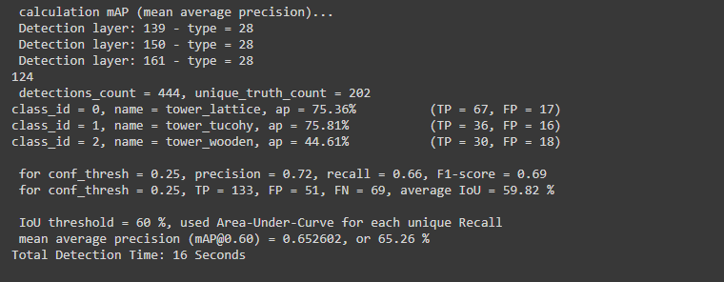

Evaluation result:

Ground_truth:

Lattice – Pink
Tucohy – Yellow
Wodden - Green

https://drive.google.com/drive/folders/1Y6KF3wSg9jABPTOlW0pDW5hcgWaytrm0?usp=sharing

Predicted :
Threshold = 0.2

Lattice – Blue
Tucohy – Green
Wodden – Red

https://drive.google.com/drive/folders/1pOu-viT6r1kFFQb1XdW1G3nNeM7SjTeo?usp=sharing

