Aero2Astro
Panneerselvam N
(12/10/2021)

Today i had trained Yolo v4 model upto 8000 epochs. And also evaluated with both training and test dataset.

Threshold_IOU = 0.2
Train :

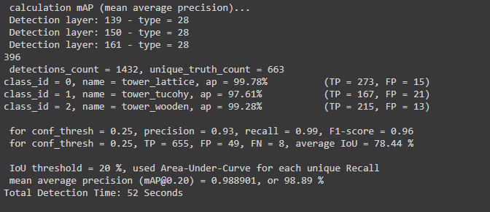

Test:

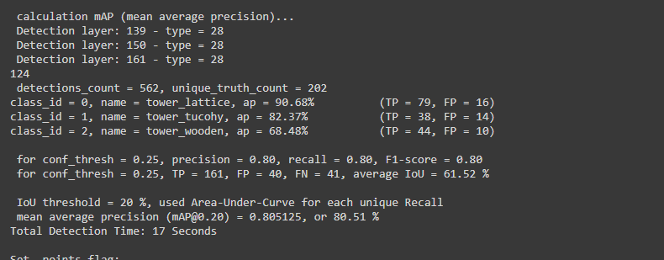

Threshold_IOU = 0.6

Train :

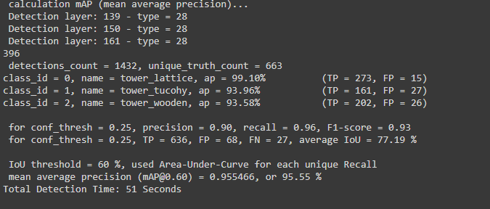

Test :

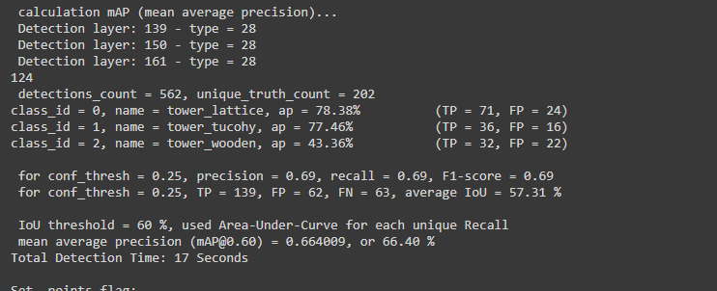

Evaluation result:
Confidence : 0.2
Image : 08_1725.jpg

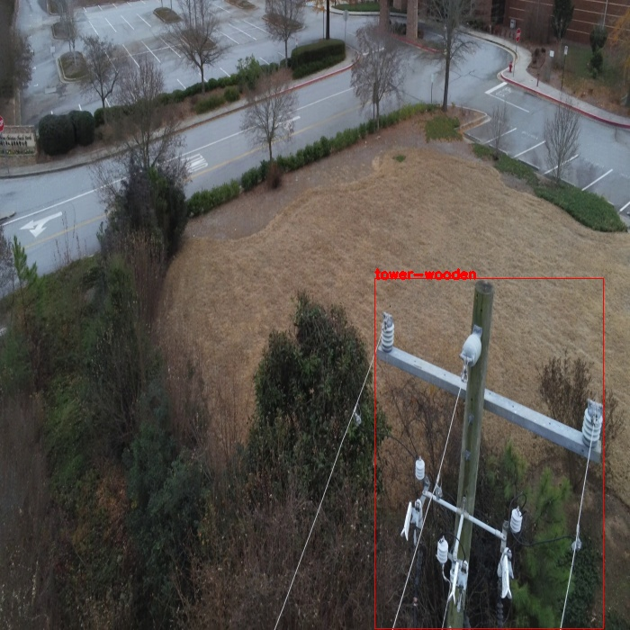
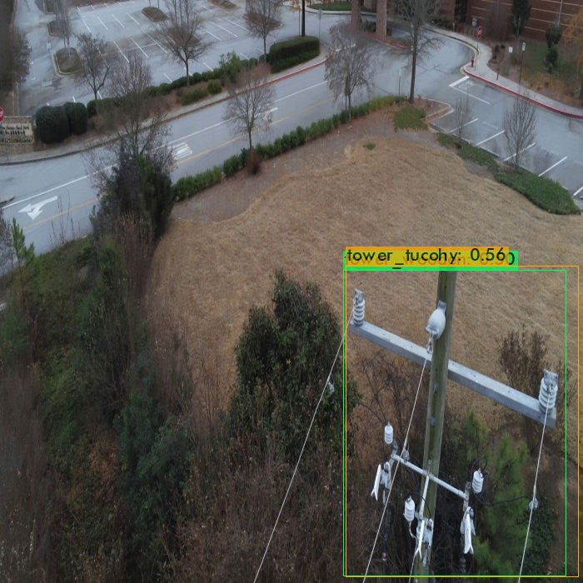
Inference : In Predicted image , wooden tower is classified as both tucohy and wooden.

Image : 14_00051.jpg

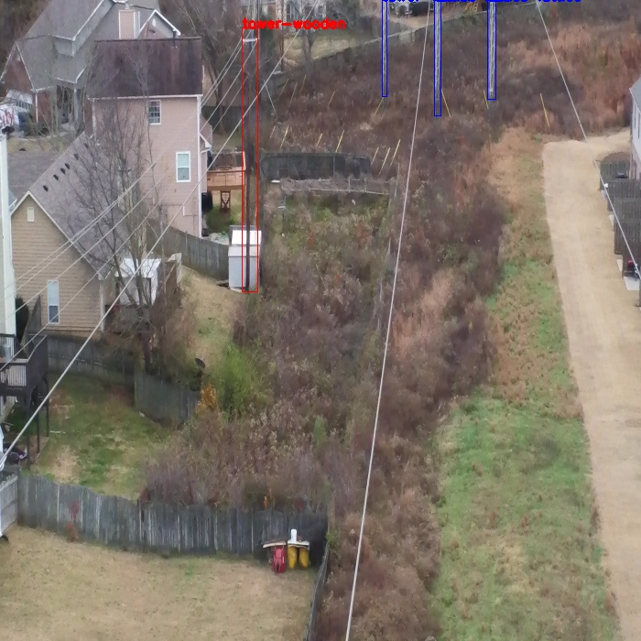
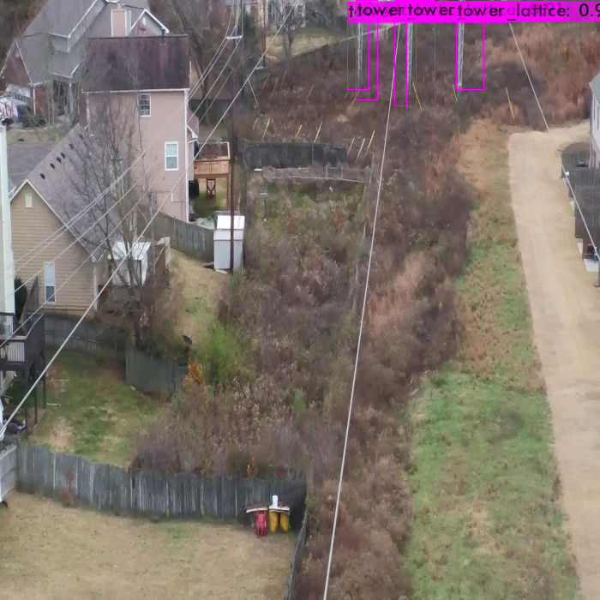
Inference : In predicted image, Wooden tower is not detected.

Image : 14_02226.jpg

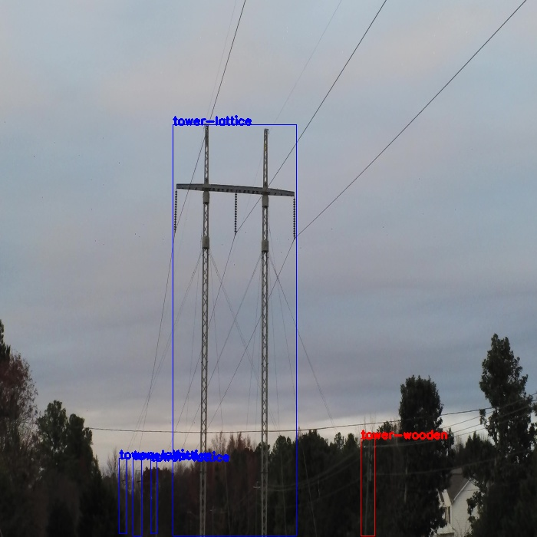
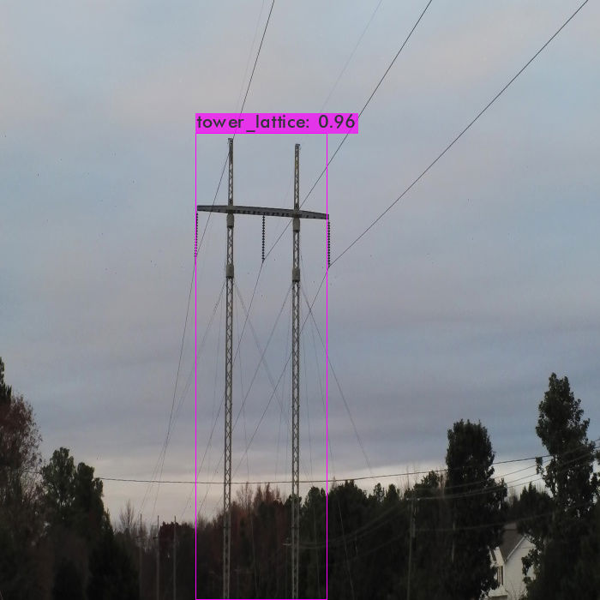
Inference : Wooden tower is not detected.

Image : 22_00331.jpg

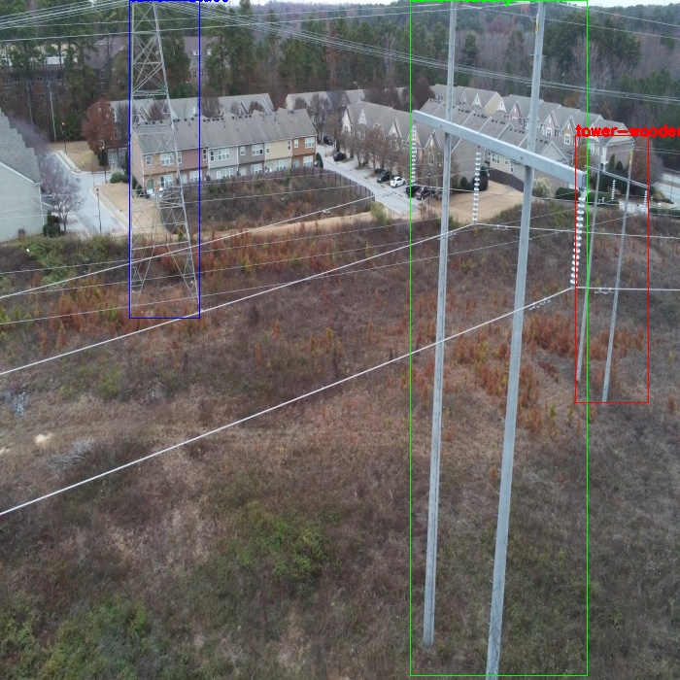
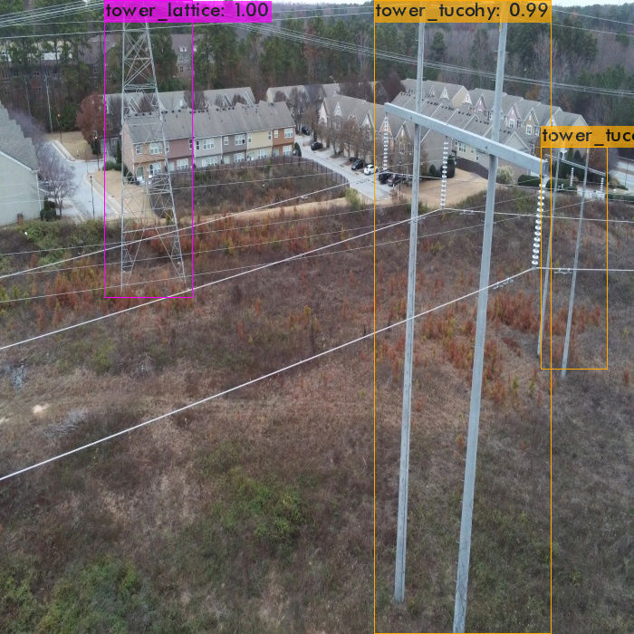
Inference : Wooden tower is mis-classified as tucohy tower.

Image : 22_01901.jpg

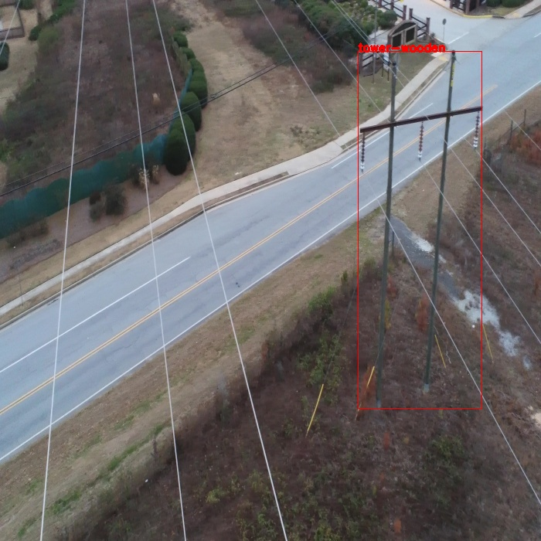
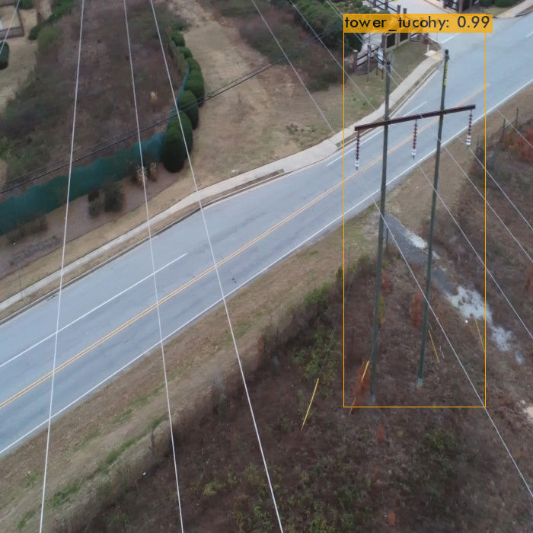
Inference: Wooden tower is mis-classified as tucohy tower.

Image : 32_6285.jpg
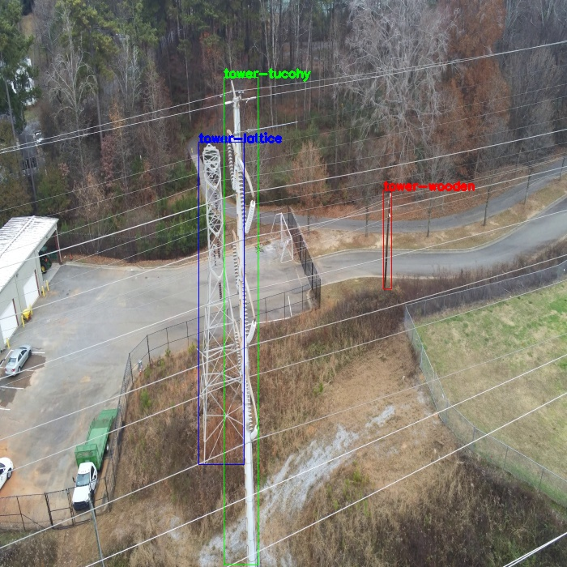

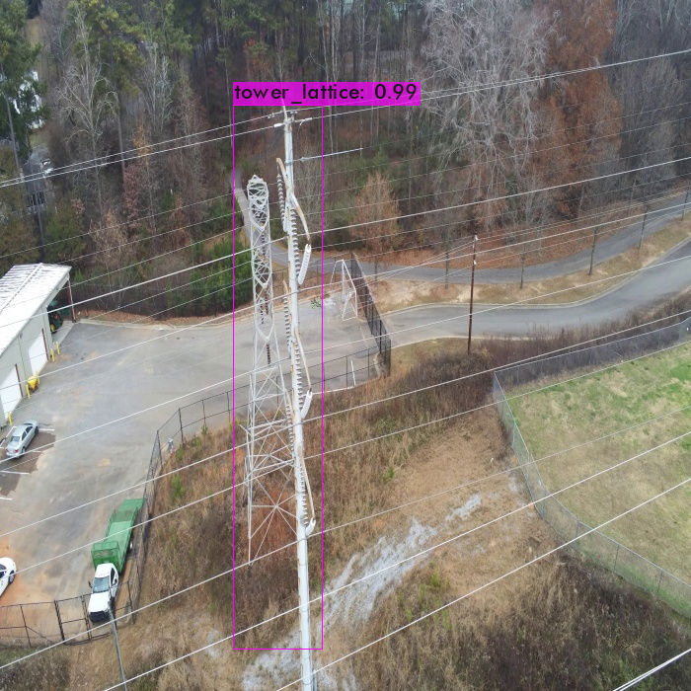
Inference: Wooden and tocohy tower is not detected.

Image : 36_825.jpg

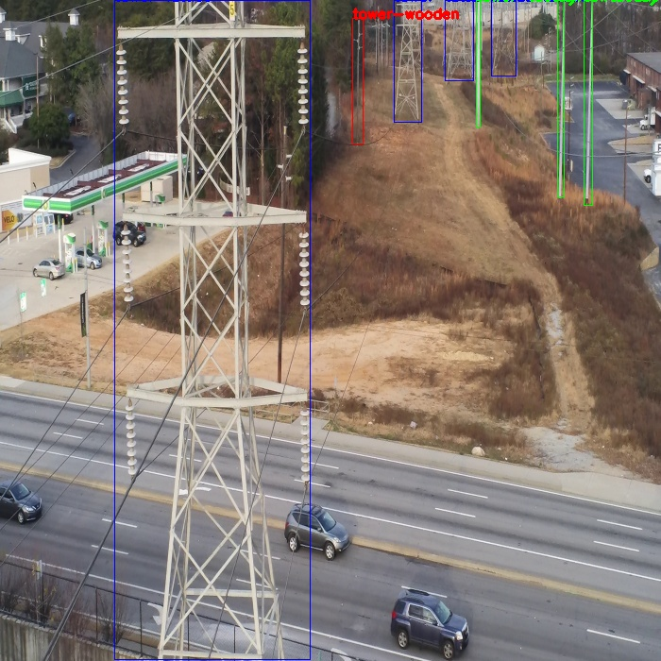
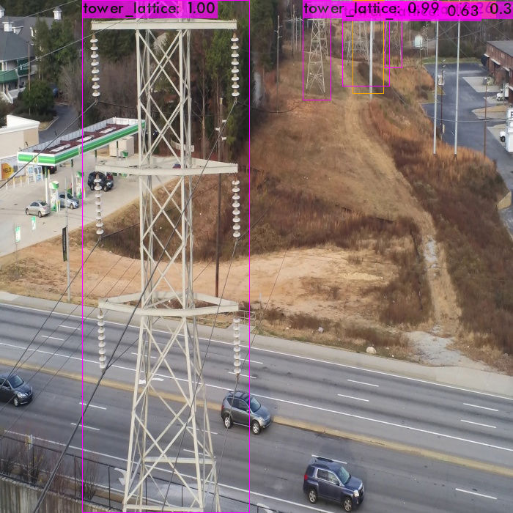
Inference: Wooden and tocohy tower is not detected.

Image : 63_00891.jpg

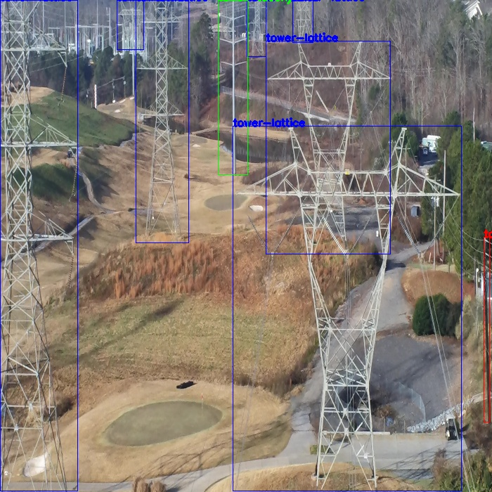
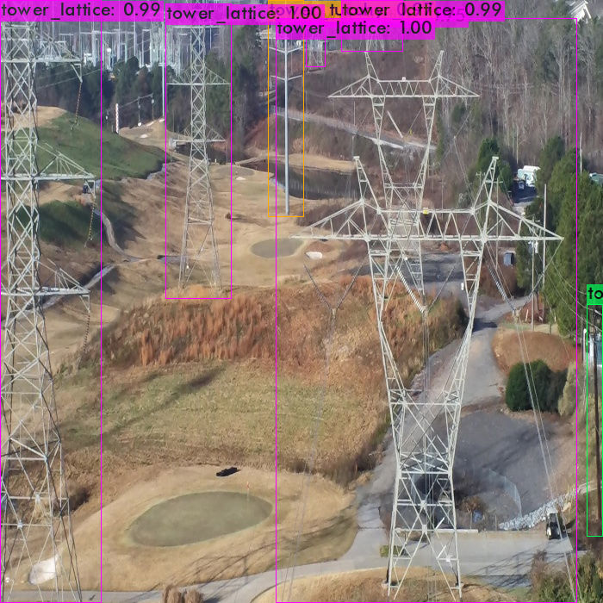
Inference : All are correct prediction.

Image : 70_01114.jpg

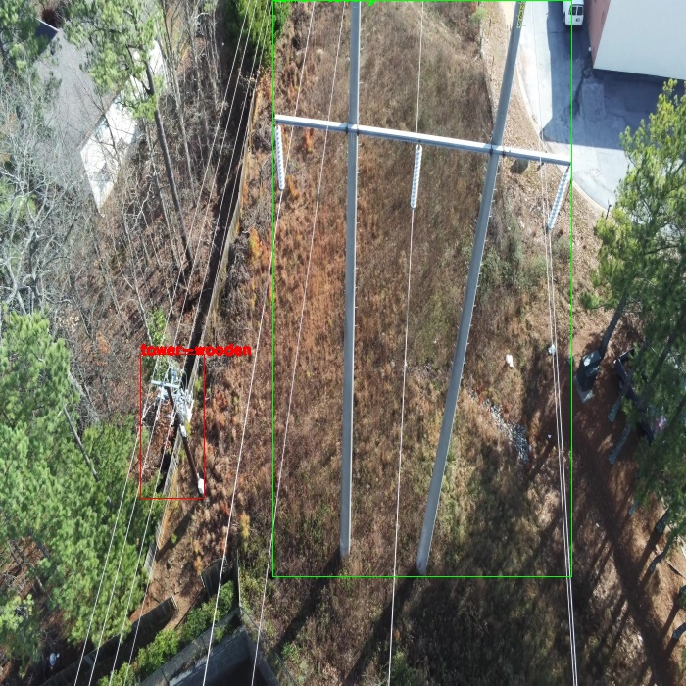
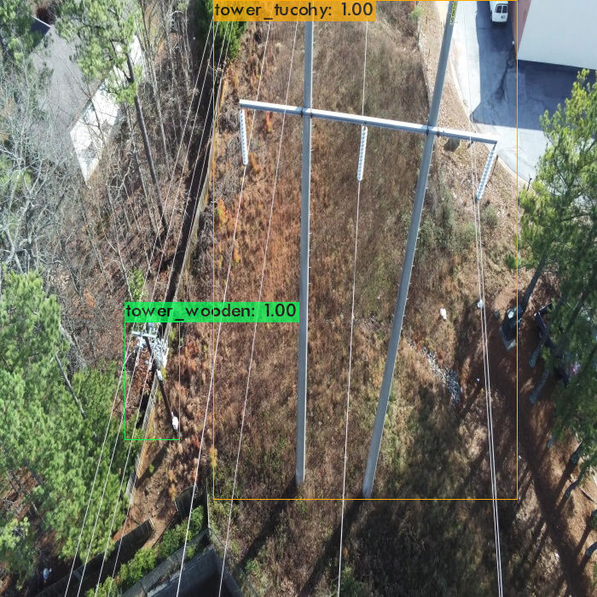
Inference : All are correct prediction.

Image : 91_15.jpg

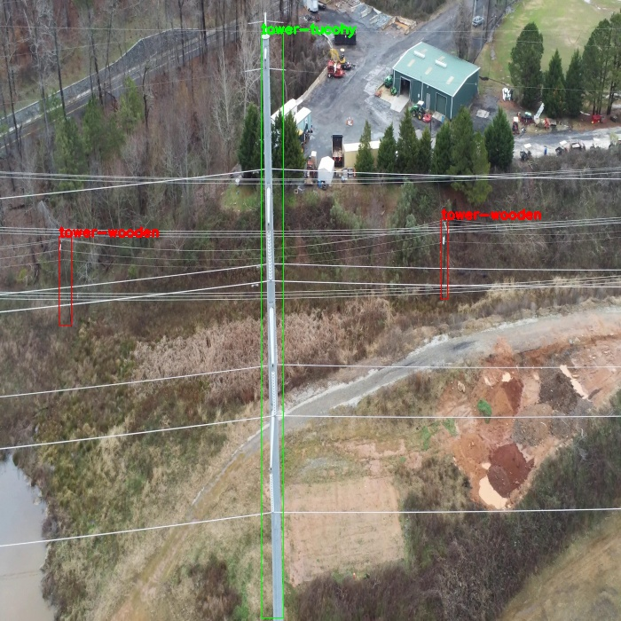
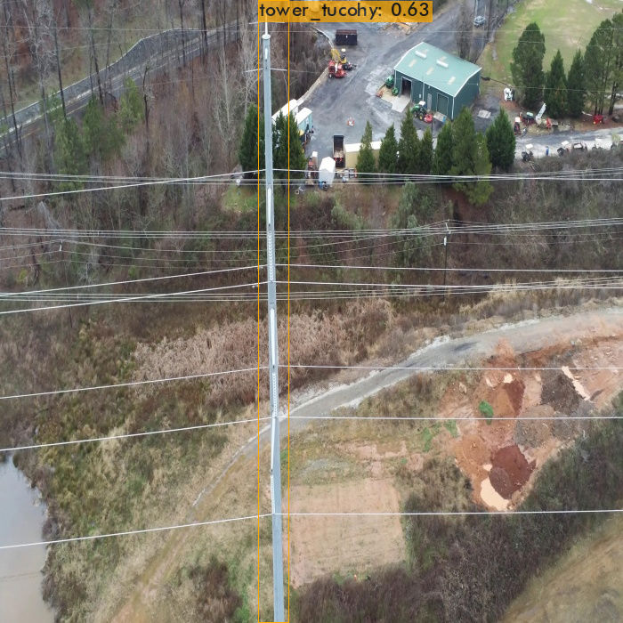
Inference: Wooden tower is not detected.

