Aero2Astro
Panneerselvam N
(13/10/2021)

Today i had trained Yolo v4 model upto 8600 epochs with jitter = 0.45. And also evaluated with both training and test dataset.

Threshold_IOU = 0.2
Train :

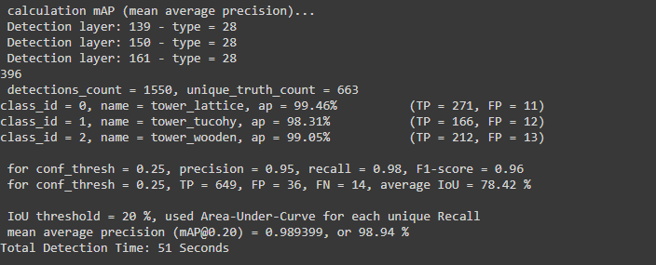

Test:

