Aero2Astro
Panneerselvam N
(14/10/2021)

Today i had trained Yolo v4 model upto 9000 epochs with jitter = 0.45. And also evaluated with both training and test dataset.

Threshold_IOU = 0.2
Train :

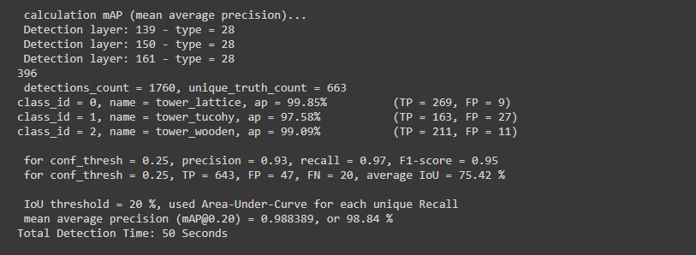

Test:

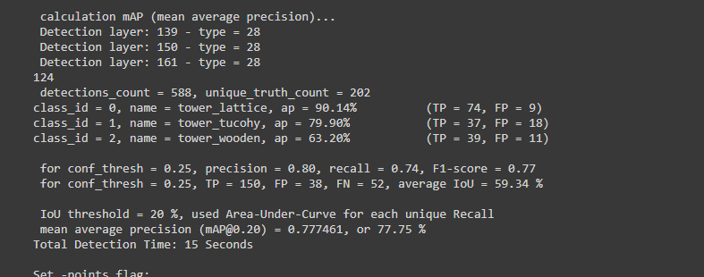

Threshold_IOU = 0.6

Train :

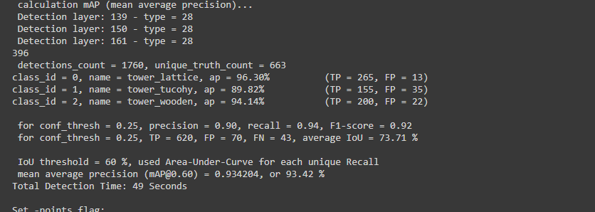

Train :

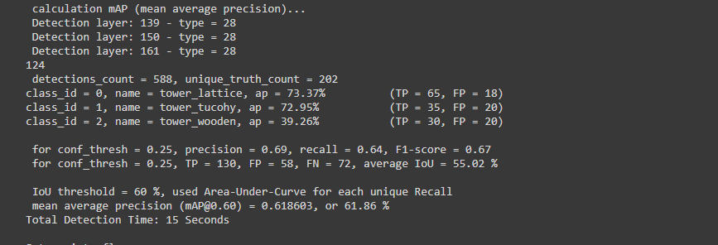

Detected Results : At 9000 epochs

Image : 08_1725.jpg
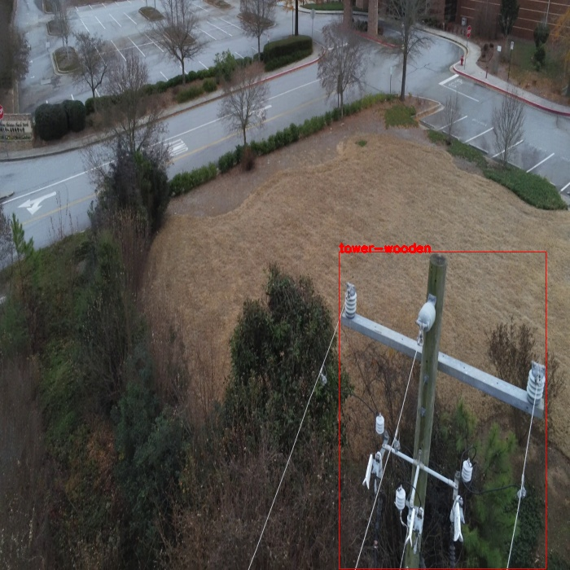
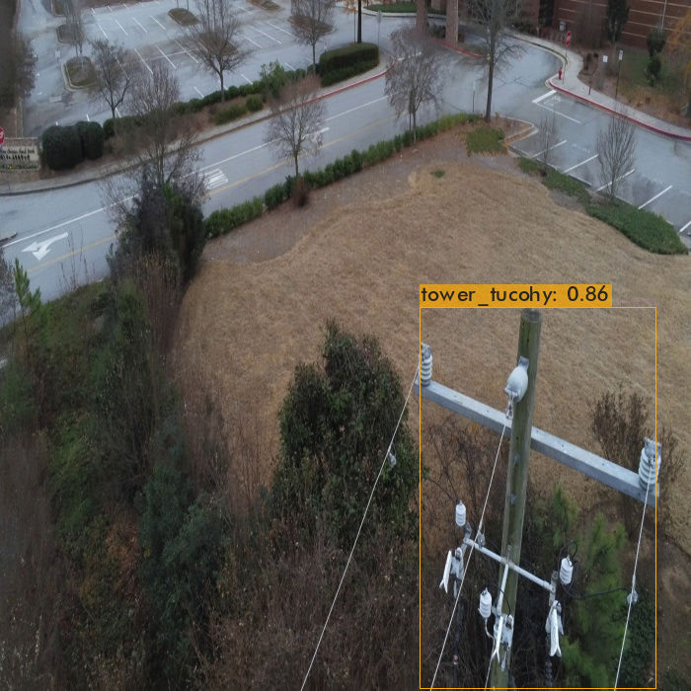
Wooden tower is mis-classified as Tucohy tower.

Image : 14_00051.jpg
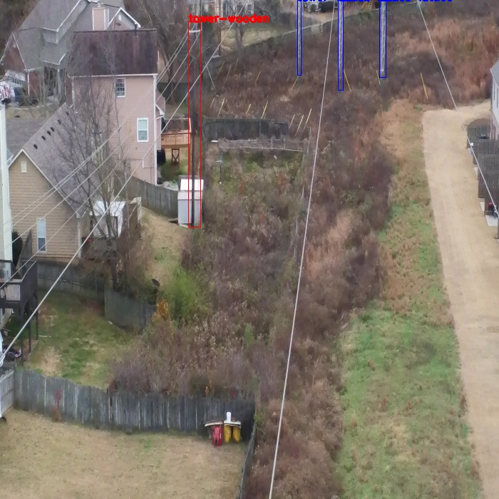
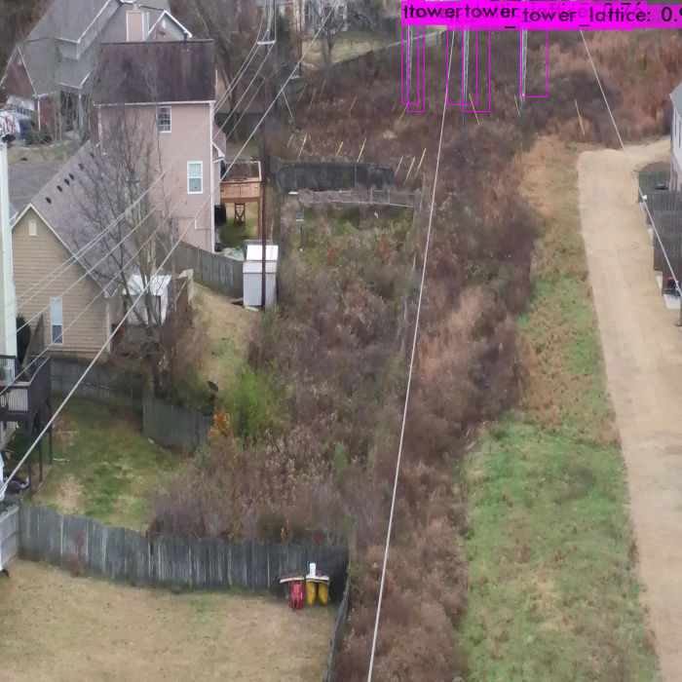
Tower wooden not detected. And multiple detections for lattice tower (due to less treshold).

Image : 14_02226.jpg

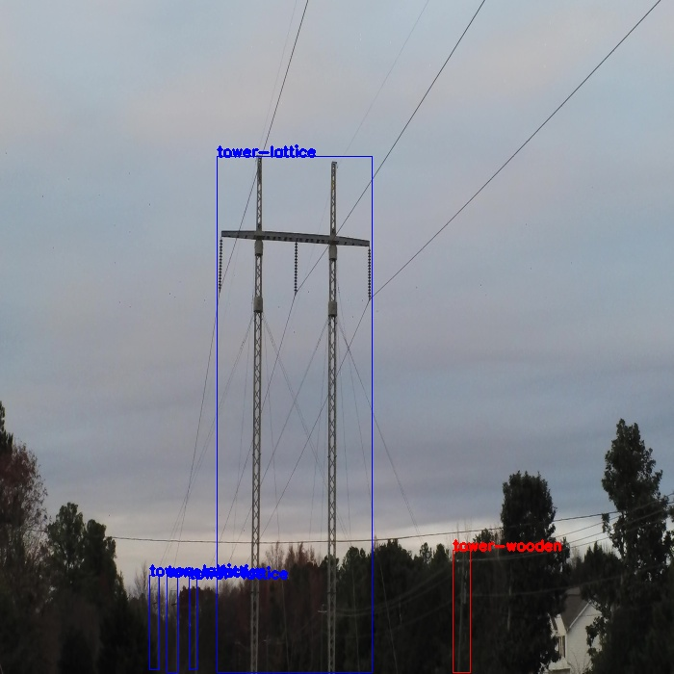
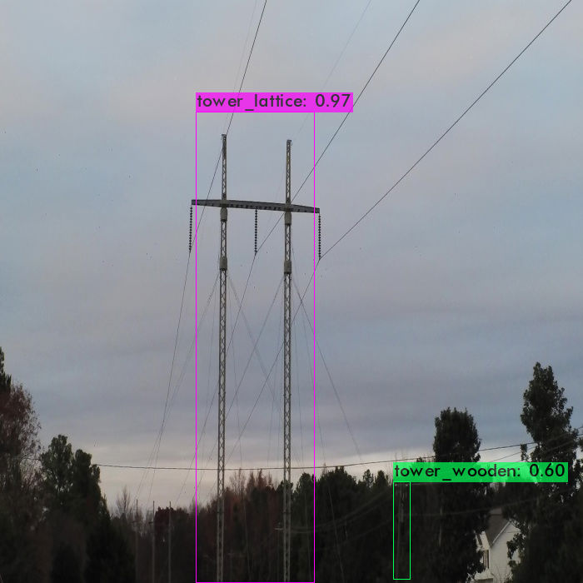
Some lattice towers not detected.

Image : 22_00331.jpg
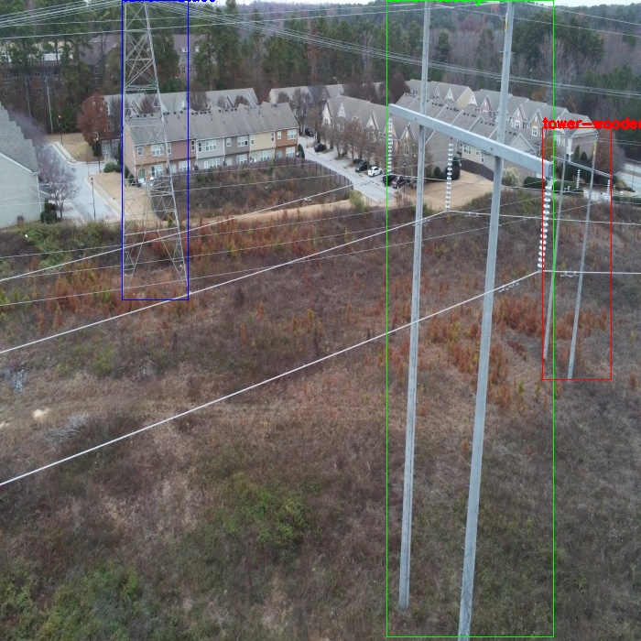

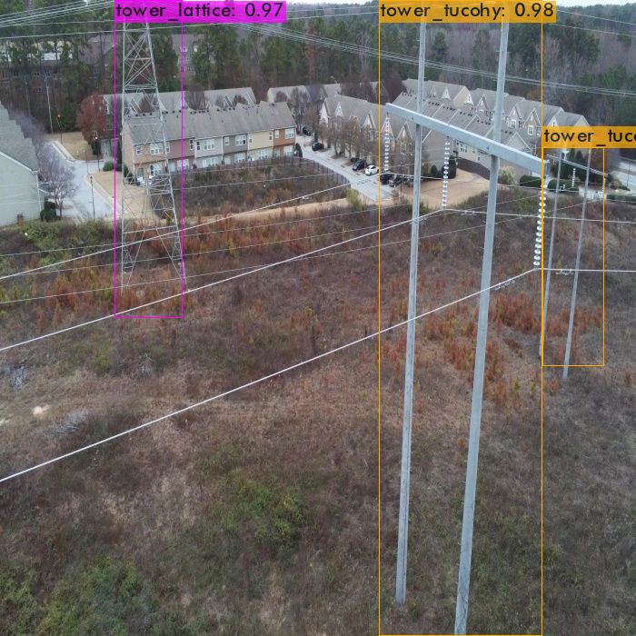

Wooden tower is mis-classified as Tucohy tower.

Image : 22_01901.jpg

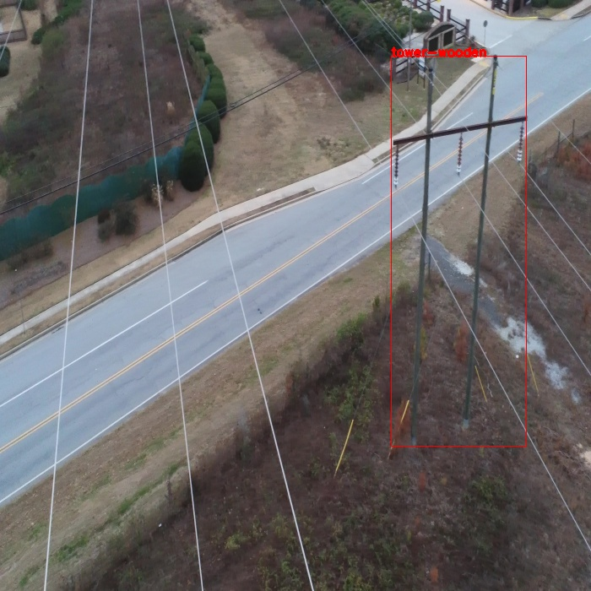
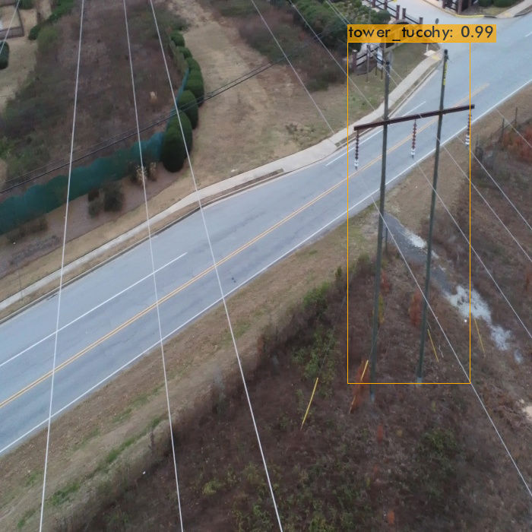
Tower wooden is mis-classified as Tucohy tower.

Image : 26_1050.jpg

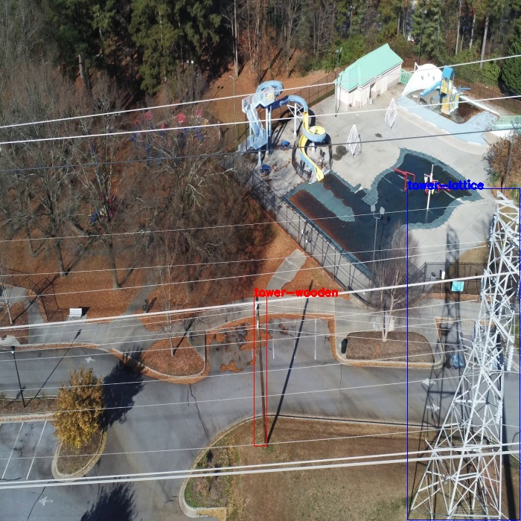
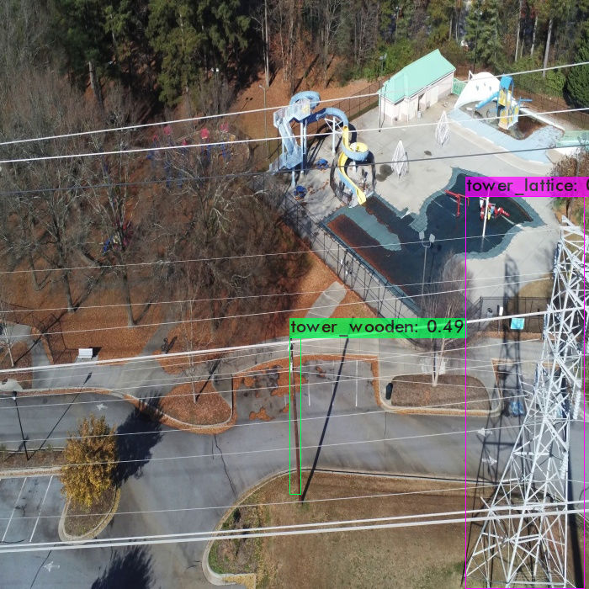
Wooden Tower has less confidence.

Image : 32_6285.jpg

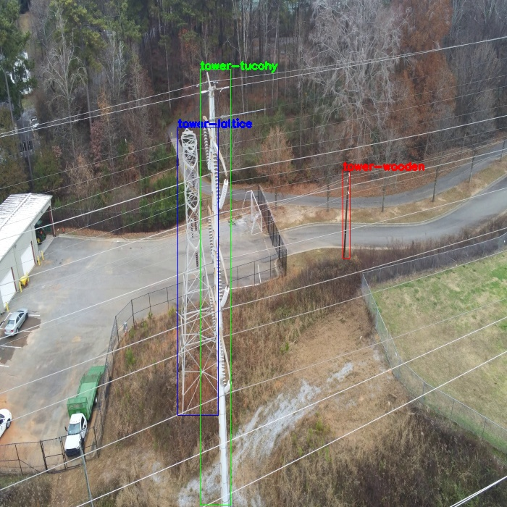
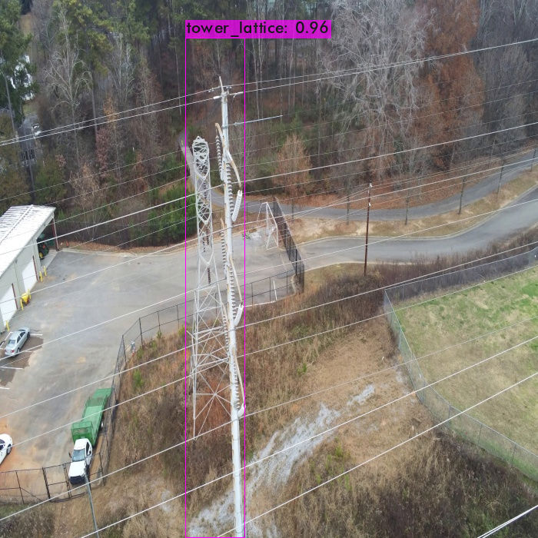
Wooden and Tucohy towers are not detected.

Image : 36_825.jpg

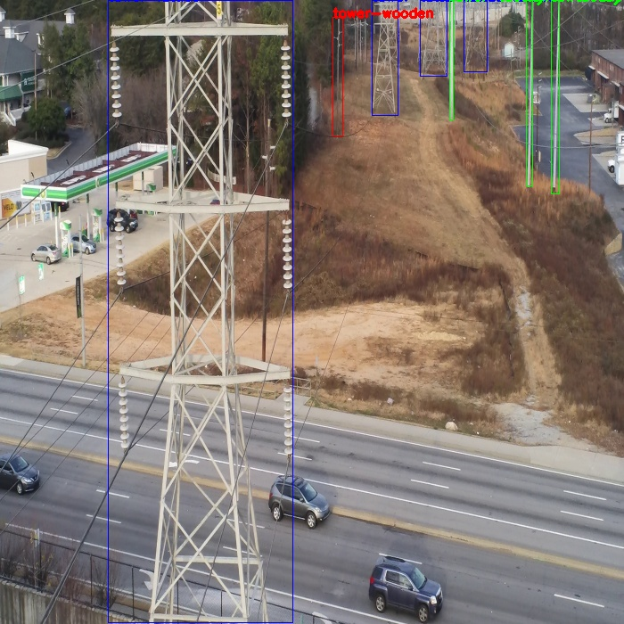

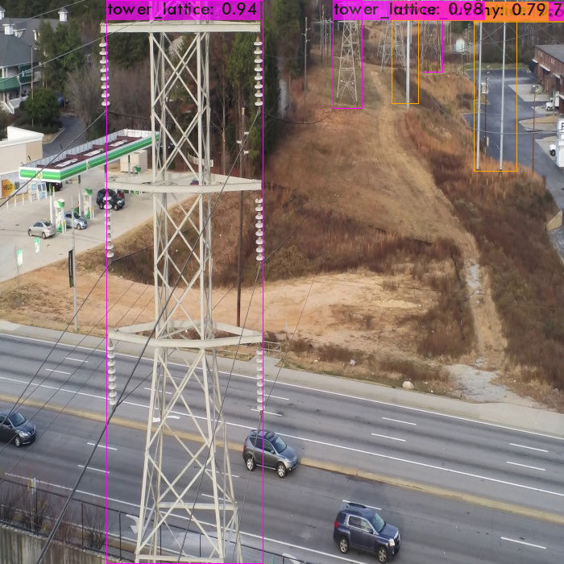
Wooden tower is not detected and Tucohy tower is detected as single detection instead of separate detection.
Image : 63_00891.jpg

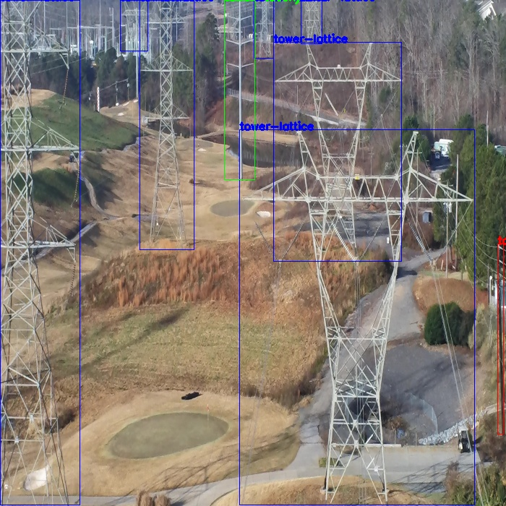
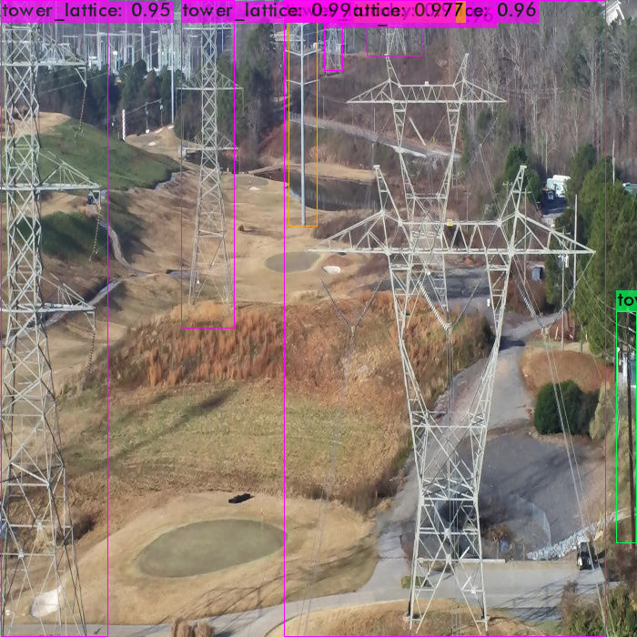
All are correct detections.

Image : 70_01114.jpg

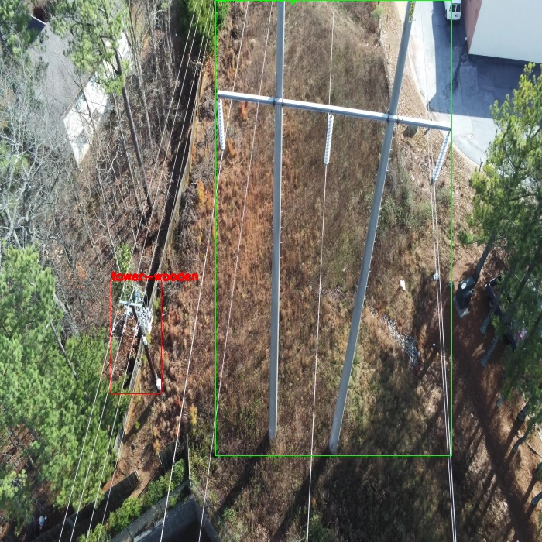
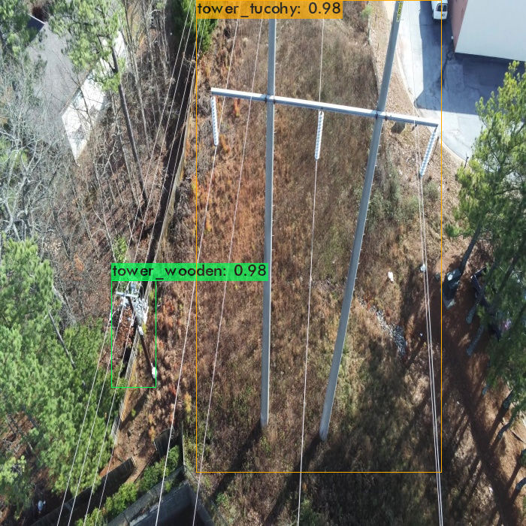
All are correct detections.

Image : 91_15.jpg

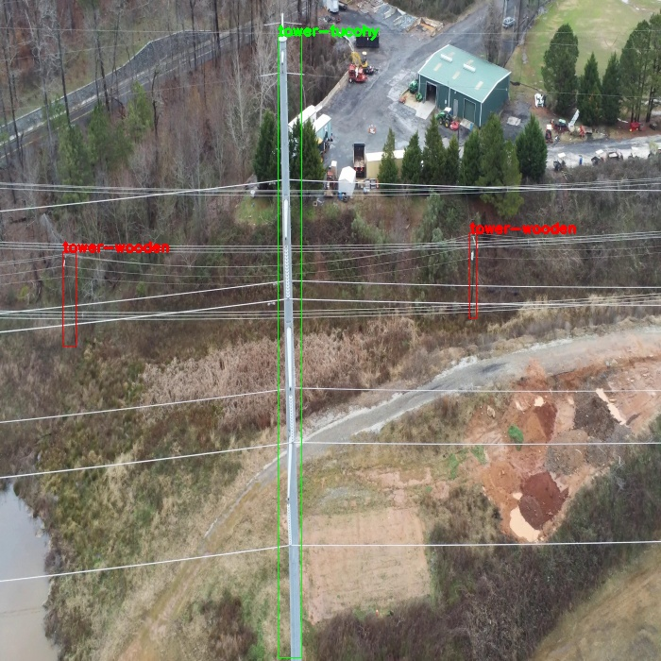
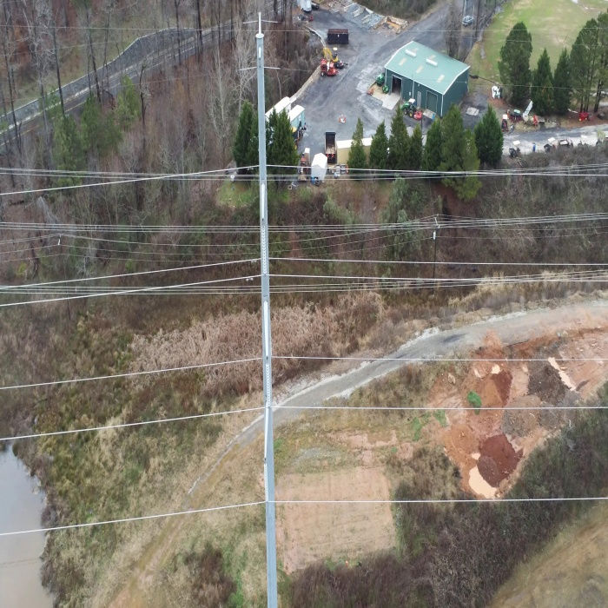
Wooden and Tucohy towers are not detected.

