Aero2Astro
Panneerselvam N
(18/10/2021)

Today i had trained Yolo v4 model upto 10000 epochs with jitter = 0.45. And also evaluated with both training and test dataset.

Threshold_IOU = 0.2
Train :

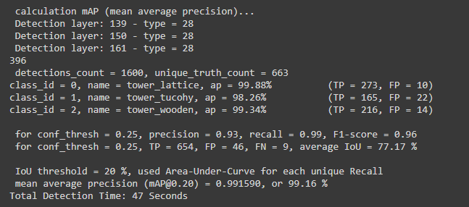

Test:

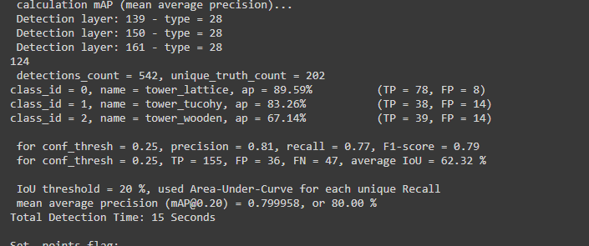

Threshold_IOU = 0.6

Train :

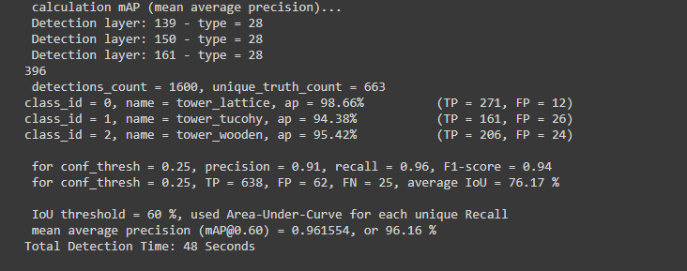
Test :

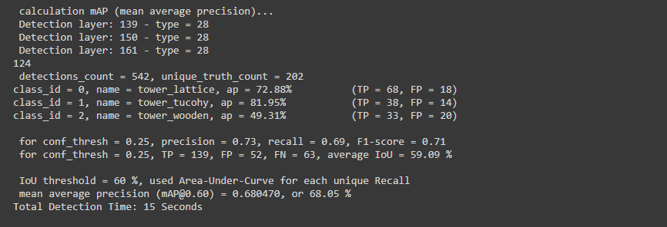
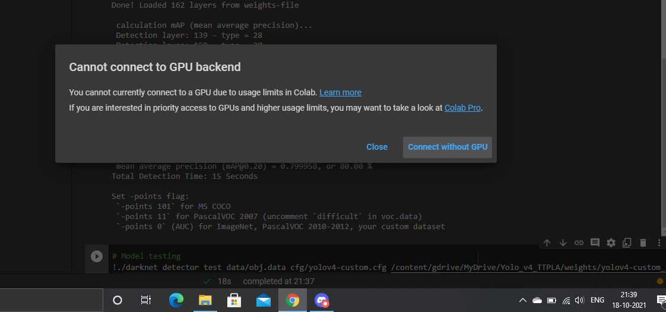
Due to kernel disconnect , not able to perform False positives and False Negatives. Tomorrow i will perform detection.

