Aero2Astro
Panneerselvam N
(19/10/2021)

Today i had trained Yolo v4 model upto 10600 epochs. And also evaluated with both train and test dataset.

Train :
Threshold_IOU = 0.2

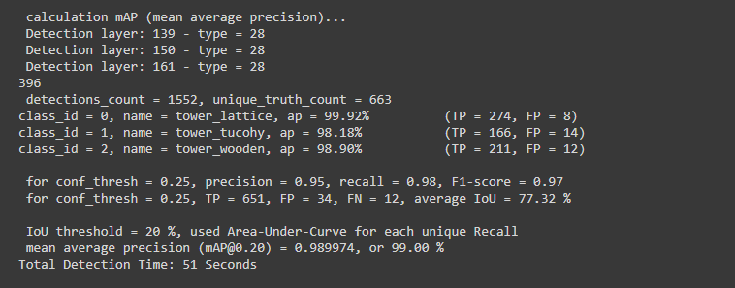
Test :

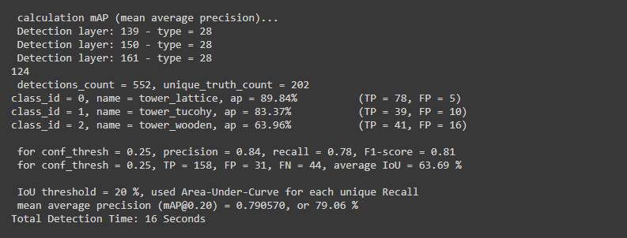

Threshold _IOU = 0.6

Train :

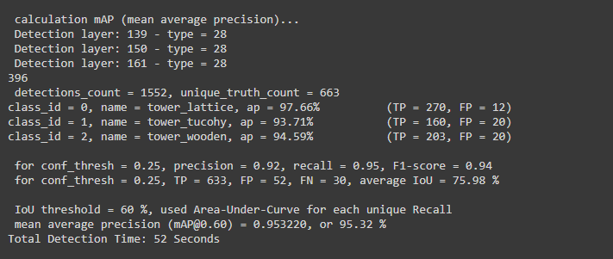
Test :

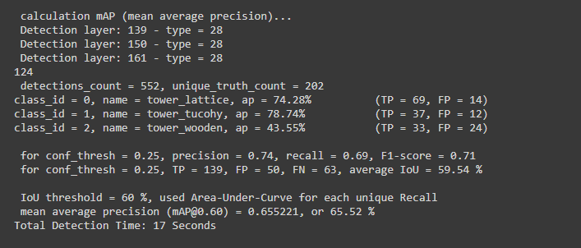

Detection Result : At 10600 epochs.
Threshold_detection = 0.2
Image : 08_1725.jpg

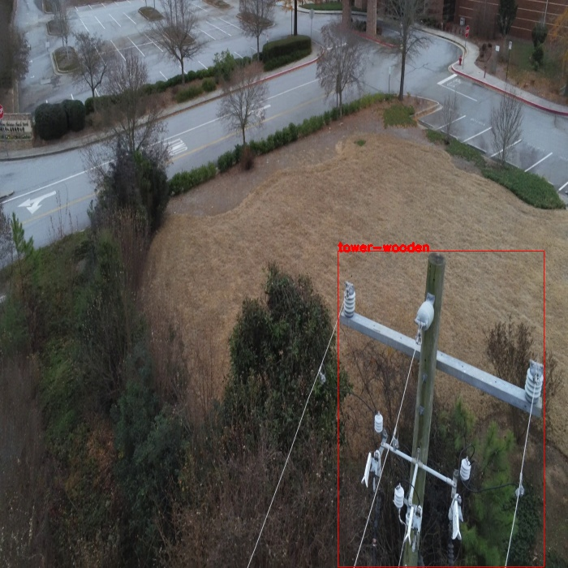
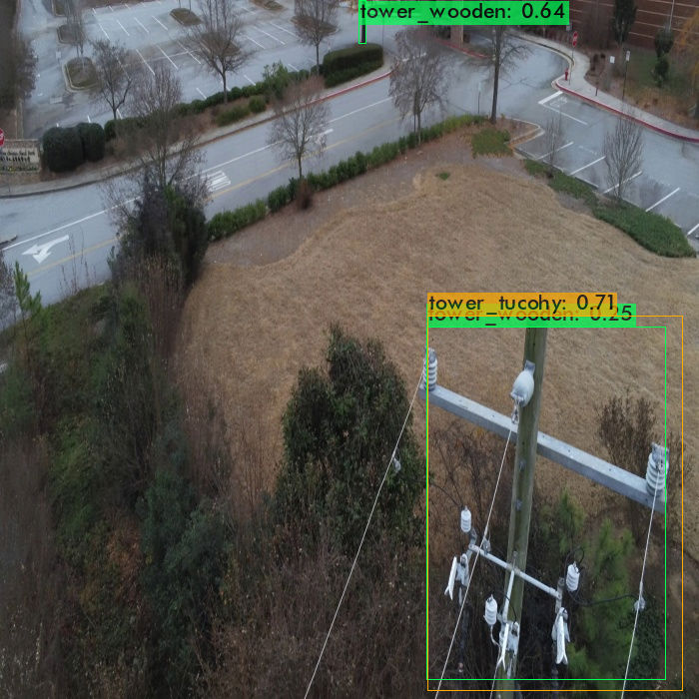
Tower wooden is mis-classified as tower_tucohy with high confidence. Tree is classified as wooden tower.
Image : 14_00051.jpg

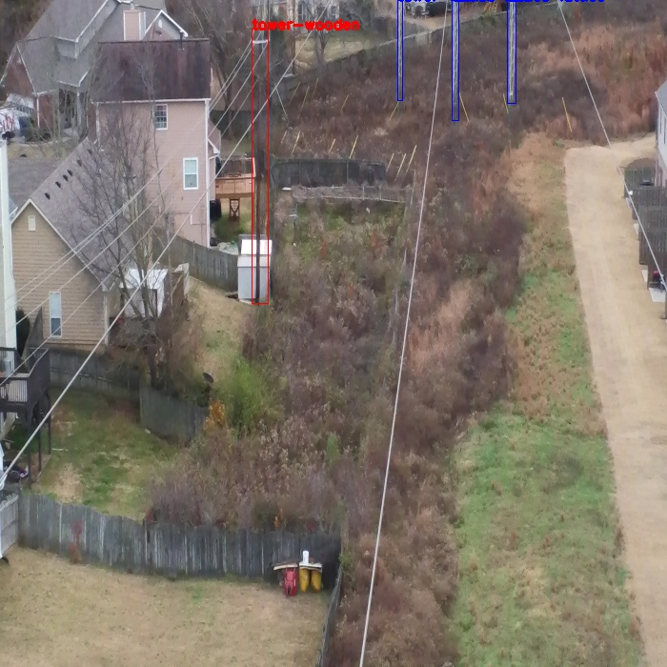
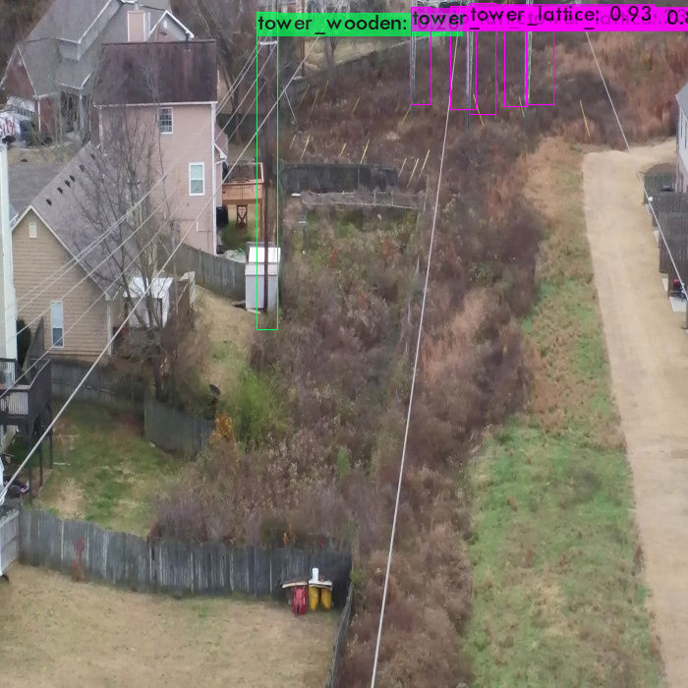
Tower lattice has multiple detection due to less threshold.

Image : 14_02226.jpg

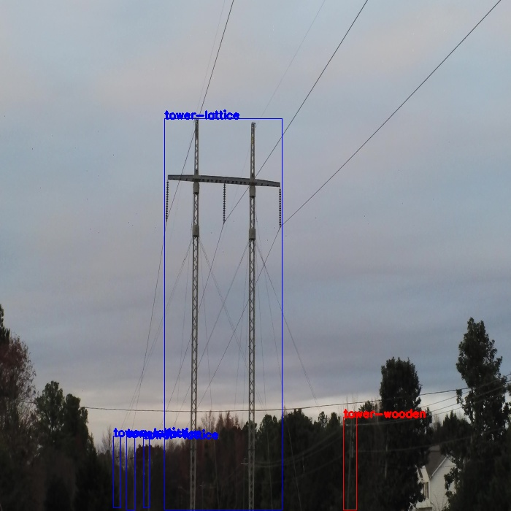
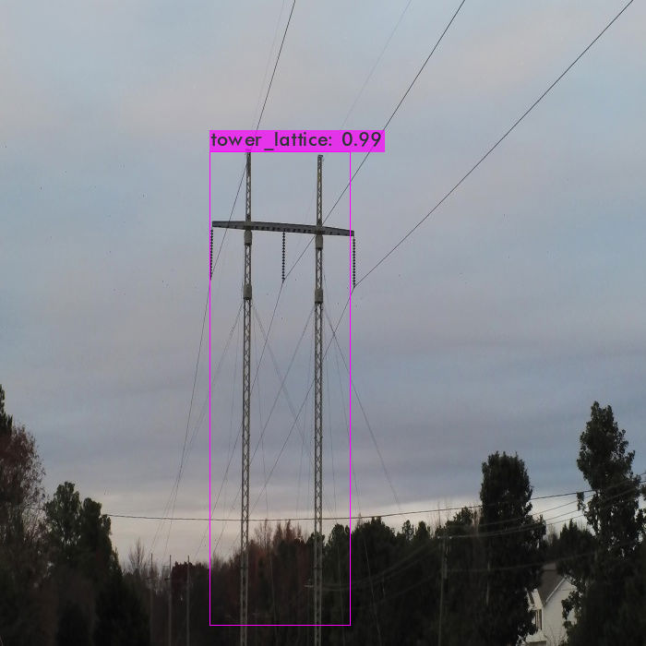
Wooden tower and other some lattice towers are not detected.

Image : 22_00331.jpg

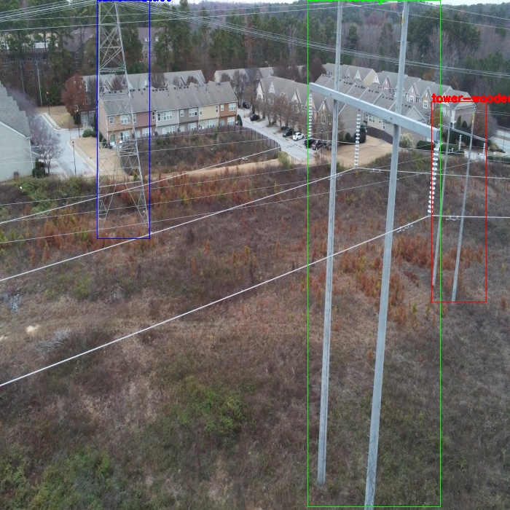
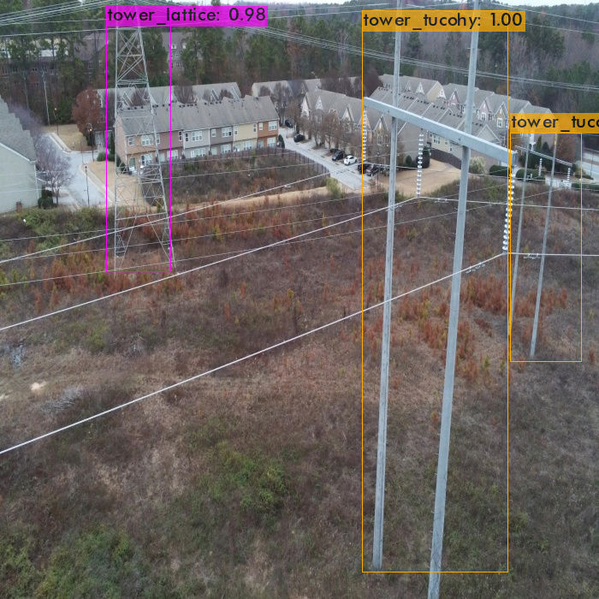
Wooden tower is mis-classified as tower tucohy.

Image : 22_01901.jpg

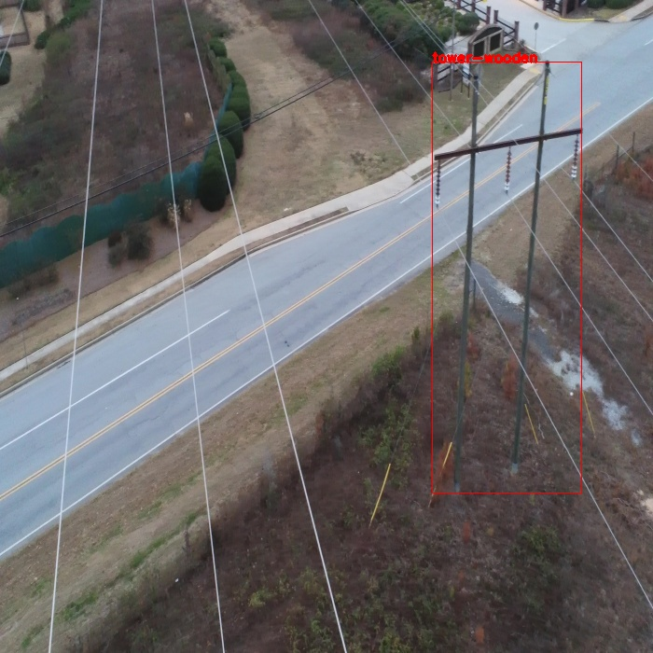
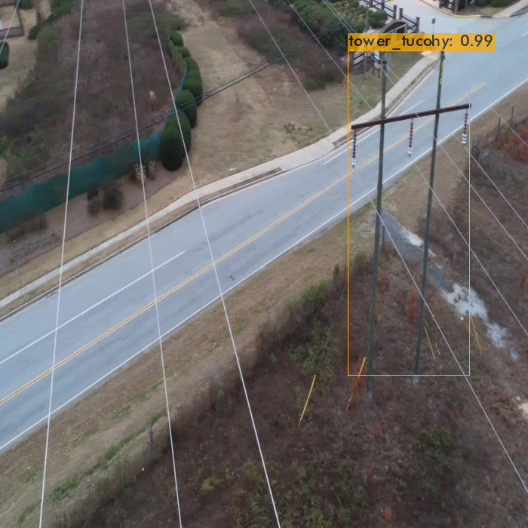
Wooden tower is mis-classified as Tucohy tower.

Image : 26_1050.jpg

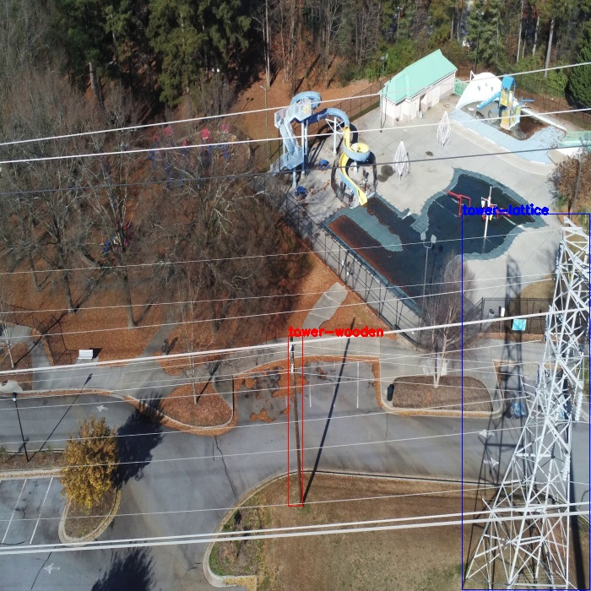
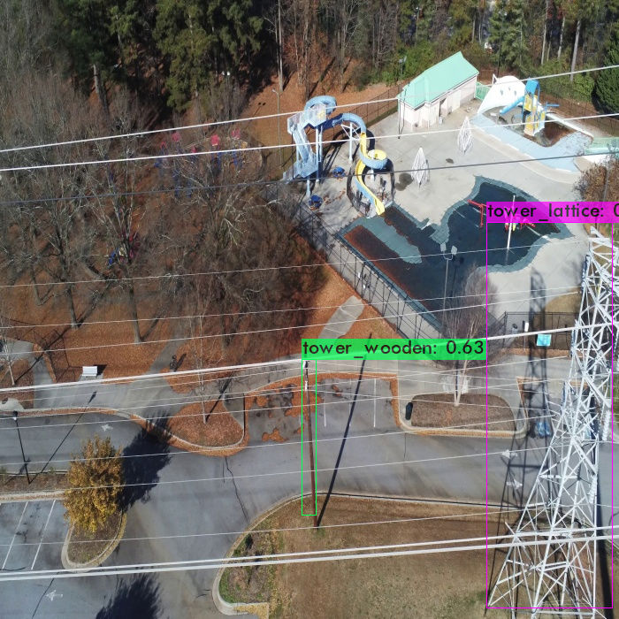
All detections are correct.

Image : 32_6285.jpg

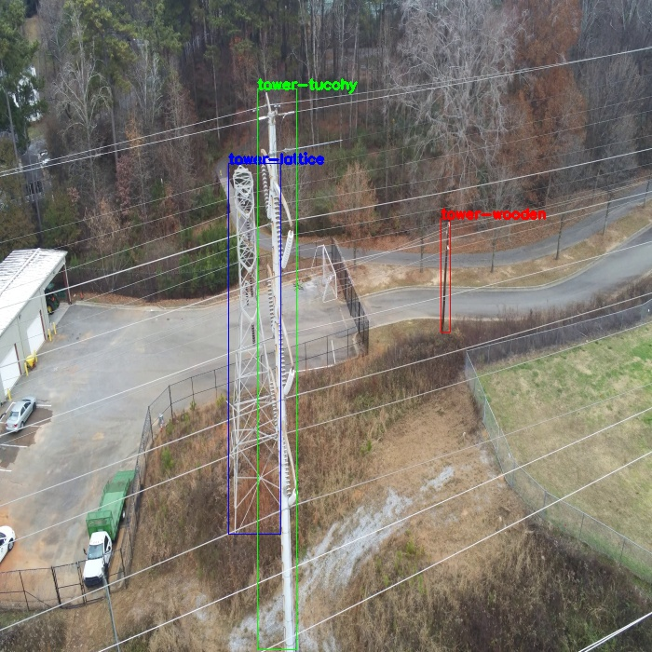
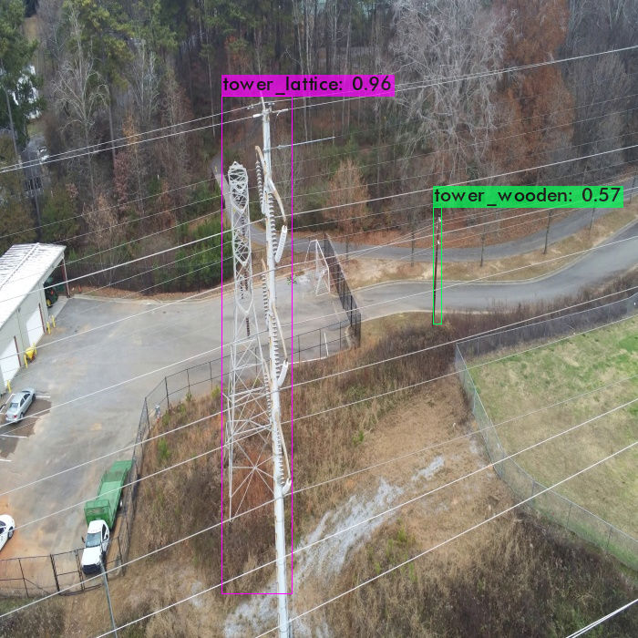
Tower Tucohy is not detected.

Image : 36_825.jpg

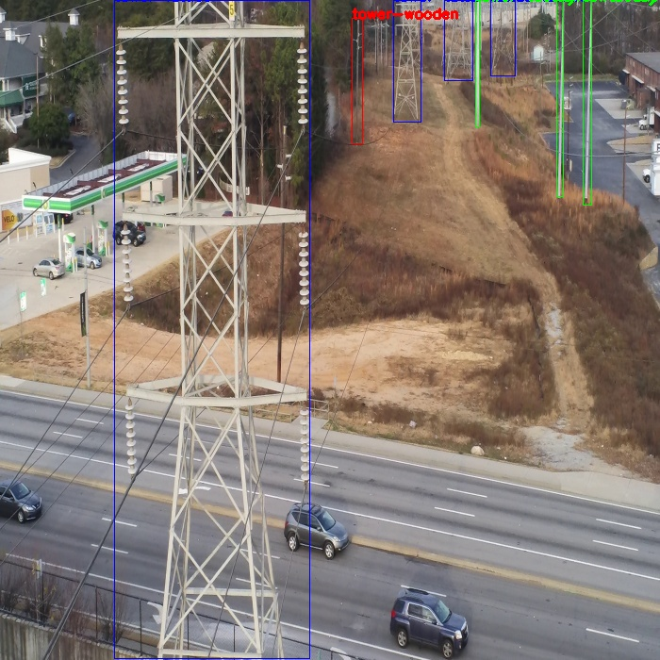
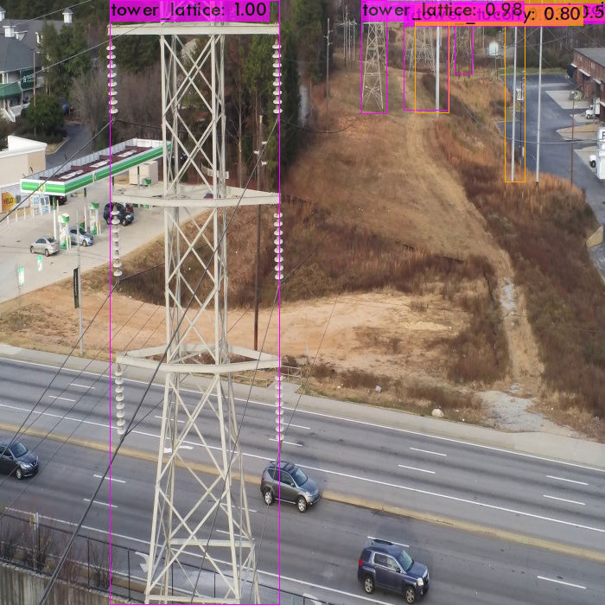
Wooden tower and one tucohy tower is not detected.

Image : 63_00891.jpg

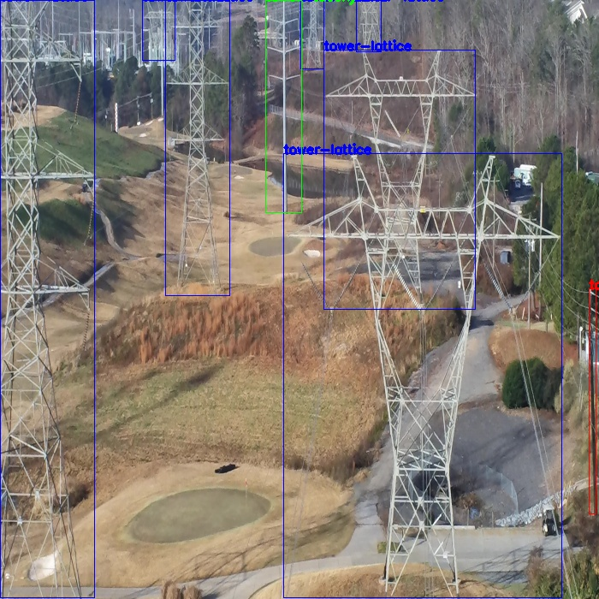
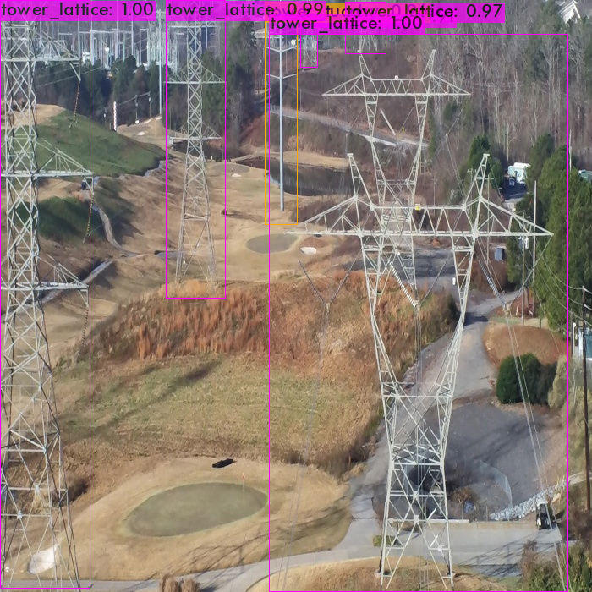
One lattice tower is not detected in right side of image. And also wooden tower is not detected.

Image ; 70_01114.jpg

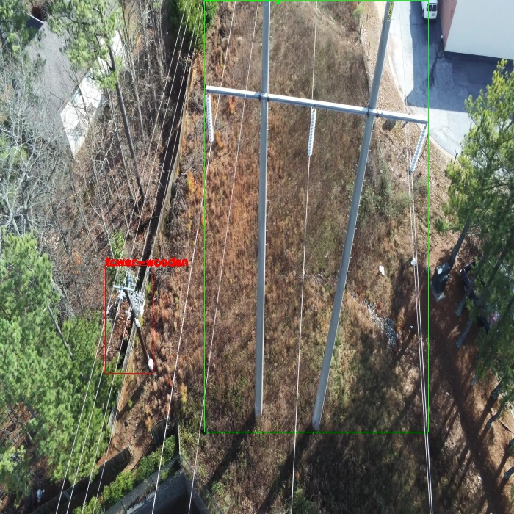
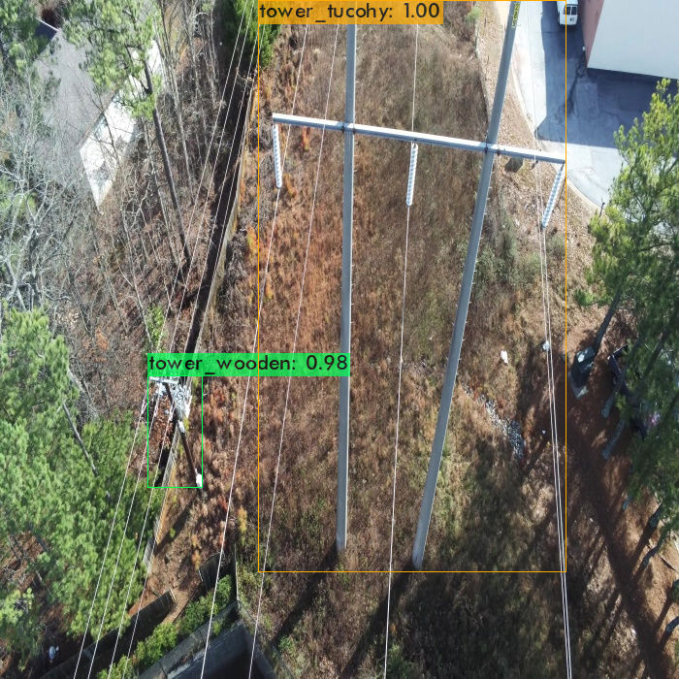
All detections are correct.

Image : 91_15.jpg

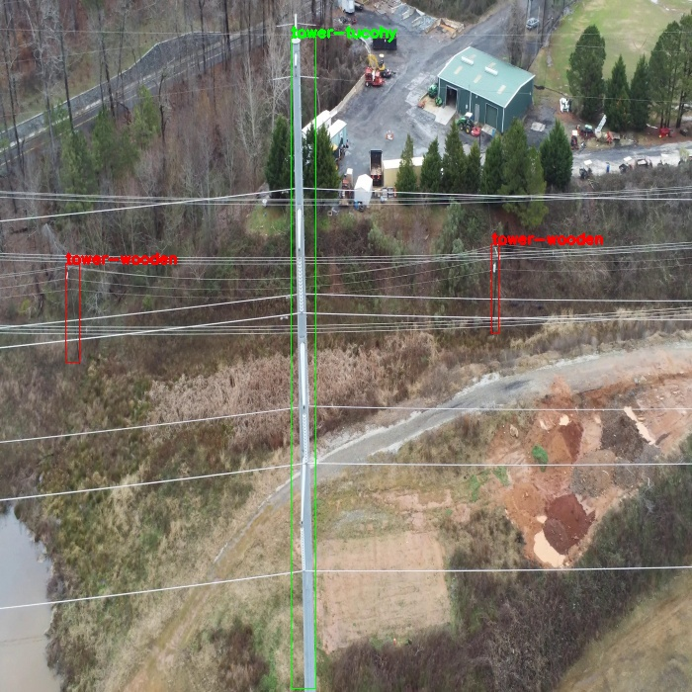
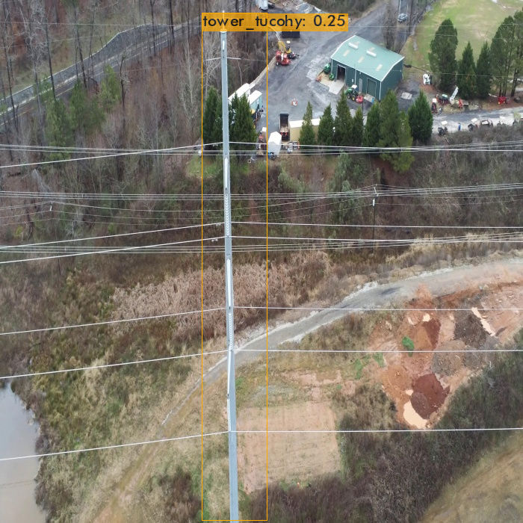
Wooden towers are not detected.

