Aero2Astro
Panneerselvam N
(22/10/2021)

Today i had trained Yolo v4 model upto 14700 epochs with jitter = 0.45. And also evaluated with both training ,val and test dataset.

Threshold_IOU = 0.2
Train :

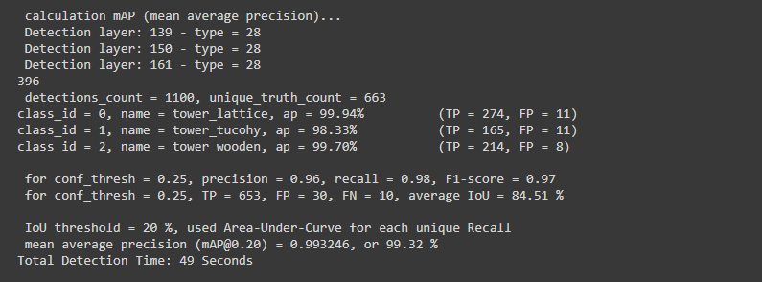
Test:

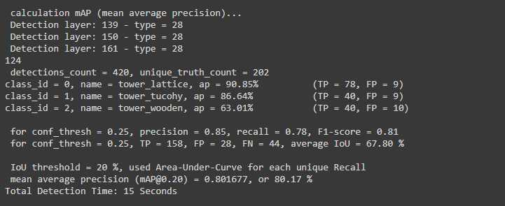

Val :

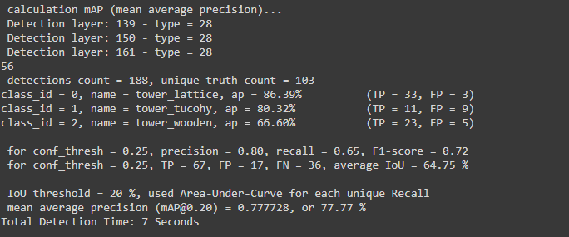

Threshold_IOU = 0.6

Train :

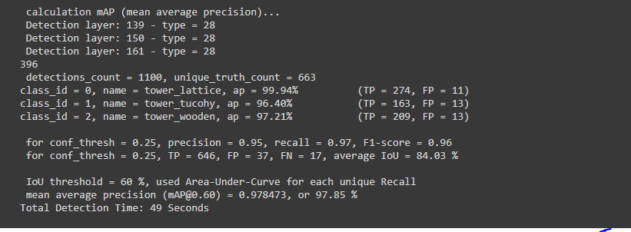

Test:

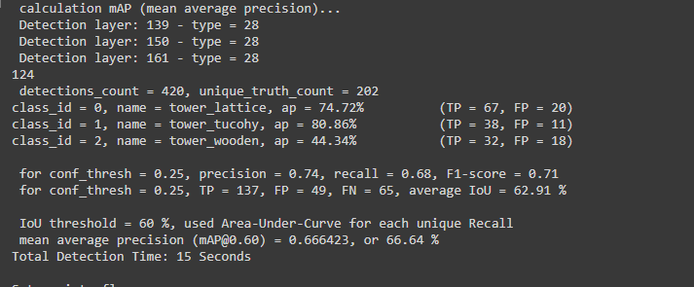
Val :

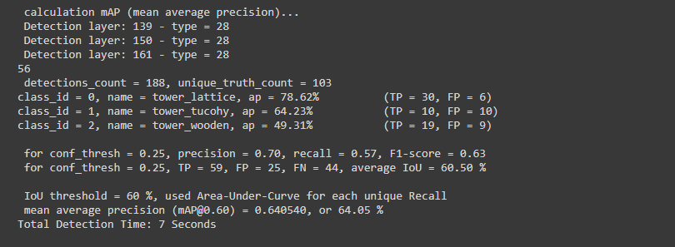

Now i am trying to find False Positive and False Negative in val dataset.(Comparing with Ground truth and Predicted txt file). After this evaluation , i will plot and submit another report.

