Aero2Astro
Panneerselvam N
(23/10/2021)

Today i had trained Yolo v4 model upto 15500 epochs with jitter = 0.45. And also evaluated with both training ,val and test dataset.
Threshold_IOU = 0.6
Train :
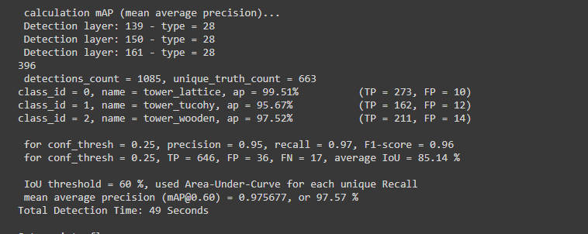
Test:
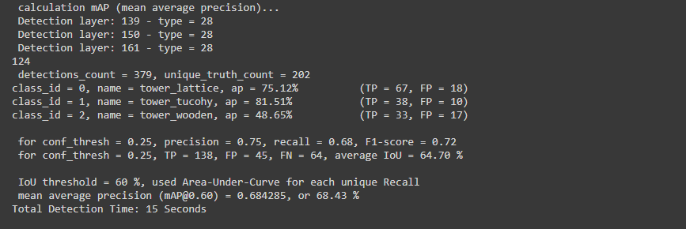
Val :
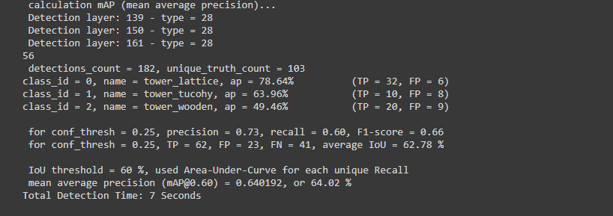
Epochs : 14700
Threshold_Conf = 0.2
Image : 08_1830.jpg

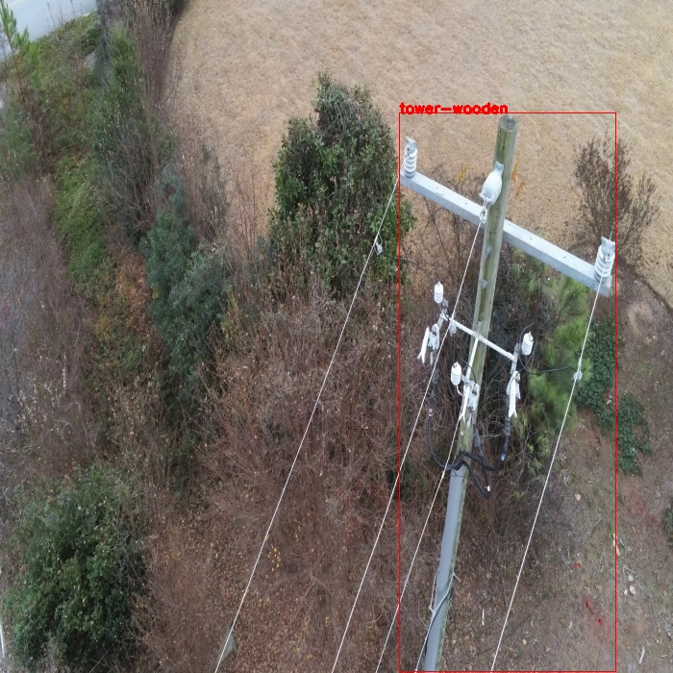
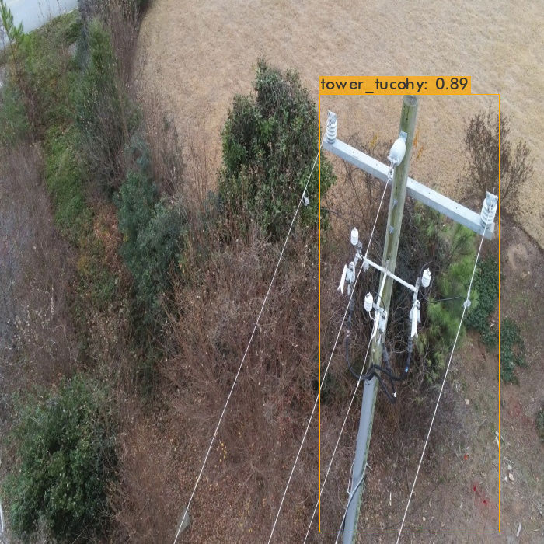
Wooden tower is mis-classified as tower tucohy.
Image : 08_1890.jpg

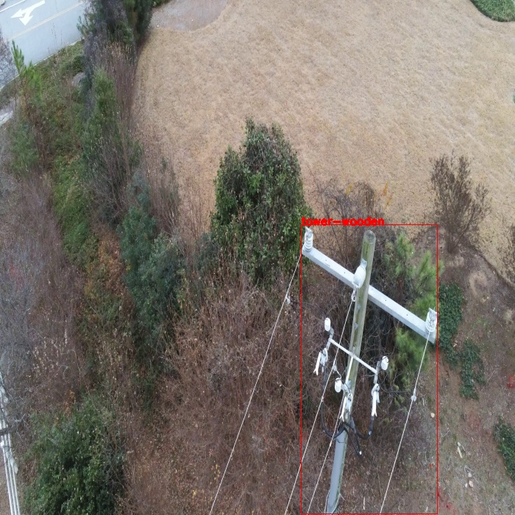
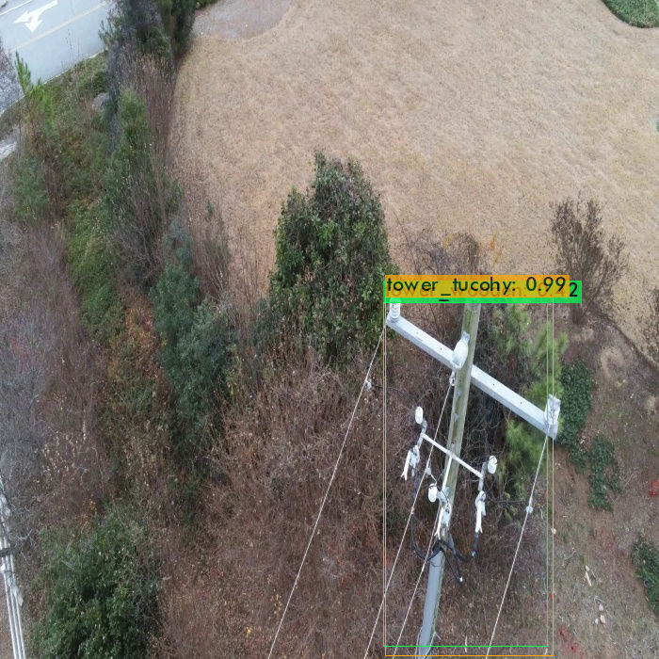
Wooden tower is classified as both tucohy and wooden.

Image :14_01171.jpg

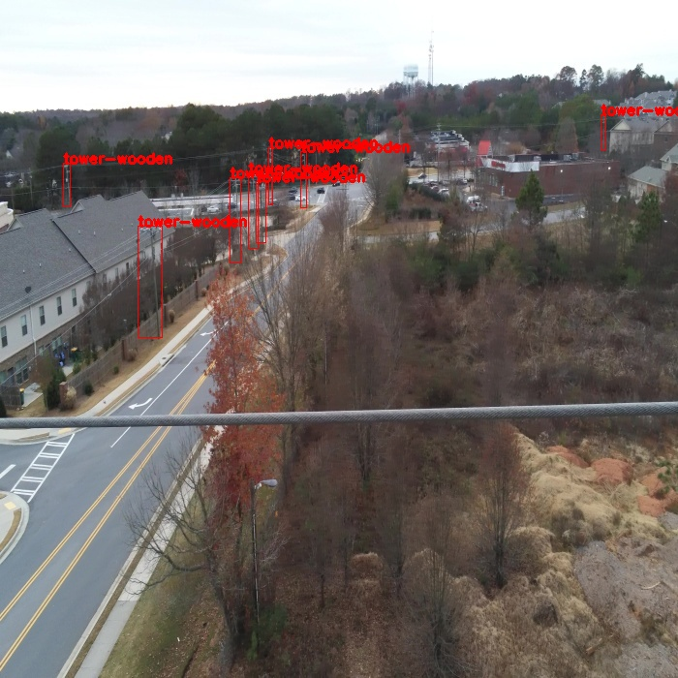
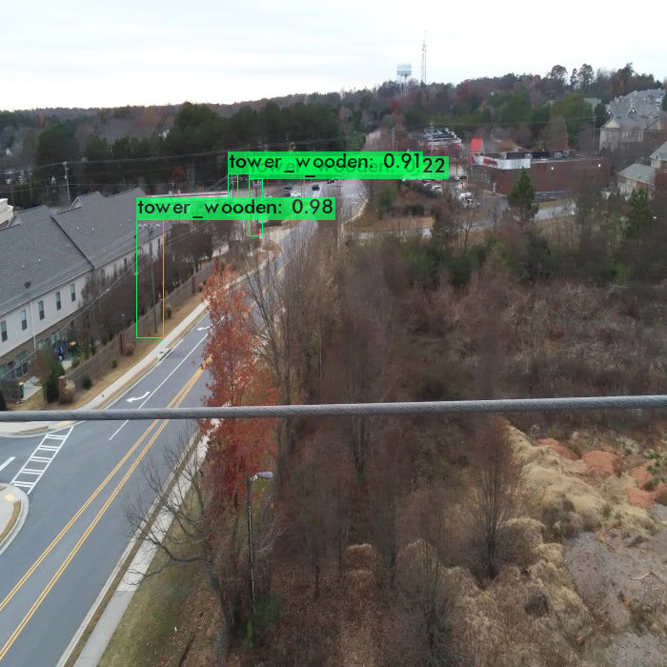
Some wooden towers are not detected .

Image : 19_00137.jpg

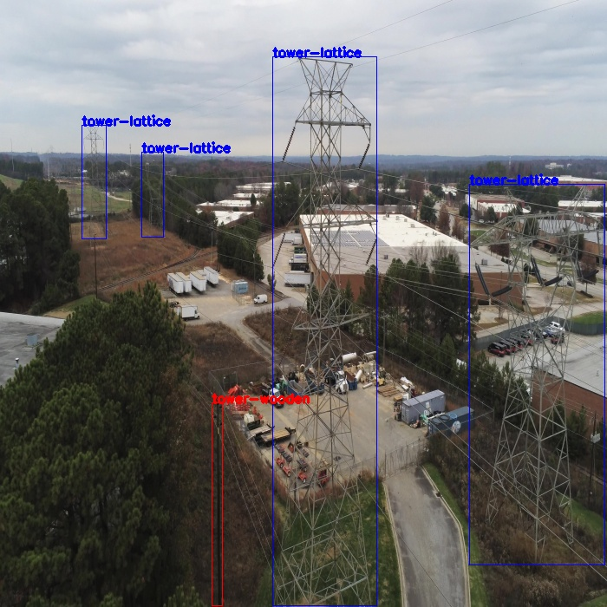
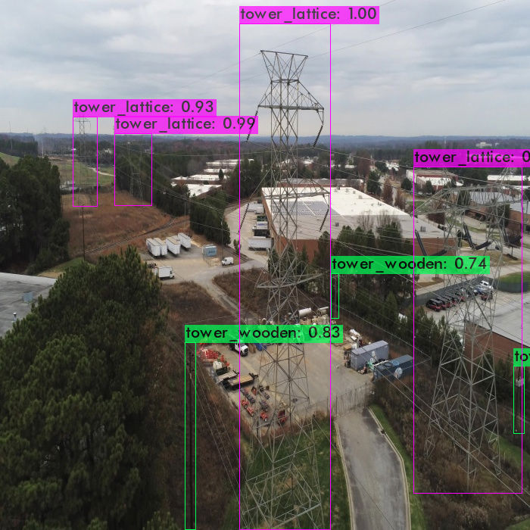
Correctly predicted some wooden towers which is not present in Ground truth.

Image : 20_7215.jpg

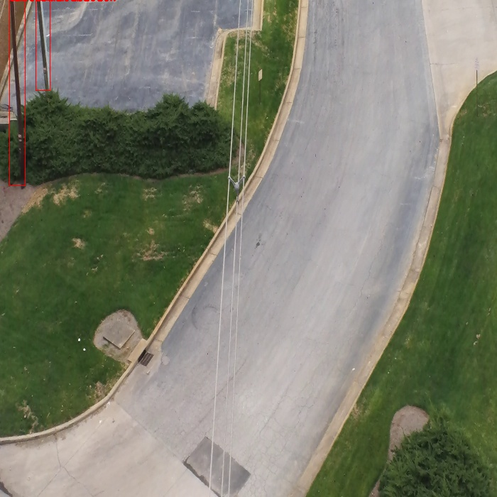
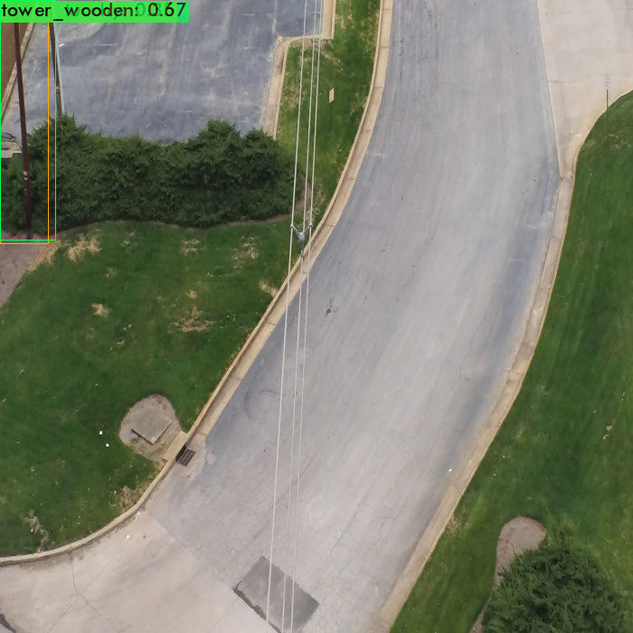
Wooden tower is classified as both Wooden and tucohy , And also one wooden tower is snot detected.

Image : 22_02021.jpg

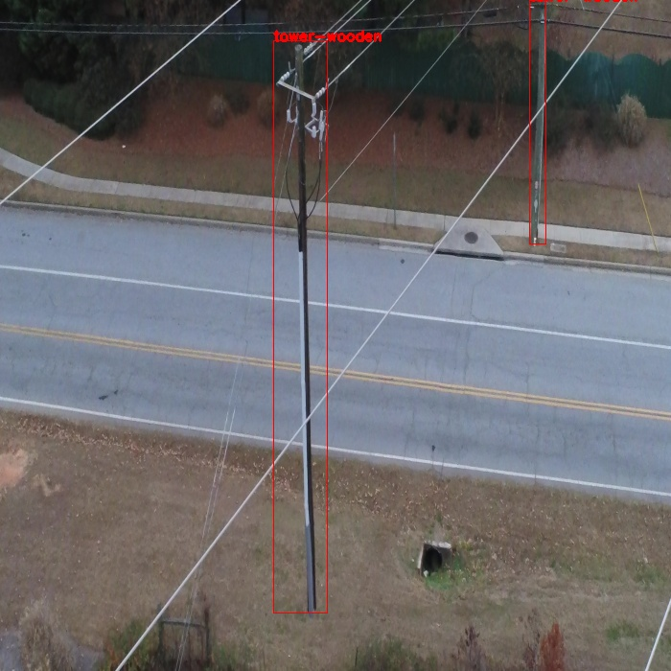
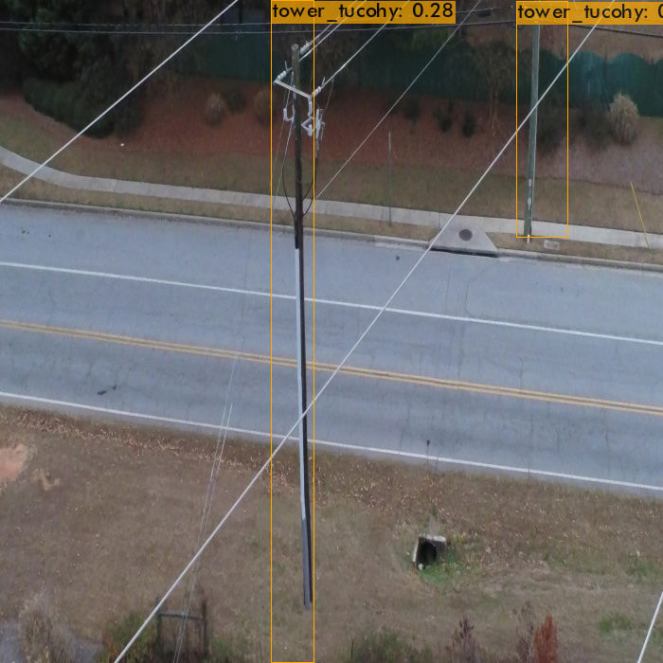
Wooden towers are mis-classsified as Tucohy tower.

Image : 25_00029.jpg

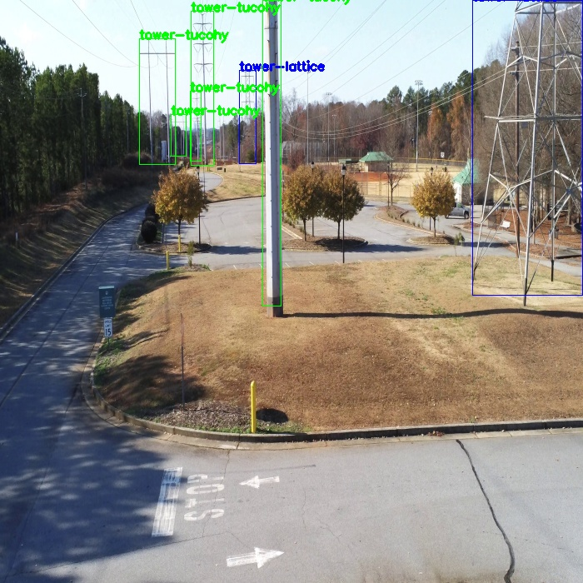
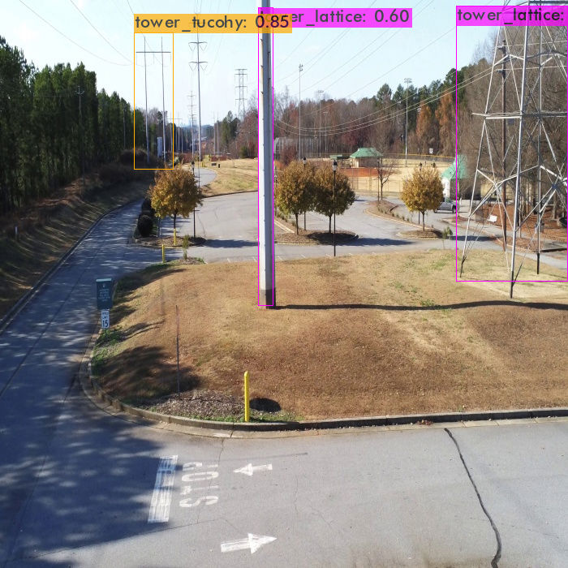
Some Tucohy towers are not detected and also one lattice tower is mis-classified as tucohy tower.

Image : 41_00961.jpg

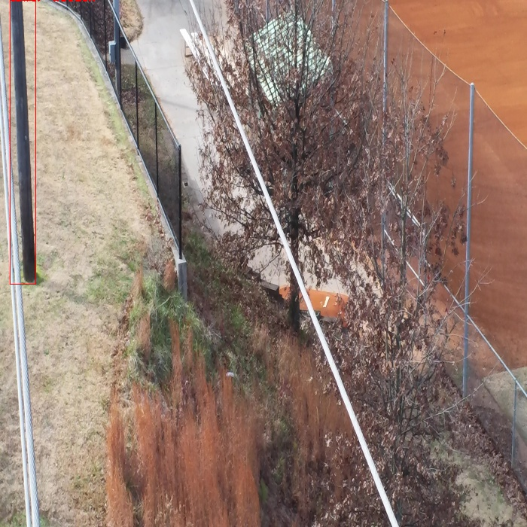
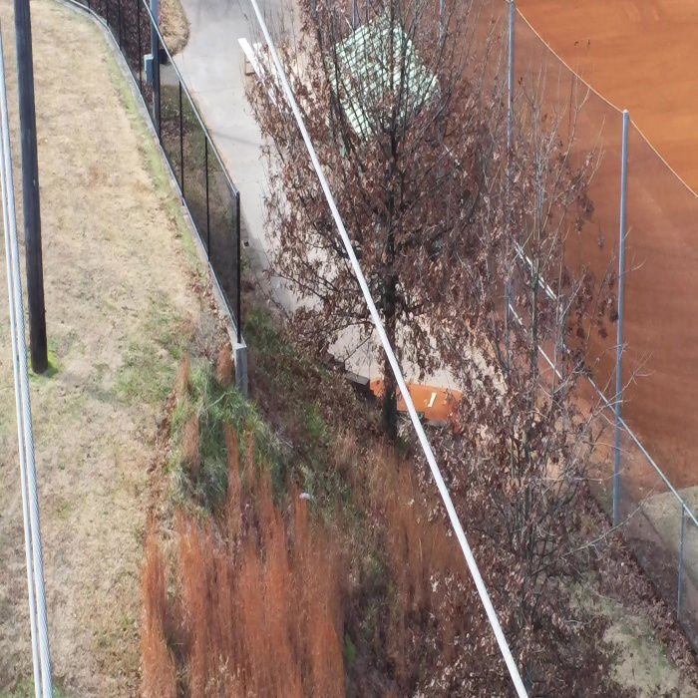
Wooden tower is not detected.

Image : 43_00591.jpg

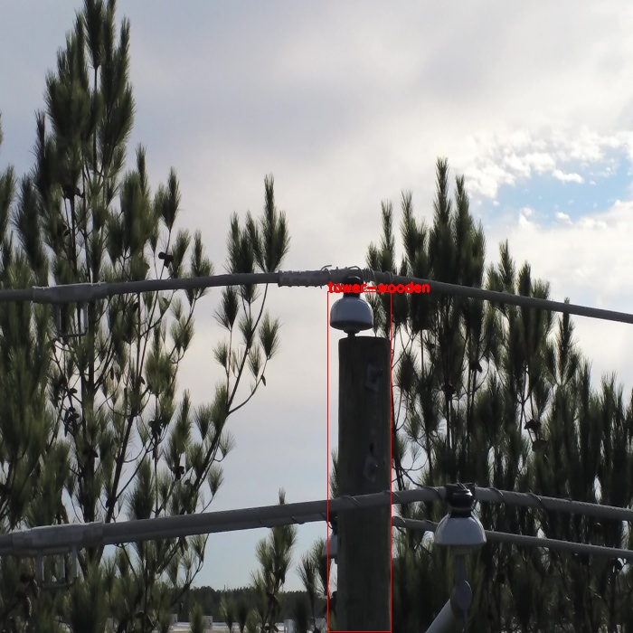
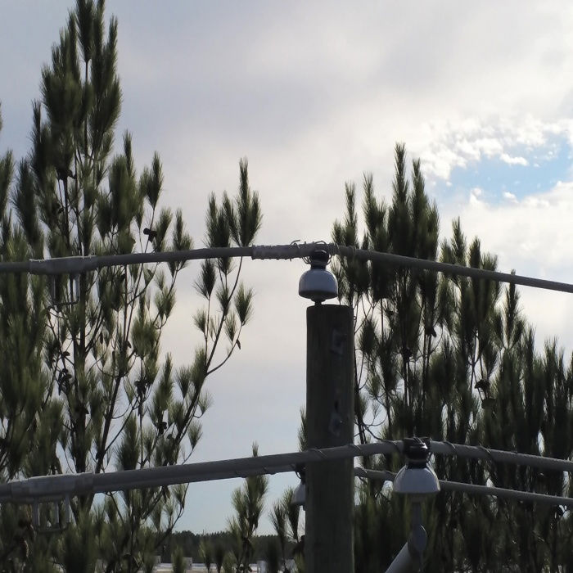
Wooden tower is not detected.

Image : 58_00956.jpg

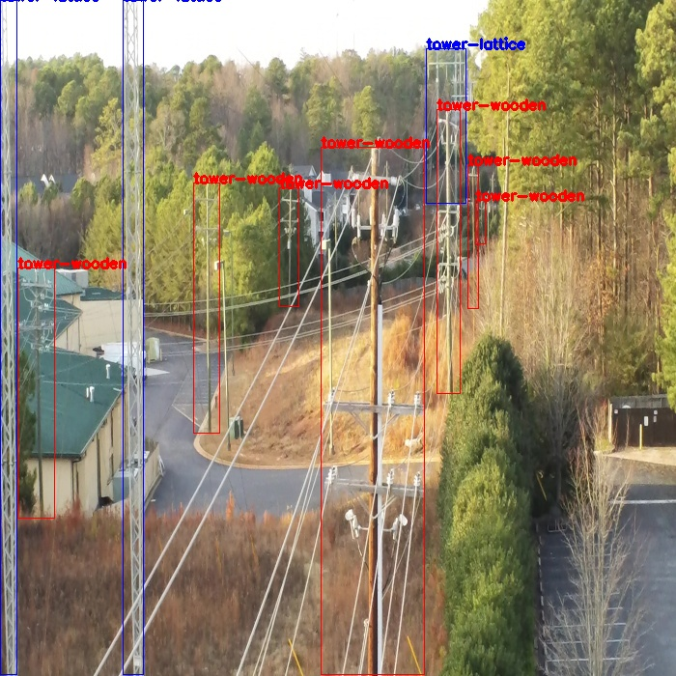
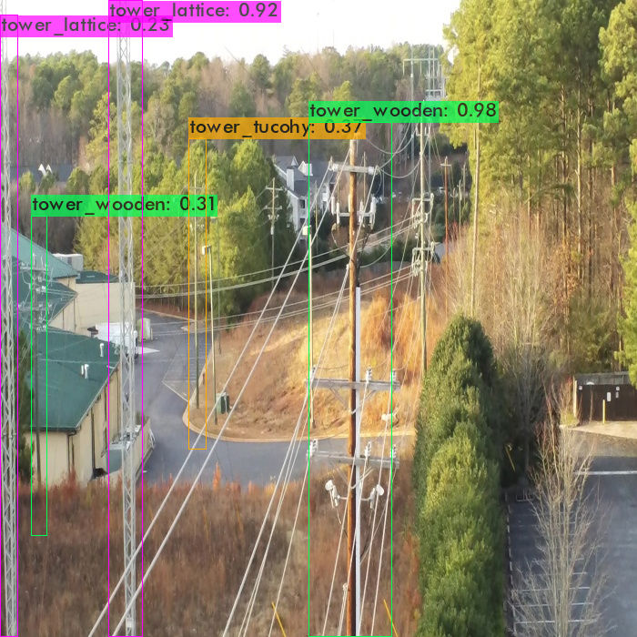
Some wooden tower and one lattice tower are not detected and one wooden tower is mis-classified as tucohy tower.

Image : 66_00191.jpg

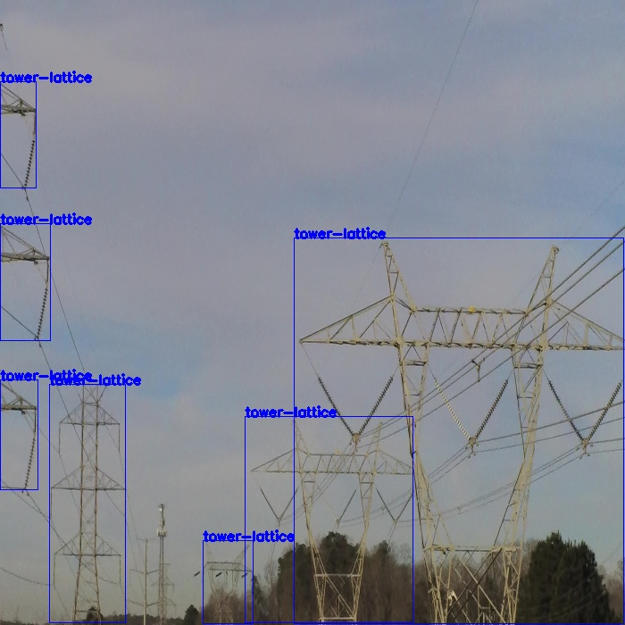
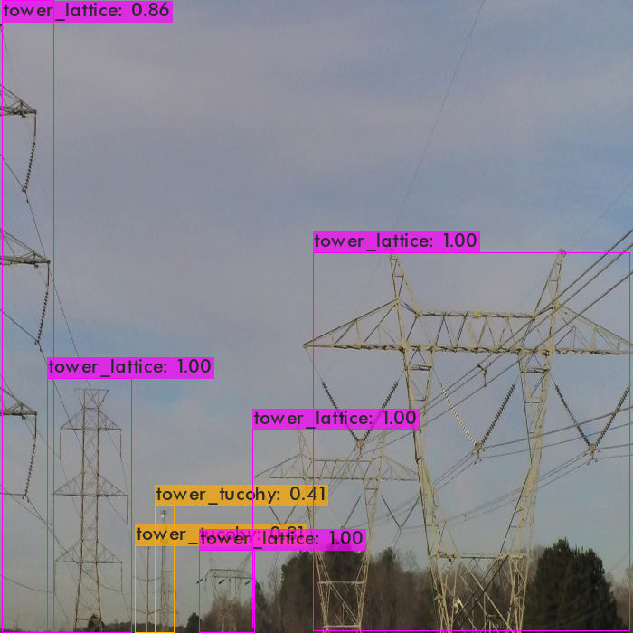
Some lattice towers are mis-classified as Tucohy towers.

Image : 67_02716.jpg

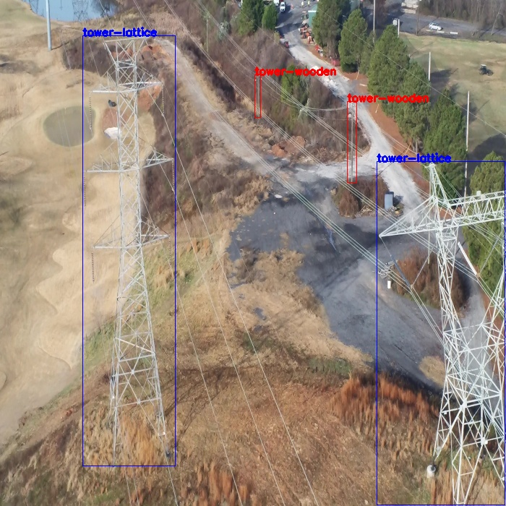
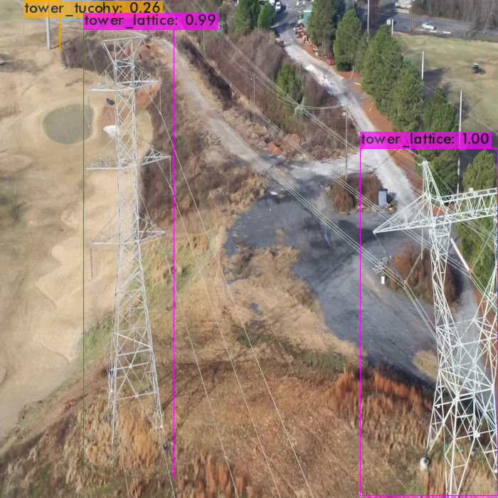
Some wooden towers are not detected and left side lattice tower has two detection due to less threshold=0.2 .

Image : 71_3880.jpg

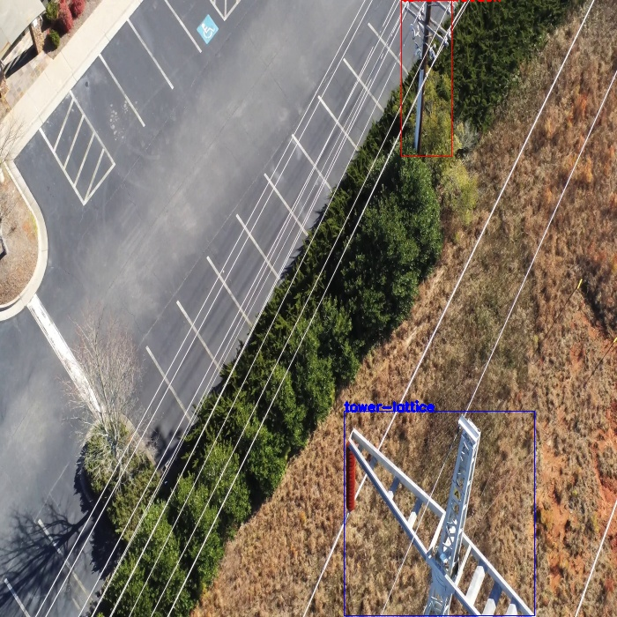
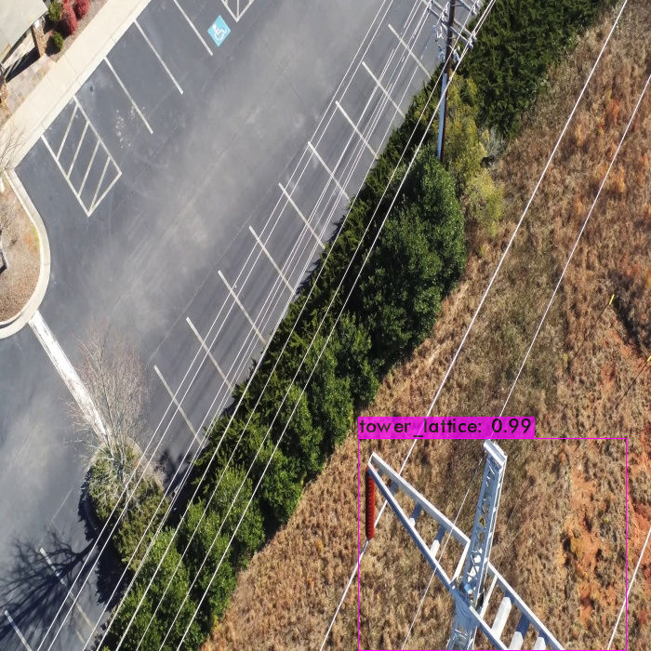
Wooden tower is not detected.

Image : 105_4350.jpg

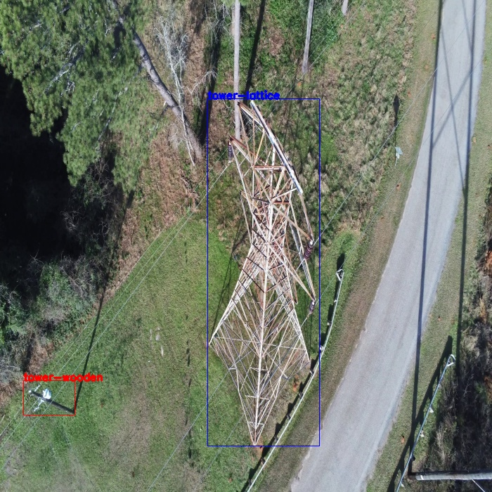
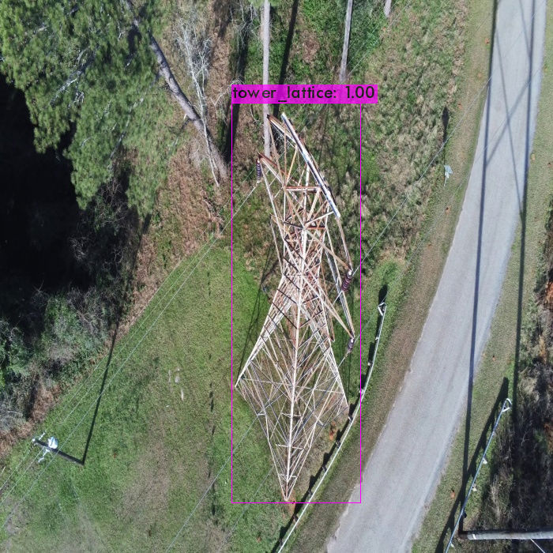
Wooden tower is not detected.

Image : 112_165.jpg

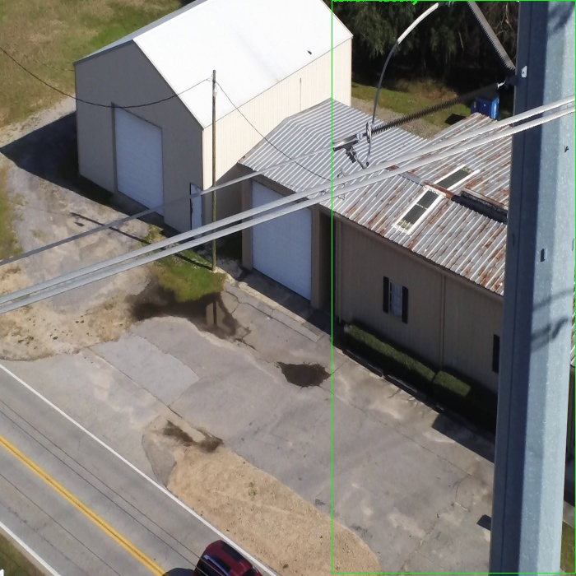
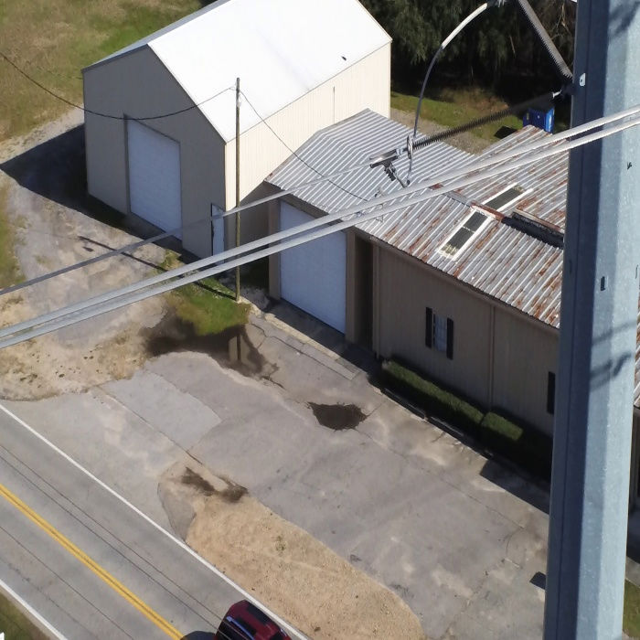

Tucohy tower is not detected.

