Aero2Astro
Panneerselvam N
(25/10/2021)

Today i had trained Yolo v4 model upto 16600 epochs with jitter = 0.45. And also evaluated with both training ,val and test dataset.

Size: 608x608 (resized)
Threshold_IOU = 0.2
Train :

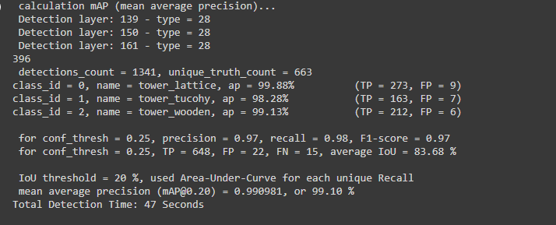
Test:

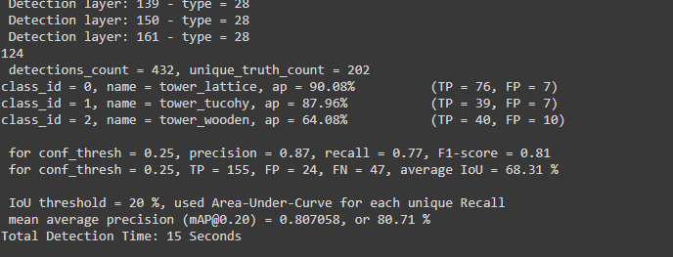

Val :
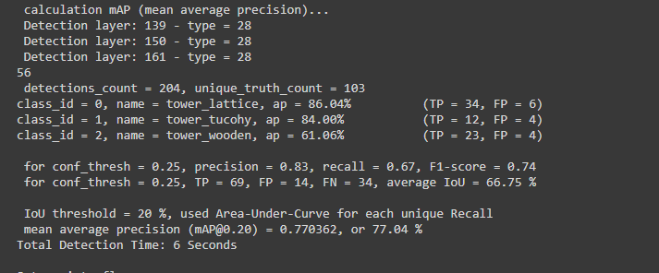
Threshold_IOU = 0.6
Train :
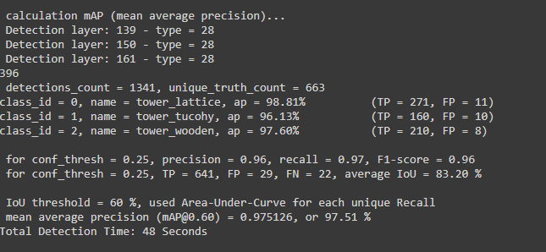
Test:
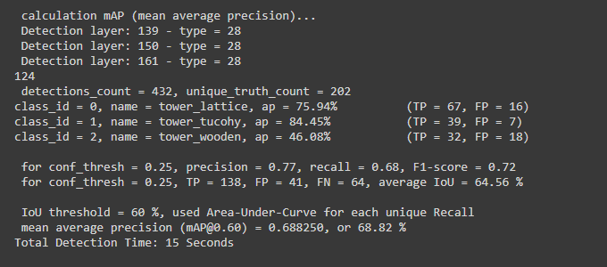
Val :
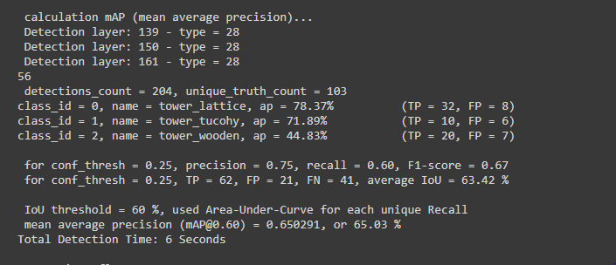
Size : 700x700 (Original size)
Threshold_IOU = 0.2
Train :
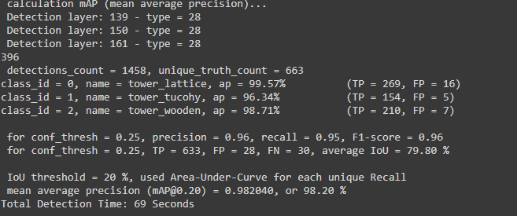
Test:
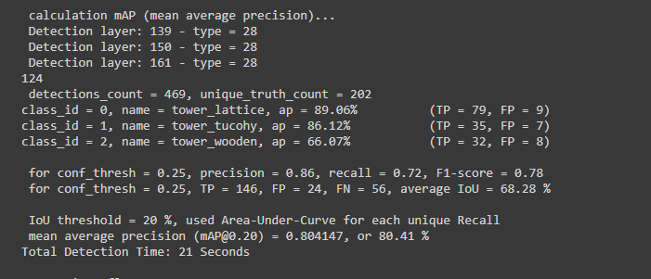
Val :
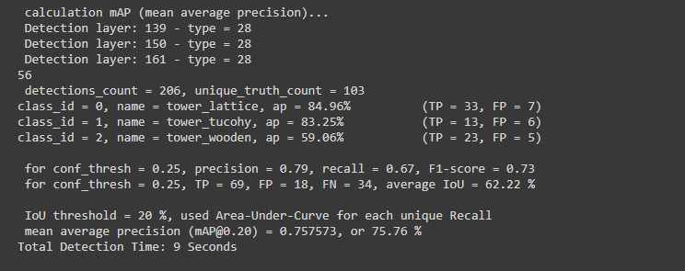
Threshold_IOU = 0.6
Train :
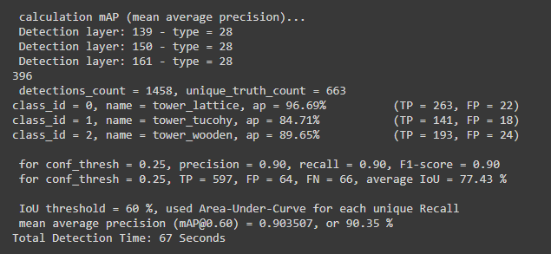
Test :
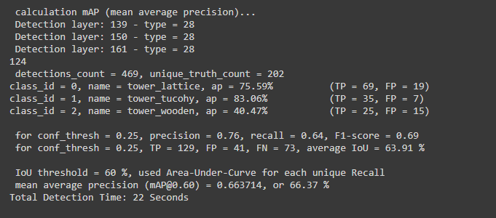
Val :
