Aero2Astro
Panneerselvam N
(26/10/2021)

Today i had trained Yolo v4 model upto 17000 epochs with jitter = 0.45. Due to colab disconnect not able to perform today’s evaluation.
Today again i try to analysis test data images and also found some images with mistakes.
Threshold_conf = 0.2
Image : 1_00186.jpg
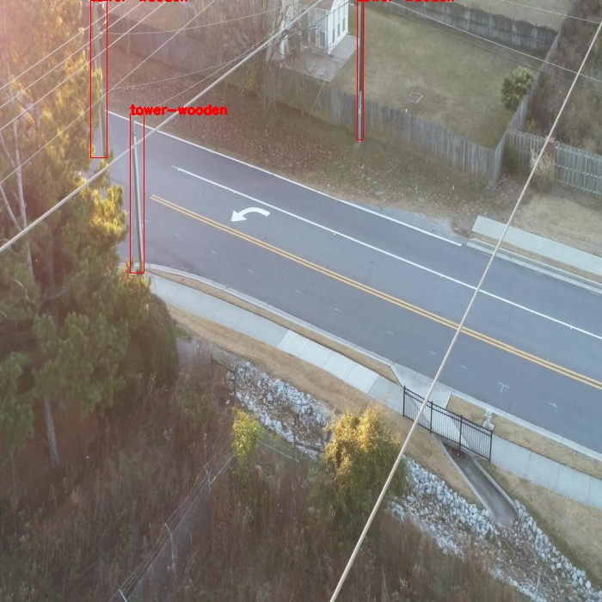
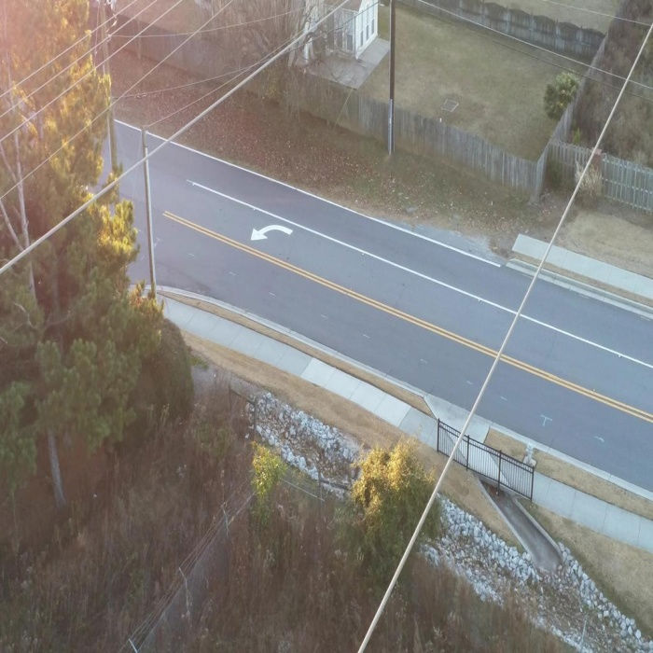
Wooden towers are not detected.

Image ; 07_1035.jpg

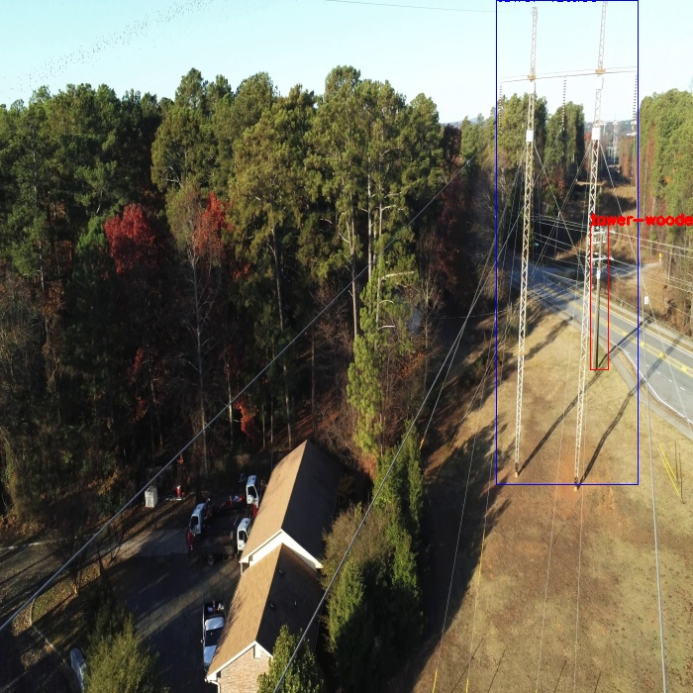
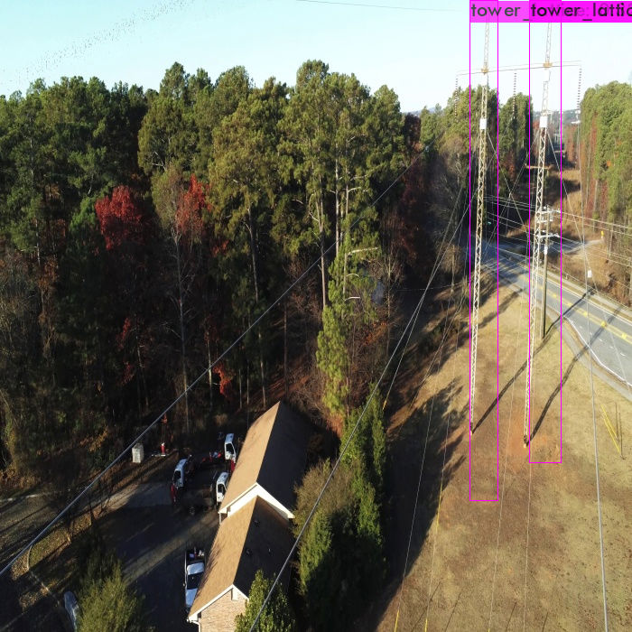
wooden tower is not detected.

Image : 13_00146.jpg

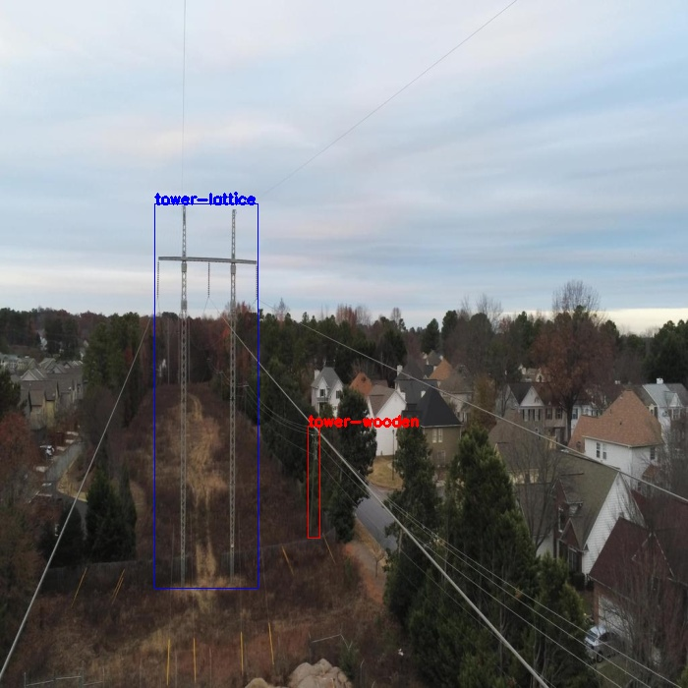
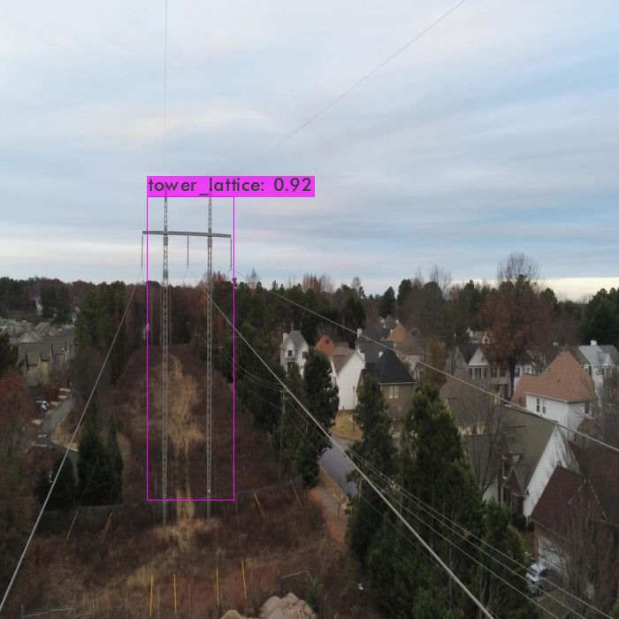
Wooden tower is not detected.

Image : 19_00413.jpg
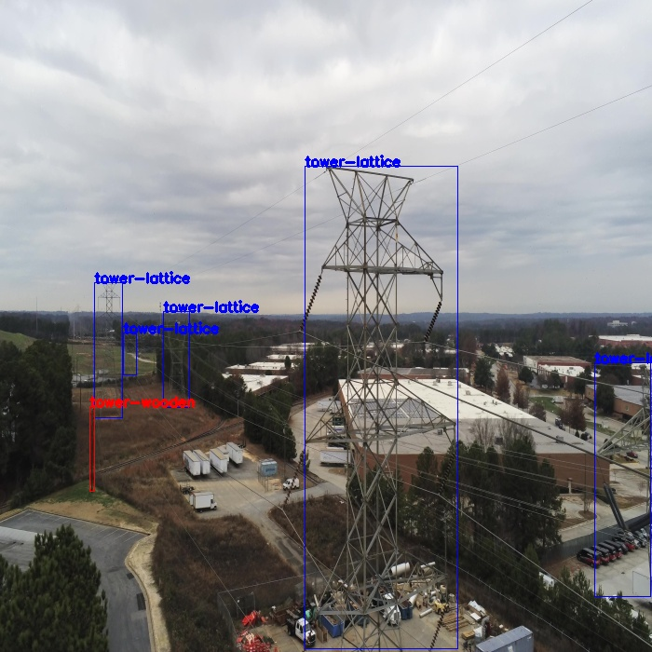
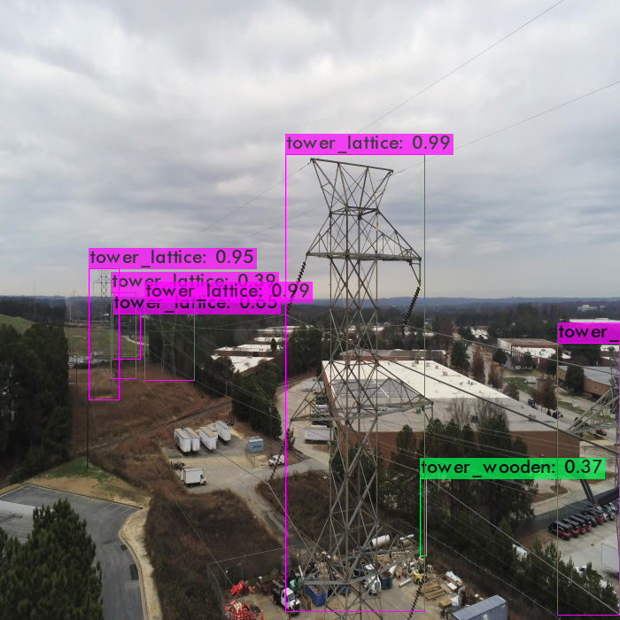
Left side wooden not detected , but right side wooden tower detected which is not in Ground thruth.

Image ; 25_00356.jpg
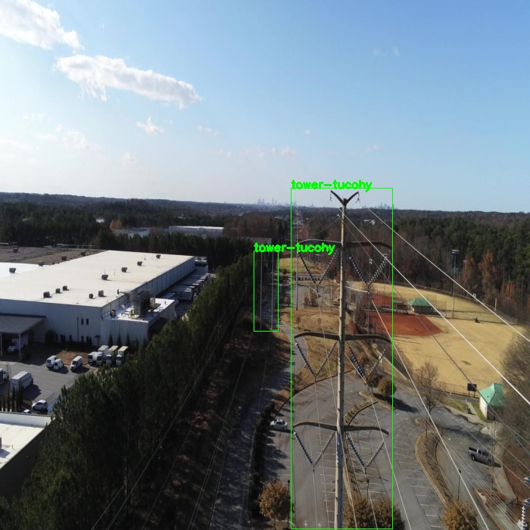
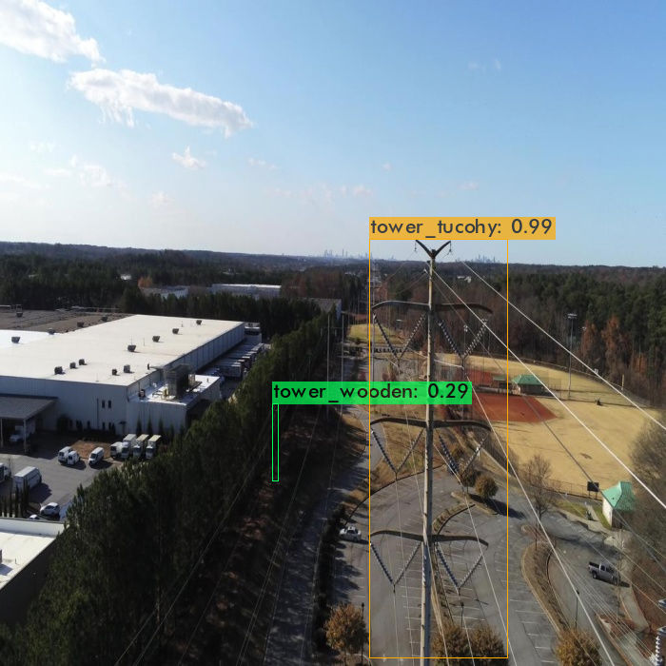
Tucohy tower is mis-classified as wooden tower.

Image : 26_00013.jpg

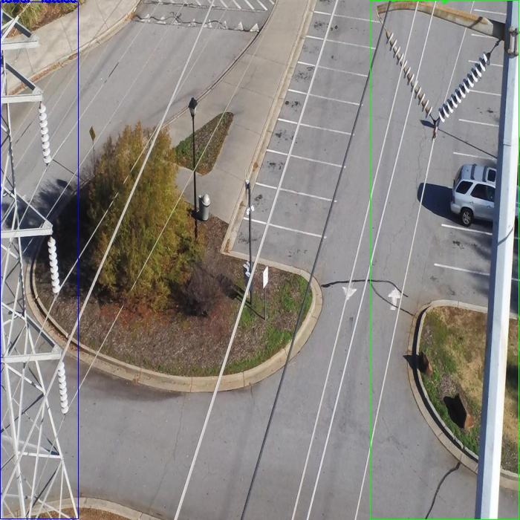
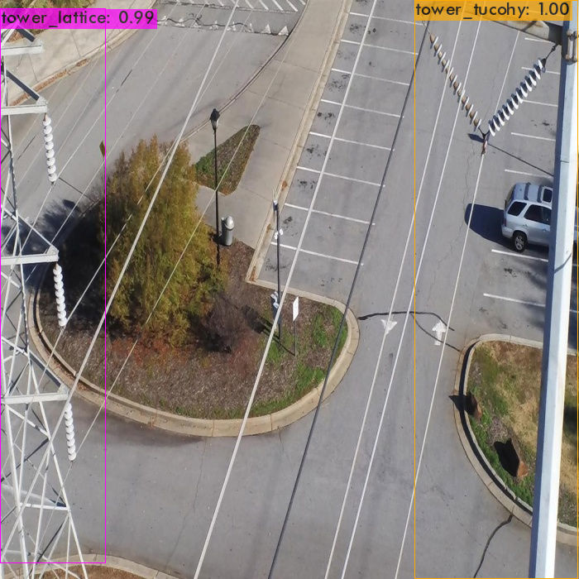
All detections are correct.

Image : 31_4110.jpg

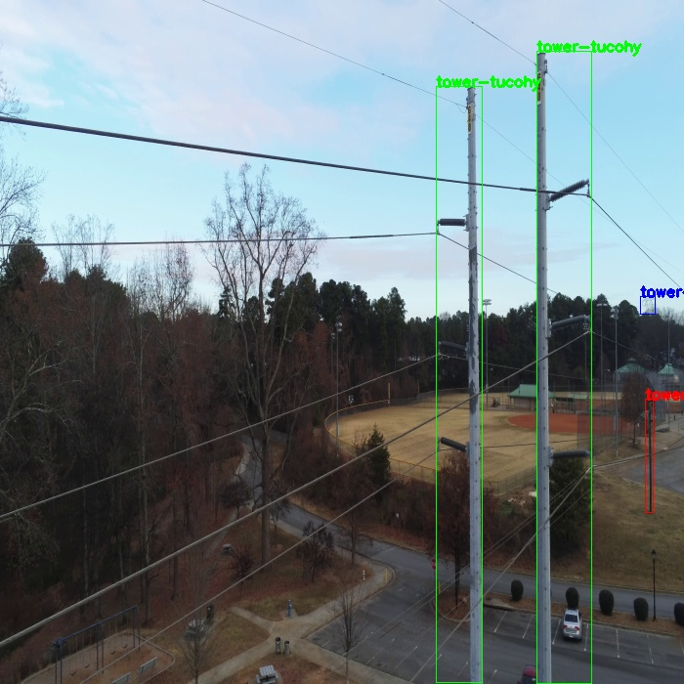
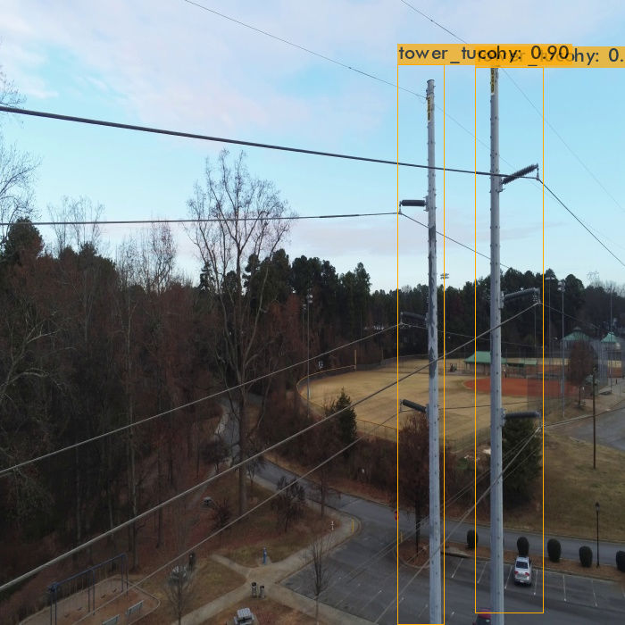
Lattice and Wooden towers are not detected.

Image : 34_135.jpg

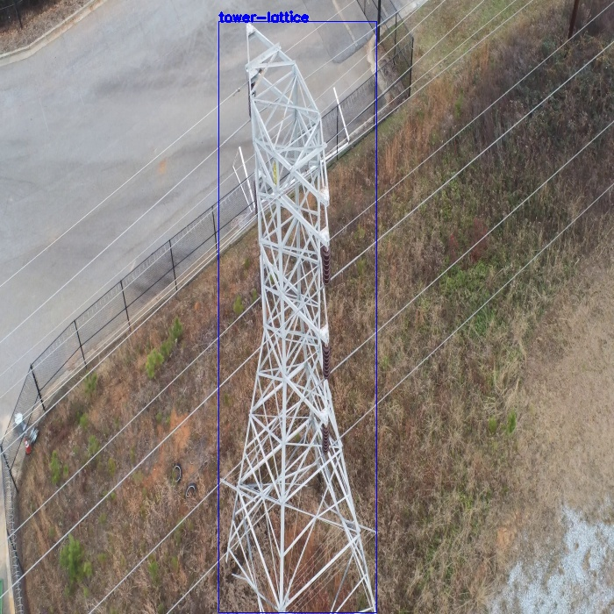
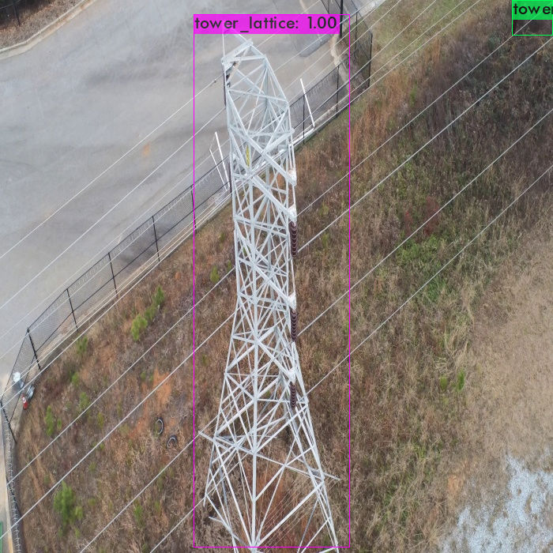
Wooden tower not detected, because which is too small.

Image : 52_00616.jpg

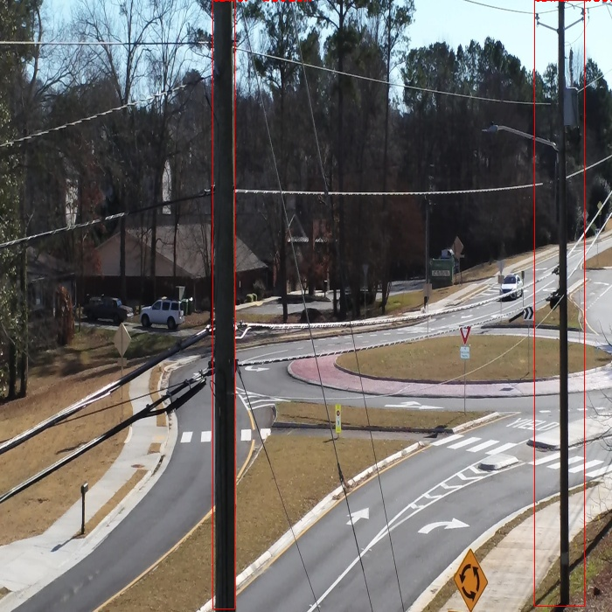
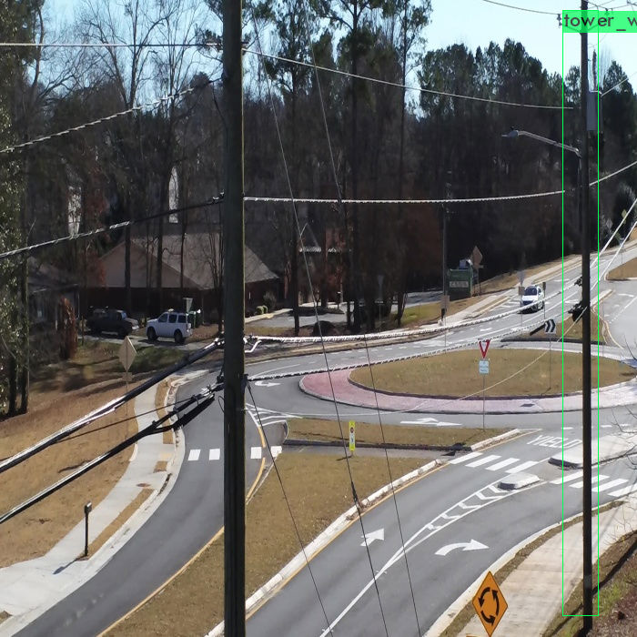
One wooden tower is not detected.

Image : 108_1830.jpg

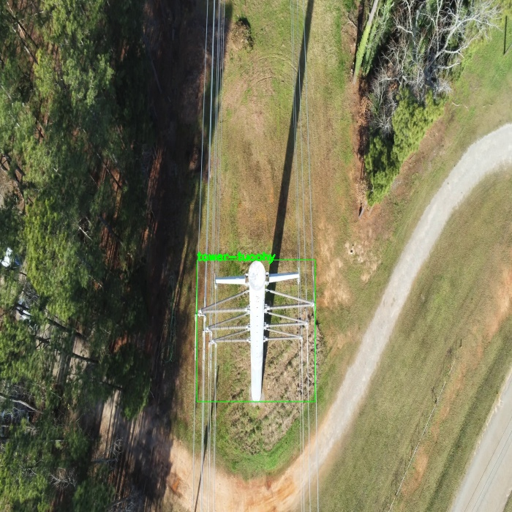
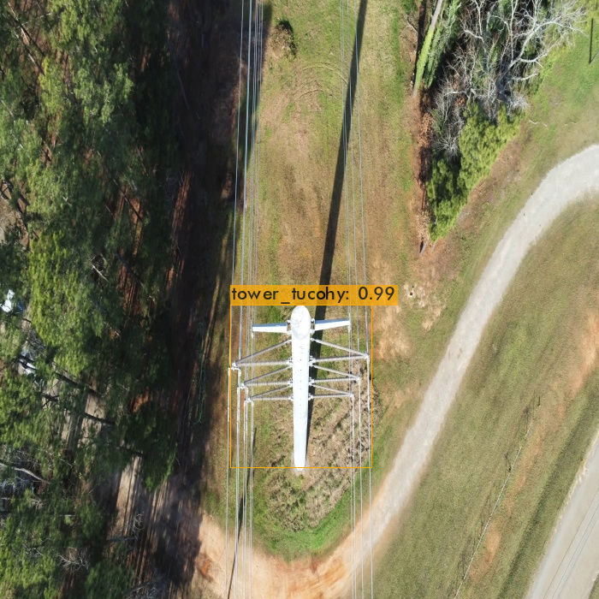
Correctly detected.

