Aero2Astro
Panneerselvam N
(27/10/2021)

Today i had trained Yolo v4 model upto 18200 epochs with jitter = 0.45. And also evaluated with both training and test dataset.
Threshold_iou = 0.2
Train :
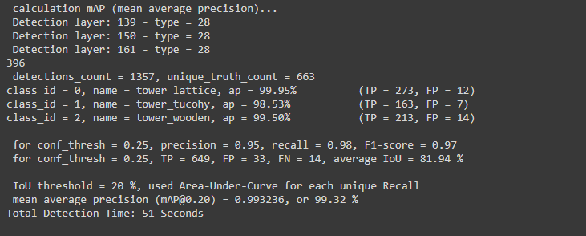
Test :
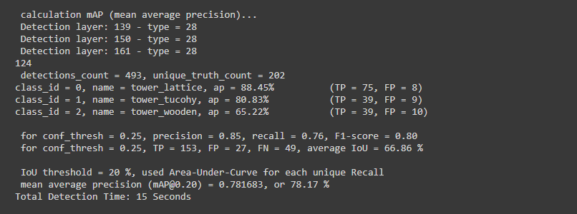
Val:
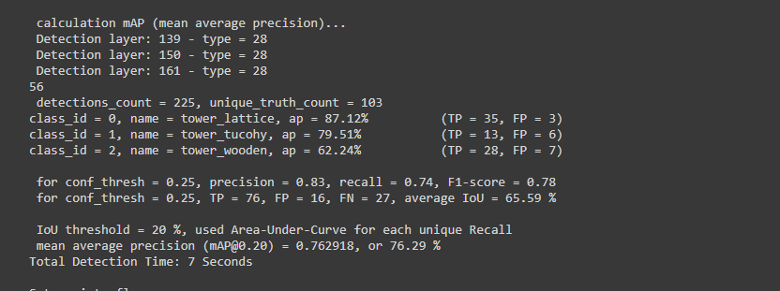
Threshold_Iou = 0.6
Train:

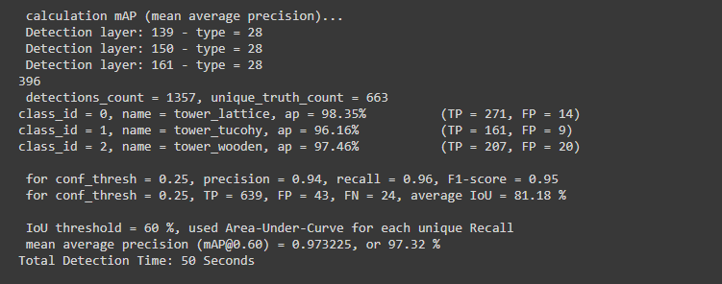
Test :
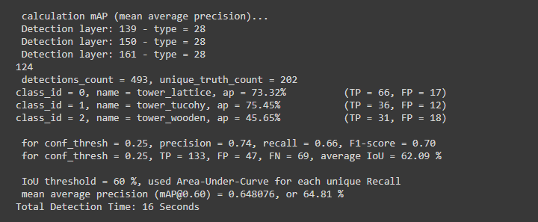
Val:
