Aero2Astro
Panneerselvam N
(29/10/2021)

Today i had trained Yolo v4 model upto 20000 epochs. And also evaluated with both train and test dataset.
Train :
Threshold_IOU = 0.2
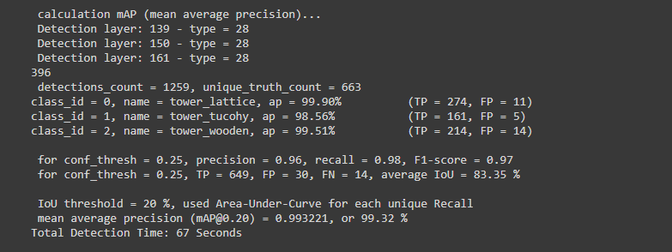
Test :
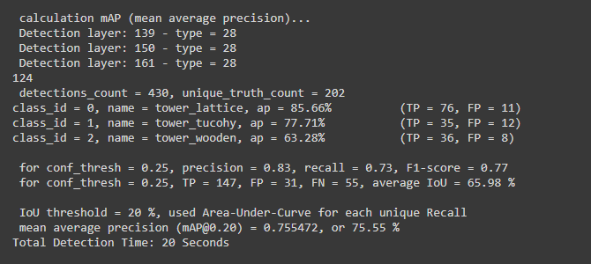
Val :
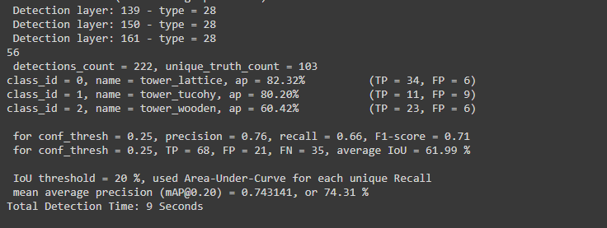
Threshold _IOU = 0.6
Train :
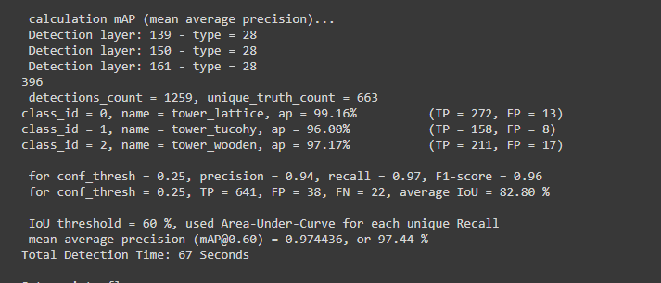
Test :
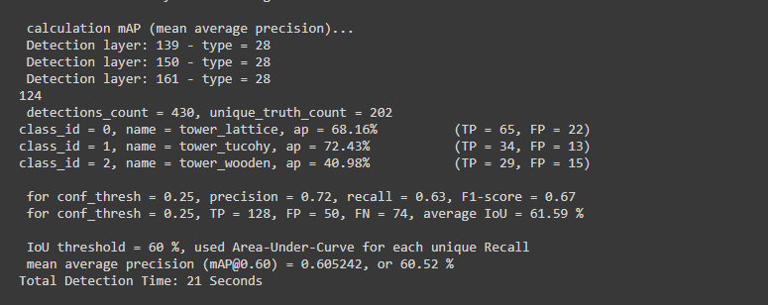
Val :
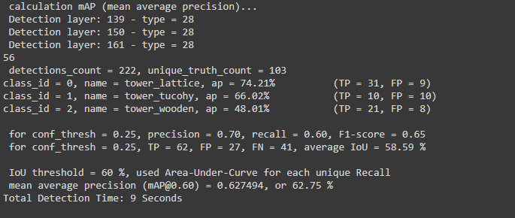

Detection Result : At 19600 epochs.
Threshold_detection = 0.2
Image : 08_1725.jpg

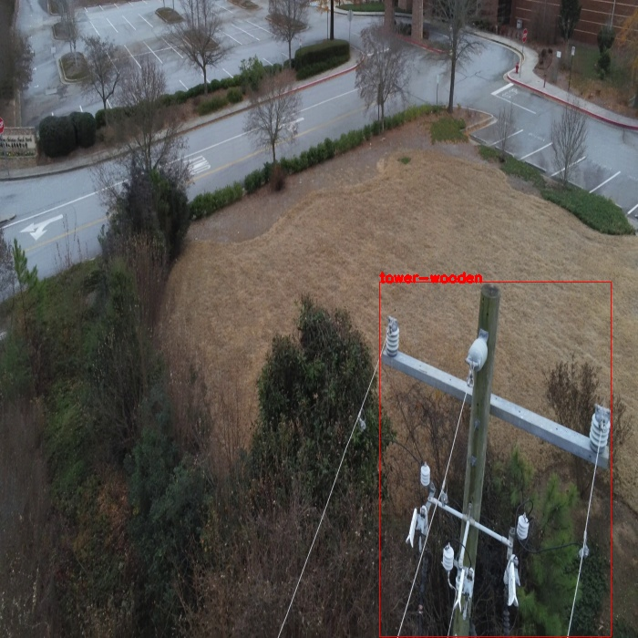
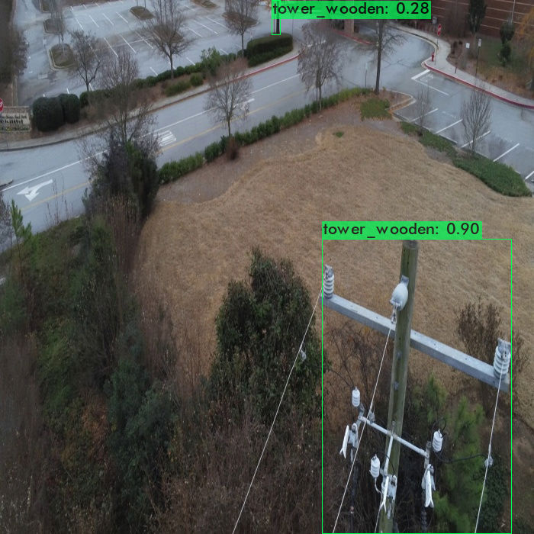
Tree is classified as wooden tower.

Image : 14_00051.jpg

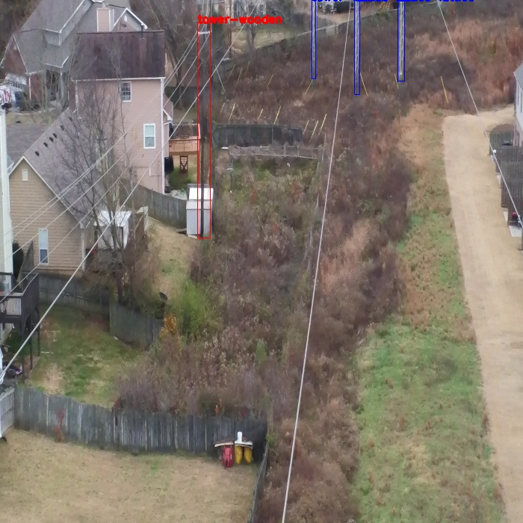
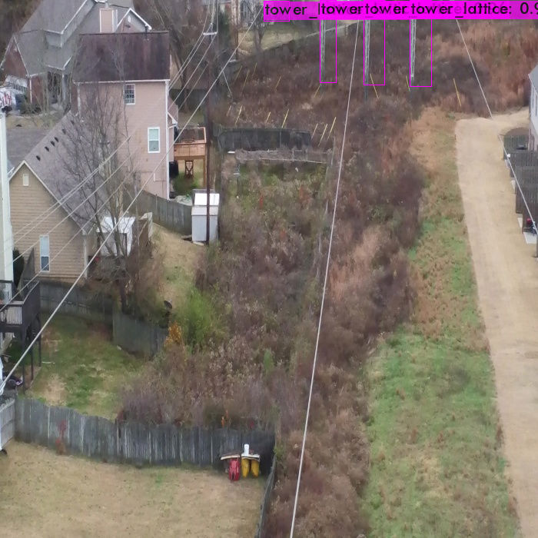
Tower wooden is not detected.

Image : 14_02226.jpg

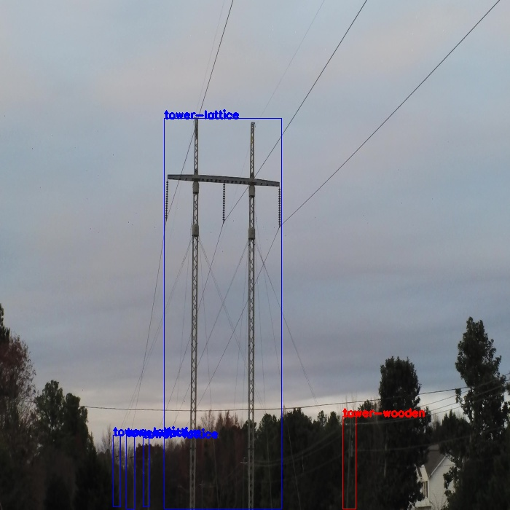
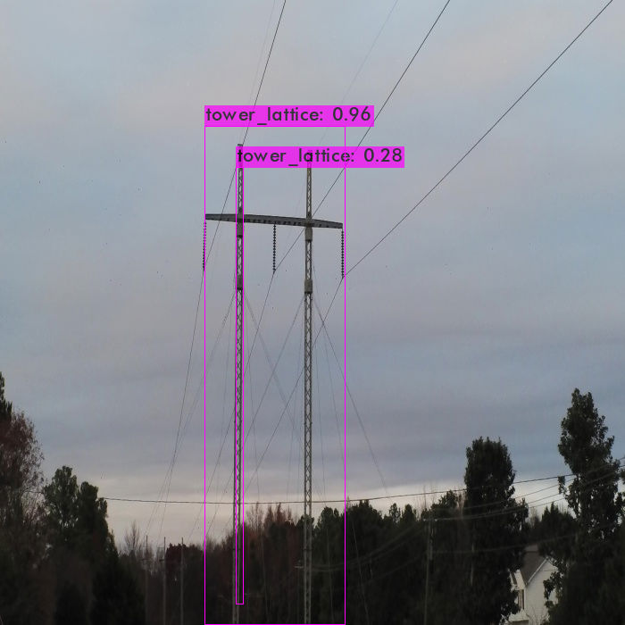

Wooden tower and other some lattice towers are not detected.Also lattice tower has multiple detections.

Image : 22_00331.jpg

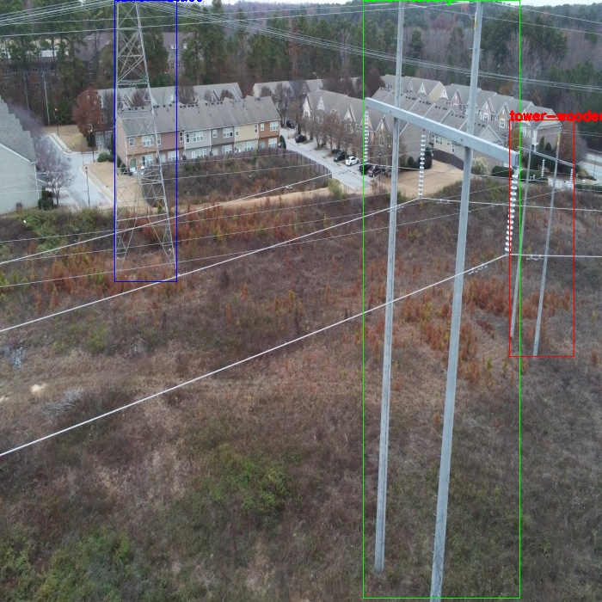
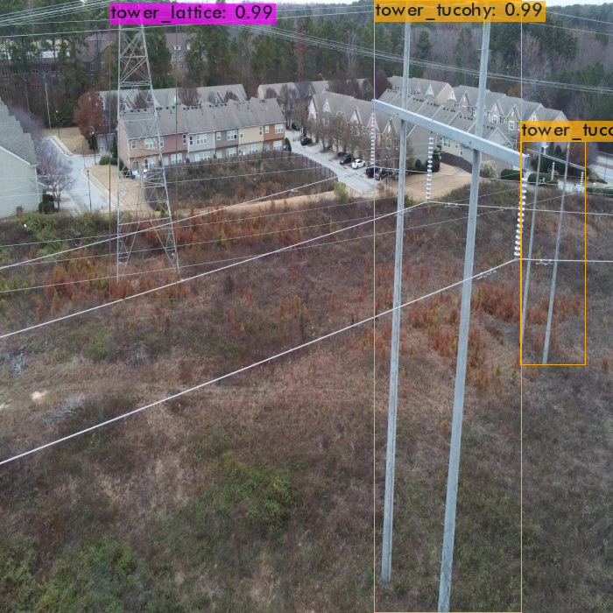
Wooden tower is mis-classified as tower tucohy.

Image : 22_01901.jpg

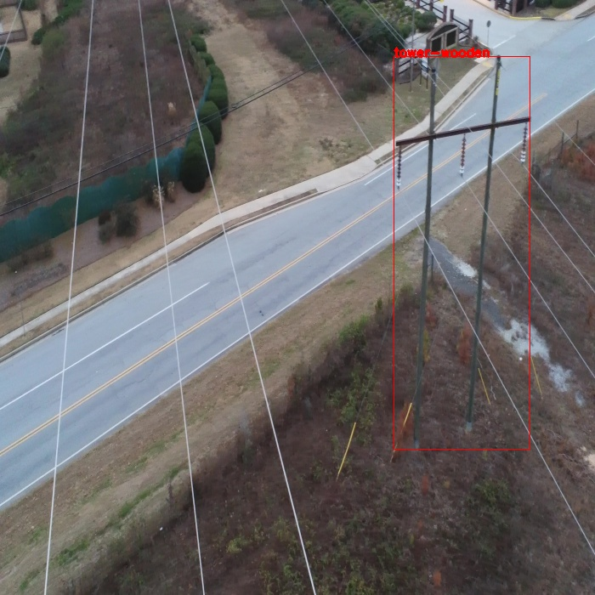
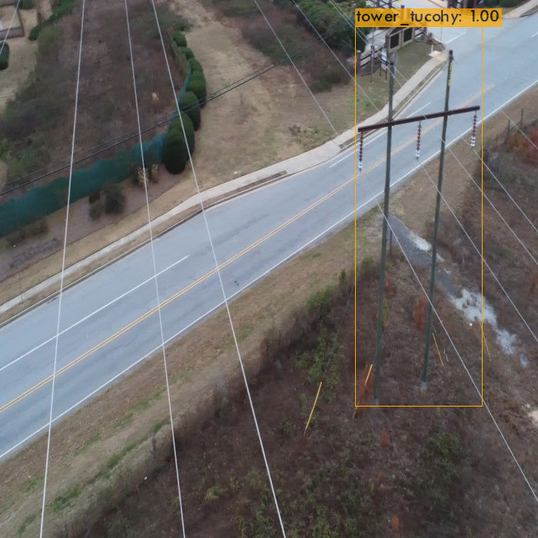
Wooden tower is mis-classified as Tucohy tower.

