Aero2Astro
Panneerselvam N
(04/10/2021)

Today i had started to training Faster rcnn upto 5500 ierations, and performed evalvation.

Train :

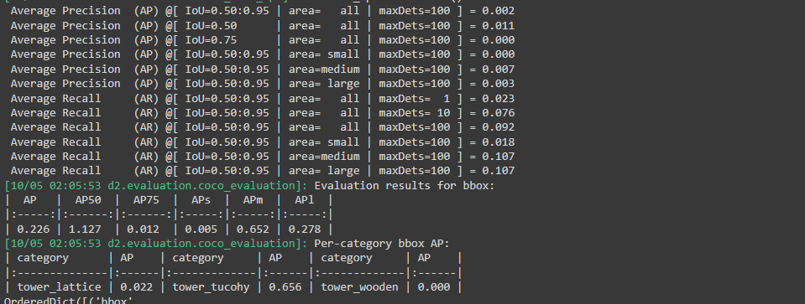

Test :

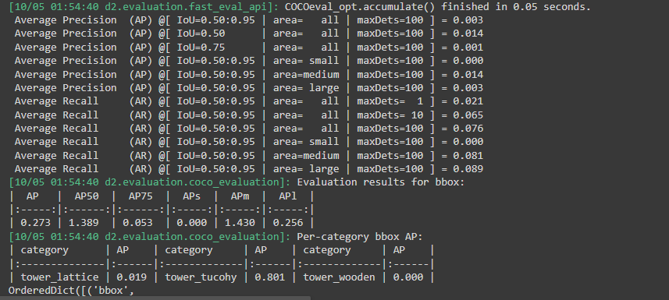

val dataset;

