Aero2Astro
Panneerselvam N
(07/10/2021)

Today i had trained Faster rcnn upto 12000 ierations. And also evaluated with both training and test dataset.

Val dataset:

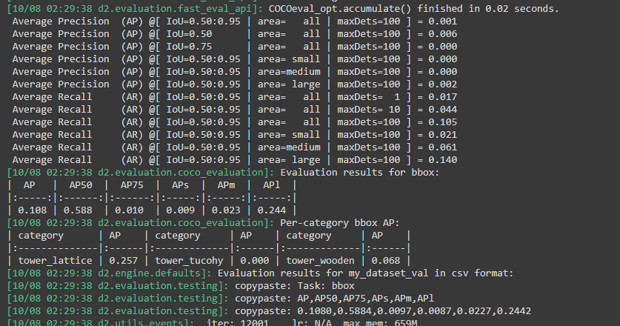
Test :
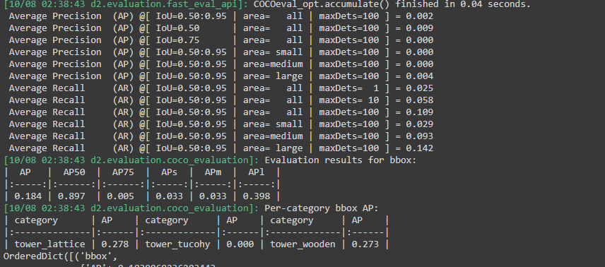

Train:

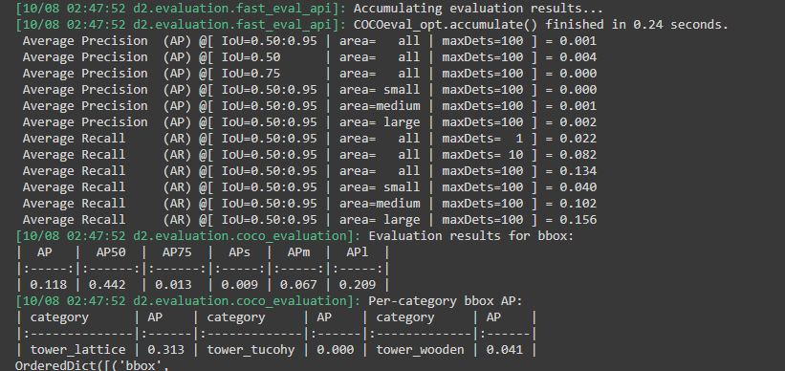

Yolo v4 Evaluation:

Ground Truth :
https://drive.google.com/drive/folders/1nlVuaMudkmGxHV_B2CK5PIotIEi1qtIc?usp=sharing

Detected results:

https://drive.google.com/file/d/17SBKRZxIWco1jdf7KFBTE4QNm62mqHus/view?usp=sharing

