Aero2Astro
Panneerselvam N
(09/10/2021)

Today i had trained Yolo v4 model upto 6200 epochs. And also evaluated with both training and test dataset.

Train :

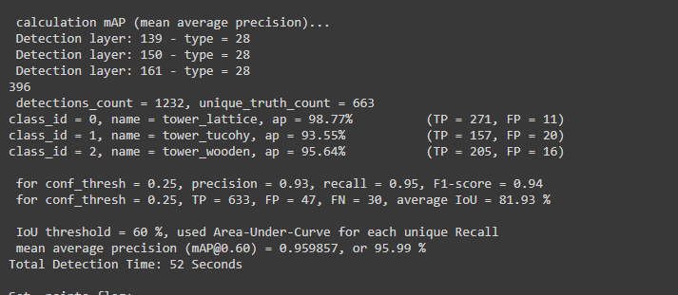

Test:

