Aero2Astro
Panneerselvam N
(25/09/2021)

Today i had trained Yolo v4 model upto 2500 epochs and performed evaluation.

Train :

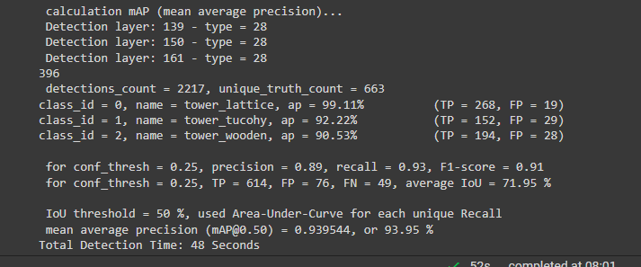
Test :

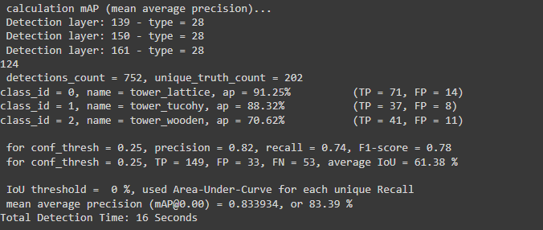
https://github.com/Panneer003/Aero2astro_code/blob/main/TTPLA/Yolov4_TTLPA_2500_eps.ipynb

Detection Result :

