Aero2Astro
Panneerselvam N
(29/09/2021)

Today i had trained Yolo v4 model upto 4800 epochs and performed evaluation.

Train :
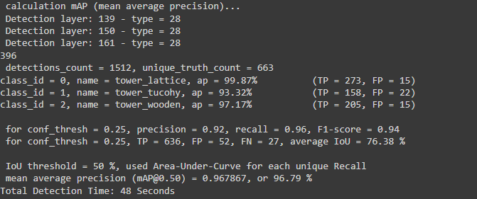

Test :
