Name : Panneerselvam N
Role : Research Intern – Inspect
Date : 10/06/2021
Object Detection Practice(Yolo v4)

I have implemented Yolo v4 object detection with Tensoflow using pre-trained weights.

Steps :

- I have taken open source Yolo v4 repository from GitHub which is implemented with tensorflow and learned workflow of this repository code.

- Next , Downloaded pre-trained weights from official Yolo v4 repository which is trained with coco dataset.

- Official Yolo v4 was created with Darknet framework. So, I have converted Pre-trained weights from Darknet format to Tensorflow format.

- Next , I had configured my system to run Yolo v4 repository.

- Finally , I had implemented Yolo v4 Object Detector with my own Input image sand videos.

Outputs :
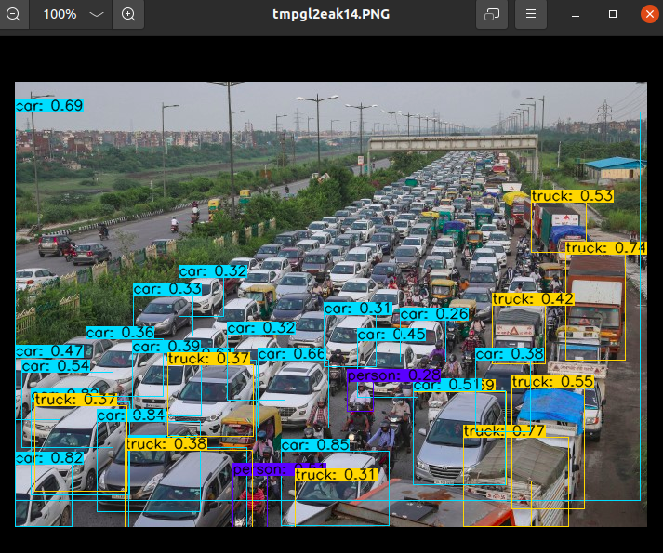

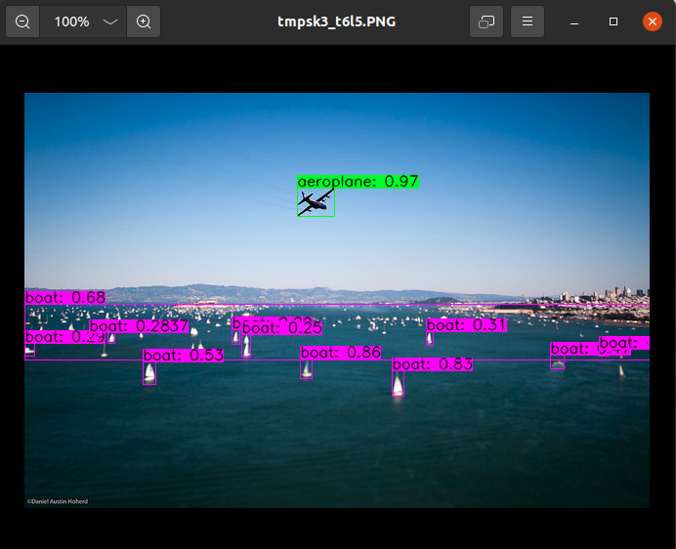

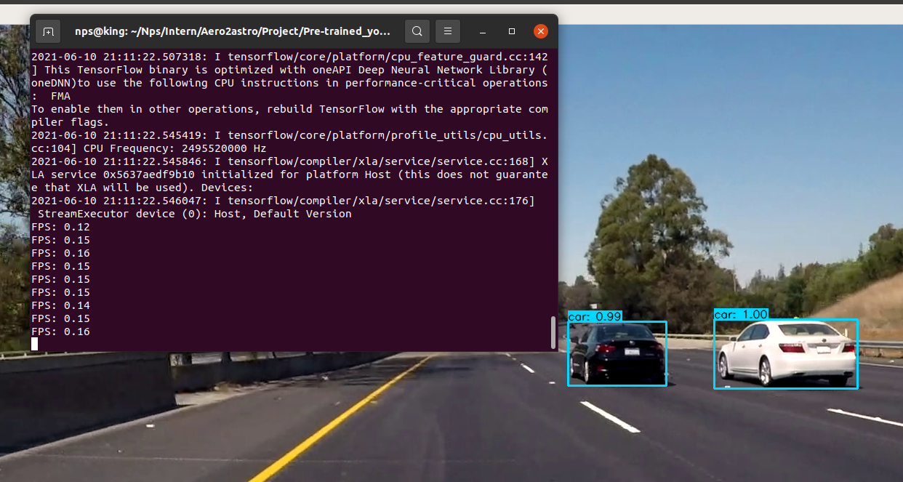
Above images is the output of Video data. I got only 0.15 FPS, because I have used CPU not GPU.
References :
Yolo v4 Repository : https://github.com/theAIGuysCode/tensorflow-yolov4-tflite.git

Pre-trained Weights : https://drive.google.com/openid=1cewMfusmPjYWbrnuJRuKhPMwRe_b9PaT

Official Yolo v4 Repository : https://github.com/AlexeyAB/darknet.git

