Name: Panneerselvam N
Role: Research Intern – Inspect
Date : 12/06/2021

Task : Object Detection Practice (Yolo v4 Custom Data)

Dataset Creation:(Group work)
We are decided to take MS COCO datasets for Yolo v4 training.
Categories are,
- Aeroplane
- Cow
- Bird
- Boat
- Motorcycle
- Umbrella

we took totally 1200 datasets, each class have 200 data. We are used Labelimg tool for annotations.

Custom model training:
I have used Official Yolo v4 Darknet framework for model training. I configured .data file , .names , .cfg file to customize model.

Configurations:
Batch = 64
Subdivisions = 16
Max_batches = 12000
steps = (9600,10800)
Filters = 33
Classes = 6

I have used Google colab and drive for model training . It took 7-8hrs for training.

Prediction :
After model training , I have downloaded trained weights and converted to TensorFlow form.

Finally I got output of object detector with help of TensorFlow code.

Output :
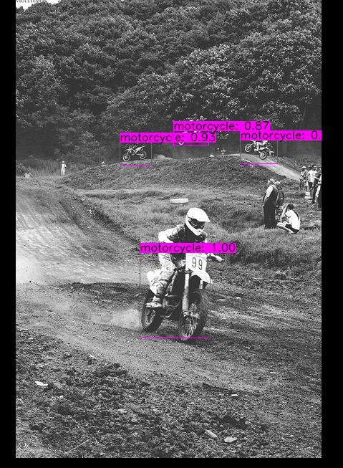
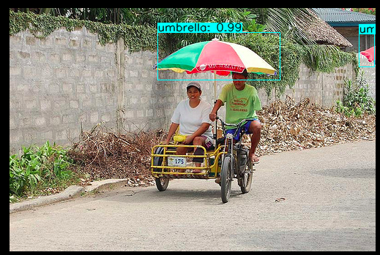
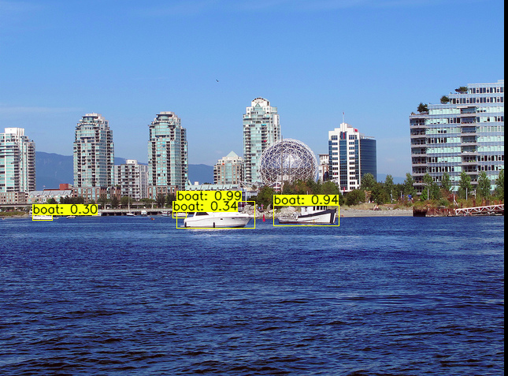

Model Evaluation:

