Name: Panneerselvam N
Role : Research Intern – Inspect
Date : 05/06/2021

Paddle Paddle You Only Look Once v2(PP-YOLO v2)

PP-Yolo is a improved version of PP-YOLO v2 and give better performance than Yolov3 and Yolo v4.
Architecture :

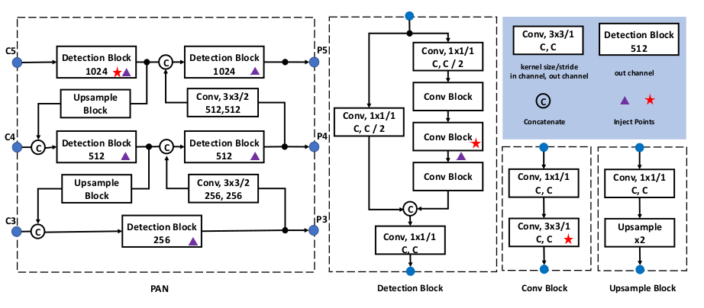
Above image shows the detection and neck of PP-Yolo v2.

Backbone :
- In PP-Yolo v1, ResNet-50 as used as Backbone , but in PP-Yolo v2 ResNet-101 is used as Backbone.

- ResNet-101 is pre-trained with COCO dataset.

Neck :
- Path Aggregation Network(PAN) is used as Neck part of PP-Yolo v2. Path Aggregation Network is improved version of PP-Yolov2.

Detection Part:
- Detection part is designed in the structure of Residual Blocks which has 3x3 and 1x1 convolutional blocks to produce detection results.

- The output channel of each final prediction is 3(K + 5), where K is number of
classes.

Optimizations :
Apart from PP-Yolo v1 optimizations , v2 has introduced lots of optimization techniques.

Path Aggregation Network:
- PP-Yolo v2 uses PAN as Neck part of Architecture. PAN is advanced version Feature Pyramid Network.

- Normal FPN merges the high level features to low level features in Top-Bottom opration. So the features of middel and low level are modified . This givesdifficulties for detect small objects.

- For overcome above problem, the PANet comes with additional layer pyramid of Bottom-top , this gives very efficient extraction low and middle level features.

Mish Activation Function:
In Yolo v4 and v5, Mish activation function gives good results in accuracy, so that PP-Yolo v2 also uses Mish Activation Function.

Mish Activation function is only used in Path Aggregation Network(PAN) in PP-Yolo v2.

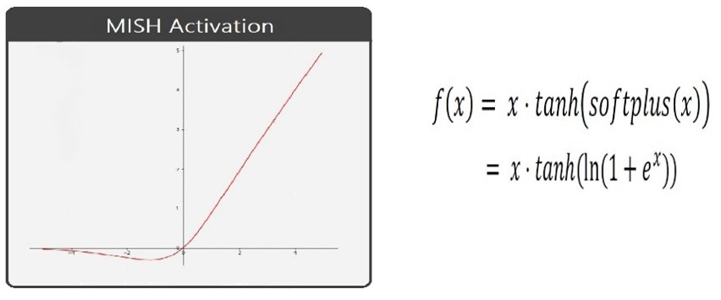
Large Input Size:
- Increase input size is one of key technique to improve model accuracy. But increasing image size will take large memory space .

- Deceasing batch size is one of the solution for above problem, image size is incrased from 608 to 768 and bactch size is decreased from24 to 12.

IoU Aware Lose:

In PP-Yolo v2 modified IoU Loss is introduced for better result in bounding box prediction.

Optimization technique that didn’t work:
Author tried some other optimization also, but that didn’t improve performance. The are some of that techniques,

- Cosine Learning Rate Decay
- Backbone Parameter Freezing
- SiLU activation function

Performance :
Author gives some Ablation study regarding optimizations,

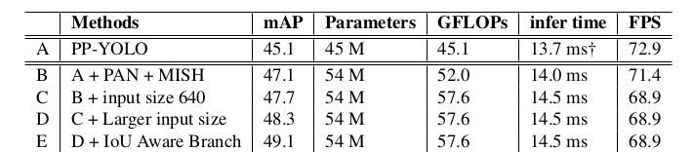
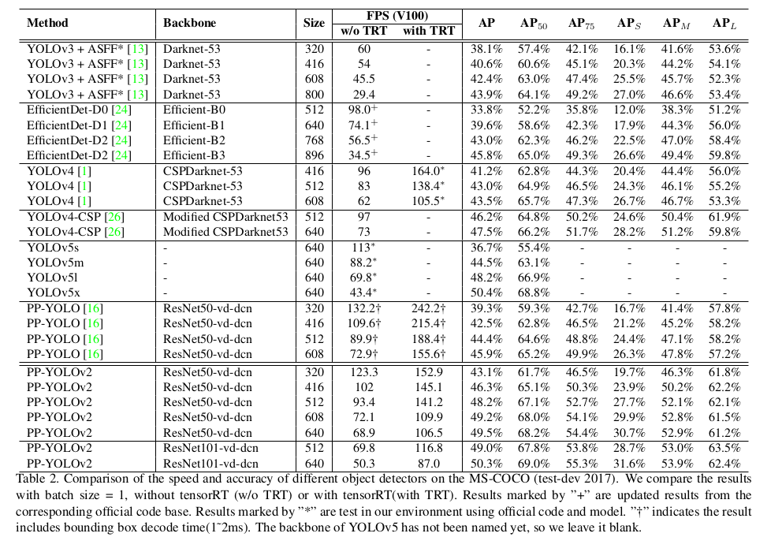
Conclusion :
Finally PP-YOLOv2 runs in 68.9FPS at 640x640 input size. Paddle inference engine with TensorRT, FP16-precision and batch size = 1 further improves PP-YOLOv2’s infer speed, which achieves 106.5 FPS. MAP also gives as 45.5.

