AERO2ASTRO

Report
by
Panneerselvam N
Research Intern - Inspect
Task 2 – Part 2
19/05/2021

Detailed Study On Tower Inspection

Electric Towers
Electric towers are the tall structure used transmit power using overhead lines .This is also called electric Pylons.

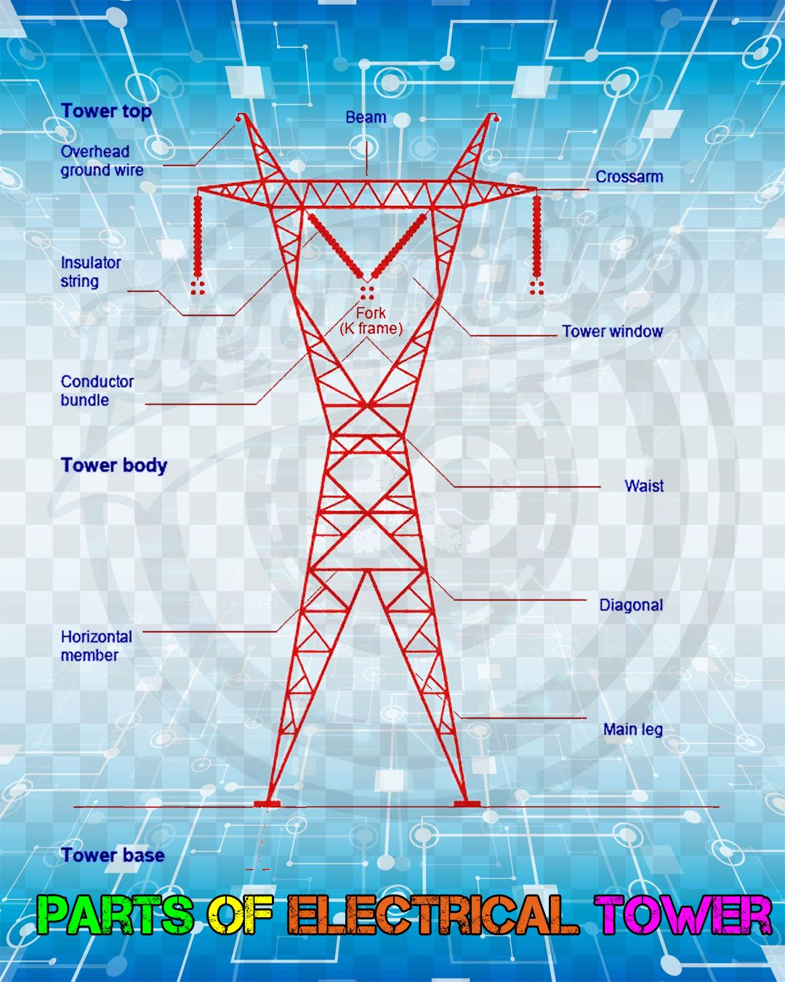
Main parts of electric tower:

1.Tower top:
Tower top is used to carry earth shield wire. This is connected at tip of tower also known as earth wire
2.Cross arm:
Cross arm is used to hold insulators. Insulators are used to carry transmission conductors. Dimensions of cross arm depends upon level of voltage to be transmitted.
3.Beam:
Beam is the portion between cross arms. This is used to hold cross arms.
4.Insulator strings:
Insulator string is used to carry transmission lines. There no. very depending upon the level of Transmission voltage to be transmitted. As the voltage level increase no. of insulators increases in a string.
5.Cage of Transmission tower(Fork K-Frame):
Cage is the main structure of Transmission towers which provides support to whole body of Transmission tower.
6.Tower body and leg of Transmission tower:
They are base of transmission tower. During design of Transmission tower minimum ground clearance of the lowest conductor point above the ground level is depends upon Tower body and leg of transmission tower. Higher the voltage to be transmitted higher will be the ground clearance required than higher will be the width between legs of Transmission towers.
7.Tower base:
Base of tower is the main holding of whole Transmission tower.
8.Vibration Damper:As clear from its name these are used for damping out vibrations due to wind in transmission towers.
Classifications of Towers:

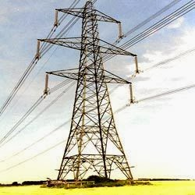
1.Majorly used for straight line transmission

2.It has small angle deviation - (2° – 5° )

2.Tension Towers(Angle):
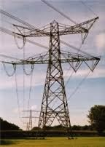
1.These type towers majorly used in turning point and where more angle deviation is required.

2.Further type:
0-10 degree tension towers (TD1)
10- 30 degree tension towers (TD3)
30-60 degree tension towers (TD6)

3.Transposition Tower:

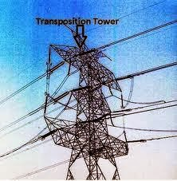
1.Transposition towers are specially used for transpose the conductors of three-phase line .

2.These types of towers are much less use in recently

Special Towers
1.These towers are used at locations such as those involving long-span river crossings, valley crossings and power line crossings.

2.Cost is high compared to other towers, because of special design.
Things to be inspected:

- The ground, such as ground movement or erosion
- Power lines, such as hot-spots or indicators of corona discharge
- Transmission towers, such as corrosion, broken components, and foreign objects on the tower
- Surrounding vegetation, such as tree growth rate and areas of vegetation encroachment
- Others ,such as unauthorized debris and construction activity

Inspection methods and Tools:
Orthomosaic Map:
An orthomosaic is a geometrically correct aerial image that is composed of many individual still images that are stitched together.
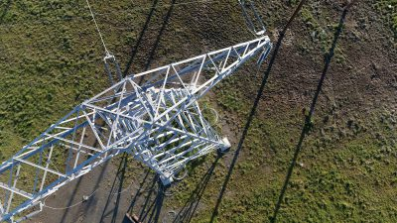
This Orthomosaic images are used to create 3D model or elevation model for analyzing all inspections

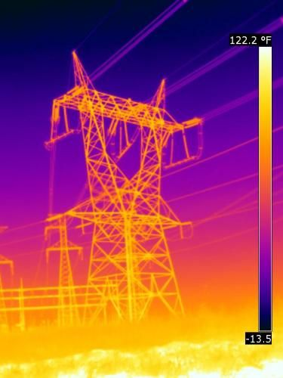
Thermal Image :
1.Thermal image is captured by thermal cameras which is used to analysis heat distributions.

2.In transmission line, if more heat is produced which shows that there will be short circuit or corona effect happened.
LiDAR Point Cloud:
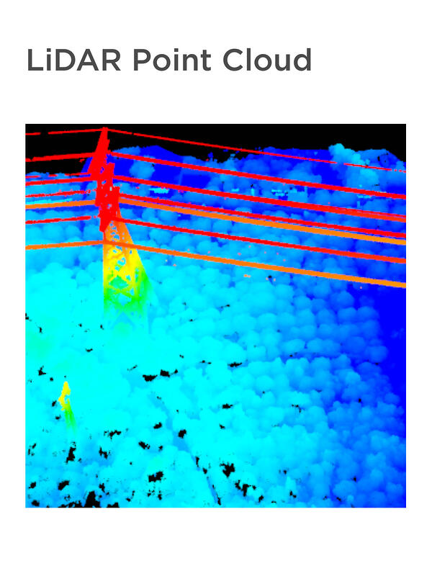
LiDAR point cloud is 3D model which is created by LiDAR data points.

This 3D model is very useful to analysis all kind of things.

Multi-spectral image
1.A multi-spectral image is one that captures image data within specific wavelength ranges across the electromagnetic spectrum.

2.This image used analysis property of land tower
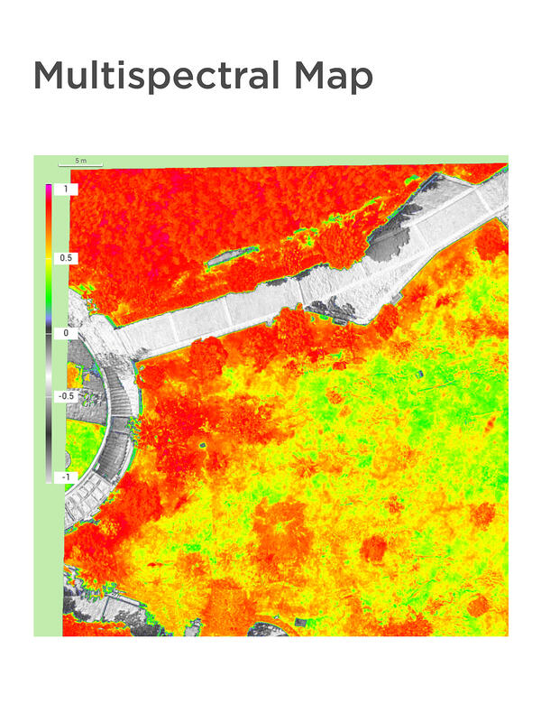

Research Paper:

Title : A Drone Based Transmission Line Components Inspection System with Deep Learning Technique

In this paper the following power line components can be detected and analyzed it’s defects.
(a) Transmission tower
(b) Lightning-arrester
(c) Suspension type white porcelain insulator
(d)Suspension type porcelain insulator
(e) Polymer insulator
(f) Spacer
(g)Porcelain insulator

(e)Polymer insulator;
(f)Spacer;
(g)Sag adjuster with bolted tension clamp;
(h)Vibration damper;
(i)Balisor.

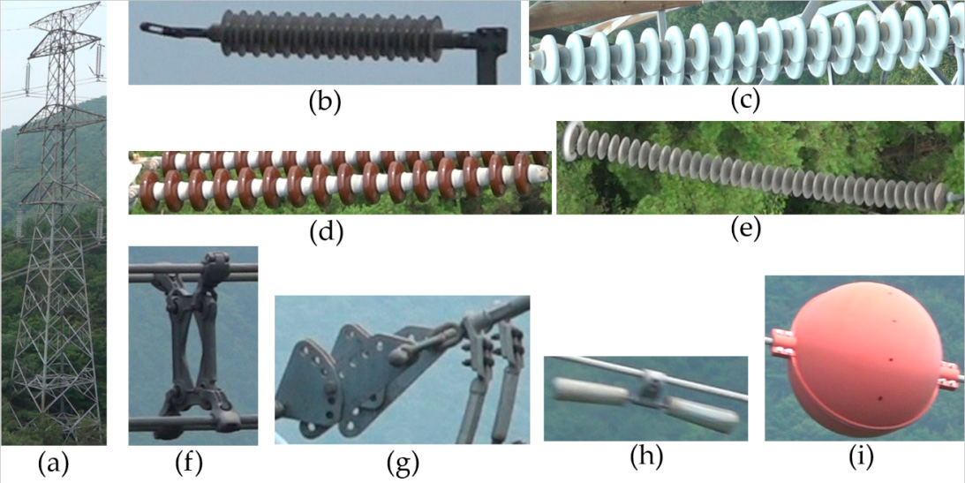
Component Detection :
Components are detected by custom object detection with Yolov3 .
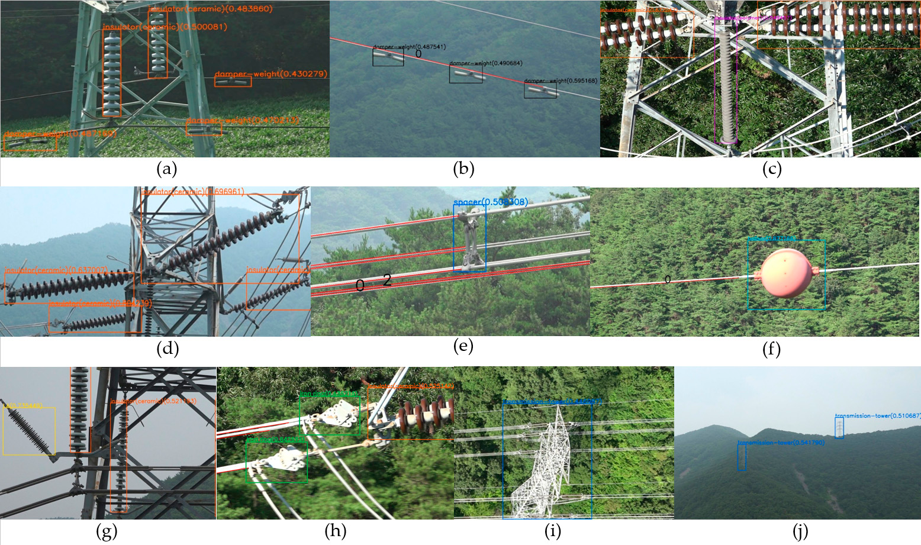
Component analysis :
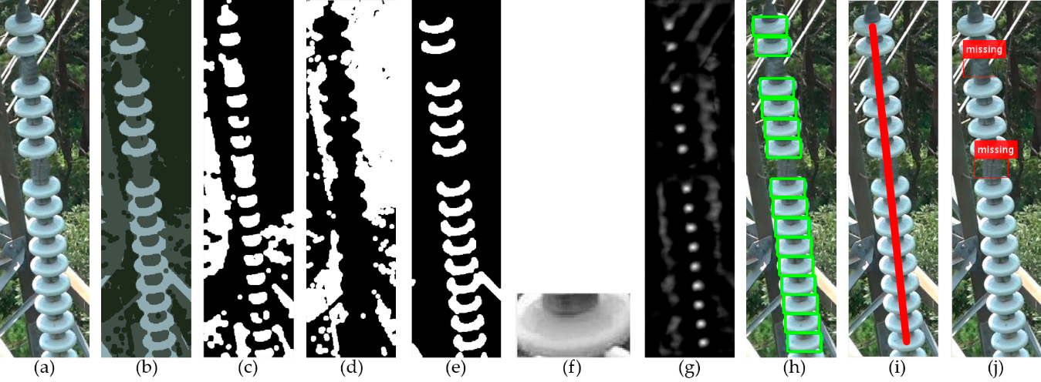
Broken Disc detection:

Steps for broken disc detection :
(a). Detected image from Yolov3
(b). Output of color clustering based segmentation
(c – e). Segmentation masks for clustering
(f) Candidate template after connected component analysis and max voting for finding most repeating pattern
(g).Activate map of the template matching
(h). Results of the template matching
(i). Dram straight line with template matching centers
(j). Detected output

Balisor Color Fading Defects:
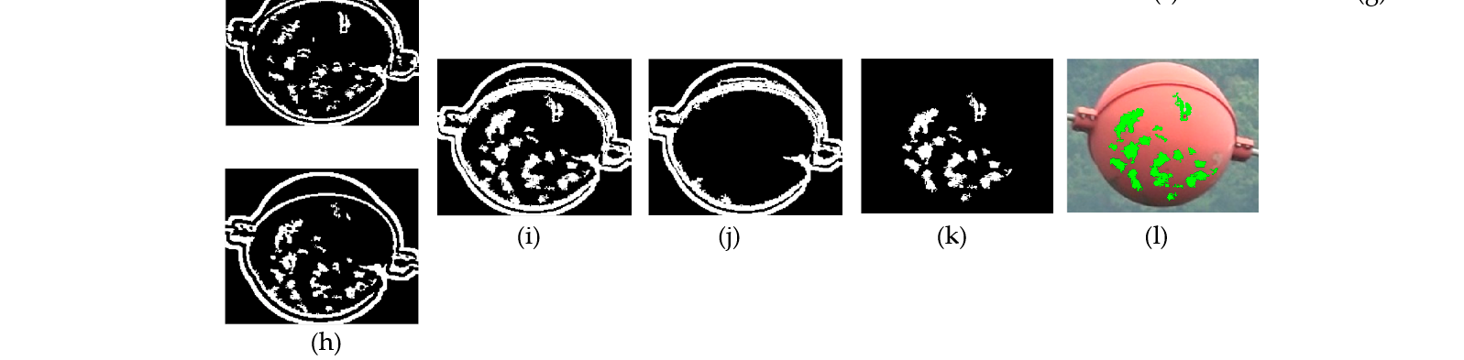
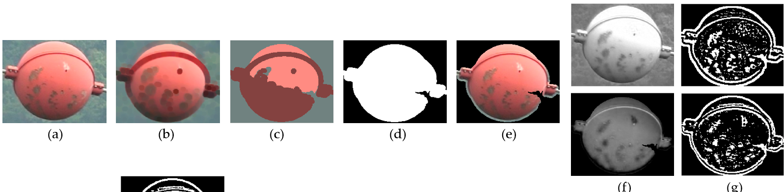
Steps: (Refer above Fig)
(a). Input image from Yolov3
(b). Eroding image
(c). Color clustering image
(d). Foreground mask
(e). Masked Foreground
(f). Balisor Image in R- and S-color space
(g). After filtering (Gaussian filter)
(h) After removing noise from (g)
(i) Combination of (h) outputs
(j) Mask for for boundary regions
(k) Defects
(l) Highlighted image
Corrosion Defects in Sag Adjusters:
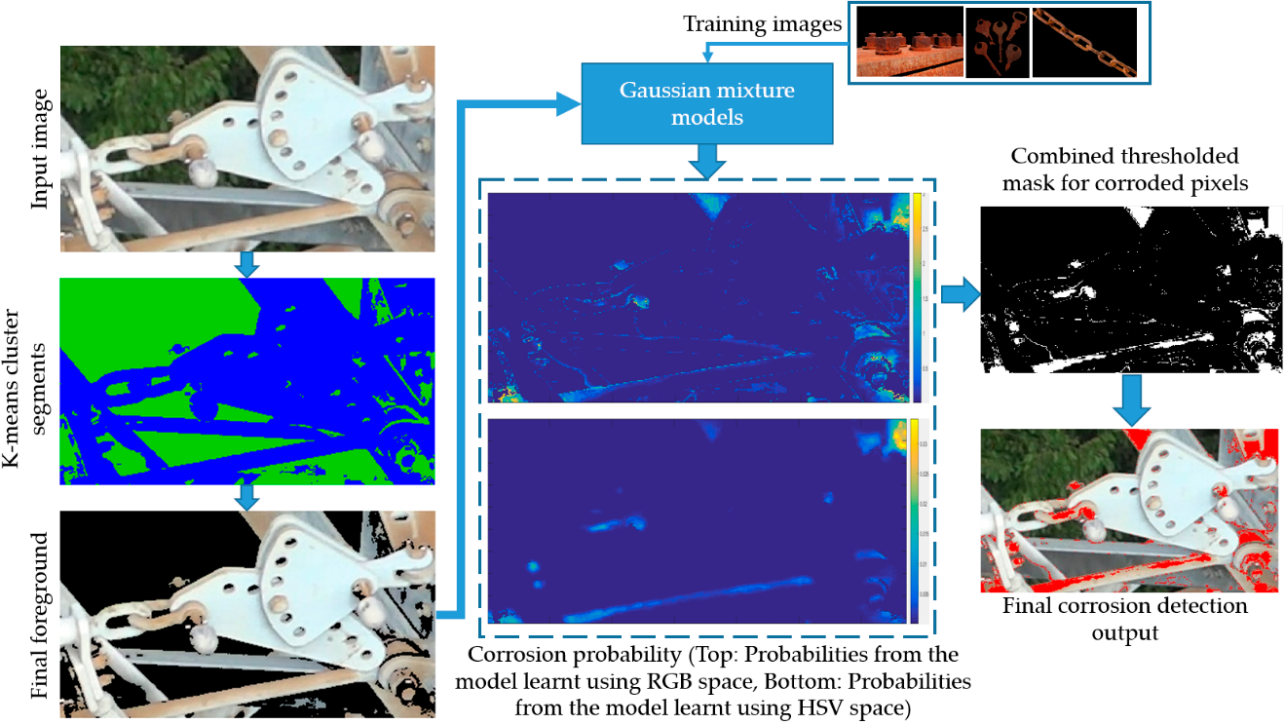
Steps:
1. Detect image from Yolov3
2. Apply K-means clustering segmentation
3. Separate Foreground from image
4. Use Gaussian mixer model to detect corrosion (Inputs are Foreground image and some corrosion image)
5. Create thresh holed mask for corrosion detection.
6. Apply thresh holed image to detected image for result

Broken vibration Damper:
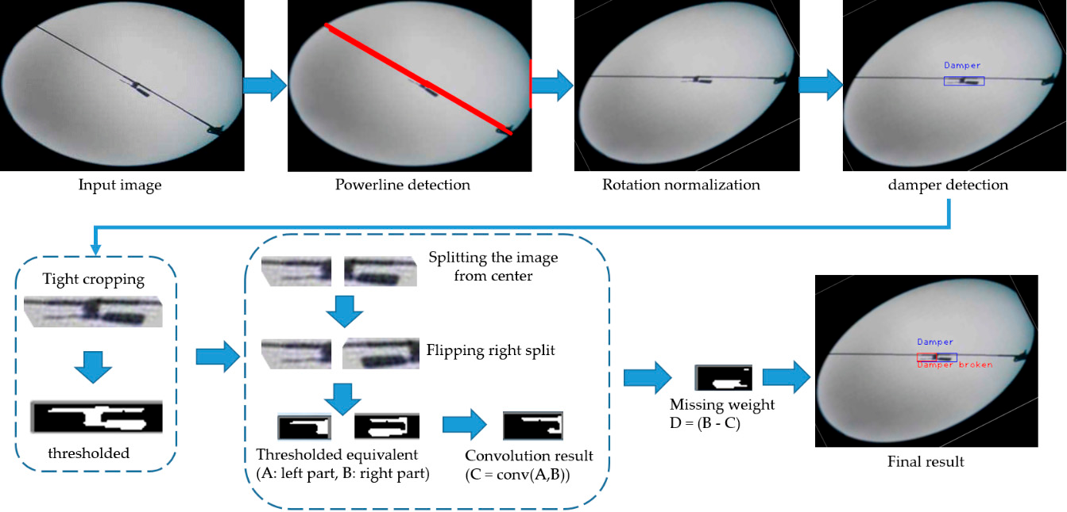
Splits and Puncher Detection in Polymer Insulator:
Splits can appear in polymer insulators because of several reasons, including low quality materials , miss-handling during transportation , weather changes or birds etc.
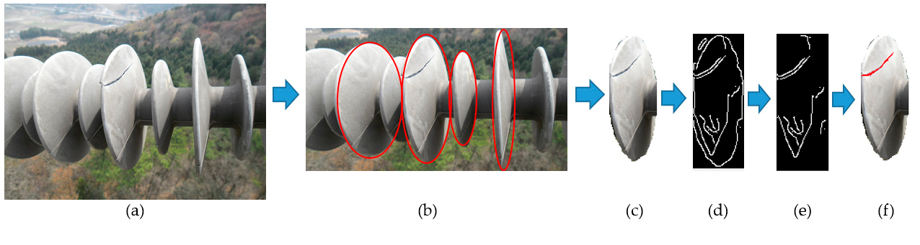
Steps: (Refer above image)
(a). Detected Image from Yolov3
(b). Ellipse Detection
(c). Detected one cap image
(d). Edge map
(e). Edge map after boundary removal
(f). Detected output with splits

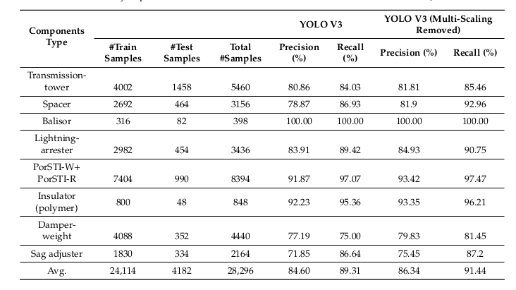
Model Performance :
Research paper link : https://res.mdpi.com/d_attachment/energies/energies-13-03348/article_deploy/energies-13-03348-v2.pdf

