AERO2ASTRO

Report
by
Panneerselvam N
Research Intern - Inspect
Task 4
20/05/2021

Wind Turbine Inspection

A wind turbine is a device that converts the wind's kinetic energy into electrical energy. This wind turbines are most important renewable energy source.

Types :
Wind turbine are majorly classified into two types.
- Horizontal axis wind turbine (HAWT)
- axis wind turbine(VAWT)
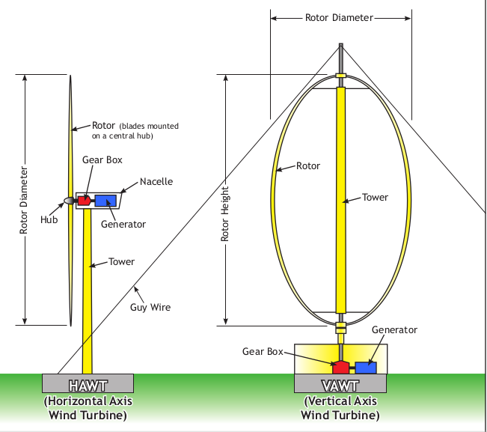
Horizontal Axis Wind Turbine(HAWT):
Horizontal axis wind turbines are the widely used wind turbines in today.

HAWTs utilize aerodynamic blades(airfoils) fitted to a rotor, which can be positioned either upwind or downwind.

Advantages :
- The tall tower base allows access to stronger wind in sites with wind shear. In some wind shear sites, every ten meters up the wind speed can increase by 20% and the power output by 34%.
- High Efficiency : (Converts 40 – 50 of receiving wind into power)
- High operational wind speed : (Able to rotate high speed, which means it produce high amount of power )

Disadvantages :
- Must be pointed to towards wind
- Massive tower and components required
- Required braking mechanism
- Large height affects appearance

Vertical Axis Wind Turbine :
A vertical axis wind turbine (VAWT) has blades mounted on the top of the main shaft structure vertically.

This VAWT further classified into three types:
1.Darrieus wind turbines

2.Savonius wind turbine
3.Giromill

Advantages :

- Produce electricity from any direction
- Not required heavy tower
- Less installation cost
- Also placed in urban areas
- Easy maintenance

Disadvantages:

- Less efficiency
- Not suit for high speed
- Required initial starting mechanism
- Create more noise and vibration

Components in Wind turbine :
Tower :
Towers carries the all the components of wind turbine.
Types:
- Tubular steel Towers
- Lattice Tower
- Bolted Steel Towers
- Hybrid Steel Towers

Nacelle:
A nacelle is a cover housing that houses all of the generating components in a wind turbine, including the generator , gear box, dive assembly, and brake assembly.

Rotor Blades :
- This rotor blades observes wind and rotates the generator’s rotor.
- It will rotate up to 160 miles/hr
- It is made up of many layers of wood , carbon , resin , fiberglass
Generator : Generates electrical Energy

Faults occur in wind turbine (Surface only):
- Leading Edge erosion
- Surface cracks
- Damaged lightning receptors
- Damaged vortex generators,
- Oil leakages in gearbox

Fault Detection Using Deep learning:
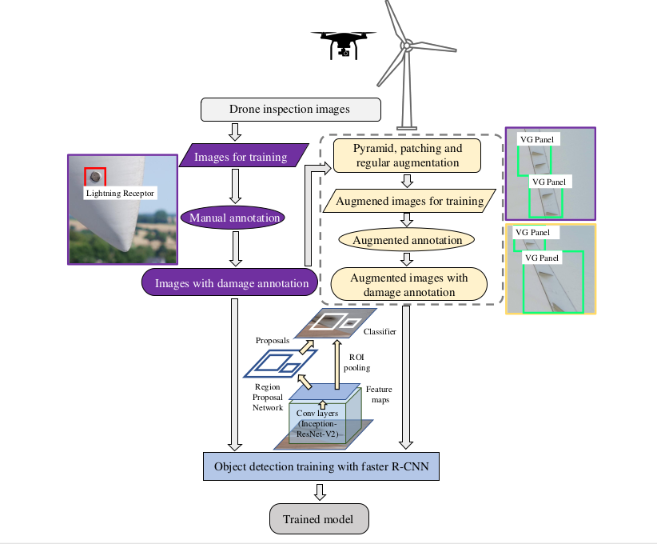
\

Image Augmentation:

Deep Learning models are always hungry for data. So, more data is required for model training.

Image augmentation method is used to create more data by slightly modifying original data.

Augmentation methods:

- Regular augmentation - (Flip , blur , zoom ,rotation )
- Pyramid and Patching Augmentation

Image resolution problem in Aerial images :
Aerial images are taken by high resolution cameras. But during deep learning model training that image are resized . So, fault part also resized and this lead to model doesn’t learn properly .

For overcome above problem we use Pyramid and Patching Augmentation.

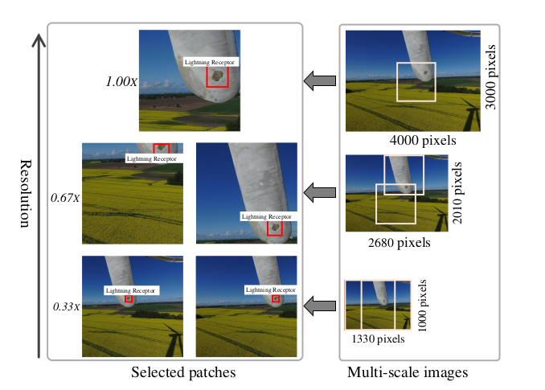
Various Object Detection Algorithms :

1. Faster R-CNN
2.You Only Look Once(Yolo)
3.Single shot detection
4.Region based Fully Convalutional network

CNN performance in fault detection:
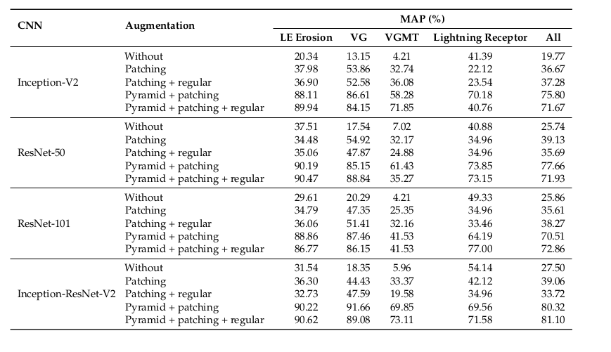
Above table clearly shows augmentation plays major role to give good results.

Multi-scale Pyramid:
Image Pyramid can create a multi-resolution representation of an image to facilitate efficient multiscale processing.
Types:
- Gaussian
- Laplacian

Datasets :
- EasyInspect Dataset
- DTU Drone Inspection Dataset
- Wind Turbine Blade SfM Image

