AERO2ASTRO
Report
by
Panneerselvam N
Research Intern - Inspect
Task 5
21/05/2021

Fault Detection Methods

Common approach for fault detection:
Object Detection
Fault Analysis

Most of the fault detection methods are using above apporoach.

Object Detection methods :

- Fast R-CNN.
- Faster R-CNN.
- Histogram of Oriented Gradients (HOG)
- Region-based Convolutional Neural Networks (R-CNN)
- Region-based Fully Convolutional Network (R-FCN)
- Single Sho Detector(SSD)
- Spatial Pyramid Pooling (SPP-net)
- YOLO (You Only Look Once

Most widely used object detection:
- Faster R-CNN
- Yolo (You only look once)
- SSD(Single shot Detection)

Faster R-CNN:

Working of Faster R-CNN :
- We take an image as input and pass it to the ConvNet which returns the feature map for that image.
- Region proposal network is applied on these feature maps. This returns the object proposals along with their objectness score.
- A RoI pooling layer is applied on these proposals to bring down all the proposals to the same size.
- Finally, the proposals are passed to a fully connected layer which has a softmax layer and a linear regression layer at its top, to classify and output the bounding boxes for objects.
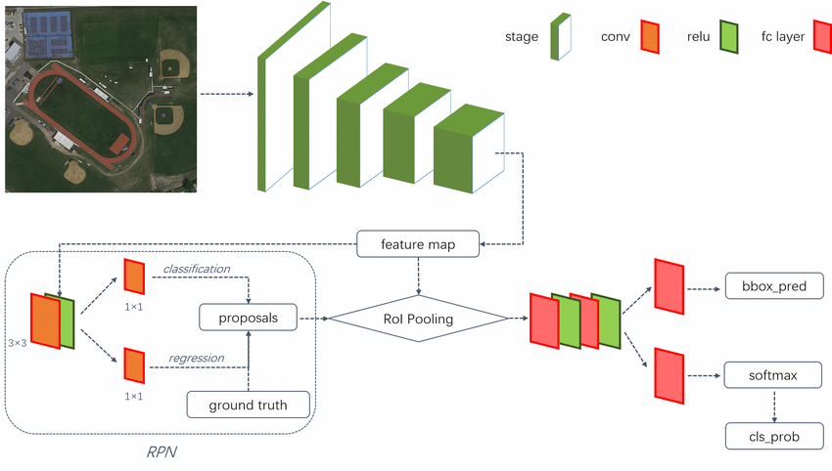
CNN Architectures :
CNN is the backbone for Faster R-CNN,

CNN Architectures and Difference:
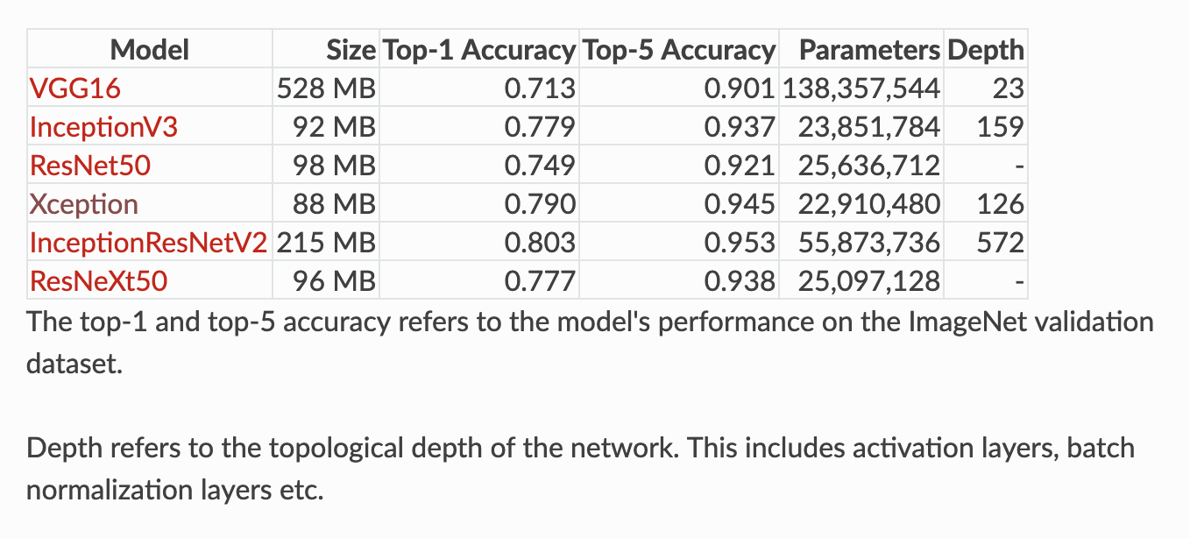

VGG16 :
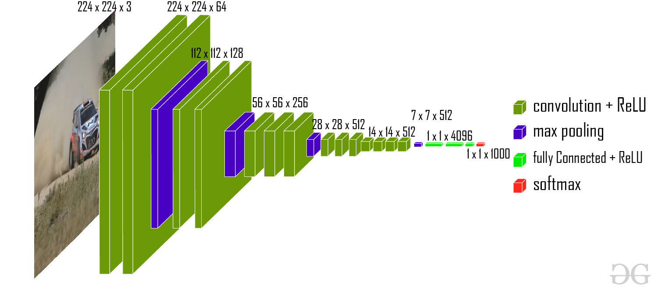
Working:
- Predefined input image fed into Five convalutional blocks followed by one by one.

- Each CNN blocks have two layers (Covalutional and Max pooling ) and it’s produce’s features.

- After these features flattened and fed into Fully connected layers. This layer gives output as 1x1x4096 vectors.

- These vector are given to softmax function. These softmax function produce probability of classes.

Softmax Function :
- The Softmax regression is a form of logistic regression that normalizes an input value into a vector of values that follows a probability distribution whose total sums up to 1.

- It is one of the activation function and majorly used output layers for Multi-class classification.
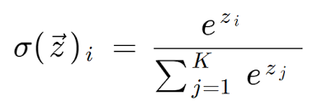

Classification Algorithms :

- Logistic Regression
- Naïve Bayes
- Stochastic Gradient Descent
- K-Nearest Neighbours
- Decision Tree
- Random Forest
- Support Vector Machine

Logistic Regression:
- Logistic Regression the appropriate regression analysis to conduct when the dependent variable is dichotomous (binary).Like all regression analyses, the logistic regression is a predictive analysis.

- Logistic regression is used to decribe data and to explain the relationship between one dependent binary variable and one or more nominal, ordinal, interval or ratio-level independent variables.

Decision Tree:

- The decision tree Algorithm belongs to the family of supervised machine learning algorithms. It can be used for both a classification problem as well as for regression problem.
- The goal of this algorithm is to create a model that predicts the value of a target variable, for which the decision tree uses the tree representation to solve the problem in which the leaf node corresponds to a class label and attributes are represented on the internal node of the tree.

Support Vector Machines :(SVM)

- SVM is one the machine learning algorithm which is used to both regressing and classification tasks.

- Objective of SVM is to find a hyperplane in N -dimensional space that distinctly classifies the data points.

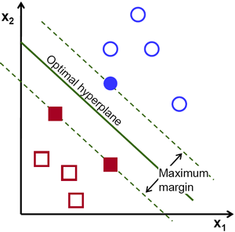
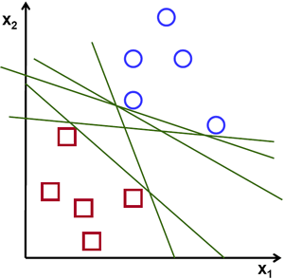
YOLO(You Only Look Once):
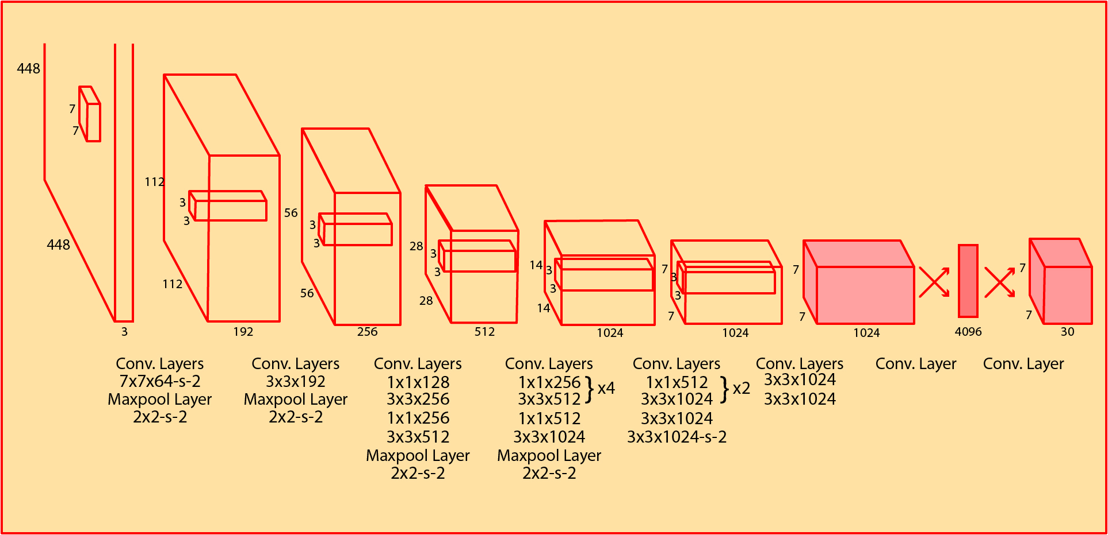
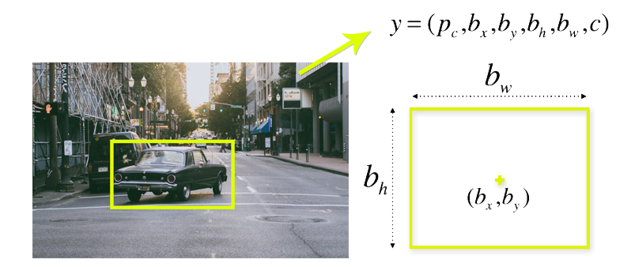
YOLO algorithm is an algorithm based on regression, instead of selecting the interesting part of an Image, it predicts classes and bounding boxes for the whole image in one run of the Algorithm.
Working :
First input image Spitted into NxN grid cells. Each grid is responsible for K bounding boxes. Because of possible of single grid have multiple images.
Sometimes Most of these cells and bounding boxes will not contain an object. Therefore, it predict the value pc, which serves to remove boxes with low object probability and bounding boxes with the highest shared area in a process called non-max suppression.

Handling Data Insufficiency :
Image Transformation : New samples are created by rotating , cropping , resizing , shifting and noising from original image.
Image synthesis :The synthetic image is generated from real-world images
by synthesizing the instance image and background image. The background image
is separated by U-Net . Mask-RCNN and FCN.
GAN(Generative Adversarial Network):
The generative model of GAN can generate an new image by inputting an original image.

The image can be transformed to another style such as day-to-night, summer-to-winter, sunny-to-foggy etc.

