AERO2ASTRO
Report
by
Panneerselvam N
Research Intern - Inspect
Task 6
22/05/2021

Fault Detection Techniques
Today I have Fully studied one research paper which title is “A Supervised Approach to Electric Tower Detection and Classification for Power
Line Inspection”

Objective :
The main objective the research paper is to Detect various types of Towers and classify it’s category.

Algorithms Used :
- Histogram of Oriented Gradients
- Multiplayer Perceptron
- Activation Functions (Sigmoid)

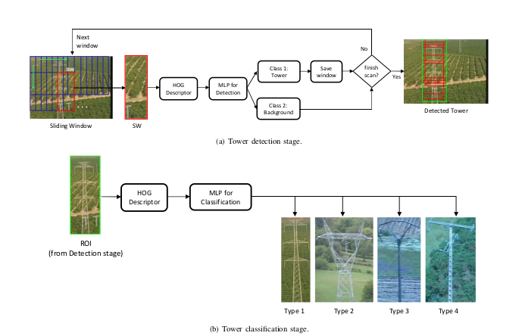
Working :
Detection part:

Here Siding window technique is used for to separate input image into various windows . These windows fed into HOG feature extractor . HOG feature extractor will create feature vector. These feature vector is used to train neural networks . These trained neural networks are used to detect Towers.

Classification :
After Tower is detected , cropped images fed into next Neural Networks for training. This Neural Networks are recognize whether this tower is Type 1 ,Type 2 or others.

Histogram of Oriented Gradients(HOG):
HOG is one of the feature extractor and which transforms image into Histograms.

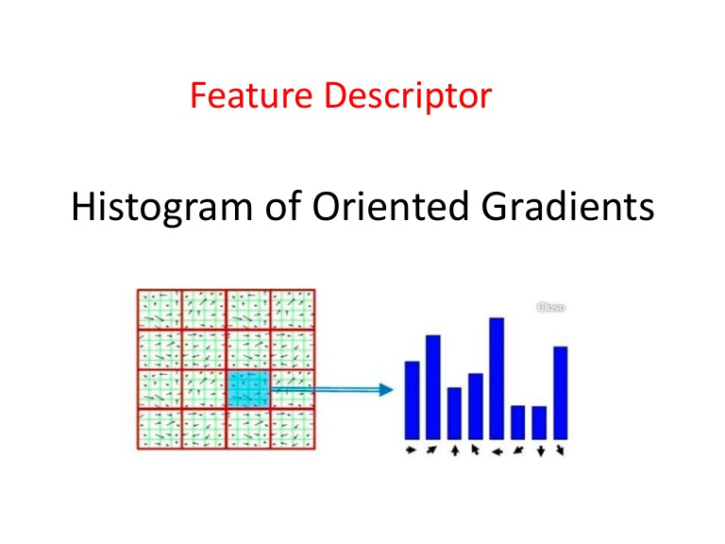

First the input image is resized in the shape of (64x128) . Next it is splited by 16 grids which means every grid has (8x8) pixels .

Gradients and angles are calculate for every single grid .
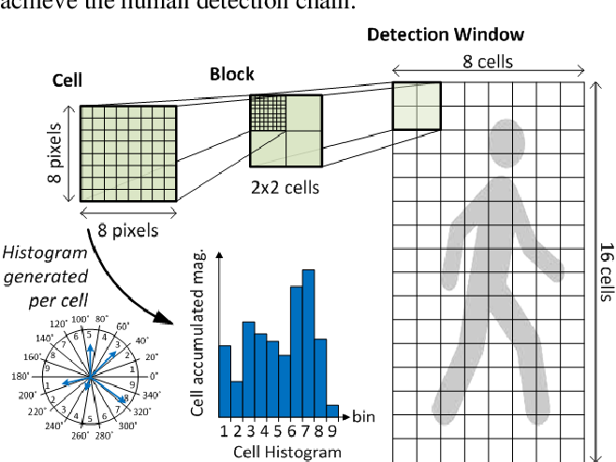
Formula for calculation : (Magnitude and Angle)

Consider any one pixel in single grid(Cell):

Gy = Difference between neighbor pixels verticall (Top and Bottom)
Gx = Difference between neighbor pixels horizontally (Left and right)

After calculating this magnitude and angle , Histograms are created by frequency of magnitude and angle between (0 – 180 degree).
Multiplayer Percetron(MLP) :
MLP is used as classifier in this paper .

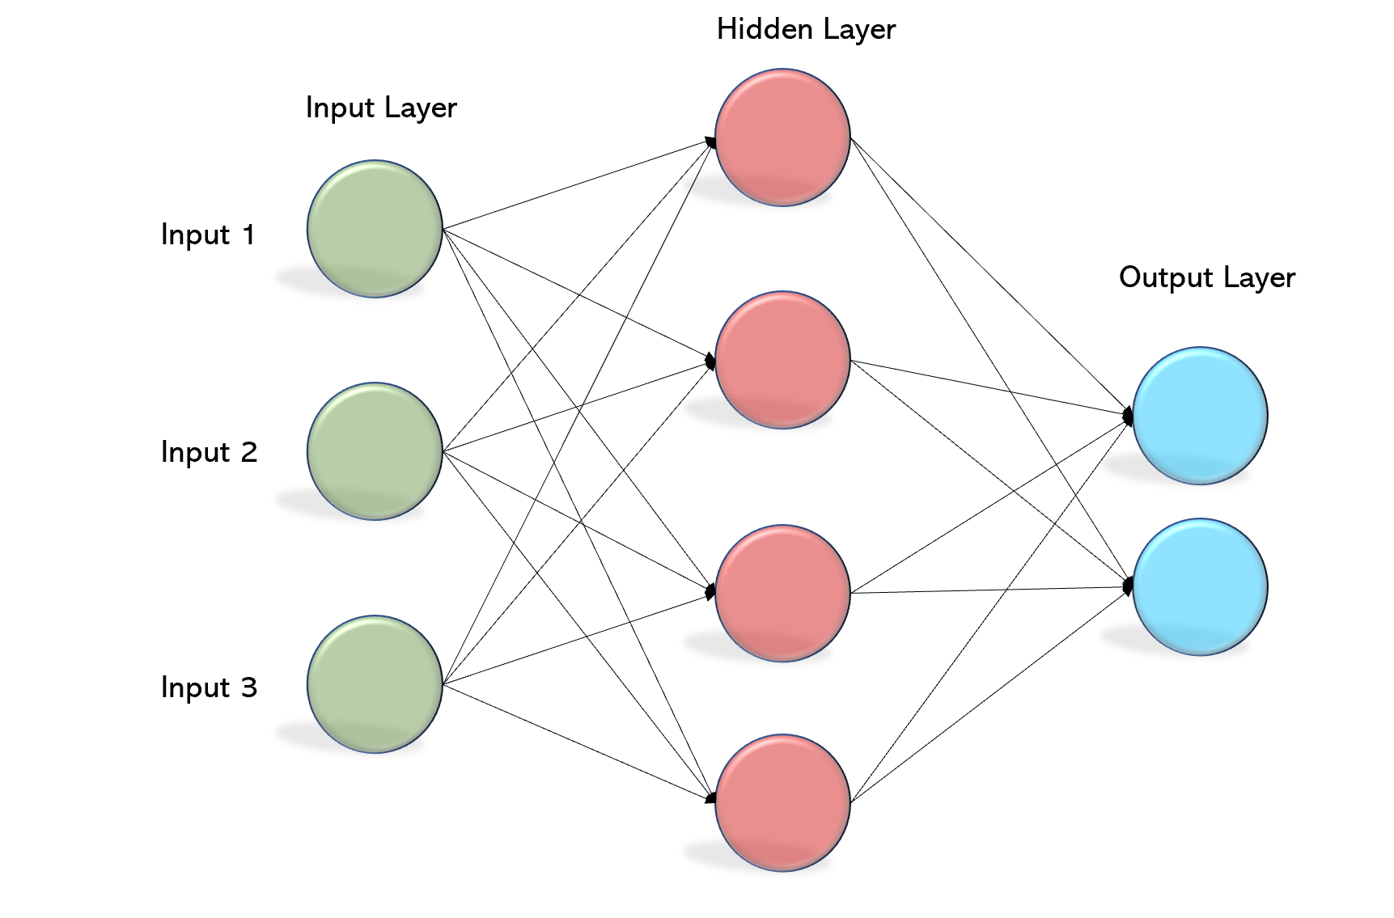

Neural Networks are separated by 3 layers:
1. Input layer
2. Hidden layer
3. Output layer

Each layer have activation function to determine outputs .
Sigmoid :
Simply sigmoid fuction converts value x into in between of 0 -1 .

if x > 0.5 → Gives 1
if x < 0.5 → Gives 0

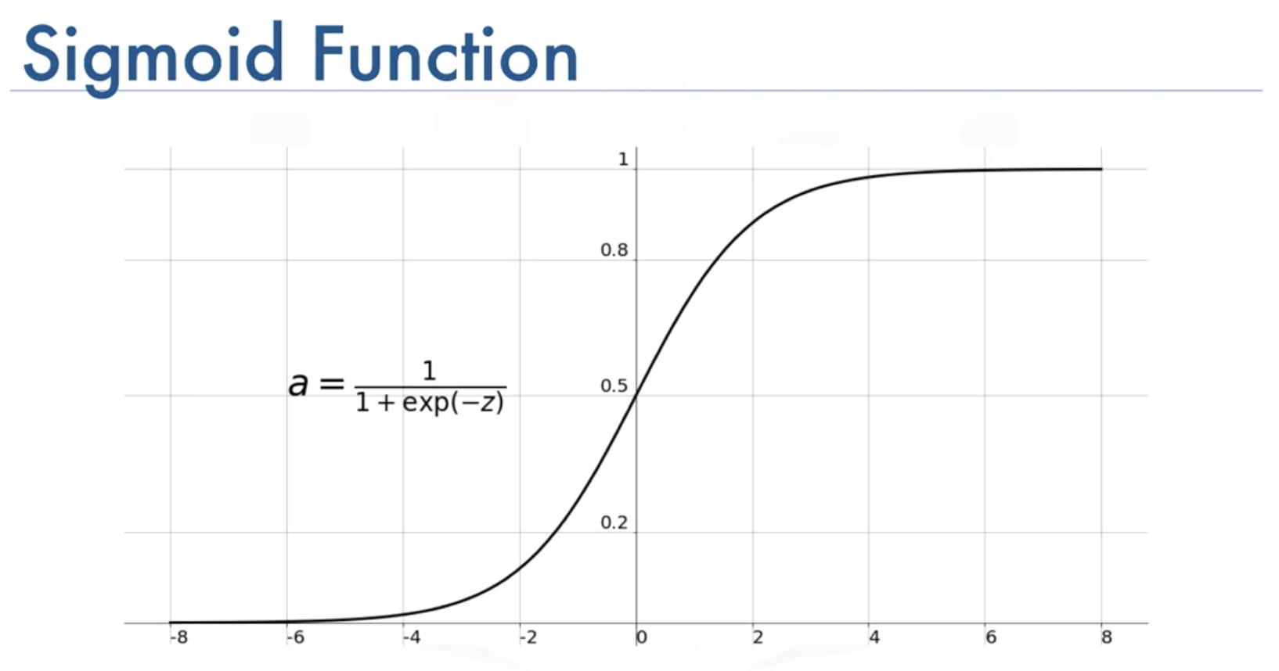

My Learning and Comments :
I have Fully learned working and Mathematics behind this HOG algorithm.

Now a days more algorithms are very efficient like YOLO , Faster R-CNN for object detection. But I think Sliding Window + HOG + Classifiers are starting point for object detection .
Reference :
Research Paper link : https://www.researchgate.net/publication/265239503_A_Supervised_Approach_to_Electric_Tower_Detection_and_Classification_for_Power_Line_Inspection

For HOG : https://www.analyticsvidhya.com/blog/2019/09/feature-engineering-images-introduction-hog-feature-descriptor/

