Name : Panneerselvam N
Role : Research Intern – Inspect
Date : 23/05/2021

Weekly Report -1

Unmanned Aerial Vehicle(UAV)
Unmanned aerial vehicle(UAV) is an aircraft with carries no human pilot or passengers. Commonly UAV are known as Drones.

Basic Components used UAV:
- Body
- Power supply - (Lithium polymer and Lithium-ion)
- Sensors - (Accelerator , speed and distance sensor , GPS, LiDAR)
- Controller - (Flight controller , System on chip , Autopilot)
- Communication medium– (Radio signal , Data link)
- Software
Firmware : ArduCopter-v1 , PX4
Middleware : PX4 , ArduPilot
Operating system : ROS , Nuttx , Linux distributions

Types of UAV :

- Multi-rotor type
- Fixed wing
- Single rotor type
- Fixed wing Hybrid

Applications of UAV:
- Aerial Inspection
- Aerial Photography
- Mapping & surveying
- Agriculture
- Product delivery
- Corp spraying and monitoring
- Traffic Monitoring
- Defence
- Drone racing

Advantages of UAV:
1.Drones can Survey dangerous places
2.Drones can enforce security and surveillance
3.Used in various industries
4.Get high quality and clear Photography
5.Good at Shooting a Wide Range
6.3D Models Can be Done Easily

Limitations of UAV:
1.Low operation speed - ( UAV has less operation speed with compared to Manned Aerial Vehicle)
2. Battery Life : (Battery Life limits the operating time of UAV)
3.Weather Changes: (Sometimes temperature , snow and wind affects the Drones)
4.Vulnerable to hackers: (There is possibility of hackers misuse Drones )
5. Operating skill : (Little bit operating skill is required to control drones)
6.Software Issues: (If software is crashed during drone flying, there will possibility to damage any people or others)
Current Advancement in Drones:
- AI enabled drone
- Drone and Virtual Reality
- Battery optimization

Aerial Inspection:
Drone is used to inspect and identify defeats or faults of an industry by capturing and analyzing drone data is called Aerial Inspection.

List of industries used Aerial Inspection:
- Agriculture
- Chemistry Industries
- Construction
- Renewable energy(Solar , wind)
- Oil and Gas

Advantages of Aerial Inspection:
1.Accuracy : (Good inspection accuracy )
2.Speed : ( Inspection speed is very high compared to manual process)
3.Safety : (Drone gives safe inspection)
4.Access any object : (Inspect even very small and big objects)
5.Cost effective : (Drone gives cost effective way of Inspection)

Disadvantages of Aerial Inspection:
1.Skills requires : (Some drone operating and domain knowledge is required)
2.Privacy : (Possible to hackers to hack drone and misuse that data)
3.Manual correction :(only inspection is done by drone ,but correction is done by manually)

Software used in Aerial inspection :
- Scopito
- Agisoft PhotoScan:
- Pix4D:
- Bentley ContextCapture:
- Droedeploy

          - Tower Inspection with Drones
A Tower is an tall structure ,taller than it’s wide and majorly used to carry something in large height.
Types of Towers:
- Lattice Tower:
- Monopole Tower:
- Guyed Tower:
- Stealth Tower:
Components Used in Towers

In Telecommunication Towers:
1.Whip Antenna - ( Used to Receiving and Transmitting Radio signals)
2.Antenna Array – (Set of antennas used provide signal in particular directions)
3.Microwave Dish – (Special type antenna used to point to point connection)
4.Port holes - (Holes cut into the base and top of tower to allow cables and wiring to pass through the tower structure, from the base station to the antennas.)
5. Remote Radio Unit(RRU) – (Radio Wireless Transceiver)

In Power Transmission Towers:
1.Conductors – (Conductors are used to power transmission)
2.Insulators – (To give insulation between two conductors)
3.Fuses – (Protects from current surges)
4.Cross arm – (Support for conductor)
5. Body Extension – (Used to increase the height of towers)
6. Leg Extension – (Gives Initila support for towers)

Aerial Inspection in Tower – Use Cases :
- Identifying Hazards – (Structural damage, Beehives , Bird nest, etc)
- Pre-work inspection - ( Use data collected via drone to determine what types of tools will be required for tower inspector to do his or her job.)
- Structural Analysis – (To find degradations in tower)

Electric Towers
Electric towers are the tall structure used transmit power using overhead lines .This is also called electric Pylons.

Classifications of Towers:

- Suspension Towers
- Tension Towers
- Transposition towers
- Special Towers
Things to be inspected in Electric Towers:
- The ground, such as ground movement or erosion
- Power lines, such as hot-spots or indicators of corona discharge
- Transmission towers, such as corrosion, broken components, and foreign objects on the tower
- Surrounding vegetation, such as tree growth rate and areas of vegetation encroachment
- Others ,such as unauthorized debris and construction activity

List of Components to be inspected:
- Transmission tower
- Lightning-arrester
- Suspension type white porcelain insulator
- Suspension type porcelain insulator
- Polymer insulator
- Spacer
- Porcelain insulator
- Polymer insulator
- Spacer
- Sag adjuster with bolted tension clamp
- Vibration damper;
- Balisor.

AI techniques used in Electric tower inspection :
- Yolov3
- K-means Clustering
- Template Matching
- Foreground Extraction
- Support vector Macines
- Gaussian Filter
Yolov3 Performance :
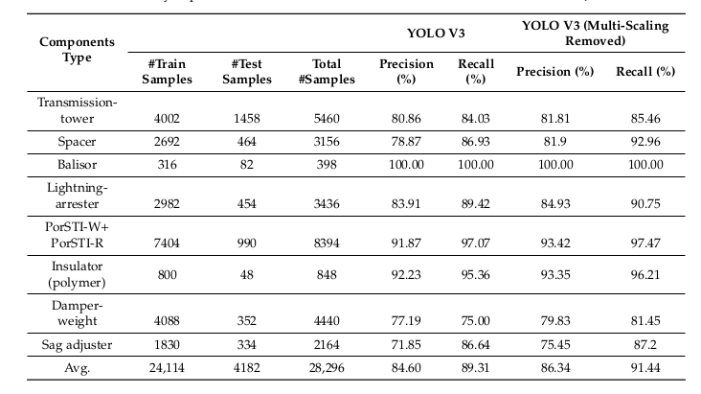
Wind Turbine Inspection
A wind turbine is a device that converts the wind's kinetic energy into electrical energy. This wind turbines are most important renewable energy source.
Types :
Wind turbine are majorly classified into two types.
- Horizontal axis wind turbine (HAWT)
- axis wind turbine(VAWT)

Components in Wind turbine :(Outer Only)

- Tower
- Nacelle
- Rotor Blades
- Lighting Receptors
- Bolts
Faults occur in wind turbine (Surface only):
- Leading Edge erosion
- Surface cracks
- Damaged lightning receptors
- Damaged vortex generators,
- Oil leakages in gearbox
Fault Detection Using Deep learning:
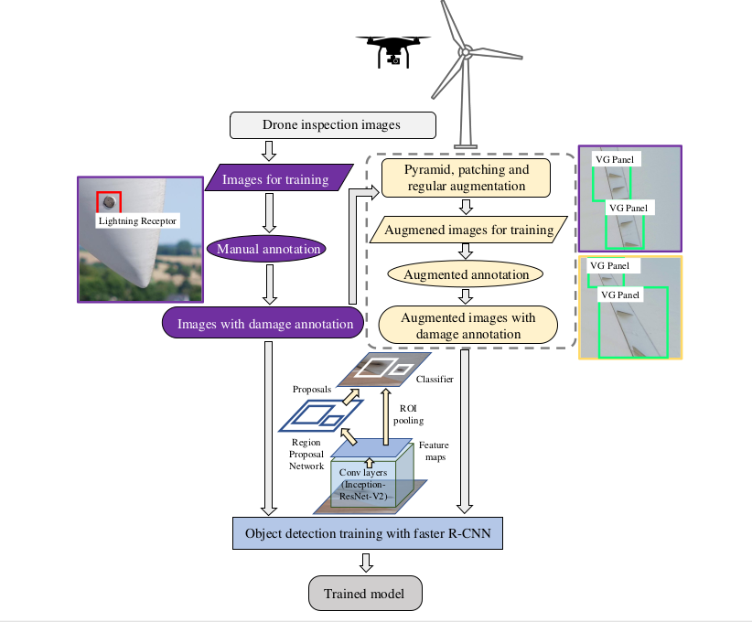
Various Object Detection Algorithms :
Object Detection methods :

- Fast R-CNN.
- Faster R-CNN.
- Histogram of Oriented Gradients (HOG)
- Region-based Convolutional Neural Networks (R-CNN)
- Region-based Fully Convolutional Network (R-FCN)
- Single Sho Detector(SSD)
- Spatial Pyramid Pooling (SPP-net)
- YOLO (You Only Look Once
Datasets availabe for wind Turbine:
- EasyInspect Dataset
- DTU Drone Inspection Dataset
- Wind Turbine Blade SfM Image

Classification Algorithms :

- Logistic Regression
- Naïve Bayes
- Stochastic Gradient Descent
- K-Nearest Neighbours
- Decision Tree
- Random Forest
- Support vector Machines
Handling Data Insufficiency :
Image Transformation : New samples are created by rotating , cropping , resizing , shifting and noising from original image.
Image synthesis :The synthetic image is generated from real-world images by synthesizing the instance image and background image. The background image is separated by U-Net . Mask-RCNN and FCN.
GAN(Generative Adversarial Network):
The generative model of GAN can generate an new image by inputting an original image.

The image can be transformed to another style such as day-to-night, summer-to-winter, sunny-to-foggy etc.

