Name :Panneerselvam N
Role : Research Intern – Inspect
Date : 25/05/2021

Research Paper Reviews
Paper – 1
Inspection of Concrete Structures by a Computer Vision Technique and and Unmanned Aerial Vehicle

Objective :
To detect and mask concrete cracks using UAV and mobile devices.

Methodology :
Recognize cracks by AlexNet and mask using sliding window techniquue.
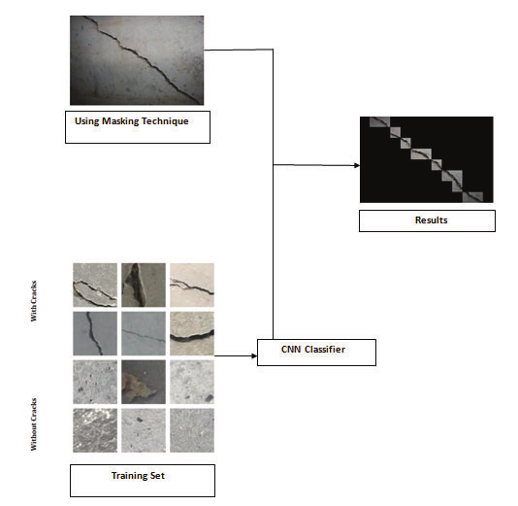

Algorithms used:

- AlexNet for object recognition and classification (3008 x 2000 input image size)
- Sliding window technique for masking (227 x 227 window size)
- Adam Optimizer for neural network optimization

Tools used :
- Tensorflow API
- Python
- Colab

Dataset:
Mendeley Data-Concrete Crack Images for Classiﬁcation by Çağlar Fırat Özgenel from Engineering, Middle East Technical University

Paper -2:
Detection Method Based on Automatic Visual Shape Clustering for Pin Missing Defect in Transmission Lines

Objective:
To detect bolts in transmission lines where pins in bolts are missed .
Here aerial images are used for inspections.

Methodology:
In this paper they designed new architecture called AVSCNet to detect bolts.

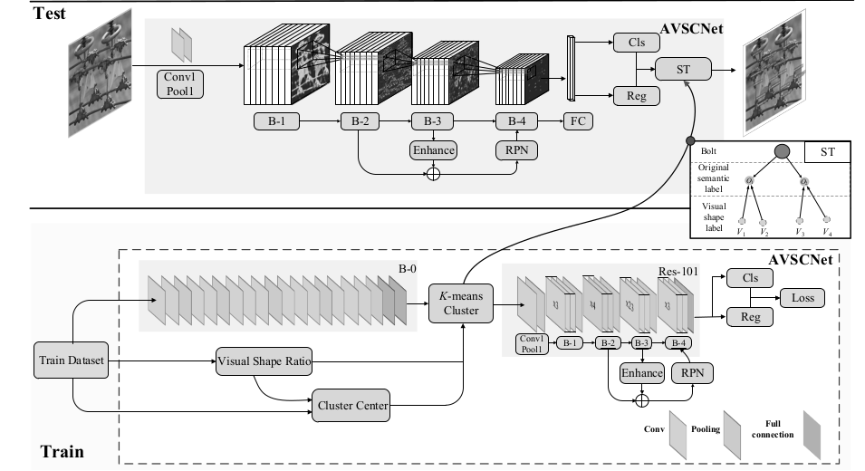
Above picture shows data flow of AVSCNet.

First Visual shape ratio are calculated for training images and image features are extracted using B-0 convolution block. Optimized deep feature is created by adding visual shape ration and output of B-0 convolution block. These feature fed into k-means clustering to create new feature. The process is mentioned as automatic visual shape clustering. Modified version of Resnet101 is used to extract more features and, Regression and Classification used for detection and bounding box generation.

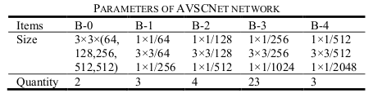
Modified Convalutional Layers:

ResNet’s Residual blocks are modified with following Feature extractor:
1. Feature Enhancement (Using bi-linear interpolation)
2.Region Proposal(RPN) Based on Feature Fusion
3.Expansion RoI

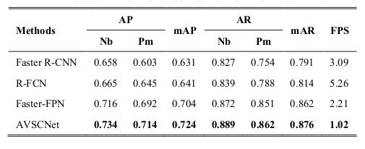
Performance:

Dataeset: Not given dataset sources.

Paper – 3

Insulator Recognition and Fault Detection Using
Deep Learning Approach

Objective :
To detect faulty insulators from an aerial images using Faster R-CNN.

Methodology:
The dataset can be created in three classes .
- Brackround
- Insulator
- Defective parts of insulator

Faster R-CNN is directly trained with above three classes . So, It directly predicts the faulty insulators where confidence level above 0.7.

Tools and Algorithms used :
- Faster R-CNN
- VGG16 (CNN)
- Softmax (Output classification)
- MXNet (Framework for Object Detection)

Paper – 4 :
Critical fault diagnosis method of small components of power
transmission based on optimizational YOLOv3 algorithm

Objective :
To optimize Yolov3 algorithm for small object detection in tower lines.

Methodology :
Yolov3 architecture are build with Two parts. There are
- Convalutional Neural Network (Darknet-53)
- Prediction Network
Optimized Yolov3 is achieved by modifying above two blocks.
Modification :
- Spatial Pyramid Pooling(SPP net) is added in between of 5th and 6th layers in each residual block.

- Feature Pyramid Networks(FPN) are added as Feature extractor for small level features also.

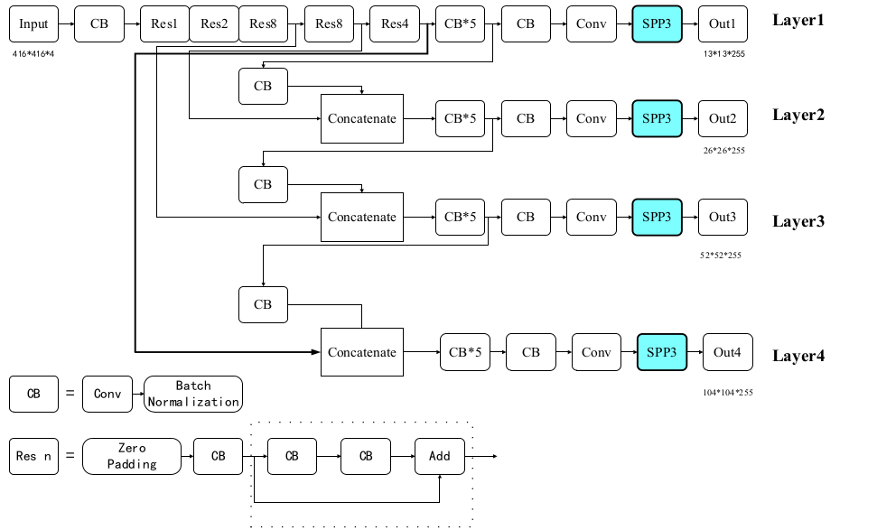
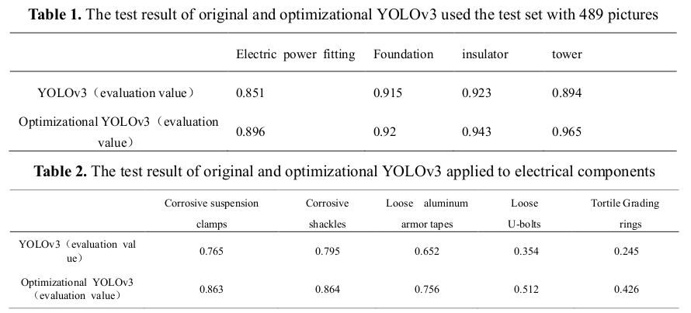
Performance :

