Name: Panneerselvam N
Role : Research Intern - Inspect
Date : 26/05/2021
Research Peper Reviews -Part 2
Paper – 5:
Fault Diagnosis of Power Transmission Lines Using a UAV-Mounted Smart Inspection System

Published Date : August 30 , 2020
Objective :
To detect partial discharge(PD) defect in high voltage transmission line using line tracking drone with UV camera.

Methodology:
Operation is separated in to two parts.
- Line Tracking (Part A)
- Consistency estimation (Part B)
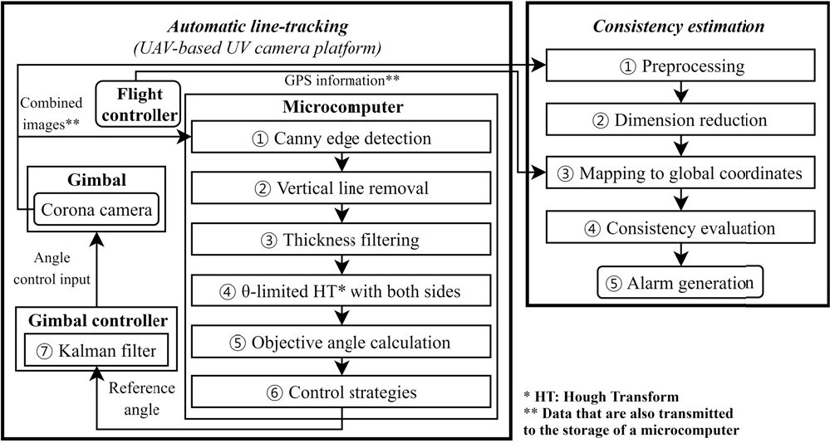
In Part-A, image is captured and pre-processed for calculating camera angle and drone direction.
In Part-B Transmission line image is captured and combined with UV image. Next, This combined image is pre-processed and mapped with GPS data. After that, Consistency evaluation is performed. Finally, If Partial Discharges in image it will generate alarm.
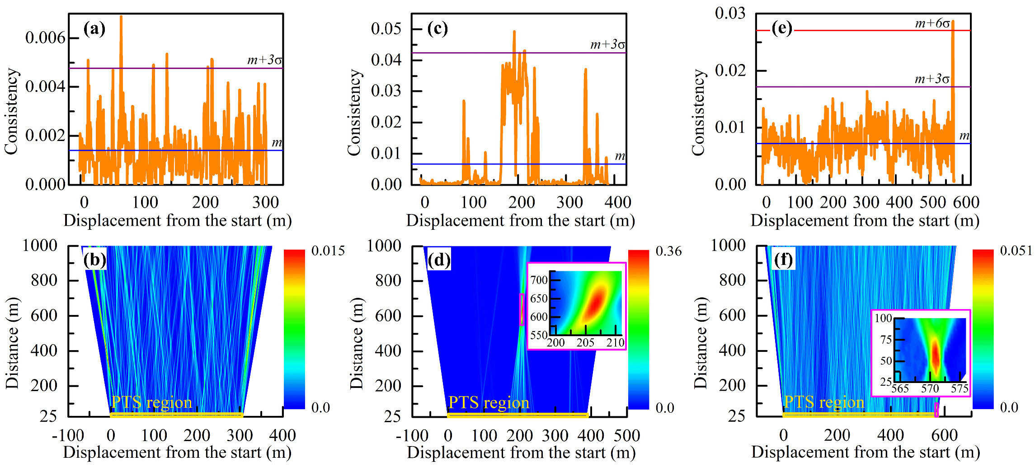

Above image shows view of Consistency estimation and detected Partial Discharges.

Conclusion :
In this paper Part-B is very useful our project. This consistency estimation method is very useful for detecting Partial Discharge problem in Over Head Transmission Line.

Paper – 6 :
An Automatic Detection Method of Bird’s Nest on Transmission Line Tower Based on Faster_RCNN

Published Date :August 25, 2020

Objective :
To detect Bird’s nest in Transmission Towers using Faster R-CNN.

Methodology :
Normal Faster R-CNN method is used to detect Bird’s Nest in Towers.
But , Some Optimization is used in CNN and Pre-Processing.

CNN Optimization:
Authors tried many CNN architecture and gives that model accuracy.

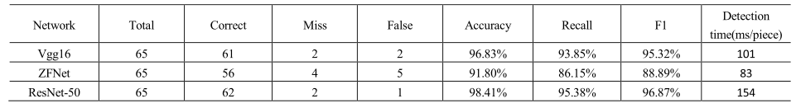
Pre-Processing Techniques:
The following data pre-processing is used to optimize model accuracy.
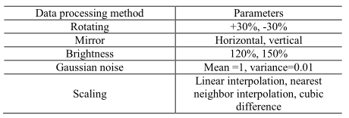

Algorithms Used:
- Faster R-CNN
- CNN (Vgg16 , ZFNet , ResNet)
- Support Vector Machines (Classifier)
- Softmax (Ouput activation function)
Conclusion :
This model gives F1-score as 96.87 %. This F1-score is achieved by above data pre-process technique and Resnet-50 architecture as a CNN.

Input data pre-processing and CNN architecture of Faster R-CNN is plays major role in ouput accuracy.

Paper – 7:
SNIPER Based Multi-Target and Multi-Scale Aerial Image Processing Method

Published Year :2020
Objective:
To detect components in power lines with Faster R-CNN and SNIPER.

SNIPER - Scale Normalization for Image Pyramids with Efficient Resampling
Methodology:
SNIPER algorithm is added in Faster R-CNN for optimize the speed.

In Faster R-CNN , Muti-scale approach is performed to detect small and Large image. By optimizing this multi scale give more operation speed in Faster-RCNN.

SNIPER is a Efficient multi scaling algorithm.
Speed of Faster-RCNN is achieved by adding this SNIPER algorithm in before of RPN.
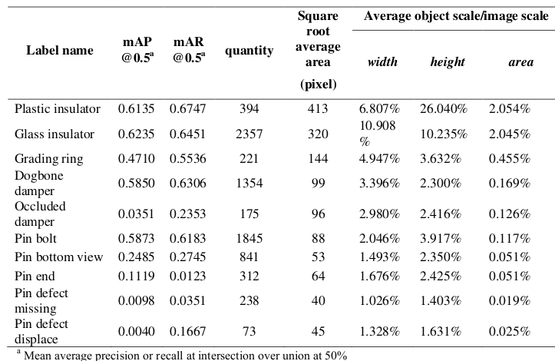
Conclusion :
This SNIPER method performs poor in small object detection and average accuracy in normal objects. It increases the speed ,but decreases the accuracy of model.

Authors says this SNIPER algorithm is perform well in Cascade detection models and gives Good accuracy and speed.
Paper – 8:
Transmission Line Scene Classification Based on Light-VGGNet

Published Year : 2020
Objective:
To classify the transmission components and backgrounds with Light-VGGNet.

Methodology:
Light-VGGNet is achieved by modifying convalutional kernel and Fully connected layer.

Modification :
- Optimized convalutional module(OMC) is used instead of normal convalutional. OMC is nothing but grouped convalutional.

- Only one Fully connected layer is used instead of three layers.

- Average pooling is used instead of maxpooling.
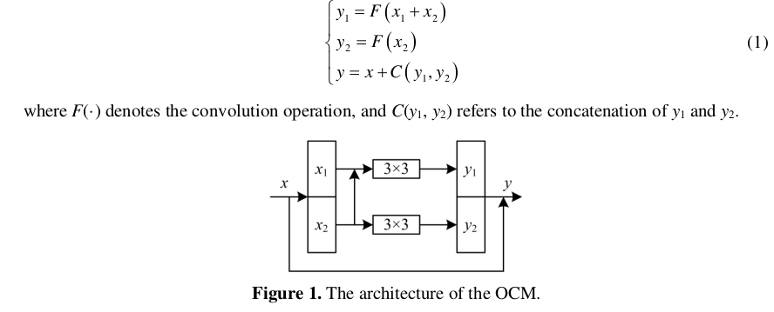
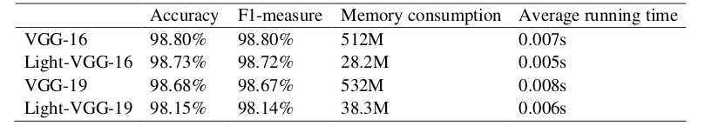
Comparison:
Conclusion:
Light-VGG16’s accuracy is very near to normal VGG16 accuracy. Speed and memory efficient is high in Light-VGG16. Overall performance of Lighter version is good.
Paper -9:
Image Detection Technology on Pin Defect to Overhead Power Lines

Objective :
To detect pin defect in Transmission Towers line with modified Faster R-CNN.

Modification :
Faster R-CNN is modified with following changes:

- ResNet101 is used instead of VGG16 in Faster- RCNN
- Input image is given in the scale of 1500 x 900

Performance:
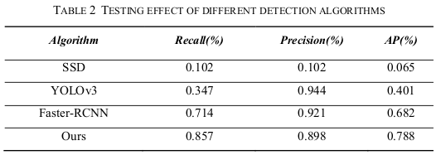
Conclusion:
Modified version of Faster R-CNN gives around 89% Precision. ResNet101 works well compared to other CNN architectures.

