Name : Panneerselvam N
Role : Research Intern – Inspect
Date : 27/05/2021
Research Paper Reviews-Part 3
Paper-10:
Research on Defect Detection Method for Steel Metal Surface based on Deep Learning

Published Year :2020
Objective :
To detect metal surface defects using improved VGG16 based object detection.

Methodology :
Metal defects can be recognized by modified VGG16 architecture.
Modification :
VGG16 has 5 convalutional blocks. 4th convalutional block is modified with new design block.

New design block consist of Residual networks and inception blocks .
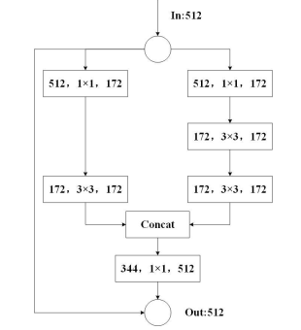

Above block is a new block which replaces the 4th convalutional block in VGG16.
Training Parameters :
Initial learning rate : 0.01
Batch size : 128
momentum :0.9
Performance:
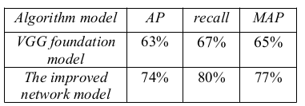

Conclusion :
Modified VGG16 gives around 77% MAP. In this paper they have used only 1400 data. If dataset is increased , accuracy also increased above 90%.

Paper – 11
Recognition Method of Aerial Insulator Defects Based on Deep Learning

Published Year :2020

Objective :
To detect insulators(Small objects) in tranmission line with YOLOv3 and Asymmetric Convalutional Block.

Methodology:
Insulator is detected by YOLOv3 with modified structure. In YOLOv3 , Darknet-53 act as convalutional block. In New structure replaces Darknet-53 with Asymmetric Convalutional Block(ACB). ACB means it perform covalutional operation with three kernel 1x1, 1x3,3x1 and sums up these ouputs.

K-means++ is used for clustring operation . Up-sampling and residual blocks are used for increase accuracy and avoid gradient vanishing , exploding problem.
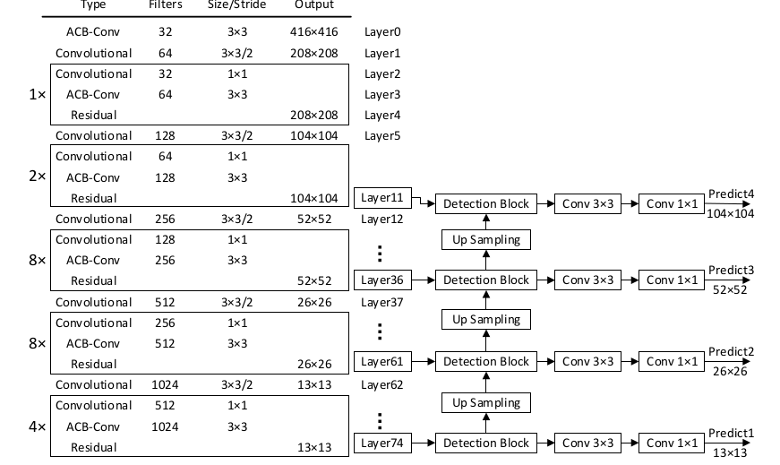
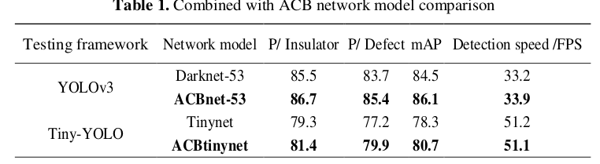
Conclusion :
ACBnet-53 gives more good accuracy and speed with compared to Darknet-53.
This model is very helpful for detecting small objects in inspection.

Paper - 12:
Detection Of Concrete Cracks Using Dual-channel Deep Convolutional Network

Published Date : 3rd July ,2020

Objective :
To recognize concrete cracks using Dual Channel Convalutional Neural Networks(DuCCnet).

Methodology:
Dual-channel CNN is used to recognize even small cracks in an image. Dual-channel means Sub-architecture is additionally added to main CNN architecture.
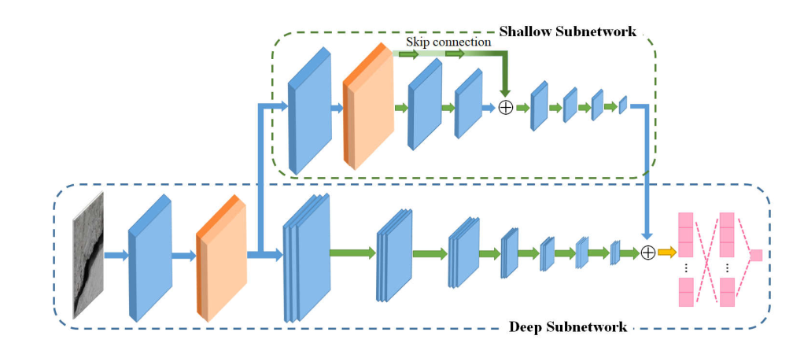
In sun-network, the skip connection is used to avoid gradient vanishing and exploding problem. Sub-network act as a residual block for main CNN. Finally two outputs are added together.

Authors tried more model before getting this architecture , The following table shows comparison.
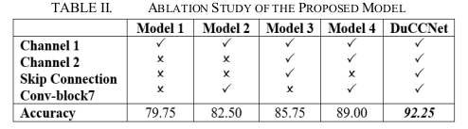

Conclusion:
DuCCNet gives around 92.25 % accuracy. It is good accuracy. Over-fitting is avoided by this Sub-Network.

Paper – 13 :
Transmission Line Image Object Detection Method Considering Fine-Grained Contexts

Published Year :2020
Objective :
To detect Transmission Line components using Region-based Fully Convalutional Neural Networks(R-FCN).

Methodology :
Normal R-FCN architecture with little modification is used for object detection.
Modification :
In R-FCN, Main CNN architecture is build with ResNet50. Squeeze-and-Excitation Blocks(SE Blocks) are used in between of ResNet blocks for extract more features.
Deformable Convalutionals and Position Sensitive Region Of Interest Pooling(PSROI) is used in 5th stage of ResNet.
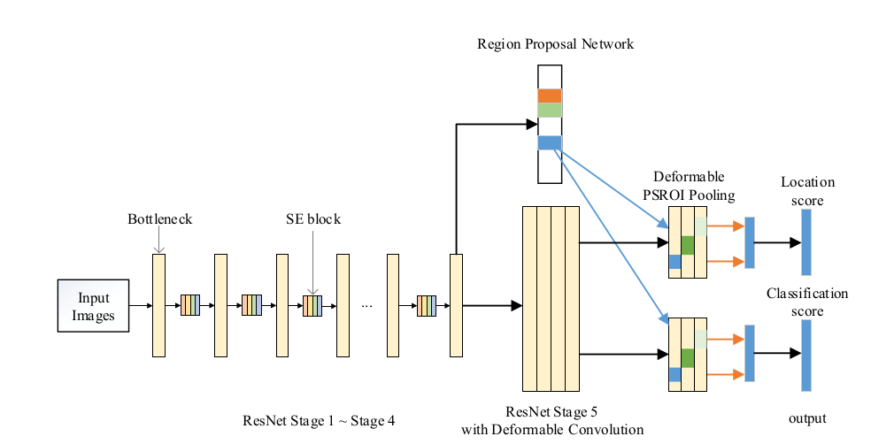
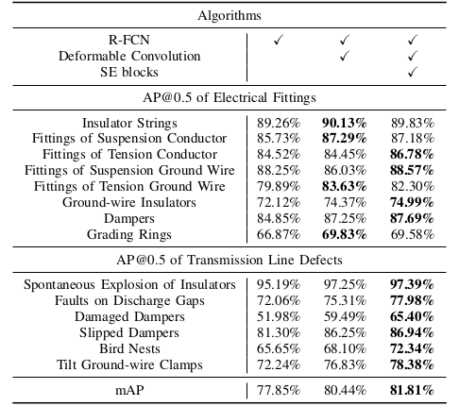
Performance:

Conclusion:
This method takes advantages of deformable convolutional layers and SE blocks to improve 3.96% AP by making better use of context information than similar other method.

Paper -14 :
A Drone Based Transmission Line Components Inspection System with Deep Learning Technique

Published Date :30th June,2020

Objective :
To identify the faults of Transmission line components using Deep learning.

Methodology:
Normal YOLOv3 is used for Object detection.
Various AI techniques and Image processing is used for fault analysis.

AI Techniques and Image Processing:
Color clustering based segmentation
Template Matching
Image Eroding
K-means Clustering
Gaussian Mixer
Edge Detection
Ellipse Detection

Performance:
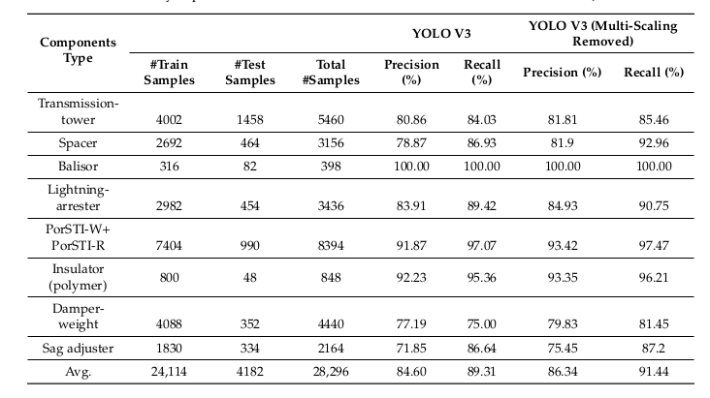

Conclusion:
In this paper various computer vision techniques are used to effectively analyze faults of transmission line components. In YOLOv3 , after removing muti-scale model performance little bit increased.

