Name :Panneerselvam N
Role : Research Intern – Inspect
Date : 28/05/2021
Research Paper Reviews – Part 4
Paper – 15:
Insulator Faults Detection in Aerial Images from High-Voltage Transmission Lines Based on Deep Learning Model

Published Date :19th may,2021

Objective :
To detect insulator faults using Cross Stage Partial Network – You Once Look Once(CSPD-YOLO).

Methodology:
Faulty insulator can be identified modified YOLO algorithm called CSPD-YOLO.

The following things can be changed in normal YOLO.
1. Cross Stage Partial Network(CSPD) is added in Darknet-53
2. Three Residual Blocks used before of YOLO head.
3. Feature Pyramid Network gives Multi-scaling functionalities to detect multiple objects.

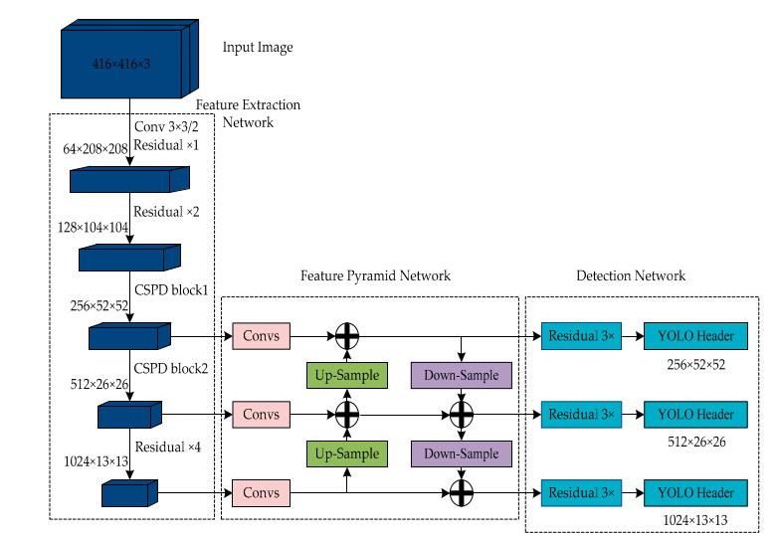
Cross stage partial Dense is used for to give Reuse of features and to extract low level features for detect small object also. Residual networks used in Convalutional blocks to avoid Gradient vanishing and exploiding.
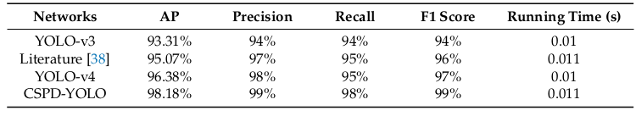
Below fig shows Final Architecture:

Conclusion:
CSPD-YOLO gives high F1-score than normal YOLOv3 and YOLOv4. This is very useful for Real Time Object Detection Tasks.

Paper – 16:
Intelligent Recognition of Transmission Line Inspection Image Based on Deep Learning.

Published Year :2021

Objective :
To recognize insulators in complex background with DetNet.

Methodology:
DetNet is a improved version of ResNet. In this paper they have used DetNet as CNN for Recognize insulators.

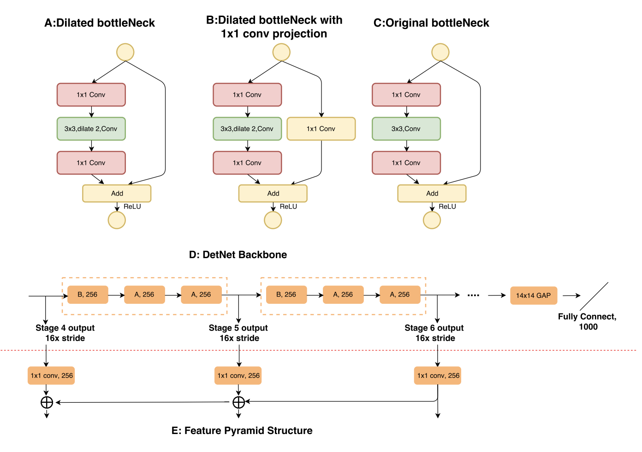
Conclusion:
DetNet gives good result with compared to ResNet Architecture. If this DetNet is used as backbone for any object detection algorithms which gives good accuracy.

Paper – 17:
Automatic Insulator Detection for Power Line Using Aerial Images Powered by Convolutional Neural Networks.

Published Year : 2021

Objective :
To detect insulator fault and diagnose with single Shot Multibox Detector (SSD).

Methodology :
Operation has two parts:
1. Object detection
2. Diagnose

For object detection SSD with VGG16 for feature extraction is used.NMS is used to avoid Multiboxes in single object. Once object is detected, output is fed into Diagnose system .
Diagnose system consist of DenseNet121 as CNN for classification to whether faulty or Normal.

Folowing data augmentation method is used to avoid overfitting and increase dataset.
- Affine Transformation
- Gaussian Blur
- Brightness and Context Transformation
- Salt and Pepper Noise
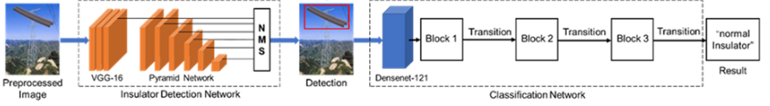
Performance :
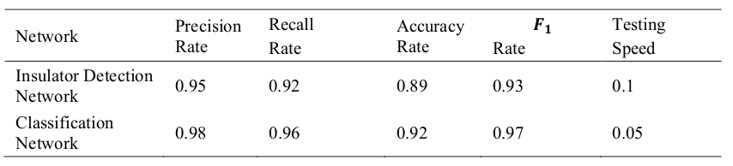
Conclusion:
This method works well in both detection and diagnose. But compared YOLO speed is little low in this object detection method. Diagnose model work pretty good.

Paper – 18:
Pin Defect Detection Method of UAV Patrol Overhead Line Based on Cascaded Convolution Network

Published year : 2020
Objective :
To detect and diagnose the pin defect in transmission line with Cascading Network.

Methodology:
The Operation separated by two tasks :
1. Pin detection in High Resolution Aerial Image
2. Defect Detection in previously detected image

Pin detection is done by Faster R-CNN, ResNet is used as backcone and Feature Pyramid Network is used for Multi-scaling purpose.
Once pin is detected the RetinaNet object detection method is used for analyze whether pin is defected or not. Totally in this hole method Two object detection method is used.
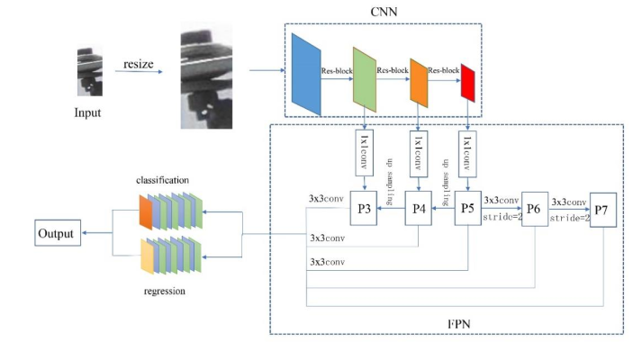
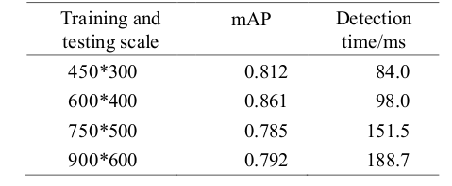

Above table shows the Scaling with respected accuracy.

Conclusion :
Accuracy of this method is decent , but compare to other methods algorithm take little high time. This is because two object detection models are used.

