Name :Panneerselvam N
Role : Research Intern – Inspect
Date : 29/05/2021

Research Paper Reviews Part – 5
Paper – 19 :
Automatic Condition Monitoring of Railway Overhead Lines from
Close-Range Aerial Images and Video Data

Published Date : September 2020

Objective:
To inspect railway towers with Deep learning and High Resolution images.

Methodology :
Aerial images are sometimes not clear and shaked. So this paper used Super Resolution algorithm to avoid that problem.

Super Resolution algorithm means it create high resolution with combination of many duplicates of that image. If video frame is used Next or Previous frames are used to create high resolutions.

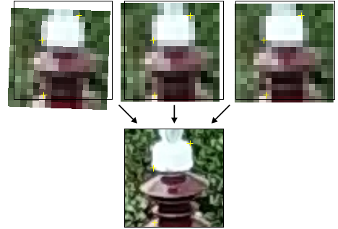
Single Shot Multibox Detector(SSD) are used to detect components in railway Tower Lines.

Above image shows the basic idea behind creation High resolution image.

Conclusion:
If input images resolution increases , high level features can be identified easily. So, there is a high chance to improve object detection accuracy.

Paper – 20 :
Research on Image Recognition of Power Inspection Robot Based on Improved YOLOv3 Model.

Published Year : 2020

Objective :
To inspect power lines with optimized YOLv3 Algorithm.

Methodology:
Object detection speed is increased by modifying some layers in YOLOv3.

Modifications:
In Yolov3 , Scale 3 and Scale 2 Convalutional layers are decreased from 8 to 4. This operation will help to increase speed of network.
In scale 1, Convalutional Layer is modified from 1024 * 3* 3 to 512*3*3 . This operation will help to learn low and medium level features fastly. Because some components in power lines small and medium size.
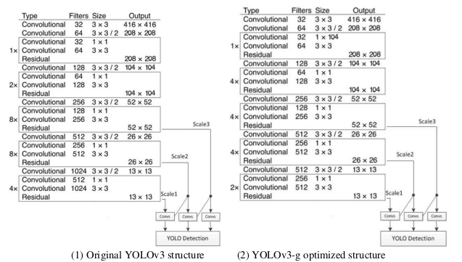
Above figure shows the modified version of YOLO v3.
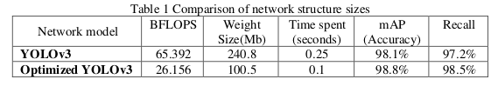
Performance :
Conclusion:
Optimized Yolov3 gives more accuracy , speed and less memory than Normal Yolov3 algorithm.
Paper – 21:
Small object detection in aerial view based on improved YoloV3 neural network

Published Year : 2020

Objective :
To detect small objects efficiently with YOLOv3 Object detection algorithm.

Methodology:
In YOLOv3 , Darknet-53 is modified with following things,

Multiscaling in YOLOv3 is reduced from 8x to 4x. This is help to learn small objects features because , if reduce origial image 8x the small object pixel reduced very small, this will to model didn’t able to learn small feaures.

Output predict layer is reduced from 4 to one. The 4th predict layer is only used for generate outputs.
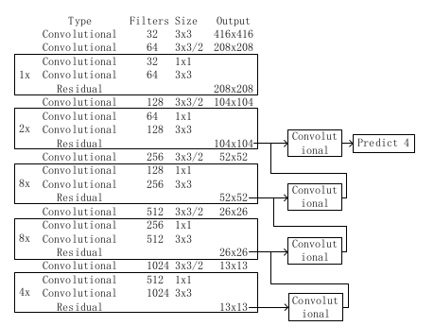

Above architecture shows improved version of YOLOv3.
Performance:
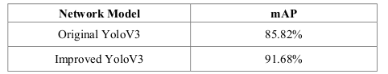

Conclusion:
The improved version of Yolov3 gives mAP around 5% than Normal Yolov3.
4x sampling gives more important to learn small objects. So , it will work good in small object also.

