AERO2ASTRO
Panneerslevam N
(12/08/2021)

Today i had trained PP yolo v2 model upto 1178 only, because some network issues in my area. And also faced another batch size error. I had already set batch size 8 in my config file, but some gpu size error raises. So I am checked GPU type. Which is Tesla P4 , this is new one i think.so I am disconnected my kernel and again reconnect it .Finally I got tesla k80. Due to network issue I am not able to perform evaluation. Tomorrow I will update it in report.

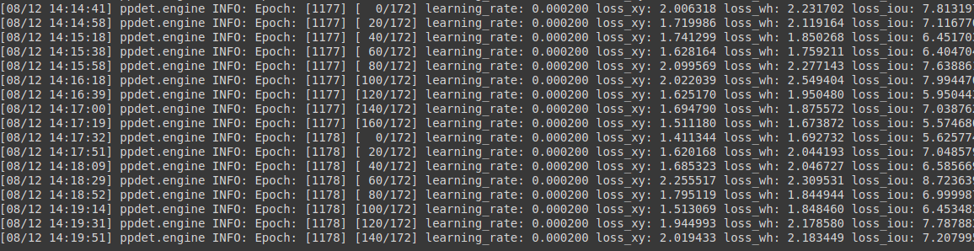
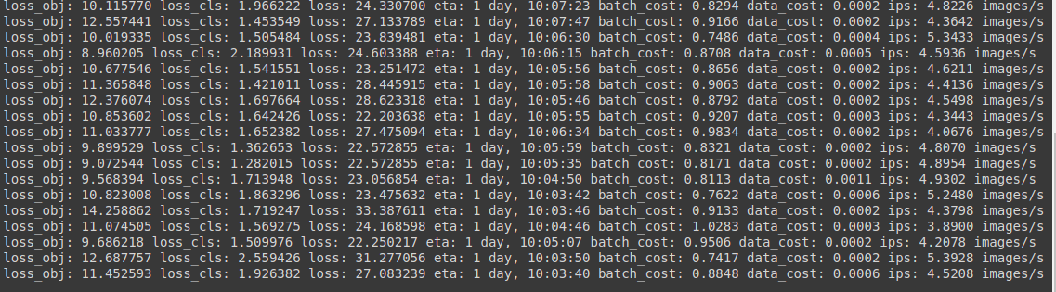
New GPU:(Tesla P4)

