AERO2ASTRO
Panneerslevam N
(13/08/2021)

Today i had trained PP yolo v2 model upto 1327 epochs. The minimum loss is 18.

Previous Model Evaluation:(PP yolo v1 1000 ins):

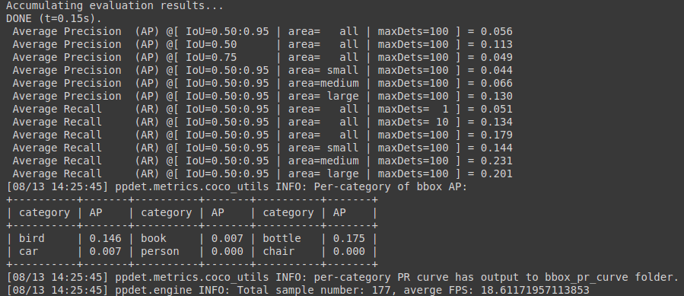

Model Evaluation : (Training data):

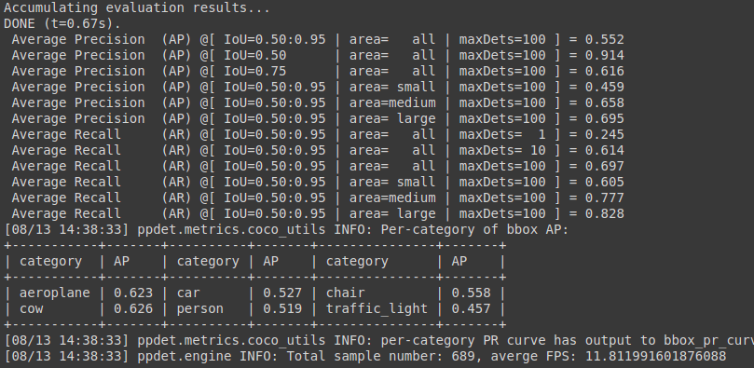

Model Evaluation: (Test data)

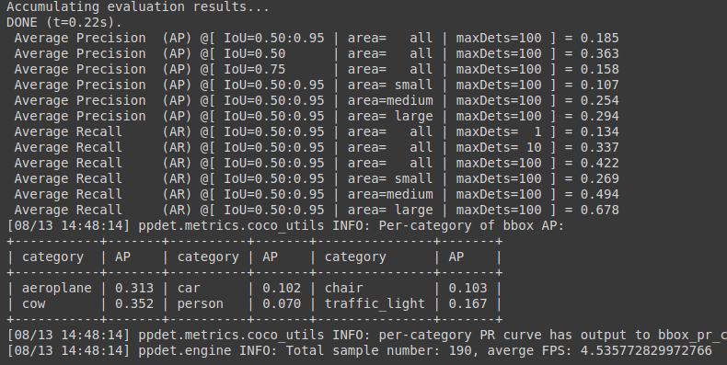
Inference speed:

