Aero2Astro
Panneerselvam N
(14/08/2021)

I had trained pp_yolo v2 model upto 1455 epochs. The minimum loss is 16 and it’s still fluctuates in between 16 to 30.

Evaluated with both training and test datasets, the mAP increased with compared to previous checkpoints.

Previous model Evaluation Result (PP -Yolo v1 1000 ins , bs = 4, lr = 0.0002)

Training Data:
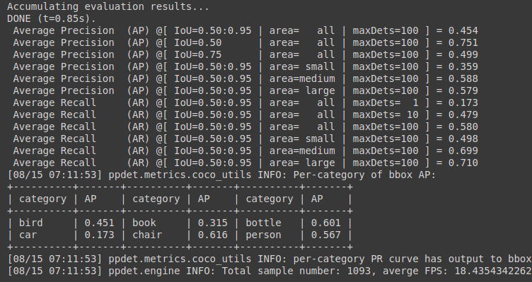
Test Data:
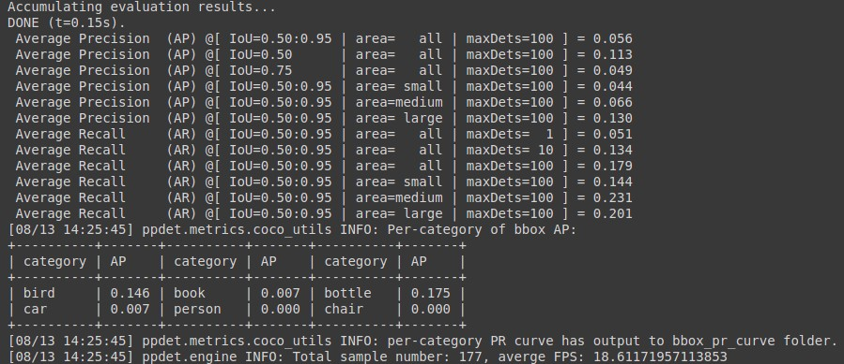

Current Model(PP-yolo v2 500 ins , bs=8, lr-0.0002)

Training Data :

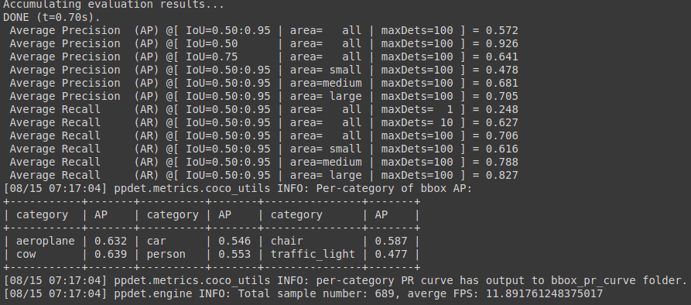

Test Data :

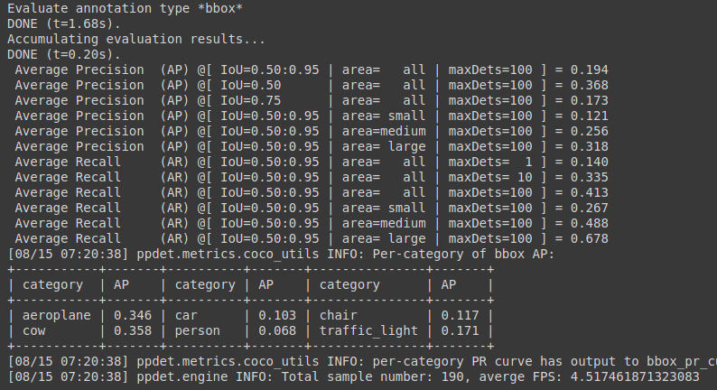

Model Inference Speed:(test data)

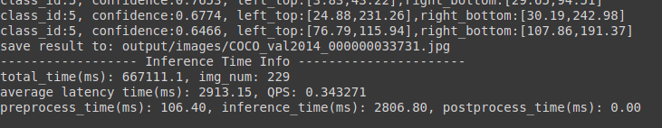
Detection result:
Threshold = 0.1

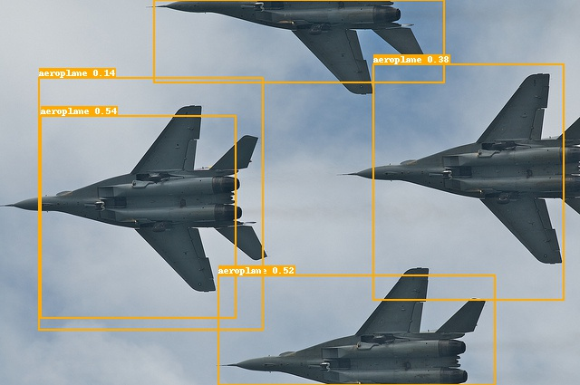


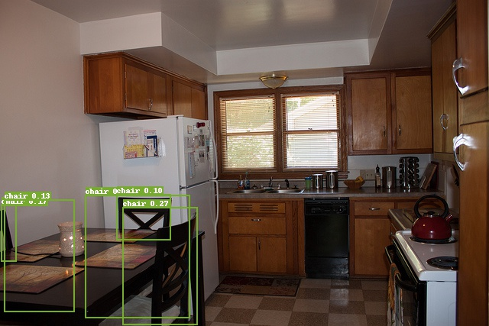



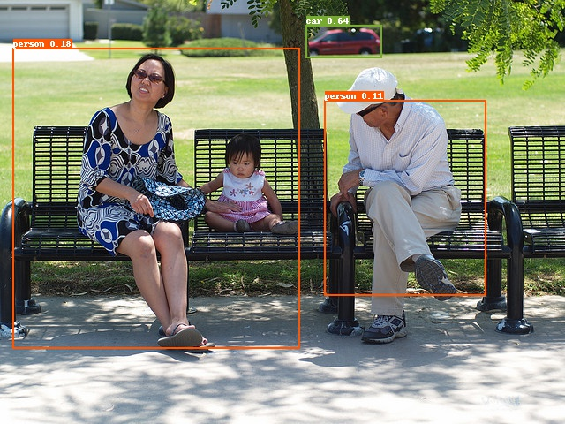

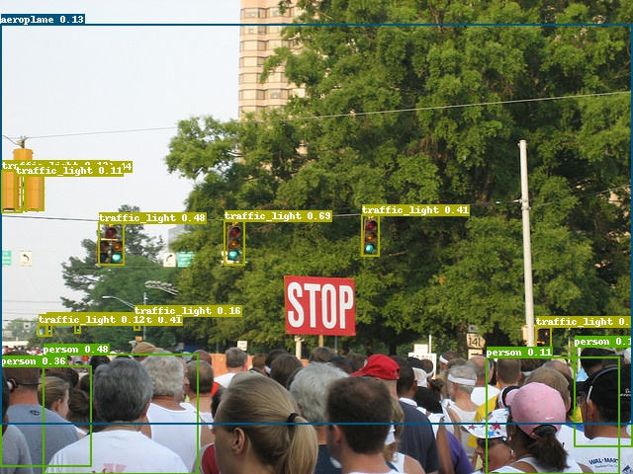

Notebook link :
https://github.com/Panneer003/Aero2astro_code/blob/main/PP_Yolo_with_official/pp_yolo_v2_500ins_until_aug_14.ipynb

