Aero2Astro
Panneerselvam N
(17/08/2021)

I had trained pp_yolo v2 model upto 1711 epochs. The minimum loss is 18 and it’s still fluctuates in between 18 to 30.

Evaluated with both training and test datasets, the mAP is decreased with compared to previous checkpoints. I think model tries to overfit, because training mAP keep increasing , but test mAP starts decreasing.

Previous model Evaluation Result (PP -Yolo v1 1000 ins , bs = 4, lr = 0.0002)

Training Data:
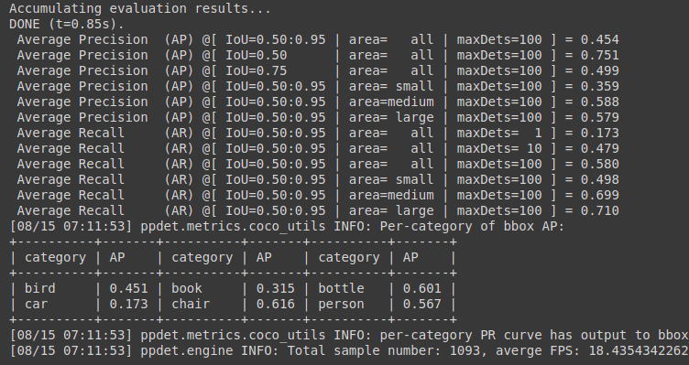
Test Data:
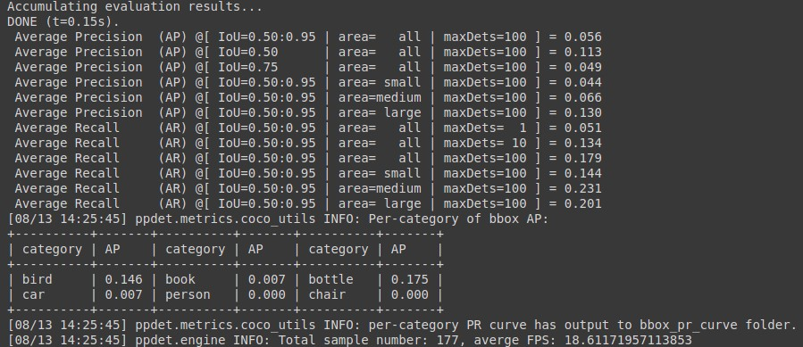

Current Model(PP-yolo v2 500 ins , bs=8, lr-0.0002)

Previous Chekpoints: (at 1455 epochs)
Training Data :

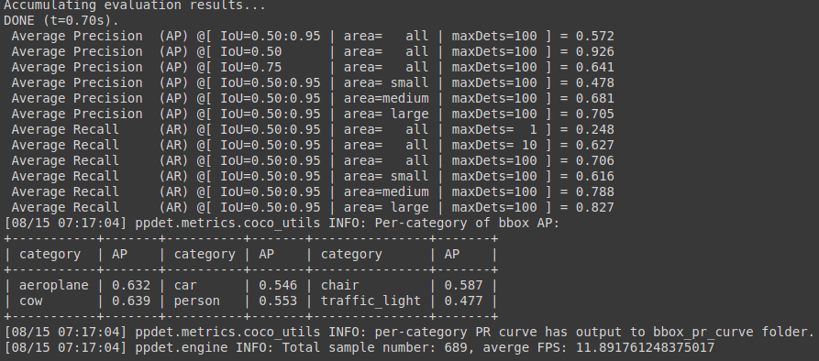

Test Data :

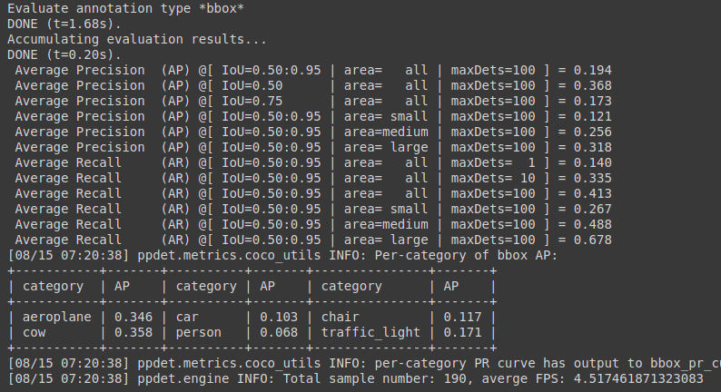

Current Checkpoints :(at 1711 epochs)

Training Data :

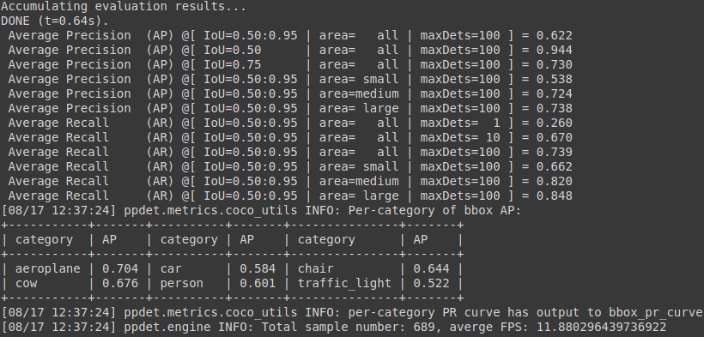

Test data :

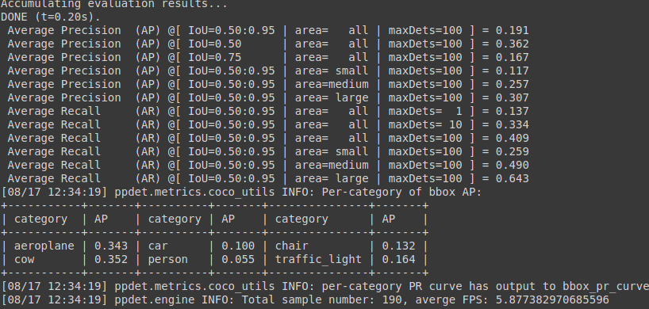

Model Inference Speed:(test data)

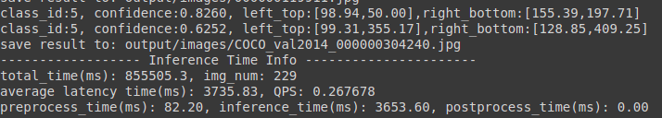

Detection result:
Threshold = 0.1

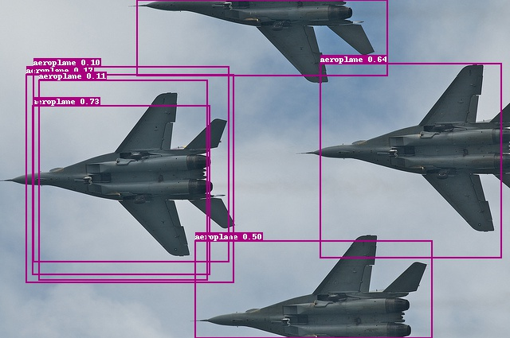

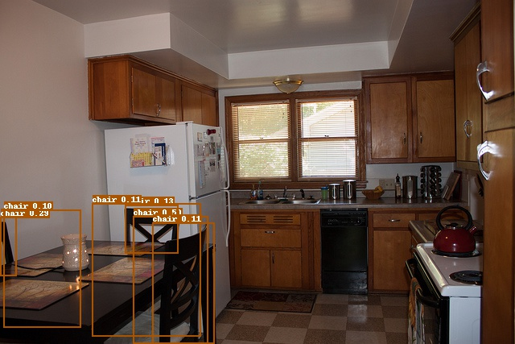

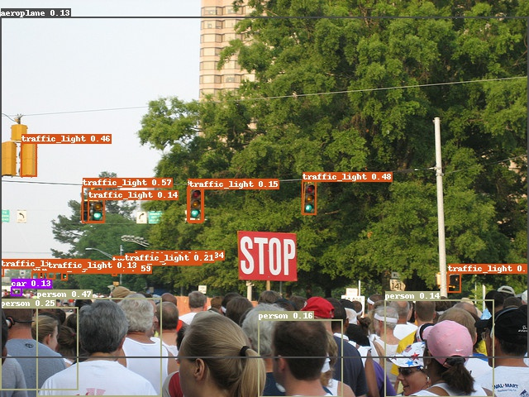
Notebook link :
https://github.com/Panneer003/Aero2astro_code/blob/main/PP_Yolo_with_official/pp_yolo_v2_1711_epochs_500ins.ipynb

