Aero2Astro
Panneerselvam N
(18/08/2021)

Today I had started to training Faster Rcnn with Detectron 2 framework.
Totally trained upto 5600 itertaions and evaluated with both training and test data. Result looks good with compare to previous two model in less epochs.

Model -1 (PP-yolo v1)
ins = 1000
bs = 8
lr = 0.0002
Training Data:
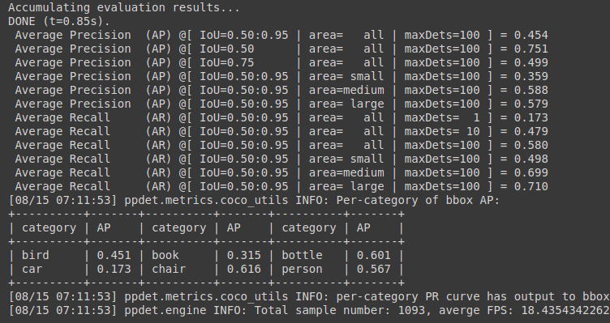
Test Data:
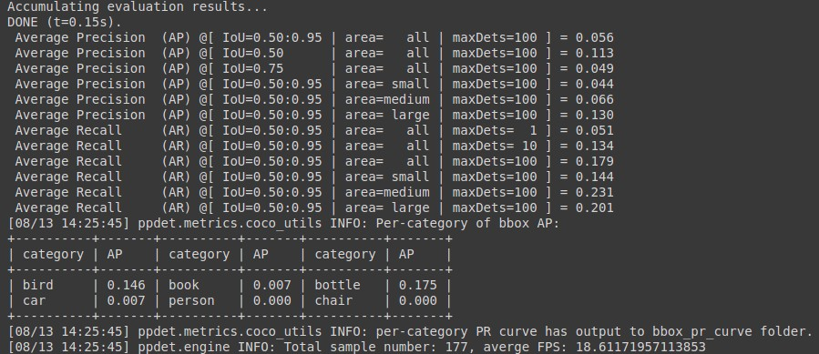

Model – 2 :(PP-Yolo v2)
ins = 500
bs = 8
lr = 0.0002
Training Data :

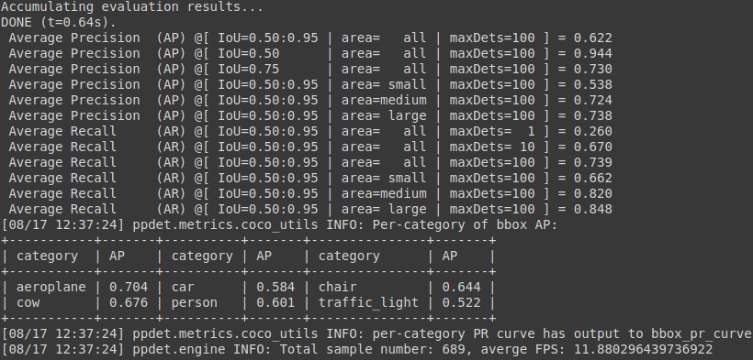

Test data :

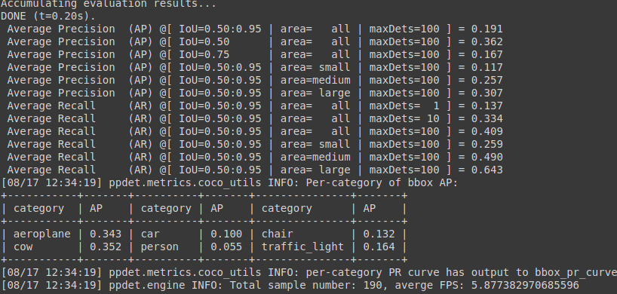

Current Model:(Faster Rcnn)
Backbone = Faster_rcnn_X_101_32x8d_FPN_3x
bs = 4
lr = 0.001
ins = 500
Train Data:

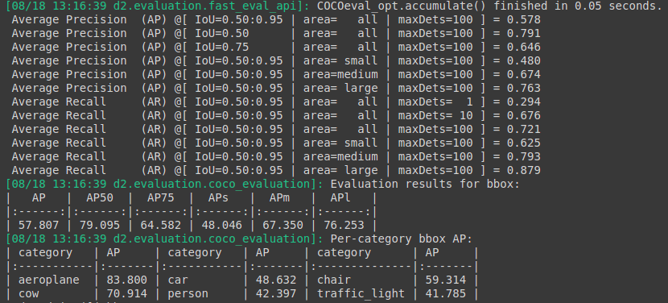
Test Data:

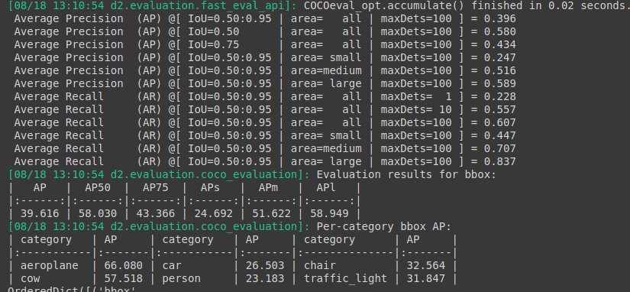

Notebook link :

https://github.com/Panneer003/Aero2astro_code/blob/main/Detectron_2/Detectron2_aug_18_500_ins.ipynb

